Teacher Observation Reimagined!

SeeMeTeach®
Overview and Features

SeeMeTeach – Teacher Observation Reimagined
A Web Based Teacher and Classroom Observation App
© 2026 V.08.16.26
SeeMeTeach ® A Quick Peek at Key Features

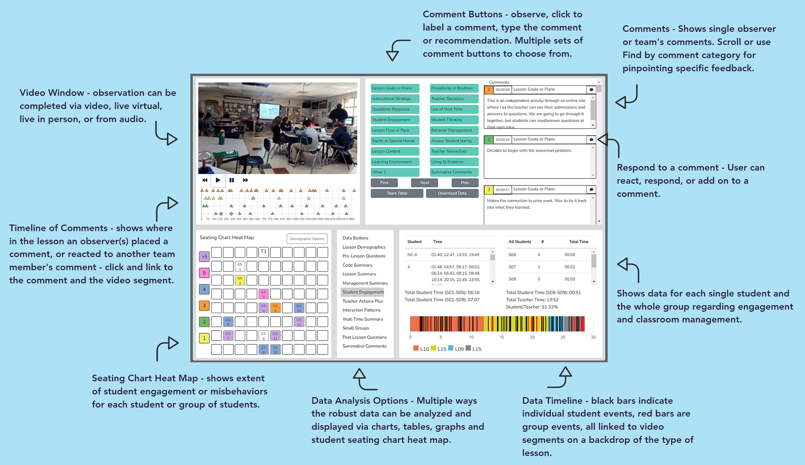

Table of Contents

1. What is SeeMeTeach?
2. Anytime, Anyhow, Anywhere!
3. Why Use SMT? Added Value, Synergy and Power!
4. A Paradigm Shift
5. The Target of the Observation
6. Who Uses SeeMeTeach?
In K-12 Schools
In Teacher Preparation
Methods Courses
Clinical Experiences
Cooperating Teachers
For Research
For Program Evaluation

7. The Qualitative Mode – Highlights and Important Features
8. The Quantitative Mode – Highlights and Important Features
9. Teacher Challenges
10. For More Information
11. Getting Started Using SMT
12. Individuals - Frequently Asked Questions
13. Teacher Education – Frequently Asked Questions
14. K-12 Schools, Teachers and Administrators – Frequently Asked Questions
15. Supporting Documents
16. Terms of Service

SeeMeTeach ® Overview and Features

1. Welcome To SeeMeTeach - Teacher Observation Reimagined!

Welcome to SeeMeTeach ® (hereafter referred to as SMT). SMT is a powerful teacher observation, feedback, and coaching tool that addresses and solves problems that limit the potential of teacher and classroom observations. SeeMeTeach has both a qualitative mode for comments and feedback and a unique quantitative mode for robust data collection that stands by itself or is linked to video or audio, with instant analysis for feedback and coaching. SMT is a tool used by educational professionals that fills the critical need for evidence-based observations when preparing teachers and improving or refining classroom instruction.

2. Anytime, Anyhow, Anywhere!

SMT can be used live in the classroom, when observing via an online video link, or directly from a pre-recorded video or audio of the teacher teaching. In a world where completing observations in a school is more difficult due to restricted visitations, SMT is even more of a ubiquitous and necessary tool for helping supervisors, future teachers, and teachers complete the required observations.

The SMT team extends a hearty welcome and congratulations to those who have decided to incorporate this powerful tool into the teacher and classroom observation process. The SMT team is looking forward to SMT being used for various reasons and in many different settings. As such, we encourage users to provide any feedback or suggestions for making SMT an even more powerful tool.

3. Why Use SMT? Added Value, Synergy, and Power!

First, SMT addresses and solves many problems related to classroom observation. SMT allows for collecting and analyzing the important but often overlooked quantitative factors that are critical indicators of instruction. SMT also contains a qualitative mode that, when paired with the quantitative mode, makes it a tool that provides instant feedback bolstered by data and evidence.

While either the qualitative comments tool or quantitative data-gathering tool can stand alone, there is additional synergistic power when using the data to add meaning and detail to the commentary aspect of the observation. The data gathered complete a story about how teachers interact with their students, how students interact with each other, and how students behave in the classroom. All these classroom dynamics are critical factors concerning the success of a lesson.

With vibrant data collection, this tool helps reduce the subjectivity of classroom observations and adds significant value to teacher or classroom observations. Beginning or experienced teachers who desire to improve their craft and strive to be more effective in the classroom know the power of using data and analysis to aid in refining and elevating their teaching to new levels. Administrators or teacher preparation personnel who want to use either or both qualitative and quantitative indicators will find SMT is a tool for powerful feedback, evaluation, and coaching. In short, any educator who studies teaching will stand to benefit from the use of SMT.

Second, SMT also addresses the problem of scant or minimal communication between members involved in the observation. SMT contains a unique observation, feedback, and collaboration platform, which helps facilitate and improve communication and the sharing of comments, data, and summative forms for up to four observation team members. In a school, this team might consist of the observing administrator, the teacher, and perhaps a peer mentor or second administrator. In a teacher education program, the team might consist of the student-teacher, cooperating teacher, university supervisor, and maybe another member of the teacher preparation team or another student teacher who is team-teaching in that classroom.

Third, the education world has entered an era of increased measurement of school effectiveness, as well as teacher preparation and teacher effectiveness. Schools, teachers, teacher preparation programs, and future teachers (edTPA) are now facing high stakes testing that has consequences. As such, using more data and evidence by those who prepare teachers or by teachers who practice in the classroom will help buffer any frivolous suggestions, subjective conclusions, or outright assaults on their practice.

With this tool, the teacher and collaborating observer(s) can establish baseline data that aids in setting targets regarding general and specific teaching skills and use data to focus in on the indicators for a learning environment in which:

- Teachers ask questions, respond, and use wait-time to foster student thinking and engagement in lessons.
- Students take risks, are willing to respond to questions, and are highly engaged in the lesson.
- Teachers know what their students are thinking, thereby knowing why their students are successful or having difficulties.
- Teachers set up the classroom climate for fruitful discussions and foster student-to-student interactions.
- Teachers develop positive relationships with students and are successful in classroom management.
- Small groups are productive, and small group members are equitably contributing and engaged in learning.

In short, SMT helps to uncover and use data and evidence-based critical indicators of teaching effectiveness that when modified, can have a significant impact on teaching and learning in the classroom. The data and comments collected are a potential source of rich and robust feedback for the person who is being observed.

4. A Paradigm Shift

This tool provides:
- A complete profile of all teacher actions and teacher-student interactions in the lesson to show the predominance of behaviors and teacher tendencies, including:
  - The types of questions asked by the teacher and how many of each type.
  - The types of teacher responses following student actions and how many of each type.
  - Wait-time averages and specific wait-times are noted for the teacher and student actions.

- A complete profile of all student actions showing interactions with the teacher, with other students, and student misbehaviors such as:
  - A heat-map summarizing which students are interacting and the amount of interaction and engagement for each student.
  - A clear picture of which students are passive vs. actively engaged.
  - A timeline of student engagement during various lesson segments with links to video.
  - Indicators that show whether students with special needs, ELL, or minority students are engaged at an equitable level in the classroom (in progress).

- An analysis of the data uncovering critical patterns of teacher-student interactions providing answers to questions such as:
  - When teachers ask questions and students respond, is it a productive pattern or one contrary to the goals of the lesson?
  - If student engagement and thinking is the goal, are open-ended questions present or absent?
  - Were all follow-ups to student responses teacher-clarifying instead of asking the student to explain their answer further?
  - What were the average times for wait-time one and wait-time two?

- A complete profile of student misbehaviors and how the teacher dealt with such behaviors and answers to questions such as:
  - Who was exhibiting misbehaviors - a few students versus many?
  - What, where, and when regarding the teacher intervention?
  - When are more misbehaviors occurring – during x type of lesson, y type of lesson, transitions between lessons, or the beginning/end of class?

- A record of small group interaction and engagement provides answers to questions such as:
  - The who, when, and what type of interactions occur between small group members?
  - Are all small group members interacting and contributing on an equitable basis?
  - What is the nature of the interactions between the teacher and the small group?

5. The Target of the Observation

SMT is a tool for data collection during an observation of a whole class period and the entire class of students or used on class subsets, such as a fifteen-minute section of small group work or a 30-minute section of lab work. Furthermore, SMT can be used at any level of K-college (or beyond), as the common denominator is teacher and student actions that paint a vivid picture of instruction. While SMT's data collection can be rich and extensive, each observation's goal and purpose will differ and determine what specific data needs to be collected and whether the user uses all the codes or a subset. As such, a user can be ready to collect data within as little as 1-5 minutes of beginning to use SMT.
A Quick Tour and Highlights of the SMT Tool - If the user wishes to quickly see the power and highlights of using SMT for observation, they should go to the SMT homepage and view the short video that provides an overview of both the qualitative and quantitative mode of SMT. This video is updated periodically to keep up with the additions and changes to SMT.

6. Who Uses SeeMeTeach®?

A Single User or A Synergistic Team - While this App is a tool that can be used by a single user who wants to study their teaching, it can also serve as the observation platform and feedback tool for a team of up to four people. The following represents those who find this a game-changing tool:

- A Pre-service Teacher
  - A pre-service teacher who wants to use the power of video and data to examine their teaching can use SMT to become more aware of specific things to improve on. SMT can be used to analyze a lesson, collect data and commentary, and develop self-analysis and reflection skills. In short, SMT is a vital asset to pre-service teachers as it helps them to prepare for writing and submitting the edTPA high-stakes assessment.

- A Teacher Preparation Team
  - This team works together to complete observations and provide feedback to a pre-service teacher. They can use the team-based communication platform to share observation details, data, and feedback and facilitate discussion between team members.
  - A methods instructor who has students completing fieldwork-based assignments can ask students to bring back videos with analysis and reflections of their efforts using SMT to document the implementation of specific strategies and results.

- Teacher Education Leadership
  - Teacher education leadership can use SMT to collect evidence and demonstrate accountability. Program directors, department heads, or Deans can register their group of faculty and future teachers SMT and use it as a tool for observations. Simultaneously, SMT is used to gather data and evidence to demonstrate the impact and effectiveness of their program on future teachers for internal reasons and to satisfy oversight entities who visit and scrutinize for evaluation purposes.

- A Classroom Teacher
  - Who wishes to view, analyze, and fine-tune their teaching.
  - Who is using video, collecting data, and using analysis, critical narratives, and reflections for bolstering their submission to the National Board of Certification of Teachers (NBCT)
  - Who wishes to use SMT data as evidence to help buffer the sometimes significant differences in teacher ratings from one administrator to another.

- A Classroom Teacher and School Team
  - A teacher and a colleague, peer coach, or mentor can use SMT to collaborate and improve instruction, and remediate, or fine-tune classroom management challenges.
  - A teacher and administrator can collaborate to complete the yearly classroom observation and feedback assessment process using data from SMT.
  - Teachers might wish to demonstrate and highlight pedagogical strengths by using SMT with a videotape of one or more of their lessons and present the data with analysis as part of their observation process.

- Administrators
  - A more evidence-based lens may help administrators justify recommendations regarding specific aspects of teaching when designing improvement plans.

- Graduate Students
  - A graduate student who is working on a Master's or Ph.D. Thesis, particularly those completing action research and studying teacher actions and student engagement in the classroom.

- A Research Team
  - Tasked with examining the effects of professional development on teaching and classroom instruction.
  - Tasked with studying how curricular innovation impacts instruction, teachers, or students.
  - Tasked with examining the impact of state or federal funding on classroom instruction.

- Supporting documents include:
    - SMT Quick Start Guide
    - SMT Training and User's Manual
    - SMT Overview and Features
    - edTPA and SMT for Rubrics 6-10
    - NBCT and SMT
    - SMT Teacher Exploration and Challenges
    - SMT PD Modules

7. Qualitative Mode - Highlights and Important Features

Highlights and important features of the qualitative mode include:
- Observations can be completed live in the classroom or by using a pre-recorded video or audio.
- The user generates a time-stamped set of observation notes that can include comments and suggestions, color-coded to the specific team member that is making a comment, labeled, and organized by category.
- The user(s) can search and find comments by category.
- Comments are also noted via symbols on the timeline below the video so the user can see who left comments and how many comments are attached to the lesson, then click to read the comment and play the video segment.
- The user can create and tag comments to a student seating chart, thereby noting events and actions by individuals or groups of students.
- When using video, comments are linked to video segments, so the teacher or observer can provide feedback with video examples of the teacher or student actions.
- Summative commentary forms can be filled out, attached, and viewable by any team member. SMT provides some standard forms, or users can also upload and use their own personalized forms as well.
- Provides a platform for the observation team (of up to four people) to collaborate and communicate, and a team member can react to and respond to another team member’s comments.

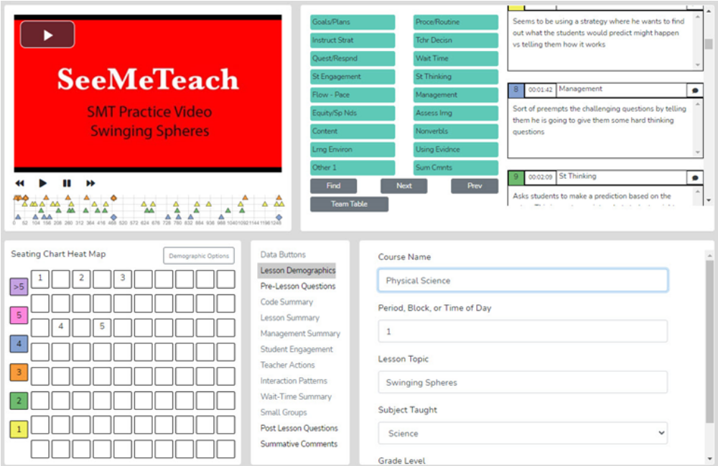

Qualitative Comment Button Choices – You can choose from many button sets when setting up a qualitative observation.
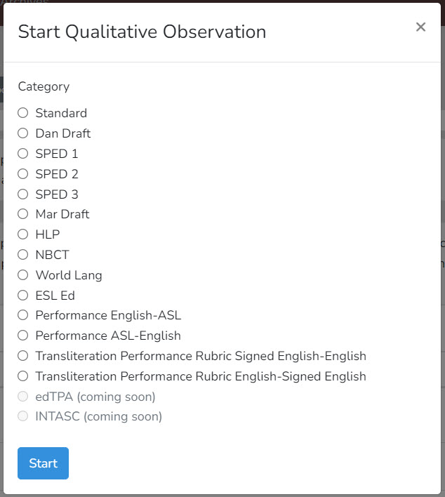

Your Custom Set
Or you can create your own button set with labels you define.

Standard Set Special Education Set 1

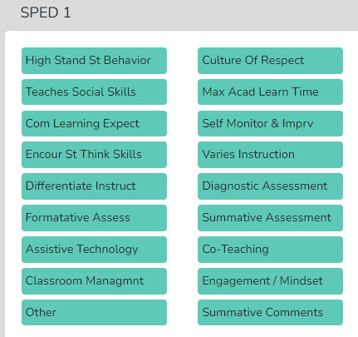
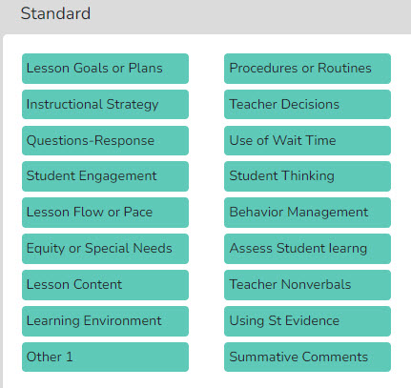
Special Education Set 2
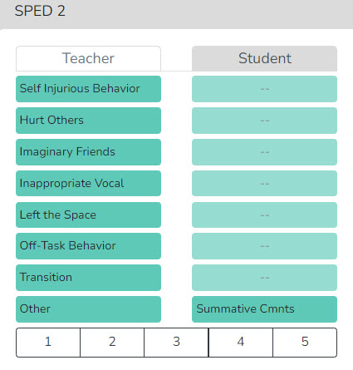
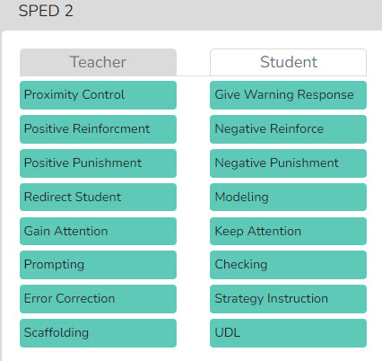

Special Education Set 3
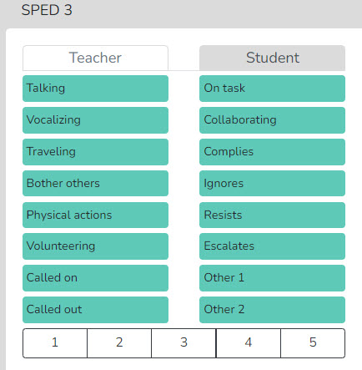
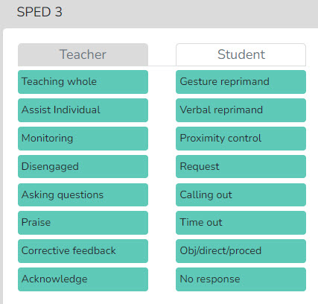
World Languages Set English as Second Language (ESL) Set
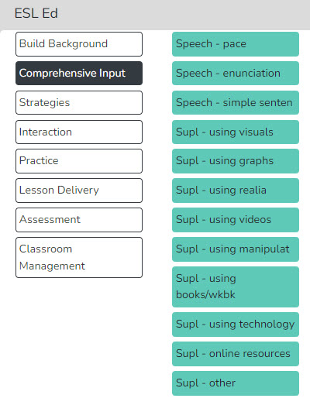
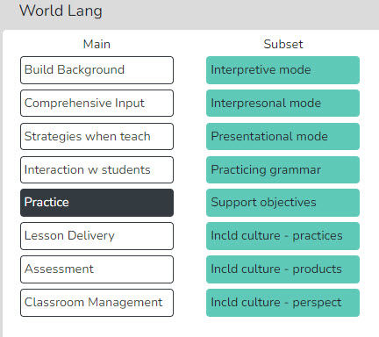

Signing ASL to English Set Transliteral Performance Signed English to English
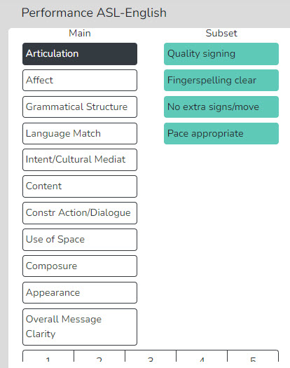
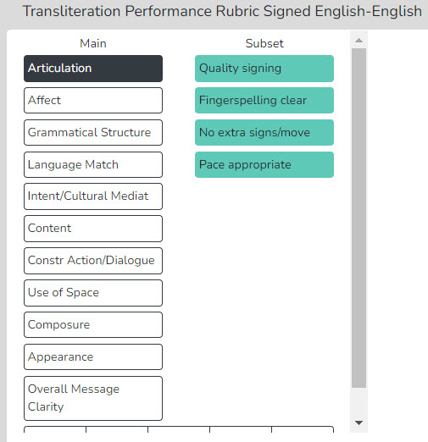

National Board Certification of Teachers
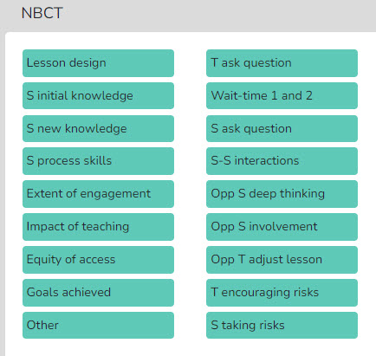

International Use – Note that the buttons can be customized with categories identified by the desired language for international use by choosing Customize Button Sets from the menu.
Lesson Plans - Before, during, or after the observation, the observer can quickly access the teacher's Lesson Plans via the Dashboard or the Team Table.
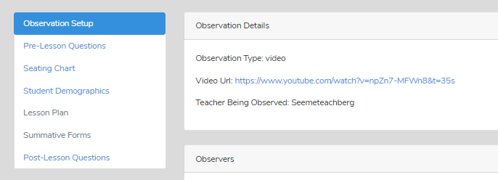

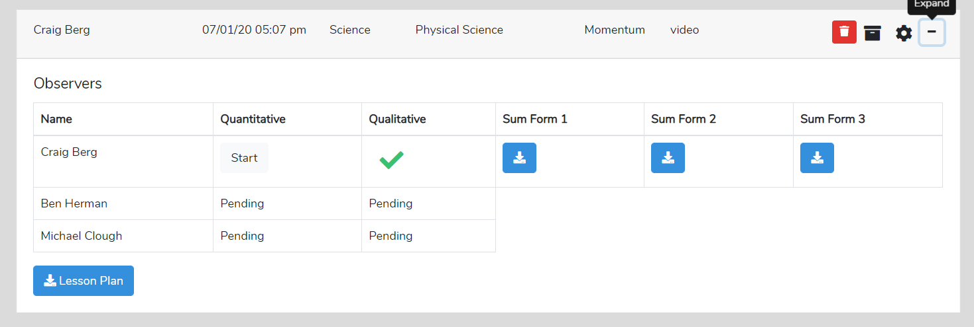

Pre-lesson Questions - To provide the observer with some context and information about the upcoming observation, the teacher can respond to the Pre-lesson Questions, which the observer can see via the Dashboard or the observation pages.
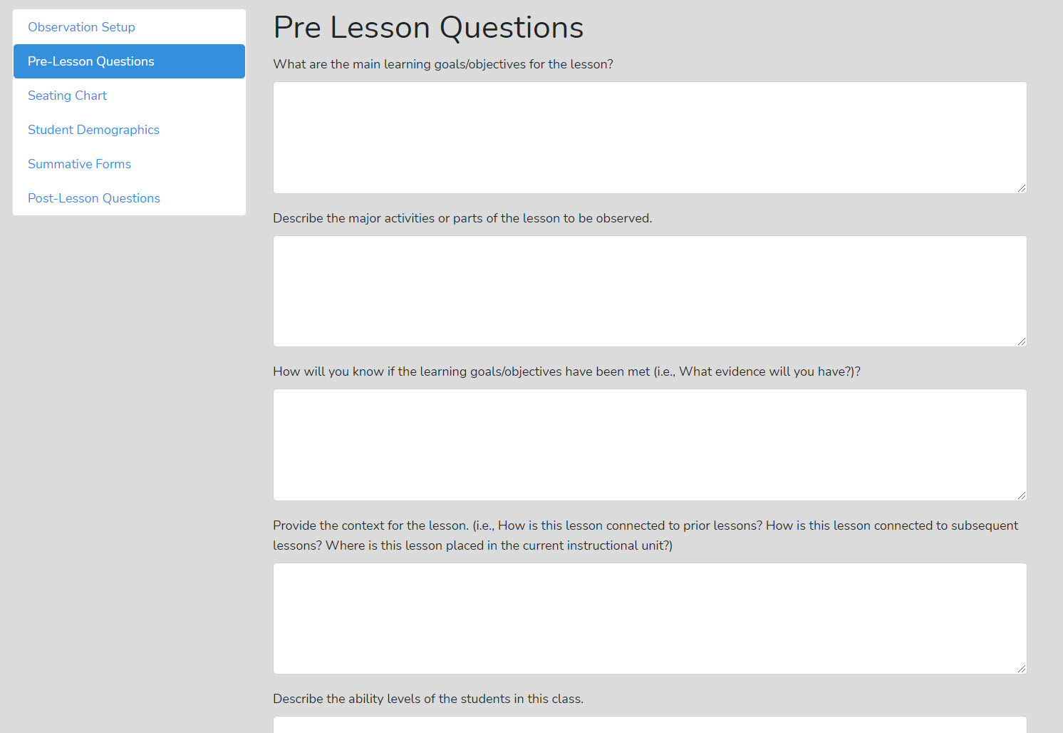

Qualitative Observation Categories and Comments - The observer, or multiple team members, provide comments labeled by categories. The user has many comment categories to choose from.
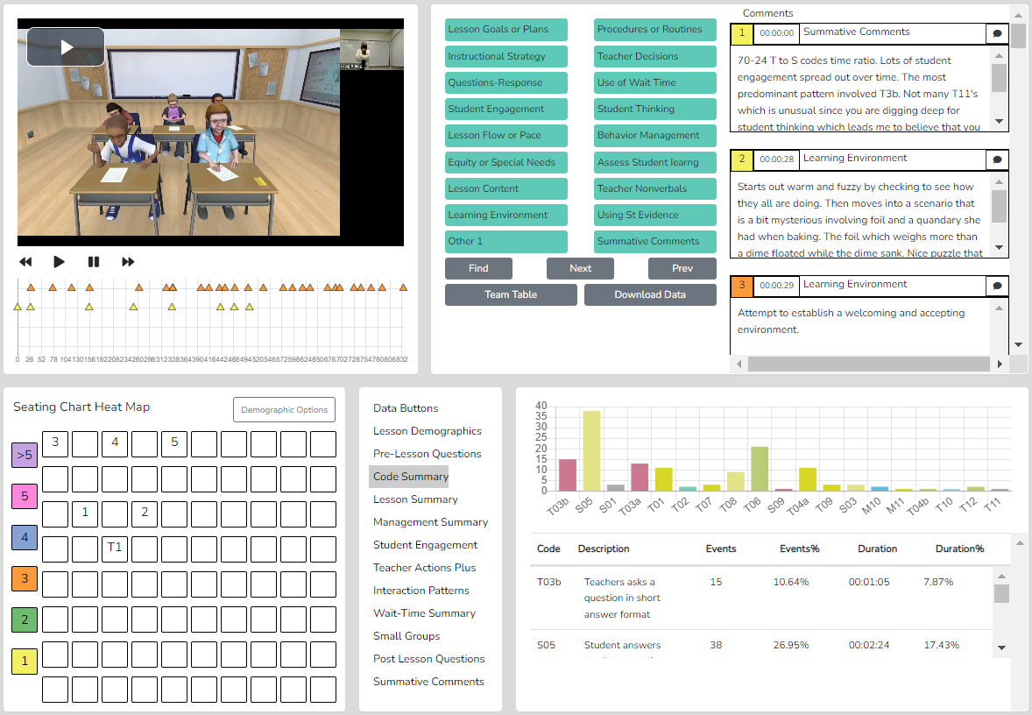

Seating Chart - The teacher or observer can create a Seating Chart and refer to it when making comments, showing each student and small group designations if desired.
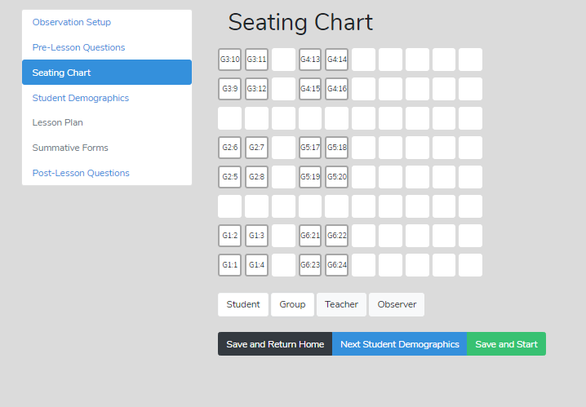
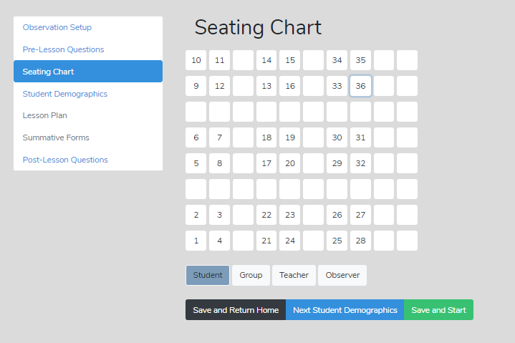

Post-Lesson Questions - To stimulate reflection, post-lesson questions can be filled out or accessed via the settings or the observation/analysis page.

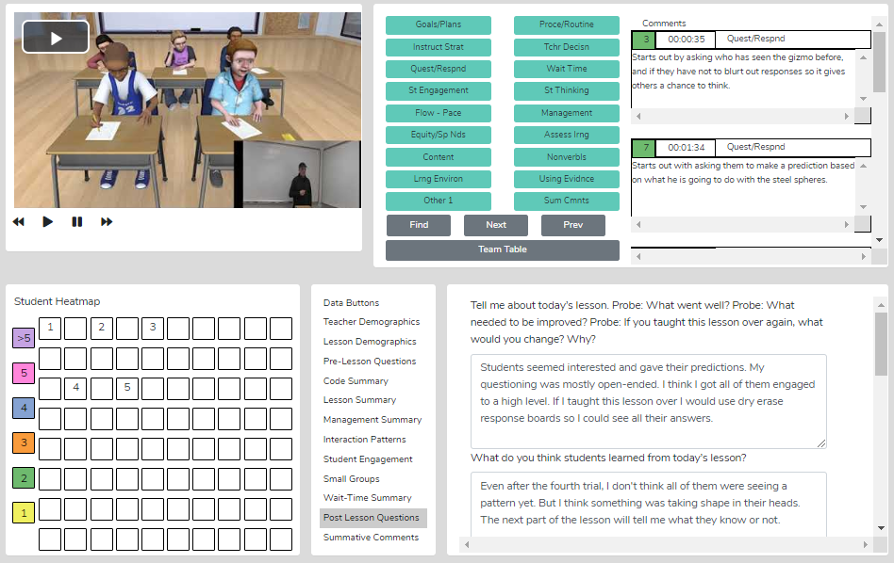

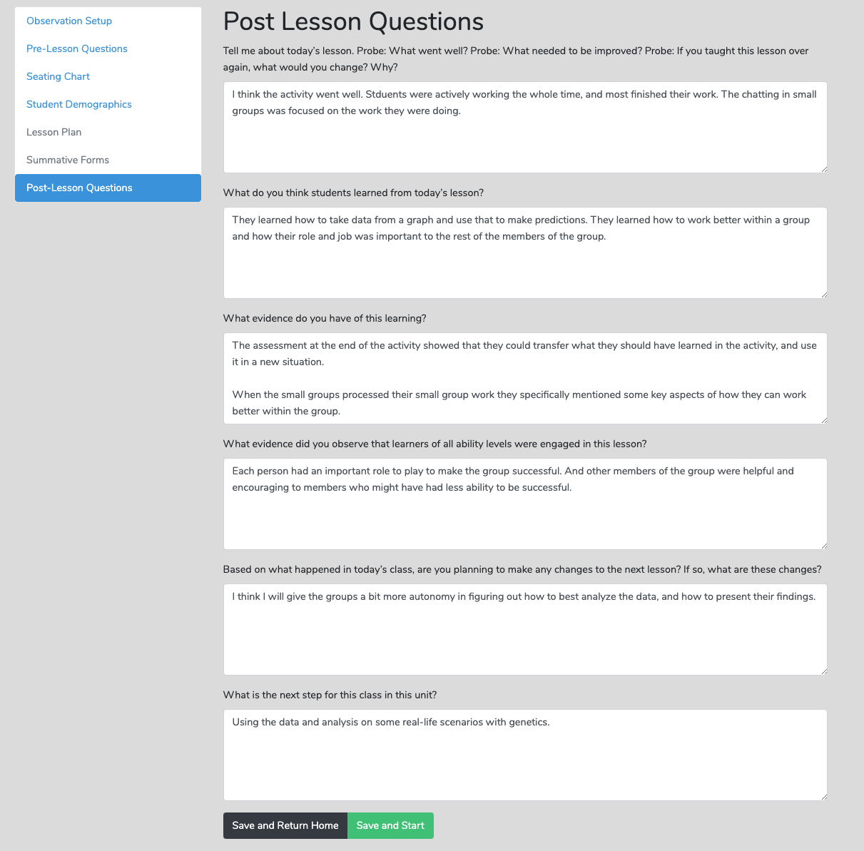

Team Table - A user can choose whose comments (or data/analysis) to view using this feature.
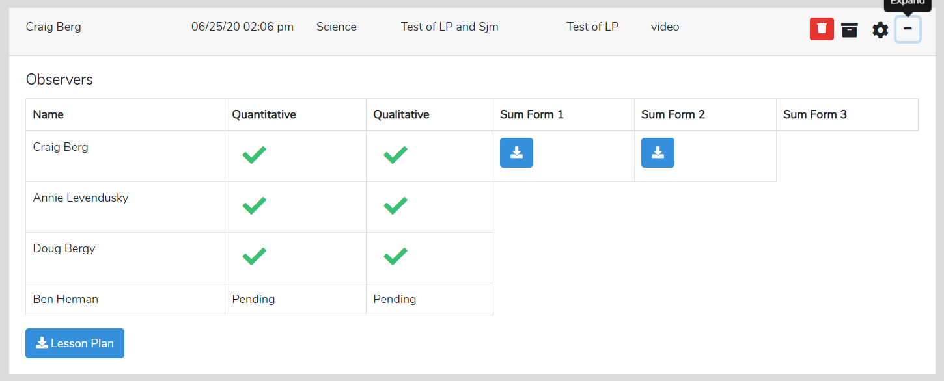

Using Data and Evidence - The observer can use data from the quantitative analysis to bolster comments made during the qualitative comments mode, thereby providing evidence-based feedback, recommendations, and coaching.

Summative Comments and Summative Forms - When the observation is over, the observer can add Summative Comments and/or fill in up to three Summative Forms to share with the observation team. An institution can incorporate its own forms and rubrics.
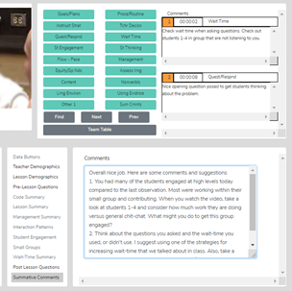
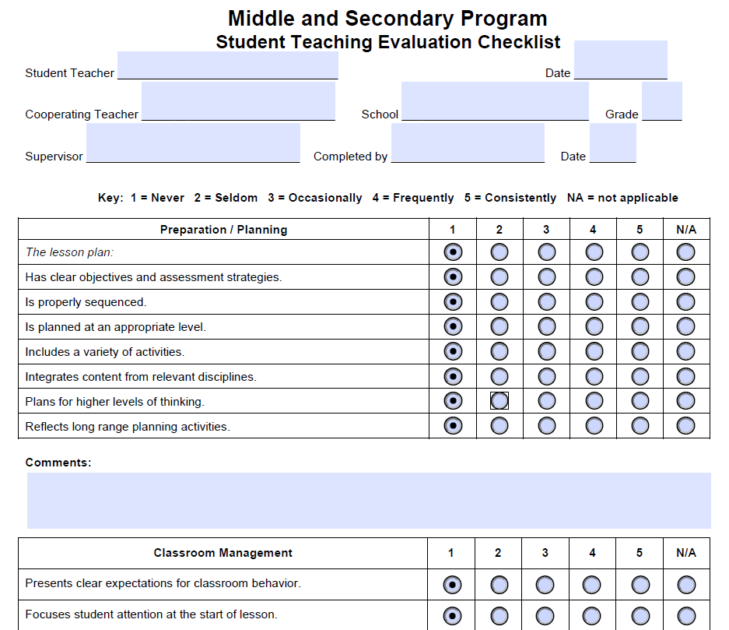

Suggested Uses - The team member's qualitative analysis might be useful regarding:
- When completing a teaching observation of a fieldwork student or student-teacher, post-observation, the qualitative analysis page is immediately available to the student-teacher, who can view comments, respond to post-questions, post their reactions and commentary, and fill out the self-reflective Summative Form(s).
- When using video for the observation, team interaction and communication can be enhanced, as any team member can do a qualitative analysis of that lesson and view any other team member's running commentary and summative comments.
- When using video, all comments are linked to specific video segments so the viewer can see any particular action as it occurred in the classroom.
- Methods of teaching instructors can view the video of pre-service teachers implementing suggested strategies, view pre-service teachers' analyses and reflections, and add their comments or suggestions.
- For a classroom teacher's yearly observation, a teacher can capture a video of their teaching and complete a self-analysis while an administrator completes their own, merging their commentary with the teacher's. A conversation then follows this whole process. When using video, comments are linked to the video, making it easy to locate any part of the observation and showcase events being discussed, enhancing feedback and coaching sessions.
- Research team members can share data and analysis screens by printing the data and analysis screens or by exporting the raw data to a .xls spreadsheet for more refined and custom analysis.

8. Quantitative Analysis and Feedback Options

Introduction to Quantitative Analysis Mode
The SMT quantitative model allows the user to collect and then analyze data related to teacher and student actions during a lesson. This data is coupled with the specific lesson type in play to show when and where student and teacher actions occur. The raw data is displayed, time-coded, and linked to the events as they took place in the video. The resulting raw data and analysis of data offer substantive insights into the activity and events of the lesson. The analysis and feedback options described below will highlight the benefits of using quantitative data during the feedback and coaching process.

Power of Video-linked Data - When using video, the data collected is linked to specific video segments that represent the data and the type of action or event by both the teacher and students. On the analysis screens, the observer, teacher, or team member can go directly to the video linked to specific data points and see examples in action.

Highlights of the Qualitative Mode
- Observations can be completed live in the classroom or by using a pre-recorded video or audio file.
- SMT collects extensive data regarding teacher and student actions that is linked to events in the classroom.
- There is an immediate post-observation analysis of data with visual representations displayed in tables, graphs, and heat maps of seating charts.
- With a seating chart, the data are linked to specific students, small groups and analyzed by student demographics.
- Data are linked to video segments making it easy to locate specific examples of a teacher or student’s actions.
- Small group actions can be noted for examining small group dynamics and engagement.
- The lesson plan is attached to the observation for ease of access for the observer or any team member.
- Summative forms tailored to local needs can be filled out, attached, and viewable by any team member. SMT provides some standard forms, or users can also upload and use their own personalized forms as well. SMT provides some standard forms, or users can also upload and use their own personalized forms as well.
- SMT provides a platform for the observation team (of up to four people) to collaborate and communicate.

Data Collection Screen

The data collection screen includes a seating chart, the video window (live or audio-only), and data collection buttons that observers use to note teacher and student actions, resulting in rich, robust indicators and analyses. For international use, the button sets can be customized in the user's native language.
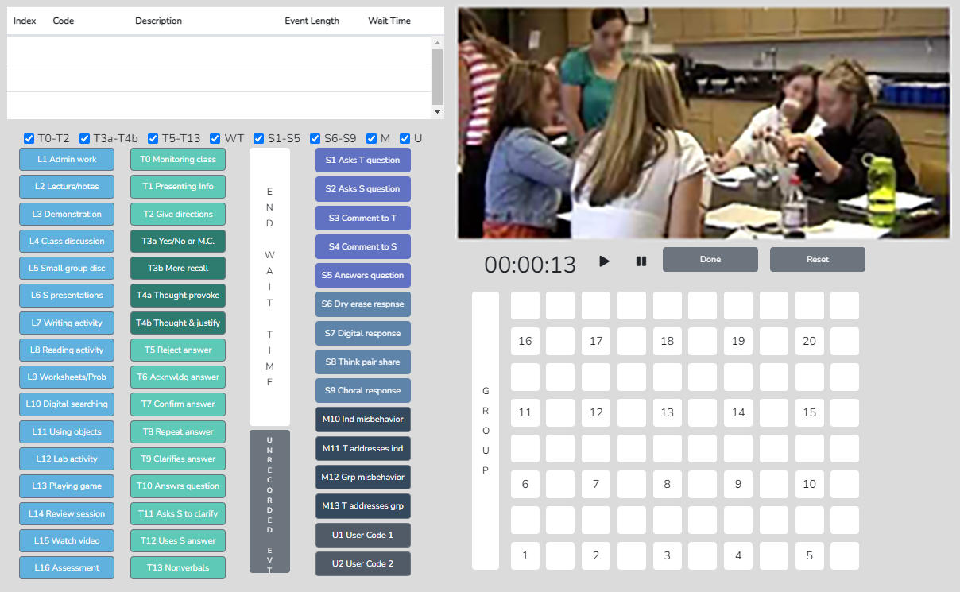

However, button sets can be toggled off for novices or users who want to collect only specific data, as shown below, making it easy to collect critical data such as student engagement. The training videos and manual scaffold the user from simple to complex data collection.
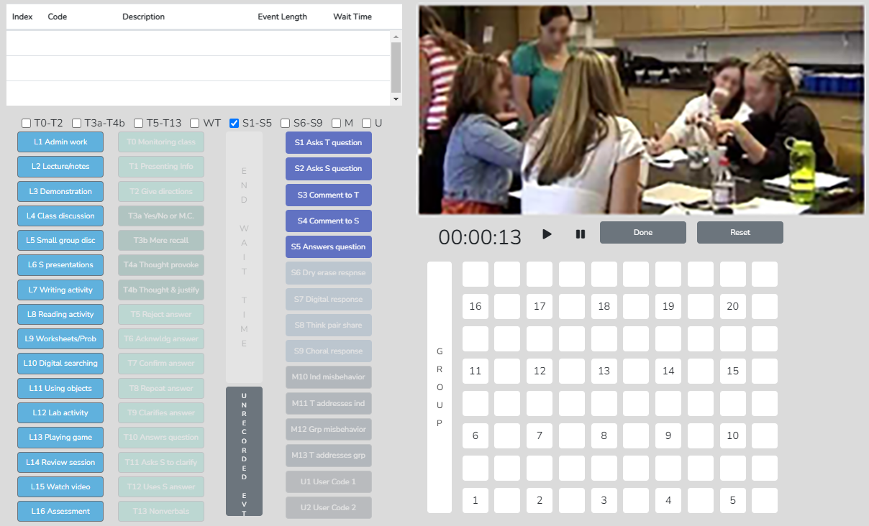

Post-Observation Data Analysis Screens

Code Summary – This feature provides a graph of the number of events of each code used during data collection and shows the relative and specific use of T, S, M, and U codes. Underneath the graph is a data table that displays data for each specific code by event frequency, event frequency compared to the total number of events, time coded by the specific event, and time accrued for that event compared to the total time of all events. The T code data is tallied underneath this data table, as are the S, M, and U codes. This data is also recorded as a percentage of total events and total time.
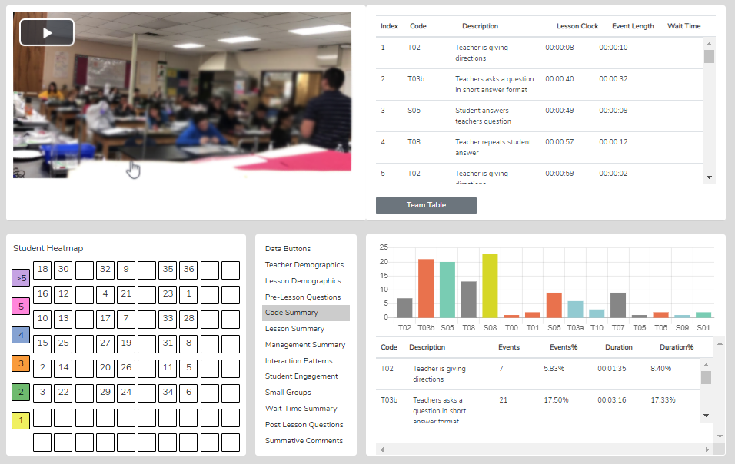

- Looking at the Code Summary, the data table, and the graph:
  - What were the predominant T codes exhibited in this lesson?
  - When looking at the data for the four question types (T3a, T3b, T4a, and T4): what is the tendency of the teacher to ask open-ended questions requiring students to think more deeply, to speculate, and construct answers vs. asking questions that require a yes/no or short-answer memory-type response?
  - If the goal was to dig into student thinking at a deep level, consider the type and number of questions asked (and your memory of the teacher asking questions in the video). What might you conclude?
- What does the teacher tend to do following a student's response? Do they tend to judge responses, acknowledge, and then clarify for a student, or instead ask a student to explain?
- Considering the type and number of questions asked, what might you conclude if the goal was to dig into student thinking at a deep level? What changes would foster more of this?
- What is the total % of T codes vs. % of S codes? This data indicates whether the teacher is doing most of the talking and events, or whether the talking is balanced between the teacher and students, and at what level students contribute to teacher-student or student-student interactions in that lesson.)

Lesson Summary – When coding a lesson, the observer notes the type of lesson in play by clicking an L button at the very start of the observation and a different L code each time the lesson type changes within the observation. As such, lesson segment types are noted and displayed in quantitative analysis mode in the Lesson Summary data window as a timeline showing the order and length of each segment of the lesson. This lesson segment display serves as a time-context reference when viewing other data, such as Student Engagement or Management Summary, so the user can see where misbehaviors or students' responses occurred in the lesson.

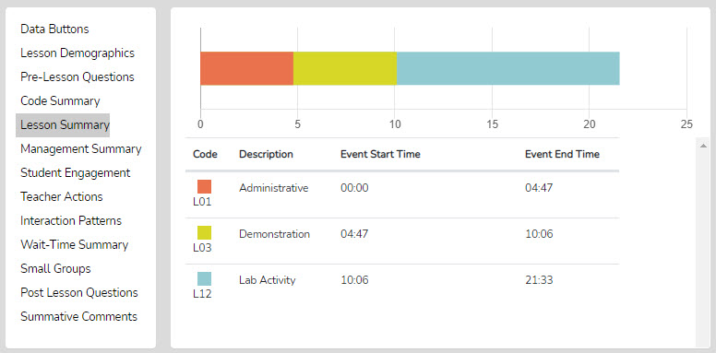

With the Lesson Summary information, the user can consider the following:

- Teachers can view how much time was spent on each segment of the lesson and think about whether more or less time was used on lesson segments than intended and how the use of time affected the outcomes of the lesson.
- After the bell rings and the class period begins, teachers can analyze how much time it took to start teaching and then decide what to do differently to begin teaching right at the start of the class period.
- Teachers can examine how much time was used for each segment of the lesson and the time needed for transitions between each part of the lesson, allowing the teacher to ponder what changes should be made to reduce the time needed for transitioning from one part of the lesson to another.
- If the lesson ended early, teachers could view that much time at the end of the lesson was not used for instruction and think about some productive things to insert into the lesson to utilize the remaining class time.
- Teachers can consider the whole class period and what might have been done to use the time more productively.

Management Summary – Management Summary provides a seating chart, timeline, and individual student data for misbehaviors using black bars on the timeline that are also linked to the video and the teacher's response and intervention using red bars that are linked to the video. It also shows when and how long the teacher reacted to and addressed misbehavior. Clicking a bar starts playing the video linked to that event.
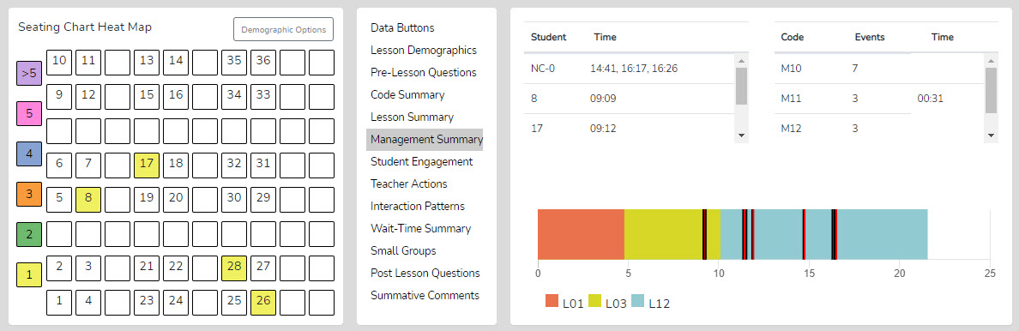

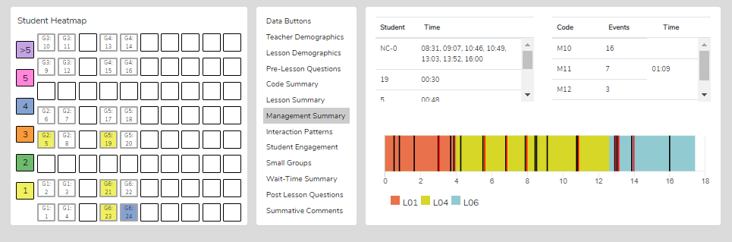

Demographic Highlighting in the Seating Chart Heat Map - In addition, if data is collected for specific students using the student seat number before entering the M code, the data can be displayed and toggled on or off by clicking the Gender, ELL, SPED, or Minority buttons. If the observer wonders how the students with special needs are disengaged during the lesson, toggle this information to find out. If the observer or teacher is concerned about equity of participation regarding gender, minority, ELL, or students with special needs, then this data is available.

Things to Ponder - How Can SMT Users Utilize the Specific M Code – Student Misbehavior Data?
When Viewing the Code Summary:
- How many classroom management events were noted by the observer?
- How many of those classroom management events were not addressed by the teacher?
  - Note that when the number of M10 events is added to the number of M12 events, if that number is greater than the number of M11 and M13 events, the teacher is probably ignoring some of the student misbehaviors either intentionally or due to the frustration of not having an impact when they do intervene.
- How much time did the teacher use to intervene in management events? (M11 and M13)

When Viewing the Seating Chart Heat Map:
- Where in the classroom are the problems occurring?
- Is there a small group or table of students who are exhibiting most of the misbehaviors?
- Are behavioral issues proximal or distant to where the teacher is located?

When Viewing the Management Summary:
- Where in the lesson, or during which lesson type, did the management issues occur? (Vertical bars on the lesson segment timeline)
- How many management issues occurred at the start of class, end of class, or during transitions from one lesson segment to another? (Vertical bars on the lesson segment timeline)

When Viewing the Video:
- How much time was needed to get all the students settled and begin the lesson when transitioning from one lesson segment to another?
- How was the teacher's movement around the classroom?
- How did the students behave or misbehave in this lesson today compared to other days in general?
- Regarding specific students who might tend to misbehave, how was their behavior today?
- Was there anything about this lesson that might have contributed to more or fewer management issues?

Student Engagement Summary – Displays student engagement events (S codes), noted by student seating number (or generically if seating chart numbers were not used), and when the events occurred. The specific time of student and teacher data is displayed on the lesson-type timeline, with black bars for student events and red bars for when the teacher engaged the whole class using Think-Pair-Share, digital devices, or other means. Clicking a bar starts the video linked to that event. In addition, the seating chart heat map shows, by color code, how many events are linked to specific students.

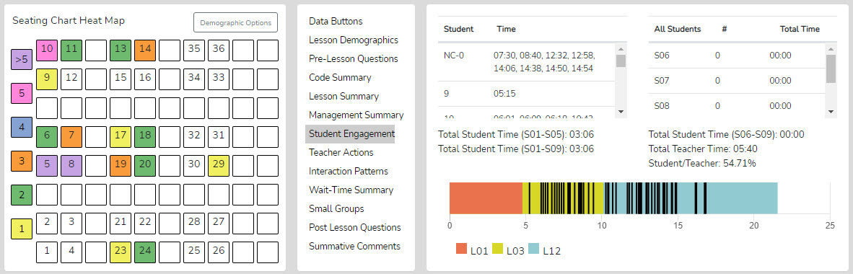

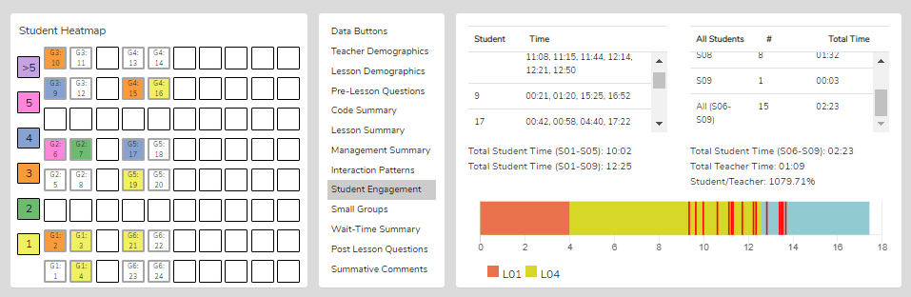

Demographic Highlighting in the Seating Chart Heat Map - In addition, if data is collected for specific students by using the student seat number before entering the S code, and the demographics were added to the seating chart, then the data can be displayed and toggled on or off by clicking on the Gender, ELL, SPED, or Minority buttons. If the observer wonders how the students with special needs are engaged during the lesson, toggle this information to find out. If the observer or teacher is concerned about equity of participation regarding gender, minority, ELL, or students with special needs, then this data is available.
Things to Ponder Using S Codes – Student Engagement Data?
- Consider how many of the students responded to at least one question and how many students were not part of the conversation. (Heat Map)
- Think about your teaching, how many of the students responded to each other at least once, and what you might change to produce more student-to-student interactions. (Interaction Patterns S-S #)
- Think about the average number of responses per student, how that fits your student engagement goals, and how that number might be increased. [Total of S1-S5 plus (the total of S6-S9 x the number of students in the class) / number of students in class]
- Look at the various parts of the class or type of lesson segment and determine if or how students were engaged, as evidenced by vertical bars. Think about parts of the lesson that were absent of student contributions and engagement and how your lesson might be altered to produce more student engagement.
- Using the demographic toggles on the Seating Chart Heat Map, examine student engagement by demographics such as gender, minority, ELL, and Special Education – think about what the data suggests in terms of equity regarding student engagement.

Teacher Actions Summary – Teacher Actions Summary is a timeline from the beginning to the end of the lesson that displays a backdrop of the lesson type (colors) in play and shows symbols for when the teacher exhibited various T code actions, so the user can follow the sequence of teacher actions throughout the lesson. The timeline also displays M and S code data; in fact, almost all collected data are represented, providing a robust set of teacher and student actions. The user can easily see when any management issues occur in the context of the rest of the teacher and student actions in the lesson. Since this is a visual display of teacher actions, student actions, and misbehaviors, as well as the teacher's reaction to misbehaviors, it provides the user with a visual of the flow of action from the beginning to the end of the lesson and visually brings forth sequences, predominance, or absence of teacher or student actions. For example, if the teacher is curious about their use of questioning, it is easy to see when any of the four questioning codes were used and what codes occurred before or after. The user may find a complete absence of higher-level questions. The user may readily see what they tend to do following a student's response. The user can target specific codes by toggling the display of T, S, or M codes on or off. Aside from wait-time data, all data is shown on this summary screen, which is often a large chunk of information and may clutter the screen.

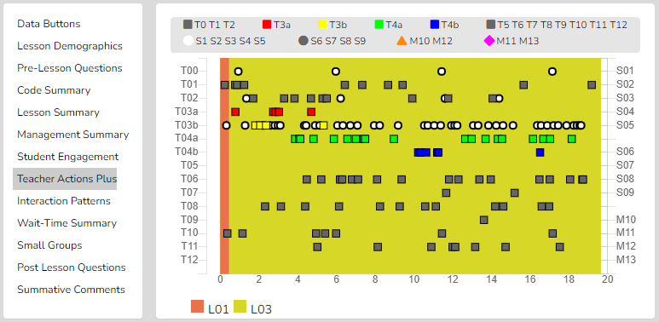

As shown below, the viewer can zoom in or out to see separate data points.

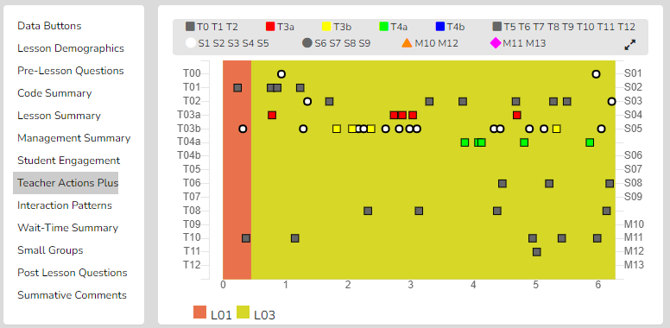

Finally, as with other data points in SMT, the user can click on any data point (symbol), and the linked video will play.

Things to Ponder About Teacher Actions Plus Data
- Looking at the Teacher Actions Plus screen:
  - What question types were used in the lesson? What followed questions in terms of S codes – one student response, or was it more than one student response? After the student(s) responded, what did the teacher tend to do next?
  - How did the teacher use the whole-group response engagement S codes (S6-S9) to engage all students in generating answers and providing maximum feedback to the teacher? If S6-S9 were not used, what evidence is there that the teacher attempted to increase students' oral contributions to the lesson?
  - Knowing that T codes (teacher responses) T6, T11, T12, and sometimes T8 tend to help get and keep students thinking more so than T5, T7, T9, and T10, what does the visual tell you about the teacher's use of the various response codes?
  - What stands out about the student misbehavior actions M10 and M12, and then how would you characterize the teacher's reaction to student misbehaviors M11 and M13?
  - How was the distribution of S codes and student contributions to the lesson?
  - What was the mix of S codes? How many S1-S4 codes were present during the observation?

Interaction Patterns – Using all the teacher actions (T codes) and student engagement actions (S codes), the user can view the predominant patterns of interaction between the teacher and students. In addition, numbers show how often students interact with each other (S-S), how often the traditional teacher-student-teacher pattern (T-S-T) is used, and how often one teacher action follows another (T-T).

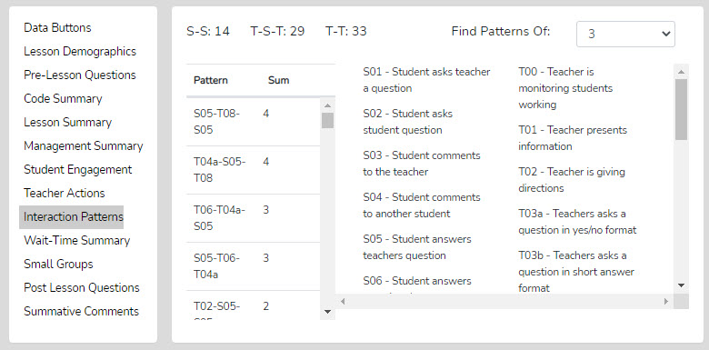

Things to Ponder About Interaction Patterns – Teacher-to-Student Interactions Data

- Looking at Interaction Patterns, examine the 3-code pattern tendency, then the 4-code pattern tendency.
  - How are the most common patterns consistent with the goals for the lesson?
  - What are some changes to how the teacher interacts with students that would be more consistent with the intentions of the lesson?
  - How did the teacher initiate questions and then respond to student thinking? How did the teacher's tendencies encourage or discourage student responses and engagement?
  - When students respond – what does the teacher tend to do? Do they tend to judge responses, acknowledge them, and then clarify for the student, or instead, ask the student to clarify? Different tendencies are more effective depending on the goals of instruction and the level of thinking or engagement the teacher wants from students.

Small Group Summary – When completing a quantitative observation and student engagement or misbehavior data is collected and tagged by an individual or group number, the observer can then use the Student Engagement, Management Summary, Seating Chart Heat Map, and Small Group analysis displays to examine the results and determine various things about how the lesson impacted small groups.

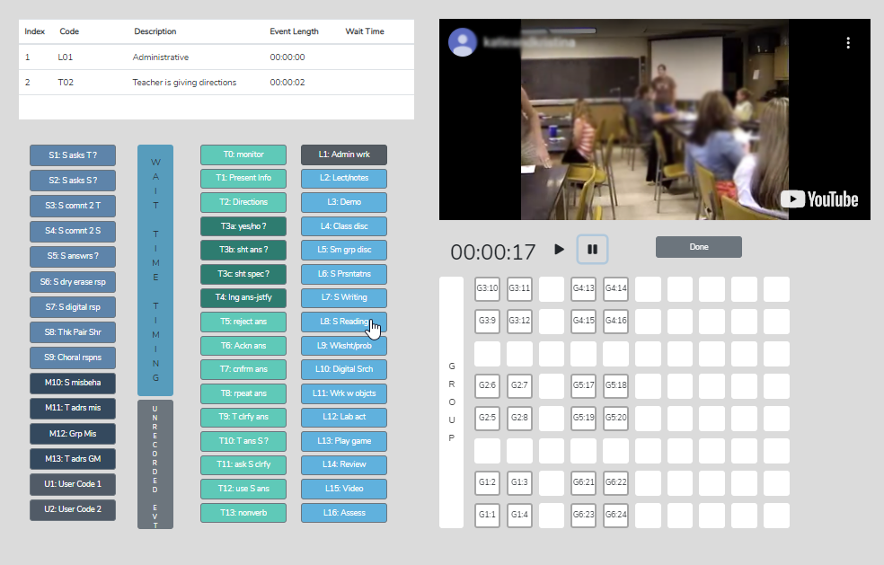

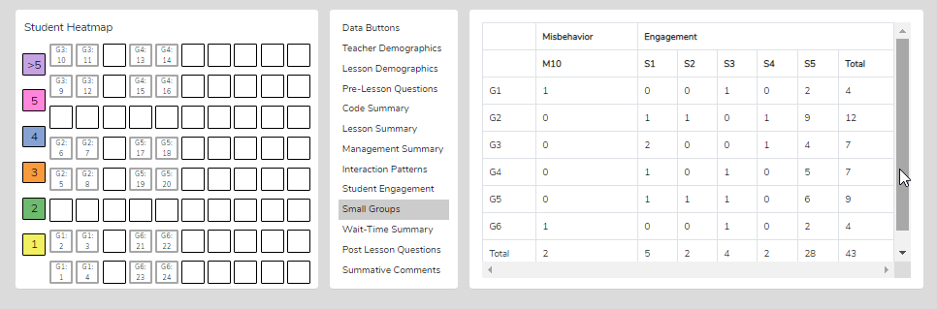

The Group Summary data collected with the student seating number allows examination of group dynamics and the number and levels of S code types of interactions that reveal the impact of a lesson on student-to-student interactions. The table shows S codes and M10 event responses coming from specific groups. If the teacher and observer were wondering how the lesson stimulated student actions (S codes) within the small group, this data would indicate that. The Seating Chart Heat Map would show how much interaction occurred within that group and color-coding to show each member's contributions.

Questions to Ponder Regarding Group Engagement and Equity Among Group Members Data
- What was their intention when the teacher approached the small groups and interacted with them? What did they want to accomplish by doing so versus observing the groups in action?
- What was noticed about the teacher's interactions with the small groups?
- How did the teacher's interactions foster the goals for the small group and the lesson? In what ways, if any, did the teacher's interactions lessen the intention of the lesson or weaken the intended purpose of having students work in small groups?
- Small groups are a great place to ask good questions and to foster student-to-student interactions – what did the observer notice regarding such? How might the teacher improve?
- How was the teacher's ability to pace themselves and get around to all small groups without taking too much time with one small group?
- We know the power of using cooperative learning strategies with small group structures (versus simply students in a group expected to work together). What might the teacher have done differently regarding small group strategies, and what impact might it have on student engagement, thinking, and learning?

Wait-Time Summary – The wait-time data is only located within the Wait-Time Summary. The Wait-Time Summary includes general summaries of wait-time by wait-time type, events, total time, and averages for each wait-time. In addition, the lower half of the summary provides wait-time averages by a specific teacher or student action. For example, the user can determine if there is more wait time allowed with higher-level questions that require deeper thinking than lower-level questions.

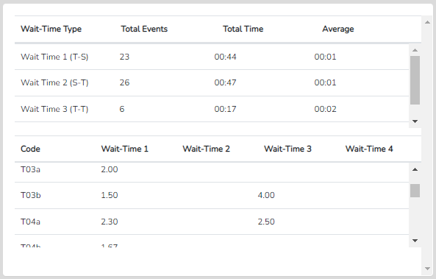

When SMT is used to collect wait time data, some very high-resolution feedback can be provided to teachers.

Wait Time Category | Specific Feedback
Average Wait Time 1 | “Students tend to respond very fast (2 seconds) which doesn’t allow other students much time to think.”
Average Wait Time 2 | “After a student responded to your question, on average you waited one second before reacting. If you increase your wait time 2, other students will also offer up answers or perhaps respond to what the first student said.”
Average Wait Time 3 | “When you asked a question and students did not put their hands up or volunteer an answer, you waited, on average, less than 2 seconds, then changed the question or called on someone to answer it.”
Feedback Pulled From Specific T and S Code Data | “Your WT for speculation-type questions was 2.5. Your WT for yes/no questions was 2.6. Higher level questions should be accompanied by more thinking time, so students have a chance to think more deeply about a response.”

Questions to Ponder and How SMT Users Can Utilize the Wait-Time Data
- How does the WT1 average correspond to the teacher's intention for using wait-time to give students ample opportunity to think about the teacher's question?
- How does the WT2 average correspond to the teacher's intention to use wait-time to give students ample time to think about a student's response and respond to that student? (Look at the relationship between WT2 average and the S-S count in Interaction Patterns.)
- How does the average WT for question types differ regarding higher-level questions and students needing more think time to generate an answer?
- If the WT average is lower than expected or desired, what is the teacher's concrete plan for increasing their WT?

Running Record - The Running Record lists all the events in sequence from the lesson start to finish. The user can scroll through the events and can click on any event to see the related video. While SeeMeTeach ® has significant built-in data analysis for instant viewing, the data can be exported to a .csv file for analysis with powerful statistical packages.
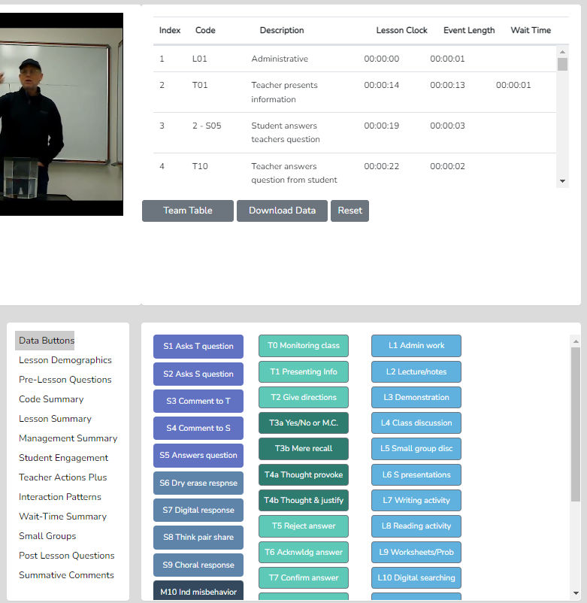

Data Buttons - The Data Buttons feature serves as a Search and Find function, allowing the user to quickly locate linked video examples of specific T, S, M, or U events. Clicking on a button finds the first instance of that specific code/event in the Running Record window, and the linked video begins to play. And, at the bottom of the Running Record window, there is a note indicating how many events of that type were located. This feature is particularly helpful for identifying the teacher's habits and tendencies. For example, the observer may notice that the teacher has a habit of asking yes/no questions, then clarifying the answer for the student. In this case, we know that having the teacher change how they interact and respond would be beneficial for learning more about the student's thinking. For example, the teacher could have asked the student to clarify their answer. As such, the observer might choose to use that data or video, all or some, to make a point about how a teacher's choices affect student engagement and their ability to uncover student thinking.

Lesson Demographics – This contains information about the lesson entered during the New Observation lesson setup or can be edited (course name, period, lesson topic, subject, and grade level).

Pre-Lesson Questions – Questions posed to the teacher that will provide context and the lesson's intent.
Pre-Lesson Questions can be accessed from both the Settings and Analysis screens.

- What are the main learning goals/objectives for the lesson?
- Describe the major activities or parts of the lesson to be observed.
- How will you know if the learning goals/objectives have been met? For example, what evidence will you have?
- Provide the context for the lesson. How is this lesson connected to the prior lesson? How is this lesson connected to the subsequent lessons? Where is this lesson placed in the current instructional unit?
- Describe the ability levels of the students in this class.
- What will you do to maximize the engagement of all ability levels of students?
- How will you differentiate the lesson for all types of learners?

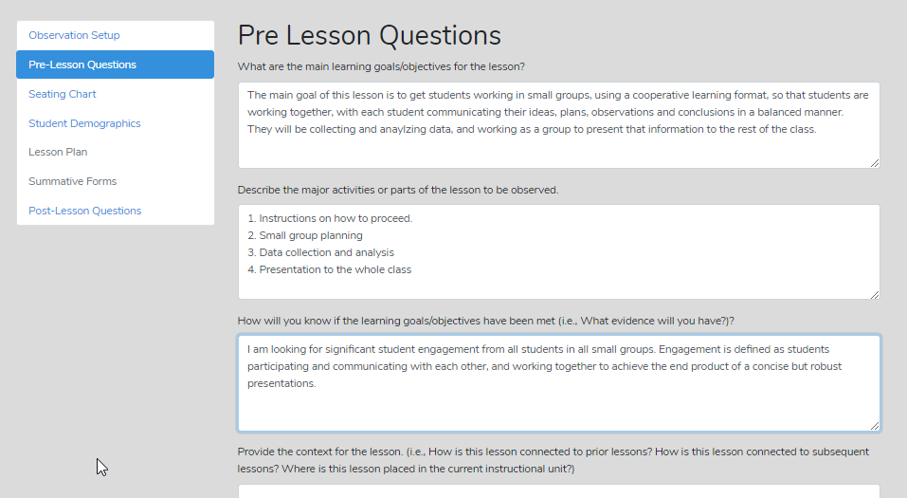

Post-Lesson Questions – Questions for the teacher to respond to following the lesson and observation.
Post-Lesson Questions can be accessed from both the Settings and Analysis screens.

- Tell me about today's lesson. Probe: What went well? What needed to be improved? If you taught this lesson over again, what would you change? Why?
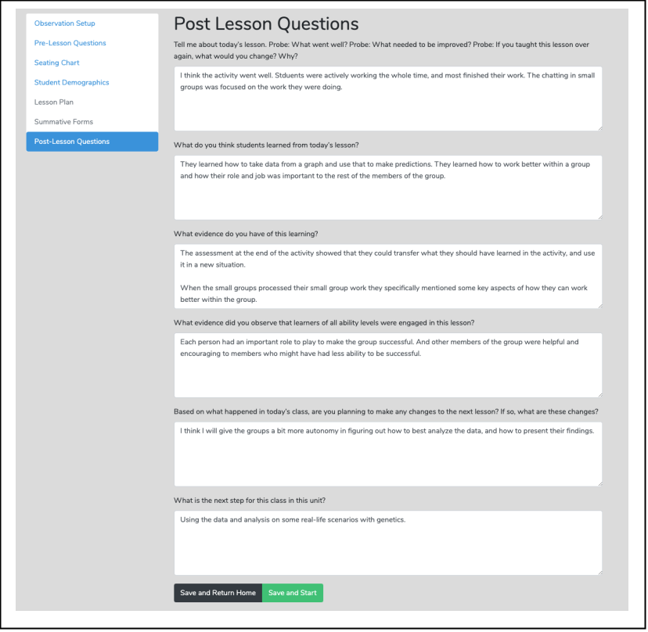
- What do you think students learned from today's lesson?
- What evidence do you have of this learning?
- What evidence did you observe that learners of all ability levels were engaged in this lesson?
- Based on what happened in today's class, are you planning on making any changes to the next lesson? If so, what are those changes?
- What is the next step for this class in this unit?

Team Unification and Synergy Using Data and Feedback – If another member of the team has completed the quantitative coding of the video, before leaving the data analysis screen (or from the Dashboard), the user can open the Team Table, click, toggle on, and view the data gathered and the analysis by that team member. Or the user can jump to any team member's completed quantitative or qualitative observation by clicking on the green checkmark in the expanded Dashboard.

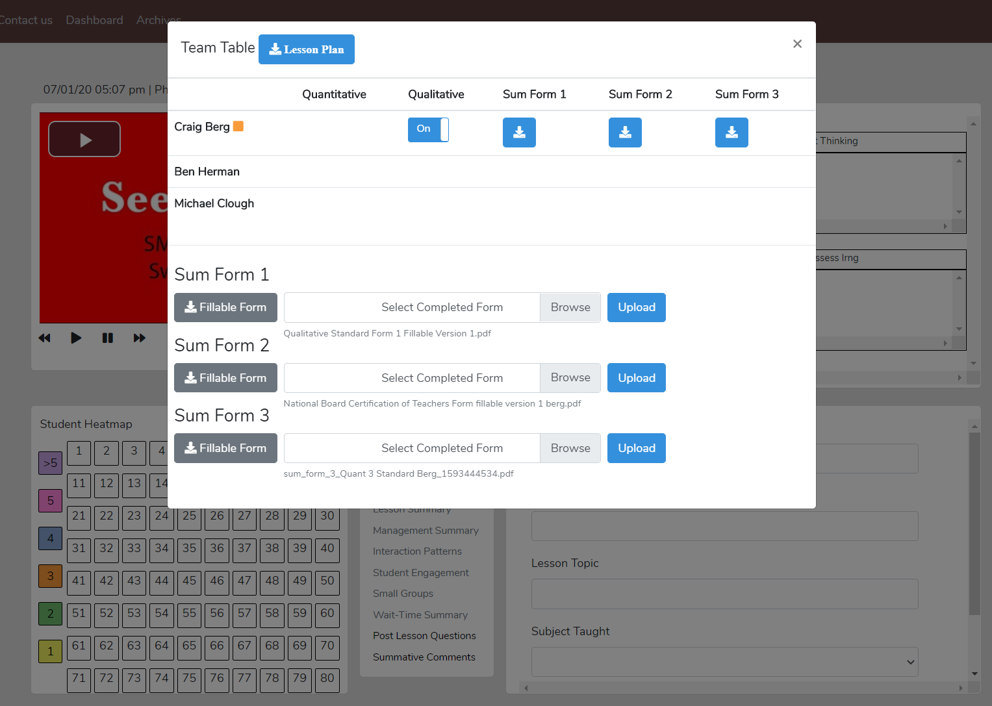

Summative Comments and Summative Forms - When the observation is over, the observer can add Summative Comments and/or fill in Summative Forms. Users can embed their institution's forms and rubrics

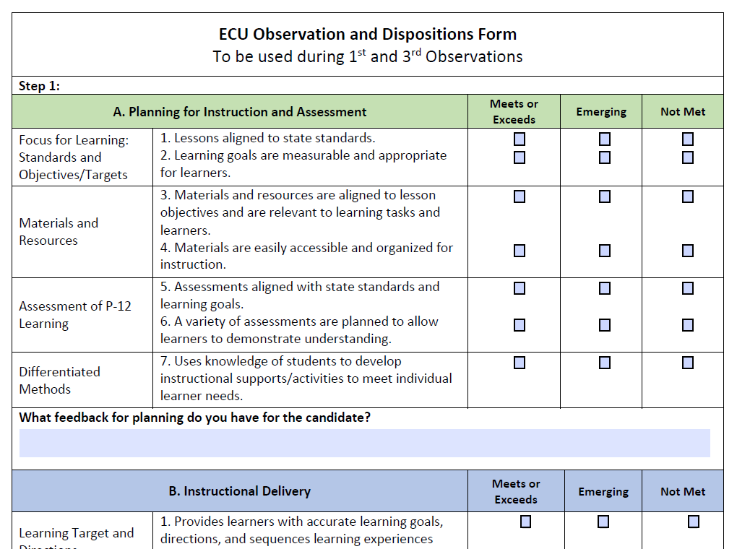

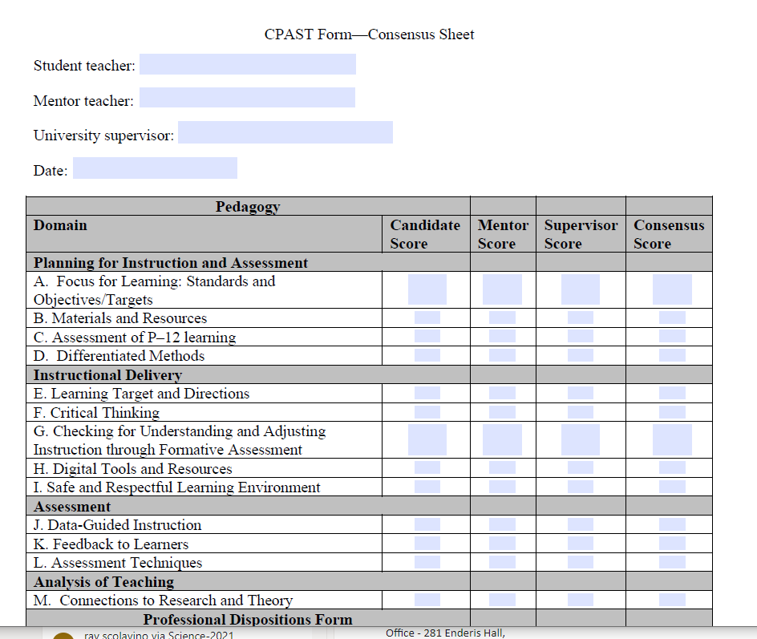
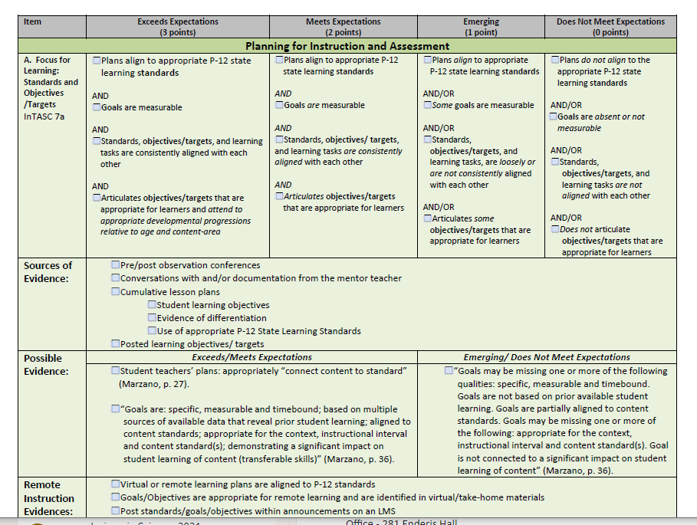

9. Teacher Challenges

What are Teacher Challenges? Teacher Challenges are mini action-research investigations that focus on a strategy, a teaching model, or teacher-student interactions that are important to your teaching. Teacher Challenges are personal explorations of teaching that gather and analyze data on an aspect of teaching, helping the teacher identify ways to improve and increase positive effects on the learner. While there are many Teacher Challenges, there is no prescribed pathway to follow or specific endpoint, except improving one's teaching. Teacher Challenges target growth, change, and fine-tuning one's teaching to improve student engagement and learning. While it is a personal exploration, the explorer quickly studies educational research to increase awareness and understanding of the existing research, guide conclusions, and learn more about the various factors linked together that form the complex act of teaching. Action research and studying one's teaching can be integral to a teacher's professional life. It should begin during the teacher preparation phase and become an expected component of a teacher's role throughout their teaching career. Improving teaching is a lifelong pursuit, and once teachers see the value of studying their teaching, the typical teacher observation becomes even more obsolete.

The Typical Flow of Activities
a. The What and Why - Describes a common teaching practice that might benefit from modifications and generates a strong case for why it is an issue. What aspect of teaching is being investigated? The teacher focuses on a strategy, a teaching model, or teacher-student interactions that are important to their teaching. The goal is to change instruction in a way that might or will increase student engagement or positively affect student learning.
b. The Challenge - The general steps that the teacher follows involve teaching a lesson in the normal manner, gathering and analyzing some data, then looking at key indicators to determine the impact on the learner regarding lesson goals. Then the teacher changes their teaching by using a different strategy or altering how they interact with students during the lesson. More data is gathered and analyzed, then compared to the original data set to determine if the changes in pedagogy had the desired effect on student engagement and, ultimately, learning. Remember that "learning" is more complex to measure, but a plethora of data and studies link student engagement to learning. As such, the primary indicator of the effect of implementing changes to teaching, based on data analysis, is student engagement, which is easy to document using the SMT observation tool.
c. The How
Round One – Baseline Data and Indicators
1. Teach a lesson as usual and capture a video.
2. Learn how to analyze the lesson and complete the SMT training needed to capture data.
3. Use SMT to capture and analyze data by linking the questions and corresponding data that serve as
best indicators.
4. Record data on the Data Summary Chart and identify what indicators to use and examine as
change measures.
5. Use SMT Modules or online resources to mine for how to change instruction to better target and
foster goals for instruction and have a greater positive impact on student engagement and learning.

Round Two – Impact of Changes to Instruction
6. Modify instruction, teach, and video the lesson, then again use SMT to collect data, followed by
comparing data that indicates change, growth, or impact when comparing the initial lesson to the
second lesson.

A Few Examples of Teacher Challenges
- Increasing Student Engagement
- Small Group Productivity and Equitable Contributions
- The Wait-Time Challenge

10. More Information

To learn more about SeeMeTeach, go to www.seemeteach.com and view the short promo video.

11. Getting Started Using SeeMeTeach

Registering to Use SMT

Users must register to use SMT, either as a single user who may also have colleagues as team members or as a user in a teacher education, school, or research group.

To use SMT, the user must first register by going to www.SeeMeTeach.com under Plans and Prices, then registering for a Basic Plan – Single User, or registering as a Group – School or Teacher Preparation Plan. A single user can still collaborate with other SMT users but is not part of an official group. Once a single user or a group of users has completed the registration, they can collaborate on observations and proceed through the scaffolded training levels at a comfortable pace. A group of users might consist of administrators and teachers in a school, or instructors, students, and cooperating teachers in a university teacher education program.

Registration For Basic Plan – Single User
A person can register as a single user and collaborate with other SMT-registered single users. Once registered, the user can invite colleagues to register for SMT and collaborate with them on teaching observations. A single user cannot collaborate with group members, as only designated group members can collaborate. However, a group member can still function outside of the group by registering for SMT under a Basic Plan – Single User with an email different from the one used for the SMT group. A Single User can collaborate with as many others as they choose.

* Note that the FAQ's at www.SeeMeTeach.com (Prices and Plans) or below in this document have FAQ's that are helpful when considering whether to register as a Single User or for a Group of Users

Registration For Groups Such as Schools or Teacher Education Programs
For an SMT group to form and function, the lead person registers and invites the individuals who will be part of the observation group.

Steps To Take To Register For and Add Users To a Group
1. Key information required for registering a group is the name and email of the key person and how many people are in the group. Note that the key person or group administrator is part of the group and can participate in observations. Therefore, the person registering should factor that into the number of group members needed. Payment is by credit card or purchase order.
* If paying by credit card, begin at www.seemeteach.com under Prices and Plans and continue registering and paying.

* If not paying by credit card, the person registering for the group should be prepared with a Purchase Order Number, and within Prices and Plans, there will be a link to a page of information to fill out and fax or email to SeeMeTeach. Upon receiving the group registration request, SeeMeTeach will confirm receipt of the registration/PO and confirm to the key person that their group can begin using SMT. Then SMT will email an invoice for payment. When the key person receives an invoice, they should process the payment quickly to continue using SMT. Note that the invoice must be paid within 30 days, or the account will be frozen until payment is received.

2. After an account has been established, the group administrator logs into SMT. Under their account name drop-down is a heading for Contacts; clicking Add New User lets them add users to their group, up to the number allowed by their registration. When they add a new user, SMT sends an email invite, and recipients must open their email, accept the invite, and add a bit of information, like a password they will use when logging into SMT. Each invited user will be listed in the Observers List and will have either a green dot (if they have accepted the invite) or a yellow dot (if they have not yet accepted) under the Status column.

3. Note that the number of individuals within a group can be increased during a payment period, and the organization will be billed accordingly, but the group size may not be decreased during a payment cycle. Once registration is complete, there are no refunds if a member leaves the group. If a group member leaves the school or the program and is no longer part of the group, the administrator can Remove them. Removing a user should free up one of the paid group slots so that the administrator can Add New User to invite a new teacher or teacher education student to the group.

Once the user or group is registered and has access to SMT, they should complete training to learn how to use SMT. The training begins with how to create an observation, followed by how to use the qualitative mode, and subsequently, a series of lessons on how to use the many features of the quantitative mode. Training support materials consist of video overviews and narratives describing the what, how, and why of SeeMeTeach ®, with practice sessions offered and structured to develop the user's skills.

12. Individual Users – Frequently Asked Questions

FAQ: If I have an individual account, who can I invite to my observation team?
Answer: Any other individual user who has an SMT registered account can accept an invitation to join an observation. You need to know the email they are using for their SMT account. Someone who is a member of a group account (Teacher Education or K-12 School) cannot join your individual account when they are already in a group account. To join your observation team, they need a separate individual SMT account using an email address different from their group account. This prevents crossover observations from individual to group accounts and is in place for security and confidentiality reasons.

FAQ: Since four is the maximum number of observers for any observation, does that mean I can only have four colleagues as observation team members?
Answer: No. While you can only have three other colleagues joining an observation (with you making a total of four on the team), your list of potential colleagues to choose from is limited only by how many people you know who have a registered SMT account. From that list, you can choose any three to join an observation. You can choose a different three for the next observation. When choosing observation partners, if using video, keep in mind confidentiality and protection of minors when it comes to deciding who can view the video

FAQ: I have an individual account, but my school will now use SMT for observation. Can I keep my individual account and still participate in the school's group account?
Answer: Yes, you can keep the individual account, but for the group account, you will need to use an email address different from the one used for the individual account. Most individual account users registered for SMT using their personal email accounts, not their school email.

FAQ: How long does the registration cost cover?

Answer: Each registration is good for one year from the date of registration. For the user's convenience, registration will automatically roll over unless they cancel their registration. SMT gives plenty of notice before the new registration begins. The user will receive an email 30 days before the rollover, giving them plenty of time to cancel before renewal.

FAQ: Can I cancel my initial registration or cancel it after the renewal has taken place?

Answer: Once registration or renewal is finalized, the user can cancel at any time by going to SMT, logging in, and clicking the Cancel Account button under Billing. If the registration or renewal process has already occurred, no refunds will be given. However, since the user paid for their registration, they can still access and use that account until that initial registration or renewal period ends. Because the user canceled the account, the next renewal will not occur. Registration renewal emails are automatically sent to the SMT user's account email.

13. Teacher Education - Frequently Asked Questions

FAQ: How can I set up an SMT account for myself (methods instructor) and the 35 future teachers in my class?

Answer: Go to www.seemeteach.com. Under Plans and Pricing, you will find the link to register and pay for a school or teacher preparation plan. The class leader or the administrator who sets up the account can participate in the group, and they are not counted toward the number of paid slots for their group. At registration, they need to know and enter how many paid accounts (teachers or other administrators) they want in their group, along with the group members' emails.

FAQ: What do I do if I have a group consisting of the clinical experience supervisor and 25 fieldwork students, and I want to add four more fieldwork students and cooperating teachers to my group?

Answer: At this time, email doc@seemeteach.com and let them know how many more users to add to your group account. Include the name of the institution, department, program, group leader or administrator's name, the email used for the group SMT account, and a phone number. SMT will add those additional slots to your account and invoice the administrator for the registration change.

FAQ: I have 21 users in my group, but one person left the program and will no longer be a part of our SMT group. Can I fill that slot with another person?

Answer: Yes, you can fill that slot with another person. Go to SMT Login, Contacts, and Remove the user who left the group. That should free up a slot and show how many more users you can invite before you reach the paid registration limit. If that number is one or more, then invite a new user to the group. They will get an email invitation they must click to accept (and they create a password, etc.). The new user, of course, doesn't pay because the group administrator has already paid for the group members. If the administrator needs more slots than initially required – see the answer to the FAQ above, in which you contact orders@seemeteach.com for support.

FAQ: I am the university supervisor for ten fieldwork students. I want to form a group of 10 students plus myself. How do we pay for SMT registration?

Answer: There are a couple of things to consider.

- First, a typical "group" registration (see alternative group formation below) can be paid by:
  - one credit card payment that covers all members of the group, or
  - the group administrator initiates payment via purchase order (email to orders@seemeteach.com or fax 866-414-3456, and SMT generates an invoice sent to the administrator of the group.

Remember, when forming a group, the group administrator has a free account, so for 1 group admin and 10 students, the request to SMT is for 11 users, but the cost is only for 10 users.

- Second, if each student in the group is paying for their registration, how can the group administrator collect the money from the ten fieldwork students?
  - Some universities add a course fee of $20 per student to cover the cost of SMT registration. Then, when the fieldwork supervisor (and the administrator of the SMT group) registers themselves and their students, they pay with a department credit card or provide a Purchase Order number so an invoice can be sent to the department for payment.
  - Note that sometimes teacher education programs pay for the registration cost for the cooperating or mentor teacher so they too can participate and collaborate in observations and feedback.

- Third, if the two group payment suggestions above are not feasible, the alternate group registration via a single-user plan process may work better. The alternative way to establish a group is to set up an informal group where the university supervisor and fieldwork students register as Single Users and then invite each other (and accept) as collaborators. Also, read the response below to understand why this might be a preferable option in some instances.

FAQ: In a teacher preparation program, if I am a methods instructor who has assignments linked to Fall semester fieldwork placements and my students who are registered SMT users finish my course and their fieldwork, then the students enter a different course in the Spring semester with a different course instructor/fieldwork supervisor who wants them to use SMT to process their student teaching observations, is it best to form registered groups or best to have all the students and the instructor/supervisor register as single users – the alternative group registration?

Answer: Unlike teachers in a school who stay within that group for the whole school year, teacher education students start and finish courses or start and complete fieldwork or student teaching experiences during a semester. So, in some scenarios, it is probably best to have teacher education students register as single users and have each student pay the registration fee that will cover them for one whole year. Then, for the 1st semester, each user can invite whoever needs to be part of their collaborative team, such as their methods instructor (or vice versa), their cooperating teacher, their university supervisor, and fellow fieldwork students if they are working together at a school placement. This process may also be best for an assignment from the methods instructor that requires small groups to collaborate on observation and provide feedback. When the semester ends and teacher education students are in different classes or have new collaborators, they can remove users who no longer should be collaborators and add new collaborators as needed under their Contacts List. The benefit of having all those users in one formal group using the group plan vs. a single-user plan is that no group user can invite someone into the group who shouldn't have access. As such, if videos are used for observation, they remain accessible to only the group members and the instructor – the people who usually have access to those classrooms.

FAQ: With the power of SMT and how the potential for collaboration between the university supervisor, student-teacher, and cooperating teacher is built right into SMT, how can we get more cooperating teachers involved in using SMT and being part of the collaborative team, sharing observation notes, data, and summative forms?

Answer: Universities highly value cooperating teachers for the feedback and mentoring they provide. Some universities secure grants and gifts from donors to cover the cost of registration for the cooperating teachers. Some institutions build it into the expense, while other universities have the fieldwork student or student-teacher pay a course fee covering the cooperating teacher's SMT registration.

FAQ: If I am in a school group or a teacher education group, I know that I can only have collaborators from a select group of people that the group administrator has invited to the group. How can I do so if I want colleagues outside of the group to collaborate with me on observations and feedback?

Answer: You are correct. You cannot collaborate with anyone outside the group using that group account. First, remember that privacy rules would likely prevent you from sharing any video of K-12 students with people who would not normally be working with them. Also, consider school district policies and laws, especially in the United States, where the Children's Online Privacy Protection Act ("COPPA") applies to children under 13 and requires parental permission to record or store any video of children under 13.

However, if you sign up as a single user, you can invite anyone you want to include as a collaborator on observations. Remember that SMT will only let a specific email address work for a group or as a single user, but not both. For example, if your school email address is used for your school group, you must use a different email address, such as @gmail or @yahoo, when you register for your single-user account.

FAQ: How long does the registration cost cover?

Answer: Each registration is good for one year from the registration date. For the user's convenience, registration will automatically roll over unless the user cancels their registration. SMT gives plenty of notice before the new registration begins. The user or administrator will receive an email 30 days before the rollover, giving them plenty of time to cancel before renewal. For schools or teacher education groups that paid for the group members, the renewal email is sent to the administrator who established the group. Those who registered as a Single User will also receive a 30-day renewal notice.

14. K-12 Schools - Frequently Asked Questions

FAQ: How can I set up a school account for myself (the Principal) and the 35 teachers in my school?

Answer: Go to www.seemeteach.com. Under Plans and Pricing, you will find the link to register and pay for a school or teacher preparation plan. The administrator who sets up the account can participate in the group, and they are not counted in the number of paid slots for their group. At registration, they need to know and enter how many paid accounts (teachers or other administrators) they want in their group. They will be asked to enter the emails of group members they plan to invite.

FAQ: What do I do if I have a school group consisting of the Principal and 25 teachers, and I want to add four more teachers to my group?

Answer: At this time, email orders@seemeteach.com and let them know how many more users to add to your group account. Include the school district name, the school, the group administrator's name and email used for the group SMT account, and a phone number. SMT will add those slots to your account and invoice the administrator for the registration change.

FAQ: I have 21 users in my group, but one teacher left the school and will no longer be a part of our SMT group. Can I fill that slot with the teacher who takes their place?

Answer: Yes, you can fill that slot with another person. Go to SMT Login, Contacts, and first remove the user who has left the group to free up space for the new person. Then SMT will show how many more users you can invite into the group before reaching the paid registration limit. Invite a new user to the group if that number is one or more. They will get an email with an invitation that they must click on to accept (and they create a password, etc.). The new user, of course, doesn't pay because the group administrator has already paid for the group members. If the administrator needs more slots than initially required, see the answer to the FAQ above, where you contact orders@seemeteach.com for support.

FAQ: With the power of SMT and how the potential for collaboration between the university supervisor, student-teacher, and cooperating teacher is built right into SMT, how can we get more university supervisors and student-teachers involved in using SMT and being part of the collaborative team, sharing observation notes, data, and summative forms?

Answer: Universities highly value collaboration between the university supervisor and the cooperating teacher for the feedback and mentoring they provide. The school might suggest that the teacher education program use SMT as an observation platform because SMT gathers a ton of data for feedback, recommendations, indicators of growth, and decision-making. Some universities secure grants and gifts from donors to cover registration costs for the university and cooperating teachers. Others build it into the expense, while other universities have the fieldwork student or student-teacher pay a course fee that covers the cooperating teacher's SMT registration.
FAQ: If I am in a school group or a teacher education group, I know that I can only have collaborators from a select group of people that the group administrator has invited to the group. How can I do so if I want colleagues outside of the group to collaborate with me on observations and feedback?

Answer: You are correct. You cannot collaborate with anyone outside the group using that group account. First, remember that privacy rules would likely prevent you from sharing any video of K-12 students with people who would not normally be working with them. In addition, consider school district policies and laws, especially in the United States, where the Children's Online Privacy Protection Act ("COPPA") applies to children under the age of 13 and requires parental permission to record or store any video of children under the age of 13.

However, if you sign up as a single user, you can invite anyone you want to include as collaborators on observations. Remember that SMT will only let a specific email address work for either a group or a single user, but not both. For example, if you use your school email address with your school group, you must use a different email address, such as @gmail or @yahoo, when registering for your single-user account.

FAQ: How long does the registration cost cover?

Answer: Each registration is good for one year from the registration date. For the user's convenience, registration will automatically roll over unless the user cancels their registration. SMT gives plenty of notice before the new registration begins. The user or administrator will receive an email 30 days before the rollover, giving them plenty of time to cancel before renewal.

FAQ: Can I cancel my initial registration or cancel it after the renewal has taken place?

Answer: Once registration or renewal is finalized, the user can still cancel at any time by going to SMT, logging in, and clicking the Cancel Account button under Billing. If the registration or renewal process has already occurred, no refunds will be given. However, since the user paid for registration, they will still have access to and can use that account until the initial registration or renewal period ends. Because the user canceled the account, the next renewal will not take place. Registration renewal emails are automatically sent to the SMT user's account email. The renewal email will be sent to the administrator who established the group for schools or teacher education groups.

15. SMT Supporting Documents

SMT Teacher Exploration and Challenges – A series of min-action research explorations into teaching. A teacher identifies an issue, collects baseline data, implements a potential solution or change to their teaching, and collects data to compare with the baseline data, looking at critical indicators of change and effective instruction.

SMT Professional Development Modules – A series of modules focusing on specific strategies and pedagogy related to exemplary instruction for the discipline.

SMT and edTPA – Documents that guide how to vastly improve the use of data and critical indicators when planning for, teaching, analyzing, and reflecting on lessons when writing edTPA Rubrics 6-10.

SMT and NBCT – How to incorporate data as evidence and indicators of powerful instruction into the NBCT reflection submission.

SMT Cooperating Teacher – How a cooperating teacher can incorporate data as evidence and indicators of effective instruction when providing feedback and coaching to future teachers in a clinical setting.

SMT and Teacher Education – How methods instructors and fieldwork supervisors can use SMT to provide feedback and coaching using evidence-based indicators. How the data collected can become evidence for overall program effectiveness. How SMT can form the core of a graduate class on teacher observation, feedback, and coaching.

SMT, Teachers, Administrators, and Schools – How using SMT, Teacher Challenges, and SMT Professional Development Modules can be used to replace or supplement teacher observation.

Graduate Students and Other Researchers – How SMT can provide a platform for pedagogical research using data vs. impressions.

Grant and Curriculum Impact Evaluators – How SMT can be used to evaluate the impact of grant-supported professional development or curriculum development on teaching and instruction, bringing critical data and indicators into the process.

16. Terms of Service

Before using SMT, you must read and agree to the complete Terms of Service/Privacy Agreement. The TOS/PA was provided during the registration process but is also located at the bottom of each page on the SMT website. Make note that the TOS/PA may be modified when necessary; modifications may occur after your initial reading during registration, so you are hereby advised to periodically read the TOS/PA for changes that may apply to you.

The following is a condensed version but is NOT a substitute for reading the complete TOS/PA document.

In short, SMT was designed and priced so anyone could access and use this powerful tool. The once-per-year registration fee covers the registrant's personal use for one year. Registration will automatically renew to allow for continued SMT usage unless the user cancels the renewal.

If you are a participant in a school or teacher preparation group, your institution may pay your fee. For those in a group, such as a school or a teacher education program, your participation may depend on continued employment at that school or district or whether you are an active student in a teacher preparation program or have completed teacher training at that school or institution. After moving to another school, your membership may change to that of the new school group (if they use SMT) or you may use it independently by registering as a single user.

As a single user, you may invite others to be part of your observation team at your discretion, per the TOS/PA. A single user may choose to continue using SMT independently of their school, teacher education program, or ancillary to what they do for observations. If the user is part of a school or teacher education group and wants to use SMT independently outside the group, they must also register as a Single User with an email different from the one used and associated with the group.

Whether you pay the registration fee or your school or teacher education program pays it, SMT is for non-commercial use only. As a registered user, or any user, you may not use SMT in any manner related to a consulting contract, any method of commercial purpose, or for-profit, performing a paid service without first establishing a written agreement with SeeMeTeach ® before any such intended use. The definition of the use of SMT includes:

* any work related to consulting or as a grant evaluator.
* any teacher or future teacher-related observation.
* any evaluation provided to a teacher, school, district, school board, university, or any teacher
preparation program (formal or informal) while serving as a consultant or independent contractor.

In other words, you may not make money by using SeeMeTeach ® in any manner without first procuring a written agreement and a licensing agreement between SeeMeTeach ® and yourself/your company.

