SeeMeTeach - Teacher Observation Reimagined
A WEB BASED TEACHER AND CLASSROOM OBSERVATION APP
© 2026 V.8.15.2026
SeeMeTeach®
User’s Manual and Implementation Guide
Table of Contents
Reimagined!

Why Use SMT and How to Get Started
- Welcome
- Terms of Service
- Anytime, Anyhow, Anywhere!
- Why Use SMT? Added Value, Synergy, and Power!
- A Paradigm Shift – This Tool Provides
- The Target of the Observation
- Who Uses SMT?
- Professional Development Supporting Documents
- Registering to Use SMT
  - Basic Plan – Single User
  - Group Plan – Schools and Teacher Preparation Programs

Training to Use the SMT Tool
- SMT Training From Novice to Expert

Capturing and Analyzing Data, Providing Feedback
- How to Set Up a Lesson Observation
- Qualitative Mode – Overview and Features
  - Capturing Comments
  - Post-Observation Screen
  - Qualitative Comments Mode Example
  - Qualitative Comments Button Choices
- Quantitative Mode – Overview and Features
  - The Mechanics of Using the Post-Observation Scoring and Feedback Forms
- Post-Quantitative Analysis Organization
  - Summative Form 3: Quantitative Data Reflection
  - Quantitative Data Embedded in Qualitative Comment Example

Coaching, Developing Reflective Practitioners, and Teachers Doing Action Research
- Post-Observation Reflection and Feedback: Helping Teachers to Become Reflective Practitioners
  - Example of a Future Teacher’s Self-Observation: Science
  - Example of a Future Teacher’s Self-Observation: Mathematics
- Teacher Action Research
- Teacher Explorations and Challenges

User Tips and Frequently Asked Questions
- Capturing and Storing Video and Audio
  - Capturing Quality Audio and Video
  - Solutions to Audio Issues
  - Hardware
  - Editing Down the Video Segments
  - Setting Up the YouTube Channel
  - Indemnification and Protection of the Video
  - Using Audio-Only When Video Is Not Allowed
- Individuals – Frequently Asked Questions
- Teacher Education - Frequently Asked Questions
- K-12 Schools – Frequently Asked Questions
- Terms of Service Agreement
- Billing, Renewal and Cancellation
- Inviting Users to Collaborate With Single Users
  - Inviting Users – Single and Group
  - Replacing Users
  - Increasing Group Size
1. Welcome To SeeMeTeach - Teacher Observation Reimagined!

Welcome to SeeMeTeach ® (SMT). SMT is a powerful tool for teacher observation, feedback, and coaching that addresses and solves problems that limit the potential of teacher and classroom observations. SeeMeTeach offers both a qualitative mode for comments and feedback and a unique quantitative mode for robust data collection, which can be linked to video or audio, providing instant analysis for feedback and coaching. SMT is a tool used by educational professionals that fills the critical need for evidence-based observations when preparing teachers and improving or refining classroom instruction.

2. Terms of Service

Before proceeding and using SMT, you must read and agree to the complete Terms of Service/Privacy Agreement. The TOS/PA was provided during registration and is also located at the bottom of each page on the SMT website. Note that the TOS/PA may be modified by SMT when necessary; modifications may occur after your initial reading during registration, so you are hereby advised to periodically read the TOS/PA for changes that may apply to you. While not a substitute for reading the complete Terms of Service, an abbreviated version is located at the end of this document.

3. Anytime, Anyhow, Anywhere!

SMT can be used live in the classroom, or when observing via a live online video link, or directly from a pre-recorded video or audio of the teacher teaching. In a world where completing observations in schools is more difficult due to restricted visitation, SMT is even more ubiquitous and necessary for helping supervisors, future teachers, and teachers complete the required observations.

The team here at SMT extends a hearty welcome and congratulations to those who have decided to incorporate this powerful tool into the teacher and classroom observation process. The SMT team is looking forward to SMT being used for a variety of reasons and in many different settings. As such, we encourage users to provide any feedback or suggestions to help make SMT an even more powerful tool.

4. Why Use SMT? Added Value, Synergy, and Power!

First, SMT addresses and solves many problems related to classroom observation. SMT enables the collection and analysis of important but often overlooked quantitative factors that are critical indicators of instruction. SMT also features a qualitative mode, making it a tool that provides instant feedback, bolstered by both data and evidence, when paired with the quantitative mode.

While either the qualitative comments tool or the quantitative data-gathering tool can stand alone, the data adds synergistic power by giving the commentary meaning and detail. The data gathered tells a story about how teachers interact with their students, how students interact with each other, and how students behave in the classroom. All these classroom dynamics are critical factors in a lesson's success.

With robust data collection, this tool reduces the subjectivity of classroom observations and adds significant value to teacher or classroom observations by introducing high-resolution indicators. Beginning or experienced teachers who desire to improve their craft and be more effective in the classroom know the power of using data and analysis to refine and elevate their teaching. Administrators or teacher preparation personnel who want to use both qualitative and quantitative indicators will find SMT to be a powerful tool for feedback, evaluation, and coaching. In short, any educator who studies teaching will benefit from using SMT.

Second, SMT also addresses the problem of scant or minimal communication between members involved in the observation. SMT features a unique observation, feedback, and collaboration platform that facilitates and improves communication and the sharing of comments, data, and summative forms among up to four observation team members. This team comprises the observing administrator, the teacher, and a peer mentor or second administrator in a school. In a teacher education program, the team typically consists of the student-teacher, cooperating teacher, university supervisor, and possibly another member of the teacher preparation team or another student-teacher who is team-teaching in that classroom.

Third, the education world has entered an era of increased measurement of school effectiveness, teacher preparation, and teacher effectiveness. Schools, teachers, teacher preparation programs, and future teachers (as assessed through the edTPA) are now facing high-stakes testing with consequences. Using more data and evidence from teacher preparation programs and from teachers who practice in the classroom will help counter frivolous suggestions, subjective conclusions, or outright assaults on their practice.

With this tool, the teacher and collaborating observer(s) can establish baseline data that aids in setting targets regarding general and specific teaching skills and use data to focus on the indicators for a learning environment in which:

- Teachers ask questions, respond, and use wait-time to foster student thinking and engagement in lessons.
- Students take risks, are willing to respond to questions, and are highly engaged in the lesson.
- Teachers know what their students think, thereby knowing why they are successful or have difficulties.
- Teachers set up the classroom climate for fruitful discussions and foster student-to-student interactions.
- Teachers develop positive relationships with students and are successful in classroom management.
- Small groups are productive, and small group members contribute equally and engage in learning.

In short, SMT helps uncover and use data and evidence-based critical indicators of teaching effectiveness that, when modified, can significantly impact teaching and learning in the classroom. The collected data and comments can serve as a rich, robust source of feedback for the observed person.

5. A Paradigm Shift Toward Using Higher-Resolution Data

This is NOT teacher observation as usual. This is teacher observation re-imagined! This tool and process can produce robust, higher-resolution data sets that observers such as teacher educators, mentors, and administrators can use to provide feedback, and that teachers can use for reflection and as indicators of growth and change in teaching skills and student engagement.

This tool provides:
- A complete profile of all teacher actions and teacher-student interactions in the lesson to show the predominance of behaviors and teacher tendencies, including:
  - The types of questions asked by the teacher and how many of each type.
  - The types of teacher responses following student actions and how many of each type.
  - Wait-time averages and specific wait-times are noted for the teacher and student actions.

- A complete profile of all student actions showing interactions with the teacher, with other students:
  - A heat-map summarizing which students are interacting and the amount of interaction and engagement for each student.
  - A record of individual and group student engagement events.
  - A clear picture of which students are passive vs. actively engaged.
  - A timeline of student engagement during various lesson segments with links to video.
  - Indicators that show whether students with special needs, ELL, or minority students are engaged at an equitable level in the classroom (in progress).

- An analysis of the data uncovering critical patterns of teacher-student interactions providing answers to questions such as:
  - When teachers ask questions and students respond, is it a productive pattern or one contrary to the goals of the lesson?
  - If student engagement and thinking is the goal, are open-ended questions present or absent?
  - Were all follow-ups to student responses teacher-clarifying instead of asking the student to explain their answer further?
  - What were the average times for wait-time one and wait-time two?

- A complete profile of student misbehaviors and how the teacher dealt with such behaviors and answers to questions such as:
  - Who was exhibiting misbehaviors - a few students versus many?
  - What, where, and when regarding the teacher intervention?
  - When are more misbehaviors occurring – during x type of lesson, y type of lesson, transitions between lessons, or the beginning/end of class?

- A record of small group interaction and engagement provides answers to questions such as:
  - The who, when, and what type of interactions occur between small group members?
  - Are all small group members interacting and contributing on an equitable basis?
  - What is the nature of the interactions between the teacher and the small group?

6. The Target of the Observation

SMT is a tool for data collection during an observation of a whole class period, the entire class, or segments of the class, such as a 15-minute section of small-group work or a 30-minute section of lab work. Furthermore, SMT can be used in any teacher education program or at the K-college (or beyond) teaching level, as the common denominator is teacher and student actions that paint a vivid picture of instruction. While SMT’s data collection can be rich and extensive, each observation's goal and purpose will differ, allowing the user to determine which specific data to collect and whether to use all the codes or a subset.
A Quick Tour and Highlights of the SMT Tool - If the user wishes to quickly see the power and highlights of using SMT for observation, they should go to the SMT homepage and view the short video that provides an overview of both the qualitative and quantitative mode of SMT. This video is updated periodically to keep up with the additions and changes to SMT.

7. Who Uses SeeMeTeach®?

A Single User or a Synergistic Team - This teacher observation App is designed for a single user who wants to study their teaching, or it can also serve as an observation platform and feedback tool for a team of up to four people. The following represents those who find this a game-changing tool:

- A Pre-service Teacher
  - A pre-service teacher who wants to use the power of video and data to examine their teaching can use SMT to become more aware of specific things to improve on. SMT can be used to analyze a lesson, collect data and commentary, and develop self-analysis and reflection skills. In short, SMT is a vital asset for pre-service teachers, as it helps them prepare to write and submit the edTPA high-stakes assessment.

- A Teacher Preparation Team
  - This team works together to complete observations and provide feedback to a pre-service teacher. They can use the team-based communication platform to share observation details, data, and feedback, and facilitate discussion between team members.
  - A methods instructor who has students completing fieldwork-based assignments can ask students to bring back videos with analysis and reflections of their efforts using SMT to document the implementation of specific strategies and results.

- Teacher Education Leadership
  - Teacher education leadership can use SMT to collect evidence and demonstrate accountability. Program directors, department heads, or Deans can register their group of faculty and future teachers in SMT and use it as an observation tool. Simultaneously, SMT is used to gather data and evidence to demonstrate the impact and effectiveness of their program on future teachers for internal purposes and to satisfy oversight entities that conduct evaluations and site visits.

- A Classroom Teacher
  - Who wishes to view, analyze, and fine-tune their teaching.
  - Who is using video, collecting data, and using analysis, critical narratives, and reflections for bolstering their submission to the National Board Certification of Teachers (NBCT)
  - Who wishes to use SMT data as evidence to help buffer the sometimes significant differences in teacher ratings from one administrator to another.

- A Classroom Teacher and School Team
  - A teacher and a colleague, peer-coach, or mentor can use SMT to collaborate and improve instruction, remediate, or fine-tune classroom management challenges.
  - A teacher and administrator can collaborate to complete the yearly classroom observation and feedback assessment process using data from SMT.
  - Teachers might wish to demonstrate and highlight pedagogical strengths by using SMT with a videotape of one or more of their lessons and present the data with analysis as part of their observation process.

- Administrators
  - A more evidence-based lens may help administrators justify recommendations regarding specific aspects of teaching when designing improvement plans.

- Graduate Students
  - A graduate student who is working on a Master’s or Ph.D. Thesis, particularly those completing action research and studying teacher actions and student engagement in the classroom.

- A Research Team
  - Tasked with examining the effects of professional development on teaching and classroom instruction.
  - Tasked with studying how curricular innovation impacts instruction, teachers, or students.
  - Tasked with examining the impact of state or federal funding on classroom instruction.

8. Supporting Documents

All the documents below are available to registered users and can be accessed through the SMT website. They guide the use of SMT for various purposes, including preparing teachers, assessing practicing teachers, professional development, and research.

SMT Teacher Explorations and Challenges – A series of mini-action research explorations into teaching. A teacher identifies an issue, collects baseline data, implements a potential solution, then plans modifications to their teaching and collects data to compare with the baseline, focusing on critical indicators of change and effective instruction.

SMT and edTPA for Rubrics 6-10 – Documents that guide how to vastly improve the use of data and critical indicators when planning for, teaching, analyzing, and reflecting on lessons when writing edTPA Rubrics 6-10.

SMT and NBCT – How to incorporate data as evidence and indicators of powerful instruction into the NBCT reflection submission.

SMT Cooperating Teacher – How a cooperating teacher can incorporate data as evidence and indicators of effective instruction when providing feedback and coaching to future teachers in a clinical setting.

SMT and Teacher Education – How methods instructors and fieldwork supervisors can use SMT to provide feedback and coaching using evidence-based indicators, and how the data collected can become evidence for overall program effectiveness.

SMT, Teachers, Administrators, and Schools – How SMT, Teacher Challenges, and SMT Professional Development Modules can be used to replace or supplement teacher observation.

Graduate Students and Other Researchers – How SMT can provide a platform for pedagogical research and using data vs. impressions.

Grant and Curriculum Impact Evaluators – How SMT can be utilized to assess the impact of grant-supported professional development or curriculum development on teaching and instruction, incorporating critical data and indicators into the process.

SMT Professional Development Modules – A series of modules focusing on specific strategies and pedagogy related to exemplary instruction for the discipline. See the description below.

SMT Professional Development Modules

Teaching is a complex activity that involves many decisions; therefore, many SMT Professional Development Modules support this endeavor. What is the substance of some of the modules? Teachers make many decisions when planning lessons, but one key decision is which strategy or teaching model to use to achieve the best outcomes. For example, when teaching science, powerful strategies include Dialogues, The Learning Cycle, The Five E's, Structured Controversy, Issues Analysis, and Problem-Based Learning. Modules for these strategies immerse the user in learning how to use them and then refine their use to obtain maximum benefit.

Another key module that all teachers would benefit from is the Teacher-Student Interactions module, as it teaches teachers how to analyze questioning and responding behaviors to identify patterns and tendencies in how they interact with students. The observation and analysis skills learned through this module also help teachers determine whether their interactions with students are compatible with the strategy used and whether those interactions support the lesson's goals or undermine their efforts. Companion guides, such as Teacher Challenges or the various modules, place data gathering and analysis as the foundation for using evidence as the central core of feedback and coaching to improve teaching.

The modules are designed for those working toward a teaching certification, or for beginning or experienced teachers who analyze and reflect on their teaching, develop professional development plans, pursue a master’s degree, or pursue an advanced or national certification(s). The modules are designed to help teachers add more tools to their teaching toolbox or refine their teaching approach. The modules provide a gateway to an expansive set of teaching tools and strategies. They are an asset for a teacher who wishes to explore and diversify their teaching by incorporating an expanded repertoire of teaching strategies and, in the process, developing a more robust research-based rationale for the how and why of teaching.

9. Registering to Use SMT

To use SMT, the user must first register by visiting www.SeeMeTeach.com, selecting "Plans and Prices," and then choosing either a Basic Plan – Single User or a Group – School or Teacher Preparation Plan. A single user can still collaborate with other SMT users, but is not part of an official group. Once a single user or a group of users has completed the registration, they can collaborate on observations and proceed through the scaffolded training levels at a comfortable pace. A group of users might include administrators and teachers in a school, or instructors, students, and cooperating teachers in a university teacher education program.

Registration For Basic Plan – Single User
A person can register as a single user and collaborate with other SMT-registered single users. Once registered, the user can invite colleagues to register for SMT and collaborate on teaching observations. A single user cannot collaborate with group members, as only designated group members may collaborate. However, a group member can still function outside the group by registering for SMT under a Basic Plan – Single User, using a different email address from the one used for the SMT group. A Single User can collaborate with as many other Single Users as they choose.

* Note that the FAQ's at www.SeeMeTeach.com (Prices and Plans) or below in this document have FAQ's that are helpful when considering whether to register as a Single User or for a Group of Users

Registration For Groups Such as Schools or Teacher Education Programs
For an SMT group to form and function, the lead person registers and invites the individuals who will be part of the observation group.

Steps To Take To Register For and Add Users To a Group
1. Key information required for registering a group is the name and email of the key person, and the number of people in the group. The key person or group administrator is part of the group and can participate in observations, but their membership is free. Therefore, the person registering should factor that into the number of group members needed. You can pay by credit card or via a purchase order using an ACH transfer.
* If paying by credit card, begin at www.seemeteach.com under Prices and Plans and continue with the process of registering and paying.

* If not paying by credit card, the group leader or key person registering for the group should secure a Purchase Order, and within the SeeMeTeach.com website and Contact Us, there will be a page that provides a fax number or an email to SeeMeTeach. Upon receiving the group registration request and PO, SeeMeTeach will confirm receipt. SMT will establish a group account and send a confirmation to the group leader, allowing their group to begin using SMT. Then, SMT will email an invoice for payment. When the group leader receives an invoice, they should process the payment quickly to continue using SMT. Please note that the invoice must be paid within 30 days; otherwise, the account will be frozen until payment is made.

2. After establishing an account, the group administrator logs into SMT. Under their account name drop-down, there is a heading for User List. Clicking "Add New User" allows them to add users to their group, up to the number specified in their registration. When they add a new user, SMT sends an email invitation. The recipient must open the email, accept the invitation, and provide additional information, such as a password to use when logging into SMT. Each invited user will be listed in the User List and will have either a green dot (if they have accepted the invitation) or a yellow dot (if they have not yet accepted) in the Status column. Before inviting users to a group, the group administrator should alert invitees to expect an email from support@seemeteach.com and to look for it, as it may go to a SPAM folder, especially with K-12 school filters. Once found, they should take action.

3. Note that the number of individuals within a group can be increased during a payment period, and the organization will be billed accordingly. Still, the group size may not be decreased during a payment cycle. Once registration is complete, no refunds are available if a member leaves the group. If a group member leaves the school and is no longer part of the group, the administrator can remove them. Removing a user should free up a paid group slot, allowing the administrator to add a new user and invite a new teacher or teacher education student to the group.

Once the user or group is registered and granted access to SMT, they should undergo training to acquire the necessary skills to use SMT. Training begins with creating a New Observation, followed by an introduction to the qualitative mode, and then a series of lessons on using the various features of the quantitative mode. Training support materials include video overviews and narratives that explain the what, how, and why of SeeMeTeach®, along with practice sessions designed to develop the user's skills. Registered users can find training materials by logging in to their SMT account and clicking the Training link.

Note that FAQs for individuals, teacher education programs, and K-12 schools are located at the end of this document.

10. Training to Use the SMT Tool

SMT Training from Novice to Expert
Introduction—For the most up-to-date training materials, go to SeeMeTeach.com and click on the Training tab. Users are encouraged to scroll down and use the training videos, cheat sheets, and keys. The user will first learn how to set up a new observation and then use the qualitative mode.
Foundational Training
Training 1 - Acclimating to SMT: Setting Up a Lesson
Training 2 - The Qualitative Comments Mode
Training 3 - Basic Information for Using the Quantitative Mode

In Training 1, the user quickly learns to set up a lesson observation using the SeeMeTeach app.
​
Then, Training 2 prepares the user to complete an observation using the qualitative comments mode, which allows them to add comments and recommendations tagged to the timeline and/or video.
​
Training 3 focuses on the data and analysis features of the quantitative mode and on how the teacher or observer can begin collecting and analyzing data. Then, proceed to further training for more extensive data collection and analysis, which will be presented to you in stages. You will find that most of the manual is devoted to learning how to use the quantitative data collection and analysis mode. While the quantitative mode of training takes more time, it is well worth it, given the wealth of data and evidence obtained and the analyses produced, which can be used for feedback and coaching or for program evaluation.

Each training session includes a video overview accompanied by a cheat sheet that highlights the essential features and components of the training and guides users as they practice data collection or analysis skills. Each training from T3 also includes an Extended Practice option and an Extended Practice Key, allowing novice users to compare their data and analysis with an expert's to determine whether more practice is warranted.
Intermediate Training – Any of these trainings can follow the Foundational Training

- Training 4 - Learn About M Codes: Student Misbehaviors and Teacher Reactions (collected by itself or collected at the same time as a student or teacher action data.)

- Training 5 - Wait-time Simple Method (a stand-alone data collection and not merged with another data collection whereas Training 9 connects Regular Wait-Time data collection with specific teacher and student actions.)

- Training 6 - Learn About S Codes: Student Actions, Student Engagement

- Training 7 - Learn About Teacher Action Codes

- Training 8 – Merging Teacher Action Codes and Student Engagement

While the quantitative mode requires more training, it is well worth the small amount of time invested, given the wealth of data and evidence obtained and the analyses produced, which can be used for self-reflection, feedback, coaching, or program or grant evaluation.

Ultimately, to proceed with the preferred pathway to becoming an SMT user capable of collecting all types of data, the SMT Team has outlined a path that begins with Training 1 and continues through Training 9. This provides the teacher and observer with a comprehensive palette of data and analyses, resulting in robust, evidence-based feedback and coaching that both can use to assess growth and chart progress.
Black Belt 1 - Training 9 – Collecting Wait Time along with S, T, and M codes

Black Belt 2 - Training 10 – Small Group Student Interactions and Teacher-Student
Interactions

SMT Trainer - Validation of Data Collection and Analysis Skills for SMT Trainer Status

Figure 1: Training Options and Pathway
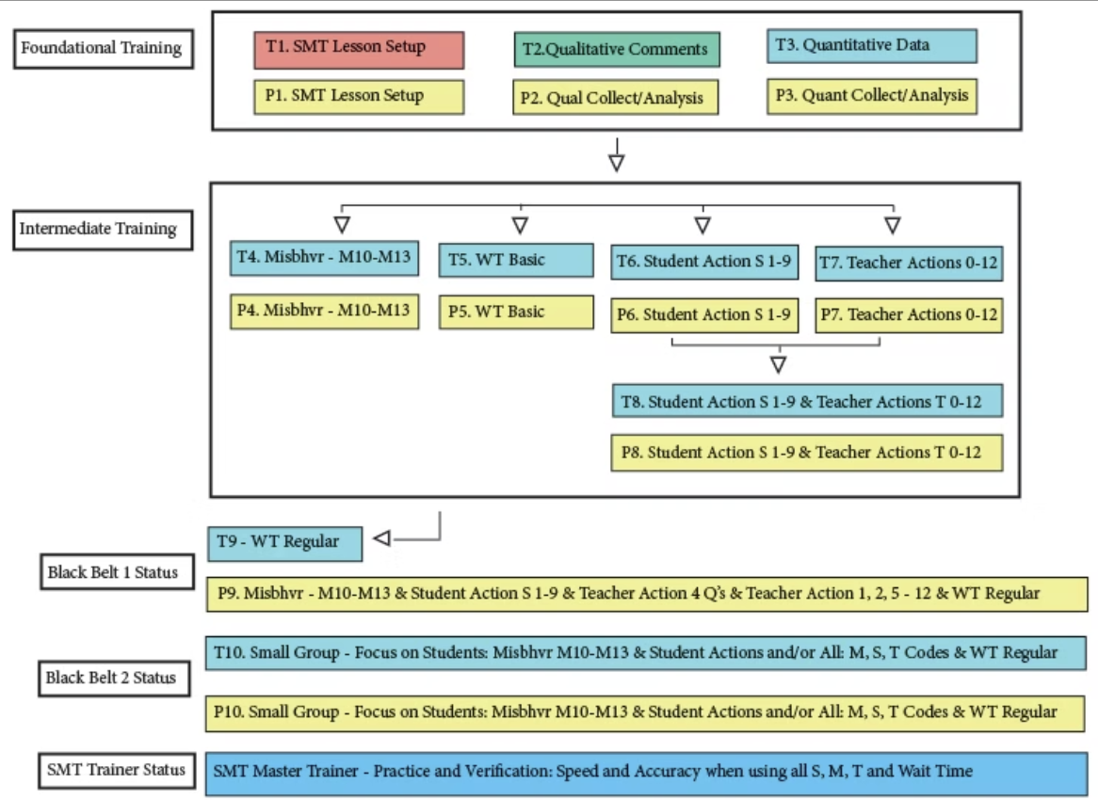

Training Elements - Each training includes a Video Overview and a Cheat Sheet that highlight essential features and components, guiding users as they practice data collection or analysis skills. Each training from T3 also includes an Extended Practice option and an Extended Practice Key, allowing novice users to compare their data and analysis with those of an expert to determine whether more practice is warranted.
Training Video Overview | Cheat Sheet | Extended Practice Key
Training 1 – Setting Up a Lesson | Cheat Sheet 1 | NA
Training 2 – The Qualitative Mode | Cheat Sheet 2 | NA
Training 3 – Basics of the Quantitative Mode | Cheat Sheet 3 | Extended Practice Key 3
Training 4 – Misbehaviors and Teacher’s Reactions | Cheat Sheet 4 | Extended Practice Key 4
Training 5 – Wait Time (Simple Method) | Cheat Sheet 5 | Extended Practice Key 5
Training 6 – Student Actions (S Codes) | Cheat Sheet 6 | Extended Practice Key 6
Training 7 – Teacher Actions | Cheat Sheet 7 | Extended Practice Key 7
Training 8 – Merging S Codes and All Teacher Actions | Cheat Sheet 8 | Extended Practice Key 8
Training 9 – Wait Time and M, S, and T Codes | Cheat Sheet 9 | Extended Practice Key 9
Training 10 – Small Group Data | X | X
SMT How to add a Lesson Plan | X | X
SMT How to add Summative Forms and Rubrics | X | X

Training Videos
Videos Used in Training and Extended Practice
​ SMT Practice Video Swinging Spheres https://youtu.be/XlPKXIkeHMA
SMT Practice Video Swinging Spheres 75% Speed https://youtu.be/CfmyeYwHyBI
​ SMT Practice Video Float Sink M * https://youtu.be/uLJ3Jvn0jHw
SMT Practice Video Float Sink A - Wait Time https://youtu.be/BaznvpVUx-U
​Videos for Additional Extended Practice
Regular
SMT Practice Video Float Sink B https://youtu.be/k38GViRMJIM
Practice Video Truck Hill L https://youtu.be/pjv0FSyR5sw
​Misbehaviors
SMT Practice Video Truck Hill M * https://youtu.be/YSD7mNBbZ1Q
​ Note * indicates a practice video more suited to practicing M codes (misbehaviors).

11. How to Set Up A Lesson Observation

Registered users who wish to conduct a lesson observation using SeeMeTeach must first log in to the online app by going to SeeMeTeach.com, clicking on Dashboard Login, then SMT Registered Users, and entering their login email and password. This will take you to a screen with a heading labeled "Dashboard" and a blue button labeled "New Observation". The Dashboard will display the list of lesson observations. Note that new users will not yet have any observations listed.
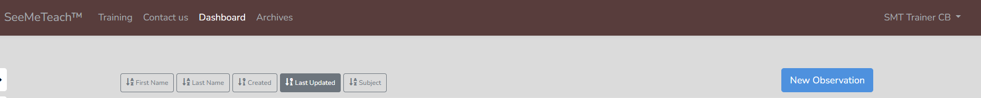

Clicking New Observation will start setting up a new lesson observation. A small amount of information is required before the observation can take place.

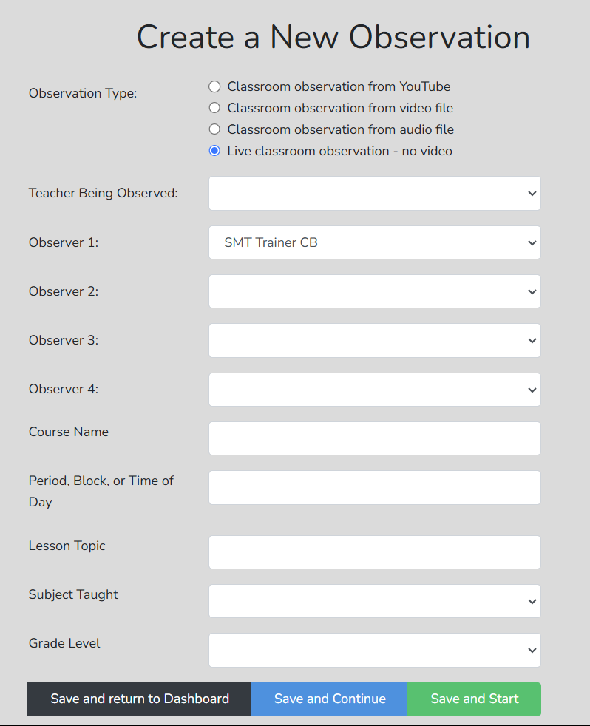

Observation Type choices include:
- YouTube—Capture and upload a video to the user’s “Unlisted” YouTube channel. SMT will ask for the video's URL.
- Video File—Capture a video by phone or device, store it on a computer, and upload it as directed. It will be stored in a secure cloud location. Many users capture video on their phones, email it to themselves, and then save it to their local computers.
- Audio File—Capture an audio file, store it on a computer, and upload it as directed. It will be stored in a secure cloud location.
- Live/No Video—This is an observation in a classroom. No video or audio is stored.

Teacher Being Observed – Select this name from a dropdown list. If you are a single user, you can invite another registered single user to join an observation. If you are a member of your group, the dropdown list is limited to those invited to that specific group by the group administrator, such as a class of future teachers or the teachers at a school. The individual identified as the teacher can view observation comments or data from other members of the observation team only if they are also listed as one of the four observers. See Observer 2 below.

Observers
Observer 1—The name entered will always default to the user logged into SeeMeTeach and setting up the observation.

Observer 2 – This can be anyone from the dropdown list. The teacher should be Observer 1 or Observer 2, so they can also enter comments or collect data.

Observers 1 and 2 are the only ones who can delete the lesson observation.

Observers 3 and 4 – These can be anyone from the dropdown list.

The other information is specific to the user.

At the bottom of the window, the user has the following options to proceed.

Saving The Lesson

Save and Return to Dashboard – takes the user back to the list of observations.

Save and Start – takes the user directly to the observation and offers a choice between Qualitative and Quantitative modes.

Save and Continue – directs the user to additional options for setting up the lesson, as shown below.

Pre-lesson Questions—To provide the observer with some context and information about the upcoming observation, the teacher can respond to the Pre-lesson Questions, which the observer can see via the Dashboard or the observation pages.
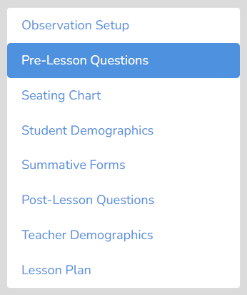
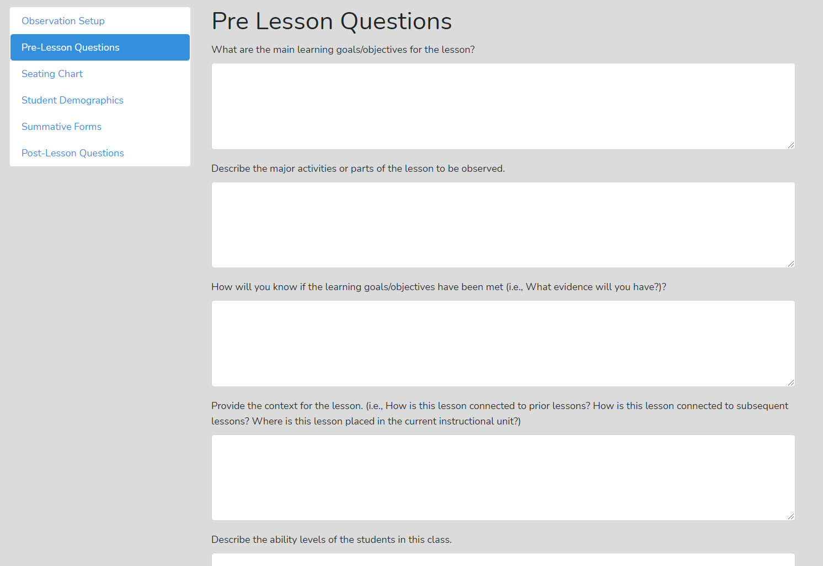

Seating Chart—The teacher or observer can create a Seating Chart and refer to it when making comments. The chart can show each student and small-group designations if desired.
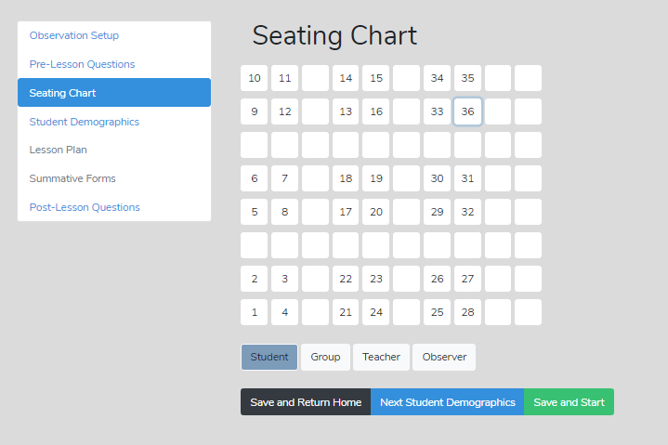

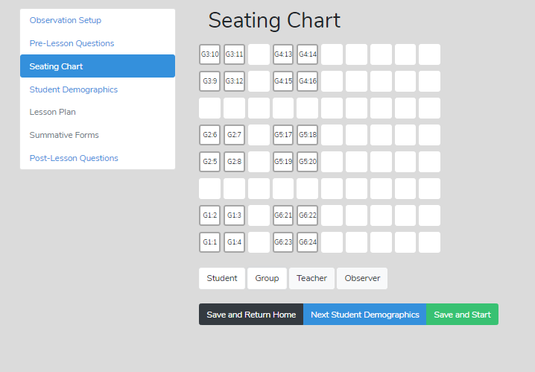

Summative Comments and Summative Forms - When the observation is over, the observer can add Summative Comments and/or fill in up to three Summative Forms to share with the observation team.

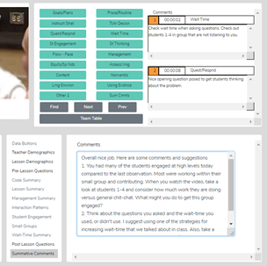

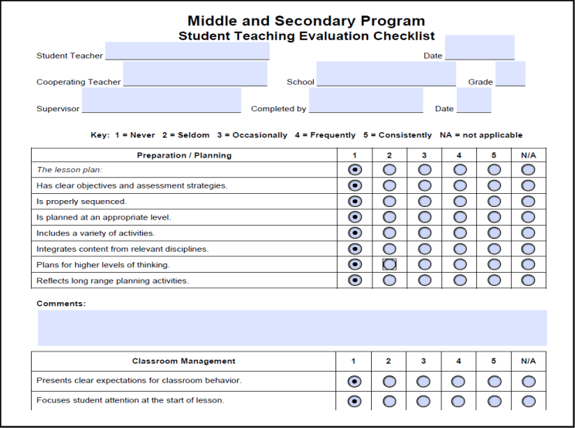

Post-Lesson Questions—Post-lesson questions can be filled out or accessed via the settings or the observation/analysis page to stimulate reflection.
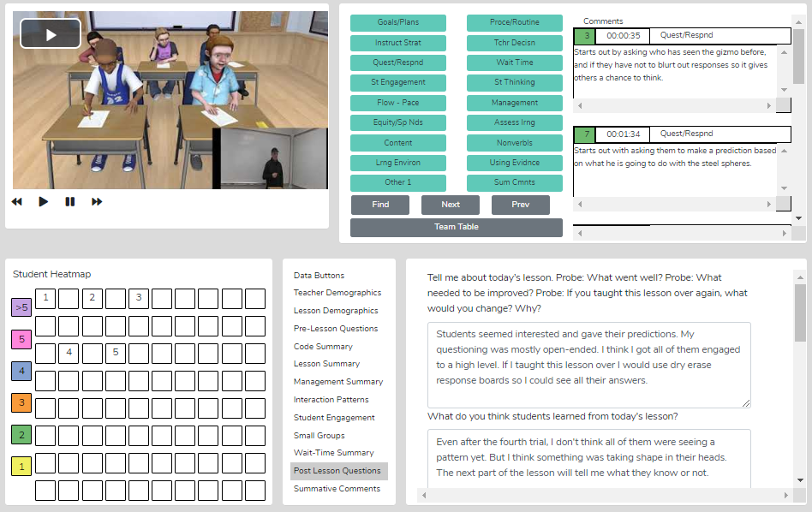

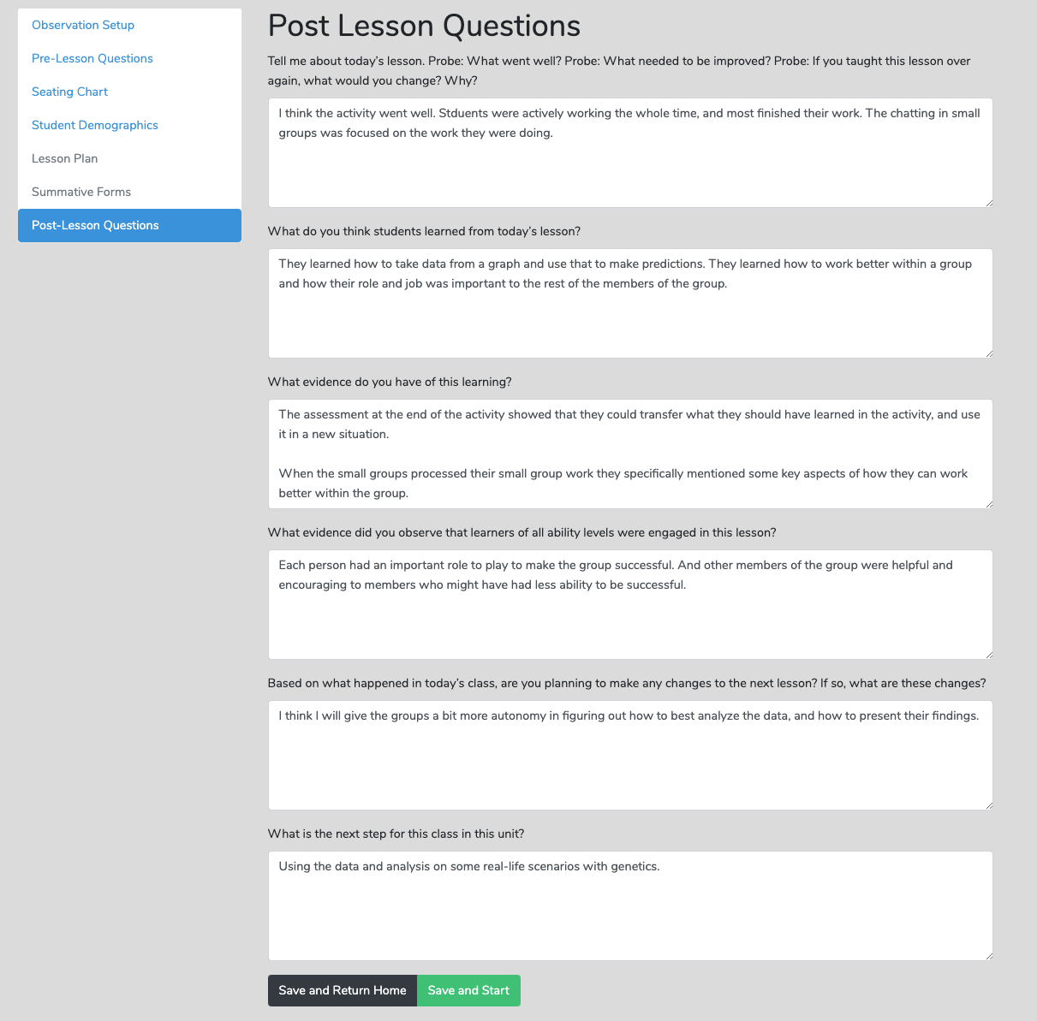

Lesson Plans—Before, during, or after the observation, the observer can quickly access the teacher's Lesson Plans via the Dashboard or the Team Table pop-up screen (shown below) when viewing the post-observation screen.

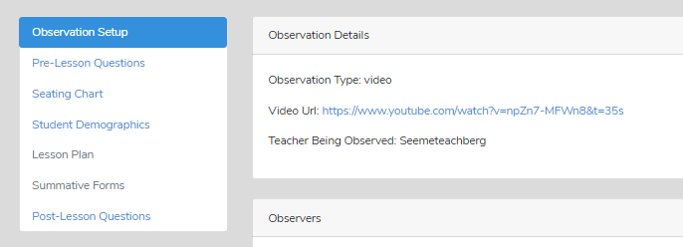

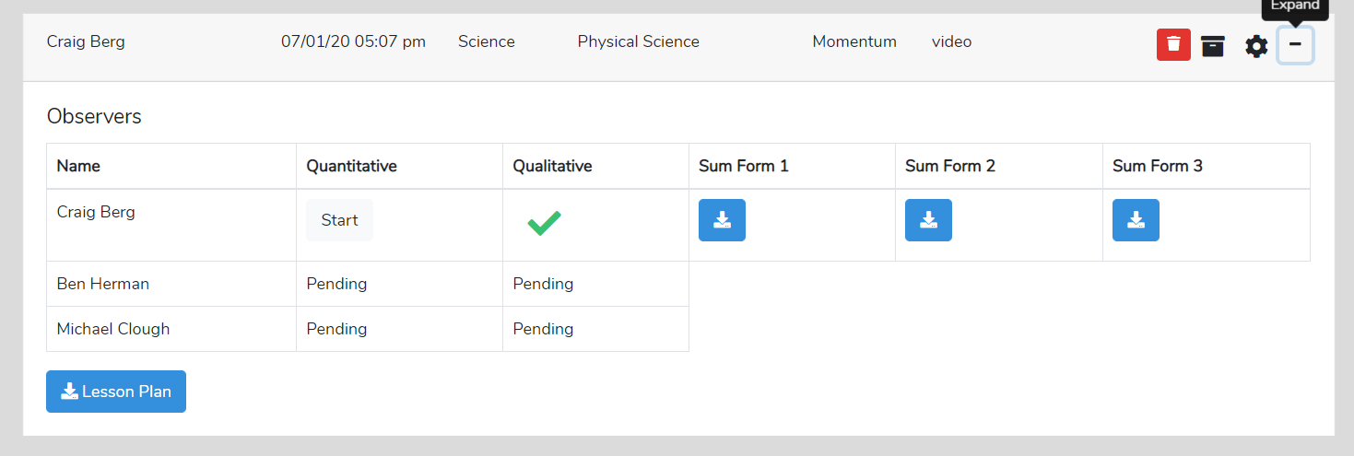

Team Table—A user can choose whose comments (or data/analysis) to view using this feature. A green checkmark indicates a user has completed that mode of observation. Note that from the Team Table, users can access the Lesson Plan and any Summative Forms completed by users (noted by a blue square icon in the Sum Form column(s). The Summative Forms, which are fillable PDF forms, are added by the user to their account.
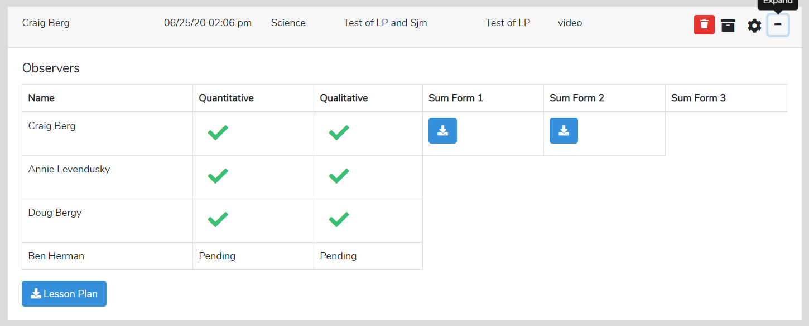

12. Qualitative Mode - Highlights and Important Features

Qualitative Observation Categories and Comments—The observer or multiple team members provide comments labeled by categories. There are many comment categories to choose from.

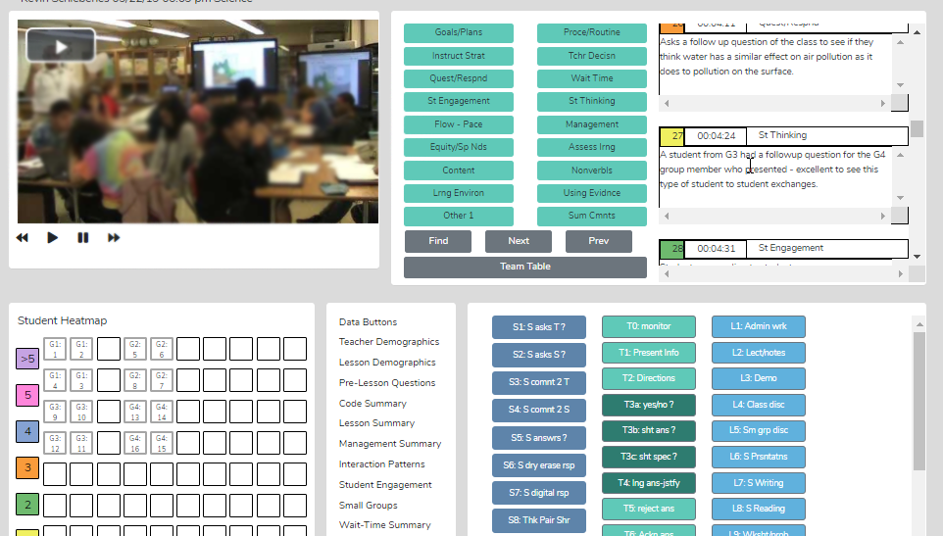

- Observations can be completed live in the classroom or by using a pre-recorded video or audio.
- The user generates a time-stamped set of observation notes that can include comments and suggestions, color-coded to the team member making a comment, labeled, and organized by category.
- The user(s) can search and find comments by category.
- Comments are also noted via symbols on the timeline below the video so the user can see who left comments and how many comments are attached to the lesson. Then, the user can click to read the comment and play the video segment.
- The user can create and tag comments to a student seating chart, noting events and actions by individuals or groups of students.
- When using video, comments are linked to video segments, so the teacher or observer can provide feedback with video examples of the teacher or student's actions.
- Summative commentary forms can be filled out, attached, and viewable by any team member. SMT provides some standard forms; users can also upload and use their personalized forms.
- It provides a platform for the observation team (of up to four people) to collaborate and communicate, and team members can react to and respond to each other’s comments.

The Qualitative Comment Mode – Capturing Comments

The graphic below illustrates what the observer would see when a lesson observation has been created and includes a video of the teaching episode.
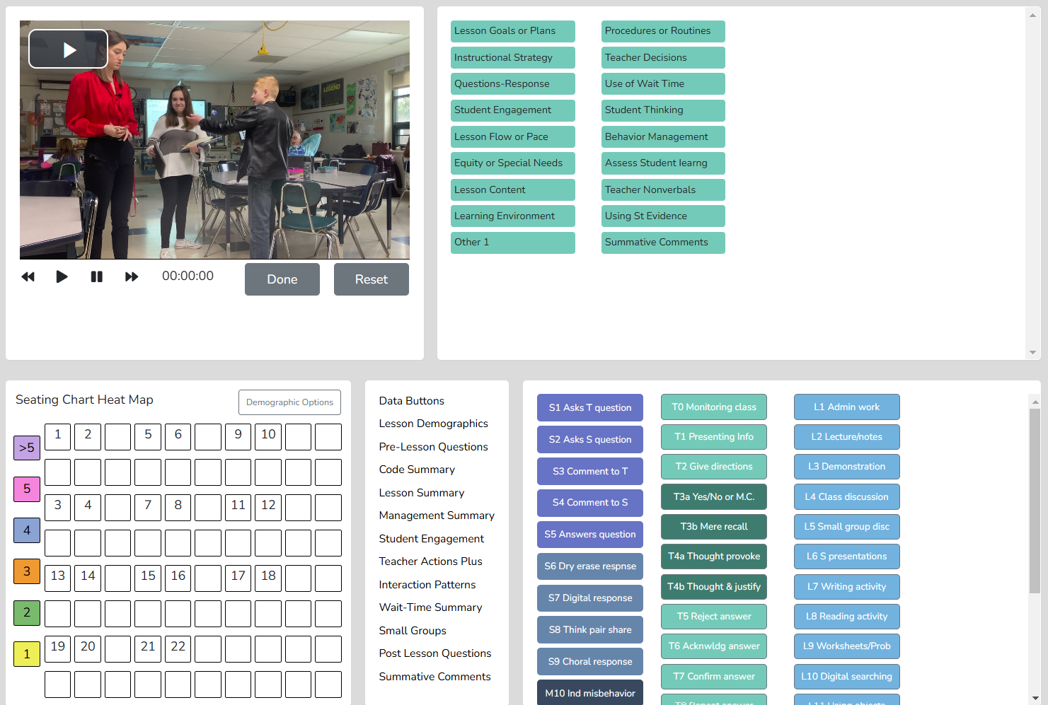

The user clicks the play arrow, and when something worth noting occurs, they click on a green button that best categorizes the comment they are about to enter. They then enter the comment and click the play video button again, repeating this process until they complete the observation.

Up to four people can be on the observation team and provide comments. This might include the student teacher, the cooperating teacher, the university supervisor, and one more, such as a mentor or coach.

The Qualitative Comment Mode – Post-Observation Screen
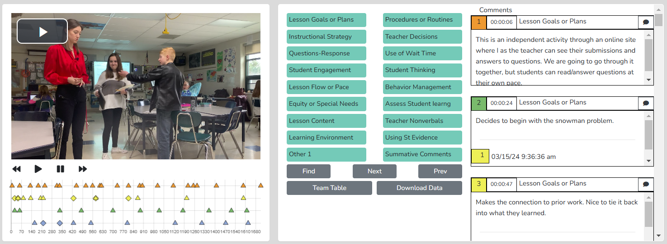

The screenshot above illustrates a qualitative observation following a future teacher and three others on the observation team who added comments and recommendations. Note that the triangles that show when comments were made in the lesson are color-correlated with the comments in the right-hand window, and both are linked to the corresponding video segment. We can isolate any observation member’s comments or view a subset. For example, the university supervisor could toggle off all comments except those from the cooperating teacher or view only the student teacher’s comments. All comments are time-stamped to the video, so if the user clicks a comment, they can view the associated video and better understand what transpired during that part of the teaching episode.

Suggested Uses - The team member’s qualitative analysis might be helpful regarding:
- The teaching observation of a fieldwork student or student-teacher by the teacher preparation program supervisor - After the observation, the qualitative analysis page is available to the student-teacher, who can view comments, respond to post-questions, post their reactions and commentary, and fill out the self-reflective Summative Form(s).
- Using video for observation can enhance team interaction and communication. Any team member can qualitatively analyze the lesson and view the running commentary and summative comments of other team members.
- When using video, all comments are linked to specific video segments so the viewer can see any particular action as it occurred in the classroom.
- Methods of teaching instructors can view the video of pre-service teachers implementing suggested strategies, view pre-service teachers’ analyses and reflections, and add their comments or suggestions.
- For a classroom teacher’s yearly observation, they can capture a video of their teaching, upload it to the app, and complete a self-analysis. Once the lesson observation with video has been set up in the teacher observation app, an administrator completes their observation and merges their commentary with the teacher's. A conversation then follows this whole process. When using video, comments are linked to the video, making it easy to locate any part of the observation and to showcase the events being discussed, thereby enhancing feedback and coaching sessions.
- Research team members can share data and analysis screens by printing the data and analysis screens or exporting the raw data to an .xls spreadsheet for more refined and custom analysis.

A Qualitative Comment Mode Example

The following is an example from a future teacher who first captured video of her teaching a lesson. She set up the lesson observation using that video and added comments as she viewed her lesson. Then, as one of the team members invited to observe, the university supervisor added feedback by adding new comments (demarcated by italics and bold) and responding to the future teacher's remarks (in bold).

Qualitative Comments Observation – Teacher RK

1 00:00:06 Lesson Goals or Plans
This is an independent activity through an online site where I, as the teacher, can see their submissions and answers to questions. We will go through it together, but students can read/answer questions at their own pace.

3 00:00:47 Lesson Goals or Plans
Makes the connection to prior work. Nice to tie it back into what they learned.

4 00:00:58 Instructional Strategy
Reminds students of previously learned vocabulary words and concepts - I find that using these words as often as possible helps them retain meanings.

6 00:01:23 Instructional Strategy
Begins by giving them a chance to read the first page. Asks, "What do you guys think?" Pretty open question. Then follows up with a yes/no question. Then asks for justification. It’s good to see you digging into their thinking.

7 00:02:11 Behavior Management
I noticed some students were beginning to chat as I opened a question up for discussion. I will remind them to listen and be respectful.

8 00:02:14 Behavior Management
Stops and quickly addresses the side conversation, then returns to the students who were answering. You did this quickly without wasting time.

10 00:03:06 Questions-Response
I am trying to get them to come up with ideas without giving them answers or leading them to anything specific. I am asking as many students as possible to share different ideas but encouraging individual work first.

11 00:03:22 Student Thinking
Sets up the scenario and asks for student predictions

12 00:03:40 Behavior Management
I tell them to answer the questions independently
You might want to be more adamant, but in a nice way

13 00:03:51 Student Engagement
I can tell students are having difficulty staying engaged in independent work. Usually, this class is groupwork-based, and they can always work together. Today was a bit of an experiment by asking them to work alone, and it is showing me that they may not be able to handle full lessons alone yet.

14 00:05:14 Learning Environment
I consistently move around the classroom and stay near students who are having trouble focusing/answering questions to create a better learning environment.
Great to see you not staying in the front of the classroom. Moving around will also tamp down some potential behavioral issues.

15 00:05:32 Using St Evidence
Students chatting = moving on in the lesson. When I notice that students are working ahead or starting to chat with their neighbors, I know I can move on with the lesson content, which I do here.

18 00:07:28 Behavior Management
The student who is up and wandering around the classroom usually needs extra attention. I allow him to move around the classroom to meet his needs (he struggles to sit still and focus), but I try to remind him not to distract other students.

20 00:08:33 Behavior Management
I noticed that some friends were chatting quite a bit, so I asked one of them to move slightly to a new seat. I didn't want to punish him, but I needed to separate the two a bit.

22 00:09:19 Student Engagement
While I am working to separate two chatty students, I am noticing that other students are losing focus on the lesson/activity. I am trying to handle the situation fully so I don't further derail the rest of the class.

23 00:09:41 Behavior Management
Moving some students who put up some resistance, and that’s ok, as it is necessary to move them

24 00:10:09 Teacher Decisions
Here I decided to stop arguing with the student who is being difficult. I decided to wait patiently for him to take a seat and rejoin the lesson, as continuing the back and forth helps no one

25 00:10:20 Behavior Management
This is my attempt to re-engage the rest of the class in the activity. During that management situation, the rest of the class derailed, as expected, so I am trying to re-engage the class. I think I could have delivered this more kindly; however

27 00:12:09 Instructional Strategy
I am walking through the video with the students - this is to help the students understand what is going on in the video (creating access points)

29 00:13:26 Questions-Response
Trying to ask open-ended questions that encourage many possible responses.
Interesting idea. Try it.

30 00:14:30 Use of Wait Time
Speaks fast (ok), but then wait time seems really short - check this and try to use at least 3.5 seconds or more

31 00:14:43 Behavior Management
Reminding a student to focus on the assignment. He was done with the questions we were currently on and didn't want to work ahead.
Ok. It's common for some students to finish faster than others, and you should pre-empt off-task behavior by telling them upfront what they can do if they finish early.

33 00:15:01 Questions-Response
Asking students to elaborate on their responses to encourage further thinking and address any misconceptions.
Curious to know what your teacher-student interaction data will look like if you are consistently doing this with students?

34 00:16:46 Using St Evidence
Some students were having difficulty answering questions, so I paused and reviewed earlier concepts to help them understand the material they were struggling with.
Are they having difficulty coming up with an answer, or do they just not want to answer in public? I would recommend pulling out the dry-erase boards so they can write their answers, then maybe follow up with think-pair-share. It’s important for you to find out what students are thinking.

36 00:18:34 Questions-Response
My questions here are lacking in speculation - they are mostly short-answer questions; however, based on how the students were answering, I realized I needed to cover some basics

39 00:20:06 Questions-Response
Asks good questions to get students to analyze the data
Yes, your questions are more open-ended, speculation-type questions at this point in the lesson.

40 00:20:15 Student Thinking
I am SO appreciative of students telling me when and where they are confused - this tells me that they are comfortable slowing down the lesson and covering our bases, and I am okay with that
Students feel comfortable because you use non-judgmental responses.

41 00:20:52 Questions-Response
I am trying to relate the experiment to their experiences because they are struggling with the content by asking questions about fridges and freezers.
Yes, they want to understand the connections, and this is important!

42 00:21:17 Behavior Management
I am placing the responsibility on the students to be respectful and focus better. I have told this class before that they are responsible for learning, and if they aren't getting the grades they want and they also aren't putting in the effort during class, then I am not to blame.
This probably isn't a one-time message; you need to deliver it and reinforce it repeatedly. Keep doing this, and pair it with the encouragement strategies you learned in classroom management.

45 00:23:30 Lesson Flow or Pace
The lesson is moving slowly here as I keep asking the same questions, but I try not to let that frustration show, since I know a slow pace is what the students need.

48 00:26:35 Assess Student Learning
The questions I am asking are prediction-based to see if the students are starting to understand the concepts the lesson is trying to convey

49 00:26:36 Instructional Strategy
Watching the video to see what occurs

52 00:28:35 Questions-Response
Leaving students with a question to think on - even though they did not get through the material I expected, I am not assigning homework, just encouraging them to think about a question they need to answer tomorrow. I don't want to overwhelm them, and I'm okay with a 1-day activity turning into a 2-day activity.

□ □ □ □ □ □ □ □ □ □ □ □ □ □ □ □ □ □ □ □ □ □ □ □ □ □ □ □ □ □ □ □ □ □ □ □ □ □ □ □

Using Data and Evidence - The observer can use quantitative analysis data to support comments made during qualitative feedback, providing evidence-based feedback, recommendations, and coaching. More on using data after the reader is introduced to the potential for data collection and analysis in Chapter 13.

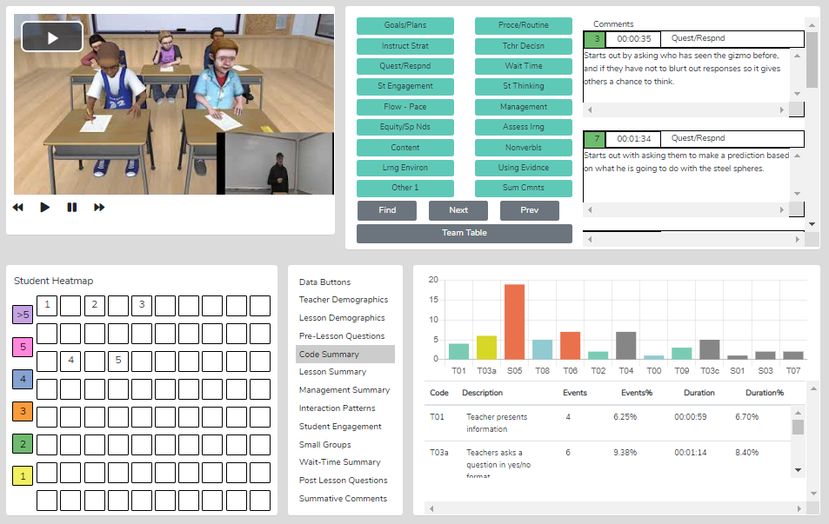

Qualitative Comment Button Choices – You can choose from many button sets when setting up a qualitative observation.

Or, you can customize a button set with labels you choose.
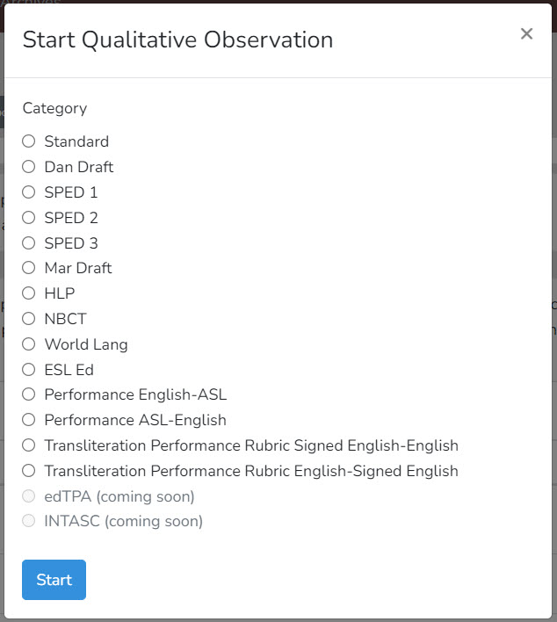

Standard Set Special Education Set 1

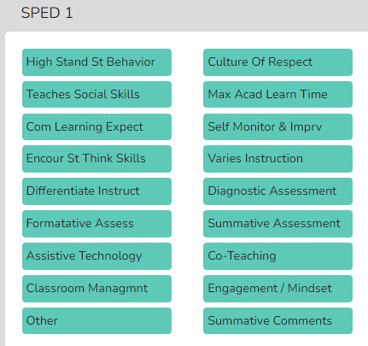
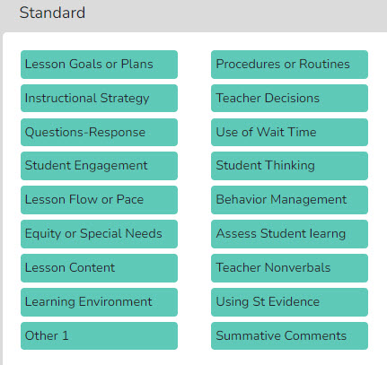
Special Education Set 2
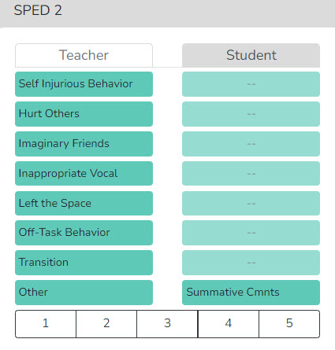
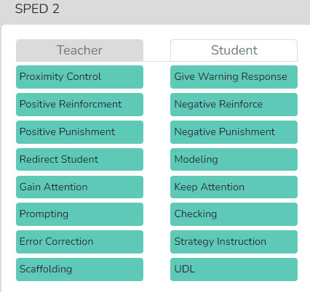

Special Education Set 3
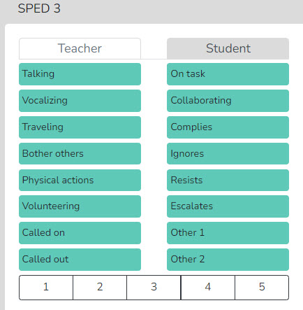
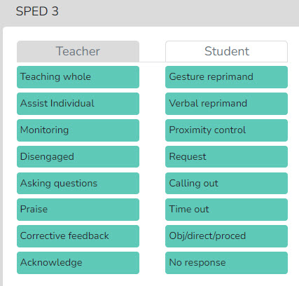
World Languages Set English as Second Language (ESL) Set
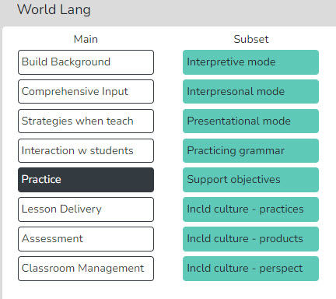
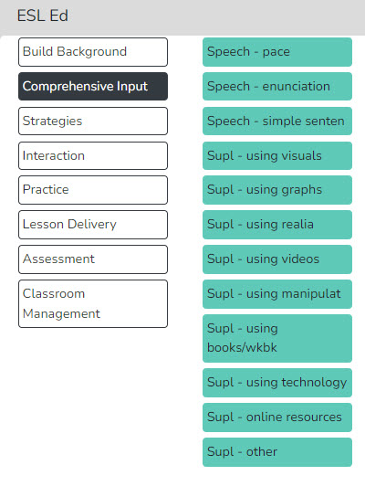

Signing ASL to English Set Transliteral Performance Signed English to English
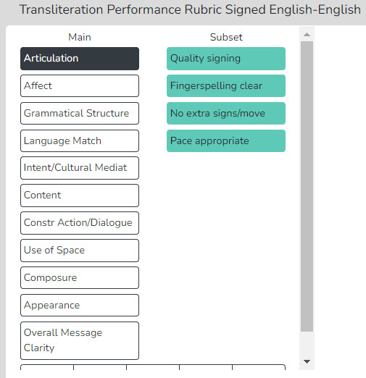
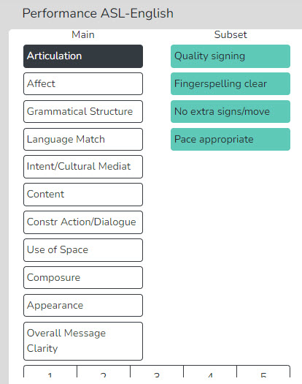

National Board Certification of Teachers Set
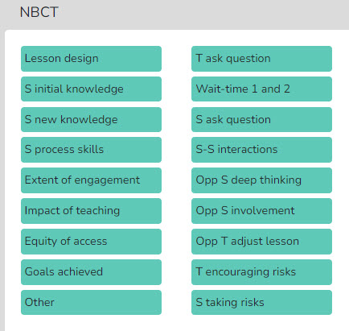

13. The Quantitative Mode – Overview and Features

The SMT Quantitative Mode: Gathering High-Resolution Data
A teaching episode contains an immense amount of high-resolution core teaching data that could and should be used for feedback, coaching, and indicators of teaching growth.
- Teacher Actions (questions, responses, wait time)
- Student Actions and Engagement
- Misbehaviors and Teacher Reactions
- Tendencies & Patterns – The Fingerprint of Teaching
- Small Group Dynamics and Equity

Quantitative Analysis and Feedback Options
The SMT quantitative model enables users to collect and analyze data related to teacher and student actions during a lesson. This data is coupled with the specific lesson type in play to show when and where student and teacher actions occur. The raw data is displayed, time-coded, and linked to events as they occur in the video. The resulting raw data and analysis provide substantive insights into the lesson's activities and events. The analysis and feedback options described below will highlight the benefits of using quantitative data during the feedback and coaching process.

Power of Video-Linked Data—When using video, the data collected is linked to the specific video segments that represent that data and to the type of action or event observed by both the teacher and students. When viewing the analysis screens, the observer, teacher, or team member can navigate directly to the video linked to specific data points and see examples in action.

Highlights of the Quantitative Mode
- Observations can be completed live in the classroom or by using a pre-recorded video or audio file.
- SMT collects extensive data regarding teacher and student actions that is linked to events in the classroom.
- There is an immediate post-observation analysis of data with visual representations displayed in tables, graphs, and heat maps of seating charts.
- With a seating chart, the data are linked to specific students, small groups and analyzed by student demographics.
- Data are linked to video segments making it easy to locate specific examples of a teacher or student’s actions.
- Small group actions can be noted for examining small group dynamics and engagement.
- The lesson plan is attached to the observation for ease of access for the observer or any team member.
- Summative forms tailored to local needs can be filled out, attached, and viewable by any team member. SMT provides some standard forms, or users can also upload and use their own personalized forms as well.
- SMT provides a platform for the observation team (of up to four people) to collaborate and communicate.

Now, let’s take an in-depth look at the rich, robust data that both observers and teachers can collect, and how it offers many possibilities for helping teachers improve instruction.

The quantitative mode offers a method for collecting high-resolution data, from simple to extensive. One user can collect vast amounts of high-quality data on the common core of instruction. It offers data collection on teacher actions, student actions, student misbehaviors, the teacher’s reactions, wait times 1-4, and more.
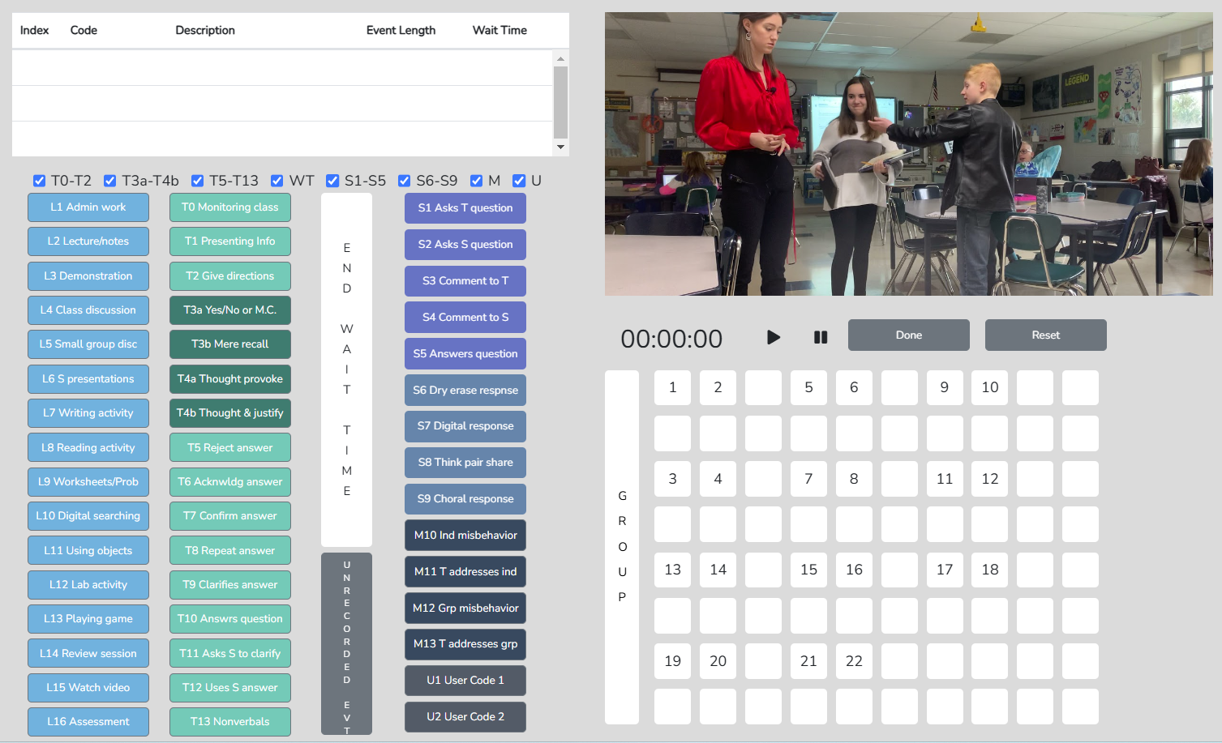

While users can utilize the whole palette of buttons after some training and practice, novices may want to begin by toggling off buttons and focusing on essential data, but a narrower set. For example, the user might only utilize the T0-T13 buttons to obtain a complete profile of teacher actions during the lesson. The observer might also focus only on question types posed by the teacher (see the picture below, left). Alternatively, the user can toggle off all buttons except S1-S5 and, when used in conjunction with the seating chart, gather data on individual student contributions in the classroom (see the picture below, right).
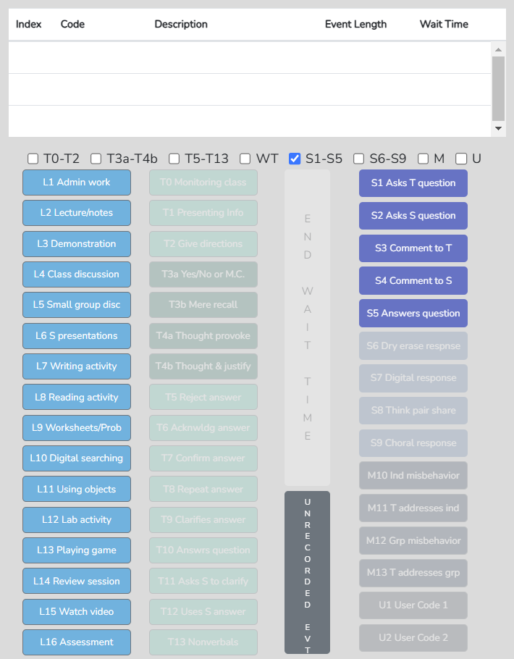
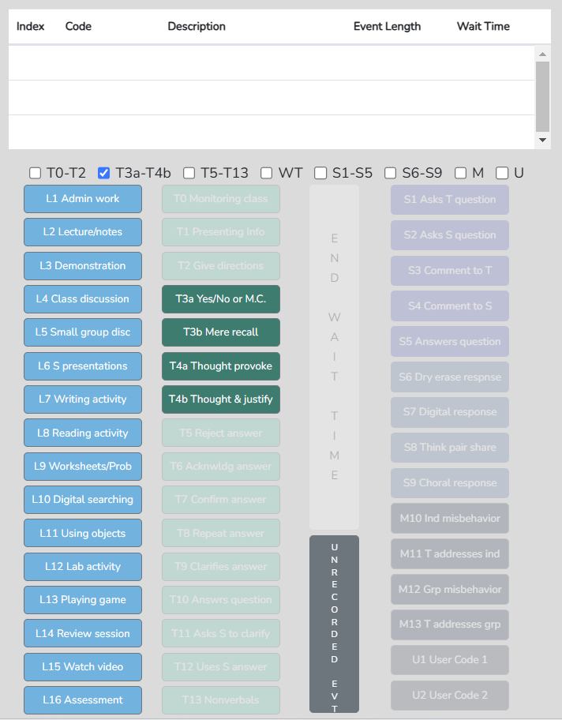

This tool was designed to enable experienced users to observe a lesson and capture data on all potential teacher and student action events. However, it was also essential to make the tool suitable for both novice and experienced users who only want to collect a subset of the teacher's or student's actions. Continue reading to learn about the features of the observation tool and the vast potential for collecting, analyzing, and using high-resolution data as a basis for feedback, coaching, and reflection.

The SMT Quantitative Mode: High-Resolution Data Analyses, Reflection and Feedback

The SMT teacher observation tool was created to enable observers to collect a rich, robust dataset that is instantly analyzed upon completion of the observation and then used for feedback and coaching. What follows are descriptions of each data summary, along with some sample data and analysis, that offer the reader a more concrete understanding of the power of using such a tool for teacher observations. Each data summary includes questions to ponder regarding the teaching episode. Then, to show how data is used in the feedback and coaching process, sample results are used to provide Joe with feedback. New teaching targets are proposed for the following observation to see how high-resolution data can inform the focus on improvement and growth indicators in teaching.

Lesson Summary – When coding a lesson, the observer notes the type of lesson in play by clicking an L button at the very start of the observation and a different L code each time the lesson type changes within the observation. As such, lesson segment types appear in the quantitative analysis mode of the Lesson Summary data window as a timeline showing the order and duration of each lesson segment. This lesson segment display is used as a time-context reference when examining other data, such as Student Engagement or Management Summary, to identify where misbehaviors or students’ responses occurred during the lesson.

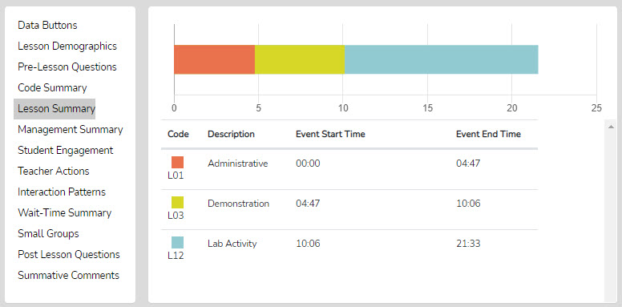

With the Lesson Summary data, the user can consider the following:

- After the bell rings and the class period begins, how much time is used to start teaching, and then decide what to do differently to begin teaching right at the start of the class period.
- How much time was spent on each segment of the lesson? Think about whether more or less time was used on lesson segments than intended and how the use of time affected the lesson outcomes.
- How much time was used for transitions between each part of the lesson allowed the teacher to ponder what changes should be made to reduce the time needed for transitioning from one part of the lesson to another.
- If the lesson ended early, view how much time at the end was not used for instruction and think about some productive things to insert into the lesson to utilize the remaining class time.

Feedback Session with Joe
Joe, the first segment of your lesson, titled “Administrative,” was approximately 5 minutes long. You took attendance, distributed some papers, and began the demonstration.
- What do you think about how many minutes it took for you to get the class started on the lesson?

If this is the beginning of class for you and it takes five minutes each day, as it did today, and if we extrapolate that to nine months of school, that’s roughly 900 minutes devoted to administrative work during class time. Since the class period is 50 minutes, that is 18 days not used for instruction and learning.
- First, what is your reaction to using 18 days for administrative activities?

Next Observation, Teaching Target, and Data
Joe, as one of your goals for the following observation, how might you reduce the administrative time shown in the Lesson Summary and increase the time spent on lesson activities?

□ □ □ □ □ □ □ □ □ □ □ □ □ □ □ □ □ □ □ □ □ □ □ □ □ □ □ □ □ □ □ □ □ □ □ □ □ □ □ □

Student Engagement Summary – When coding a lesson, the observer notes who and what type of student action occurred, as well as when it happened during the lesson. Student seating numbers can explicitly note student engagement events or be used generically if seating chart numbers were not provided. The seating chart heat map illustrates the number of events associated with each student, with colors indicating the count. This summary also displays student contributions to the class using black bars on the timeline and red bars to indicate when the teacher engaged the whole class using Think-Pair-Share, digital devices, or other methods. Clicking a bar starts the video linked to that event.

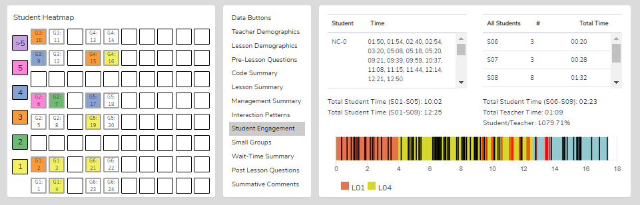
Below, notice the Student Time column. Clicking student number 9 will show black bars only for that student's contributions.

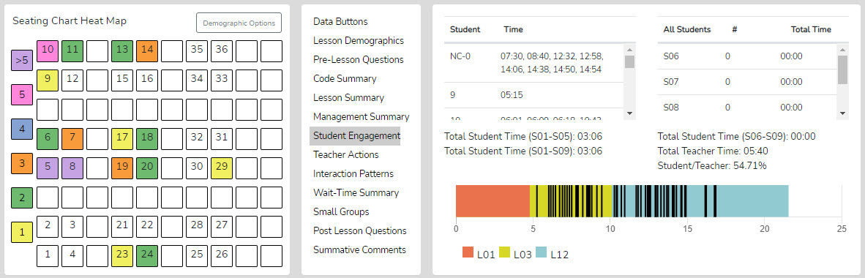
Below, clicking an S6-S9 event (upper right column) shows only the whole-group events as red bars.
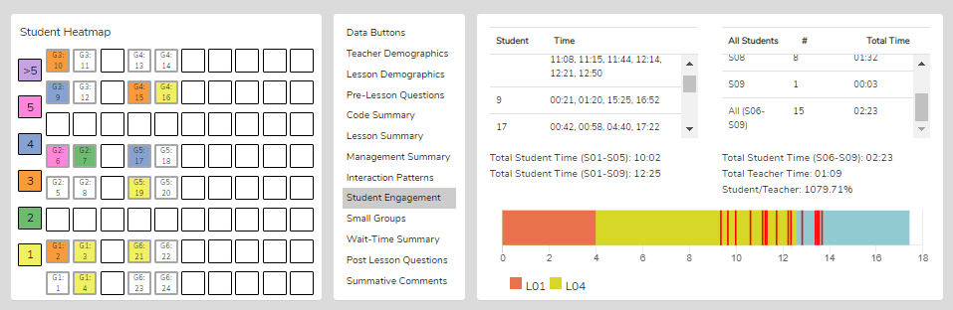
Demographic Highlighting in the Seating Chart Heat Map - Additionally, if data is collected for specific students by using their student seat number before entering the S code, the data can be displayed and toggled on or off by clicking on the Gender, ELL, SPED, or Minority buttons. If the observer wonders how students with special needs are engaged during the lesson, toggle this information to find out. If the observer or teacher is concerned about equity of participation by gender, minority status, ELL status, or students with special needs, this data is available.

With the Student Engagement data, the user can consider the following:

- Consider how many students responded to at least one question and how many were not in the conversation. (Heat Map)
- Think about your teaching: how many students responded to each other at least once, and what you might change to produce more student-to-student interactions. (Interaction Patterns S-S #)
- Think about the average number of responses per student, how that fits your student engagement goals, and how that number might be increased. [Total of S1-S5 plus (the total of S6-S9 x the number of students in the class) / number of students in class]
- Look at the various parts of the class or type of lesson segment and determine if or how students were engaged, as evidenced by vertical bars. Think about parts of the lesson that were absent in student contributions and engagement, and how your lesson might be altered to produce more student engagement.
- Using the demographic toggles on the Seating Chart Heat Map, examine student engagement by demographics such as gender, minority, ELL, and Special Education – think about what the data suggests regarding equity in student engagement.

Feedback Session with Joe
Joe, let’s look at the seating chart heat map. It shows the color-coded levels of student contributions. It indicates how many times each student answered a question, asked a question of the teacher or a fellow student, or commented to the teacher or a fellow student.
- What does the seating chart heat map tell you about student engagement during the lesson?
- What is your reaction to half of the students not making a single contribution?
- The next time I observe, what would you like to see regarding student engagement when viewing the seating chart heat map?
- What is your plan for increasing student engagement?

Joe, let’s shift our focus to the lesson timeline, marked by the black and red vertical bars. As you know, the black bars each represent a student contribution, and the red bars indicate a whole group of students responding – in your case, you were using choral responses.
- What is your reaction to the timeline of student engagement?

Joe, the timeline shows consistent student contributions throughout the lesson, compared to the large empty spaces from the previous observation, which were due to much more teacher talk. For the current lesson, there are many red bars from minutes 9-14, indicating that the whole group is responding. You used a variety of methods for whole-group responses, including choral responses to yes/no questions.
- Joe, tell me how choral responses are helpful to you.
- Instead of using choral responses, what are ways to get responses from all students? This also shows how individual students respond to your questions.

Next Observation, Teaching Target, and Data
Joe, one of your goals for the following observation is to create a lesson plan that maximizes student contributions and engagement, as shown by the seating chart heat map and the lesson timeline.

□ □ □ □ □ □ □ □ □ □ □ □ □ □ □ □ □ □ □ □ □ □ □ □ □ □ □ □ □ □ □ □ □ □ □ □ □ □ □ □

Wait-time Summary – Wait-time can be collected on its own or in conjunction with teacher and/or student actions. Wait-time data is located only within the Wait-Time Summary. The Wait-Time Summary includes general summaries of wait time by wait-time type, events, total time, and averages for each wait-time. Additionally, the lower half of the summary presents wait-time averages for specific actions by teachers or students. For example, users can determine if more wait time is allowed for higher-level questions that require deeper thinking than lower-level questions.
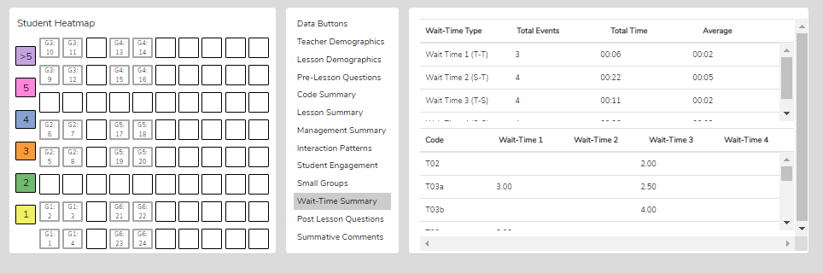

With the Wait-Time Data, the user can consider the following:

- How does the WT1 average correspond to the teacher’s intention for using wait-time to give students ample opportunity to think about the teacher’s question?
- How does the WT2 average correspond to the teacher’s intention to use wait-time to give students ample time to think about a student's response and respond to that student? (Look at the relationship between WT2 average and the S-S count in Interaction Patterns.)
- How does the average WT1 for question types differ regarding higher-level questions and students needing more think time to generate an answer?
- How does using greater WT2 bring forth more student-to-student responses?
- If the WT average is lower than expected or desired, what is the teacher’s concrete plan for increasing their WT?

Feedback Session with Joe
Joe, look at your wait-time data.
- What are your conclusions about the wait-time you used during this lesson?

So, you said your WT-2 was sufficient. After a student responds, you pause for about 5 seconds before responding. This week, you used much more WT-2 than in the last lesson, which averaged only 1 second.
- What did you see happening during this lesson, now that you are using more WT-2, that you did not see during the last lesson?

Joe, on the bottom half of the table, look at the wait time for each question type.
- How does wait time differ for yes/no questions compared to questions designed to elicit deeper student thinking?

Joe, your WT-1 averaged 2 seconds. If we check the video for a T action followed by another T action, you will see that sometimes you ask a deeper-thinking question, but then, with a very short pause of 1-2 seconds, you follow up by changing it to a yes/no question. You probably don’t realize you're doing that, but let’s examine some video segments that illustrate it.

Next Observation, Teaching Target, and Data
Joe, you just looked at the data table. You told me that the average wait time for yes/no questions was almost identical to the wait time used for questions requiring speculation and justification, and that wait-time averages across all question types were well below what is needed to trigger the positive effects of using wait-time.
- What can you do while teaching a lesson to prompt and remind yourself to consciously incorporate sufficient wait time, especially using WT-1 during your teacher-student interactions?
- Joe, I suggest capturing video or audio of you teaching a couple of times this week and a couple of times next week, and just collecting the wait-time data to improve your wait-time so that by the following observation, you have established higher averages of WT1 and WT2.

□ □ □ □ □ □ □ □ □ □ □ □ □ □ □ □ □ □ □ □ □ □ □ □ □ □ □ □ □ □ □ □ □ □ □ □ □ □ □ □

Code Summary—This summary provides both raw and analyzed data, displayed in a graph and a table, with counts and percentages of teacher actions, student actions, student misbehaviors, and teachers' reactions to these misbehaviors.

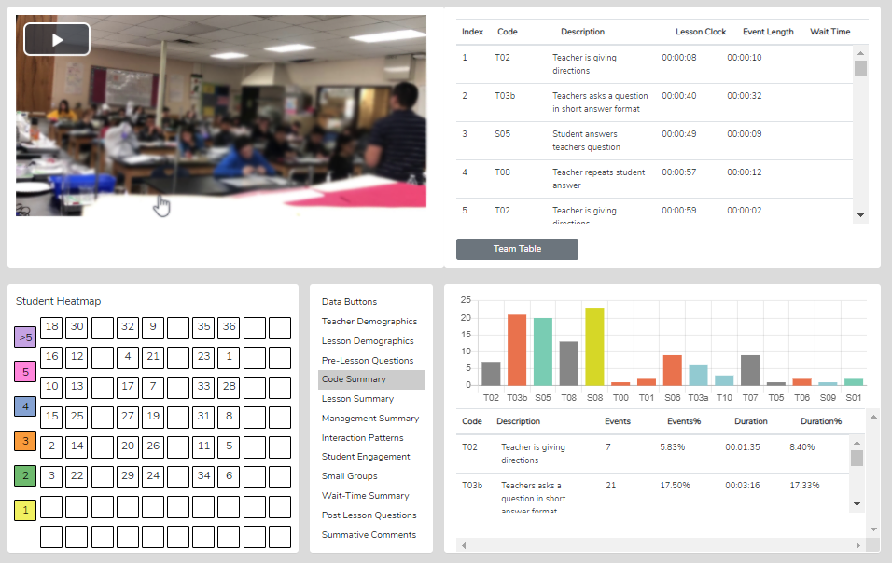
With the Code Summary data, the observer or teacher can consider the following:

- Looking at the Code Summary, the data table, and the graph:
  - What were the predominant teacher actions exhibited in this lesson?
  - When looking at the data for the four question types, what is the tendency of the teacher to ask open-ended questions requiring students to think more deeply, speculate, and construct answers vs. asking questions that require a yes/no or short-answer memory-type response?
- What does the teacher tend to do following a student's response? Do they tend to judge responses, acknowledge, and then clarify for a student, or instead ask a student to explain? What actions get students thinking more deeply about the idea?
- Considering the type and number of questions asked, what might you conclude if the goal was to dig into student thinking at a deep level? What changes would foster more of this?
- What is the total % of T codes vs. % of S codes? (This data indicates whether the teacher is doing most of the talking and shows if the talking time is balanced between the teacher and students, and at what level the students contribute to the teacher-student or student-student interactions in that lesson.

Feedback Session with Joe
Joe, look at the data table in the Code Summary showing that you talk about 92% of the time, while students have about 7% talk time.
- What does that data indicate regarding your goal of fostering and increasing student engagement during this lesson? How might you change the lesson to increase student contributions to the lesson, and what would you see during the lesson and from the data that would indicate you have been successful in improving student contributions and engagement?

Let’s examine the data on question types posed during the lesson. Of the 87 questions you asked, 75 were yes/no, 10 were recall questions, and 2 required students to speculate.
- How does the data support your intention to get students to think more deeply about the topic and obtain responses that provide you with more understanding of their thinking? What suggestion(s) would you have for the next lesson?

Stimulating student thinking and understanding what students think, know, or understand depends on how you respond after they answer questions. Let’s look at the data on the chart for the teacher's responding behaviors: you either rejected student answers (15%), confirmed student responses (80%), or repeated a student’s responses (5%).
- How does that data fit with your intentions? How might you improve your teaching to suit your lesson and student learning goals?

Next Observation, Teaching Target, and Data
The data also show that, following your initial response, your predominant action is elaborating on the student's one- or two-word answer. Therefore, you are clarifying and adding meaning to that response—it turns into a short mini-lecture after each student's response.
- What is your reaction to such data? For the following observation, how might you change your response pattern to learn more about student thinking, what they know or believe about the topic, and how the lesson impacted their thinking?

□ □ □ □ □ □ □ □ □ □ □ □ □ □ □ □ □ □ □ □ □ □ □ □ □ □ □ □ □ □ □ □ □ □ □ □ □ □ □ □

Management Summary – When coding a lesson, the observer notes a student's misbehavior and can link it to the seating chart; therefore, the data includes the who and when of the misbehavior. The observer also notes when the teacher reacts. This summary provides a seating chart, timeline, and individual student data for misbehaviors, using black bars on the timeline linked to the video, and the teacher’s response and intervention, using red bars connected to the video. Clicking a bar starts the video linked to that event. A seating chart heat map displays the number of misbehaviors that occurred, their locations within the classroom, and demographic data.

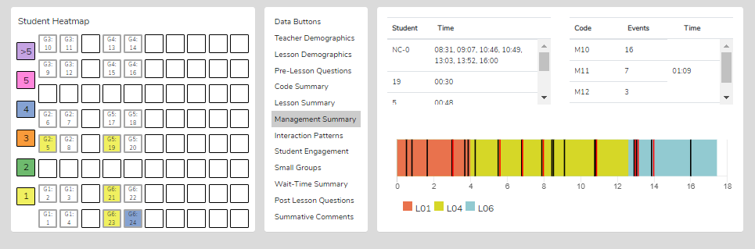
Demographic Highlighting in the Seating Chart Heat Map - Additionally, if data is collected for specific students by using their student seat number before entering the M code, the data can be displayed and toggled on or off by clicking on the Gender, ELL, SPED, or Minority buttons. If the observer wonders how students with special needs become disengaged during the lesson, toggle this information to find out. If the observer or teacher is concerned about equity of participation by gender, minority status, ELL status, or students with special needs, this data is available.

With the Student Misbehavior Data, the user can consider the following:

When Viewing the Code Summary:
- How many classroom management events were noted by the observer?
- How many classroom management events were not addressed by the teacher?
  - Note that when the number of M10 events is added to the number of M12 events, if that number is greater than the number of M11 and M13 events, the teacher is probably ignoring some of the student misbehaviors either intentionally or due to the frustration of not having an impact when they do intervene.
- How much time did the teacher use to intervene in management events? (M11 and M13)

When Viewing the Seating Chart Heat Map:
- Where in the classroom are the problems occurring?
- Is there a small group or table of students exhibiting the most misbehavior?
- Are behavioral issues proximal or distant to where the teacher is located?

When Viewing the Management Summary:
- Where in the lesson, or during which lesson type, did the management issues occur? (Vertical bars on the lesson segment timeline)
- How many management issues occurred at the start, end of class, or during transitions from one lesson segment to another? (Vertical bars on the lesson segment timeline)

When Viewing the Video:
- How much time was needed to get all the students settled and begin the lesson when transitioning from one lesson segment to another?
- How was the teacher’s movement around the classroom?
- How did the students behave or misbehave today as a whole, compared to other days in general?
- Regarding specific students who might tend to misbehave, how was their behavior today?
- Was there anything about this lesson that might have contributed to more or fewer management issues?

Feedback Session with Joe
Joe, the seating chart heat map showing student misbehavior indicates that four students each misbehaved once. The map also indicates that one of your students, number 24 in Group 6, had four incidents of misbehavior. This student seemed to be the source of your deviation from your lesson plan.
- Describe the misbehaviors of student 24 and then talk about how you handled the incidents. We can go to the video for a quick reminder of the incidents if needed.

Joe, you just said this student’s behavior made you very uncomfortable and that you weren’t sure what to do. Let’s look at the video to see how you reacted.
- Joe, how would you characterize your intervention and what happened?

Next Observation, Teaching Target, and Data
Joe, you recognized that the situation escalated because of your intervention. Let’s discuss other ways to intervene in these misbehaviors that can help de-escalate the situation. You can implement those changes, and we will look for that in the following observation.

□ □ □ □ □ □ □ □ □ □ □ □ □ □ □ □ □ □ □ □ □ □ □ □ □ □ □ □ □ □ □ □ □ □ □ □ □ □ □ □

Interaction Patterns—When using the teacher actions (T codes) and student engagement actions (S codes), the user can view the predominant interaction patterns between the teacher and students. In addition, numbers show how often students interact with each other (S-S), how often the traditional teacher-student-teacher pattern (T-S-T) is used, and how often one teacher's action follows another teacher's action (T-T). The summary then examines the teacher’s teaching fingerprint, uncovering and highlighting central tendencies and patterns in their interactions with students and the level of student-student interaction present in the lesson.

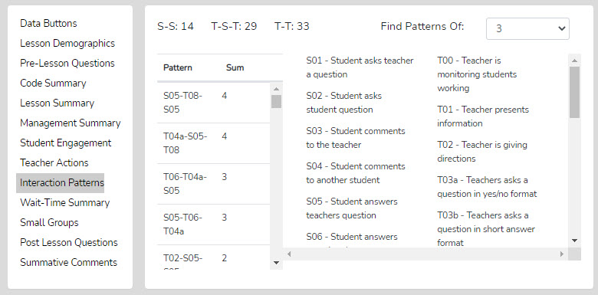
With the Interaction Patterns Data, the user can consider the following:

- Looking at Interaction Patterns, examine the 3-code pattern tendency, then the 4-code pattern tendency: How are the most common patterns consistent with the goals for the lesson? What are some changes to how the teacher interacts with students that would be more consistent with the intentions of the lesson?
  - How did the teacher initiate questions and respond to students’ thinking? How did the teacher’s tendencies encourage or discourage student responses and engagement?
  - When students respond, what does the teacher tend to do? Do they tend to judge responses, acknowledge them, and then clarify for the student, or instead, ask the student to clarify? Different tendencies are more effective depending on the instructional goals and the level of thinking or engagement the teacher desires from students.

Feedback Session with Joe
Joe, your predominant interaction pattern shows that you most often ask a recall-type question and confirm the student's response. Your second- and third-most-used teacher-student interaction patterns show that, alongside recall-type questions and confirmation, you frequently repeat a student’s response.
- What is your reaction to seeing this pattern of teacher-student interactions compared to your goals for instruction and what you had intended for a predominant teacher-student interaction?

Next Observation, Teaching Target, and Data
Joe, you said earlier that you wanted your students to think more deeply about the topic and understand the reasoning behind their responses, which are often one- to two-word answers.
- So, what would the data show in the next lesson as the predominant pattern needed to get students to think at a deeper level and provide more explanation of their answers?

□ □ □ □ □ □ □ □ □ □ □ □ □ □ □ □ □ □ □ □ □ □ □ □ □ □ □ □ □ □ □ □ □ □ □ □ □ □ □ □

Teacher Actions Plus – Teacher Actions Plus is a timeline from the beginning to the end of the lesson that displays the lesson type (colors) in play and shows symbols indicating when the teacher exhibited various T-code actions, so the user can follow the sequence of teacher actions throughout the lesson. This graphic is like a set of footprints in the sand that tells a robust story of the teacher's actions, student engagement, and student misbehaviors, as well as the teacher's reaction to students during the lesson - essential indicators become apparent at a glance.

This timeline also displays M and S code data; in fact, almost all collected data are represented, creating a robust dataset that captures teacher and student actions. The user can easily see when management issues occur in the context of the teacher's and students' actions during the lesson. Since this is a visual display of teacher actions, student actions, and misbehaviors, as well as the teacher’s reactions to these behaviors, it provides the user with a clear representation of the flow of actions from the beginning to the end of the lesson. It visually highlights sequences and the presence or absence of teacher or student actions. For example, if the teacher is curious about their use of questioning, it is easy to see when any of the four questioning codes were used and what occurred before or after. The user may find a complete absence of higher-level questions. The user may readily see what they do following a student's response. The user can target the display of any T, S, or M codes by toggling them on or off.

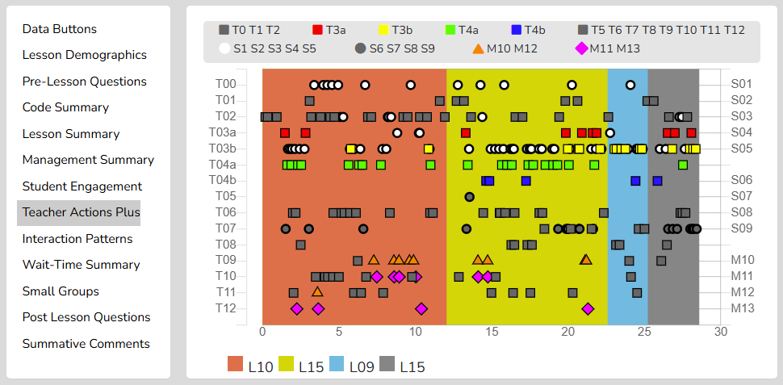

As shown below, the viewer can zoom in or out to separate data points.
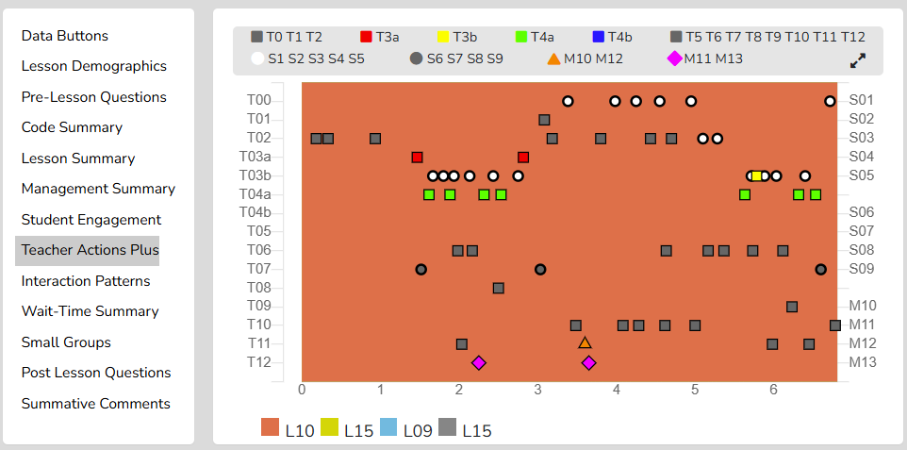

Finally, as with other data points in SMT, the user can click on any data point (symbol), and the linked video will play.

With the Teacher Actions Plus data, the user can consider the following:

- Looking at the Teacher Actions Plus screen:
  - What question types were used in the lesson? What followed the teacher’s questions regarding S codes – was it one student response, or was it more than one? After the student(s) responded, what did the teacher tend to do next?
  - How did the teacher use the whole group response engagement S codes (S6-S9) to engage all students in generating answers and providing maximum feedback to the teacher? If S6-S9 were not used, what evidence is there that the teacher attempted to increase students’ oral contributions to the lesson?
  - Knowing that T codes (teacher responses) T6, T11, T12, and sometimes T8 tend to help get and keep students thinking more so than T5, T7, T9, and T10, what does the visual tell you about the teacher's use of the various response codes?
  - What stands out about the student misbehavior actions in M10 and M12, and then how would you characterize the teacher’s reaction to student misbehaviors in M11 and M13?
  - How was the distribution of S codes and student contributions to the lesson?
  - What was the mix of S codes? How many S1-S4 codes were present during the observation?

Feedback Session with Joe
Joe, the data in Teacher Actions Plus shows that you asked many speculation-type questions during most of the lesson. About 15 minutes into the lesson, you began asking questions requiring students to explain their answers.
- Tell me about your lesson plan and how it matches the data showing the question and response types used in the lesson.

Let’s turn our attention to the student engagement data.
- What do you conclude about the types and amount of student engagement for this lesson, and how did this data match up with the goals you had for students?

Joe, this lesson has some behavioral issues, mostly from minutes 7 to 15.
- What do you think might have triggered these behavior events, and when looking at a couple of the video segments, how would you characterize your reaction to these events?

Next Observation, Teaching Target, and Data
Joe, as you look ahead to the next lesson, what changes in your teaching are you targeting next, and how should that be reflected in the next set of data for the upcoming observation?

□ □ □ □ □ □ □ □ □ □ □ □ □ □ □ □ □ □ □ □ □ □ □ □ □ □ □ □ □ □ □ □ □ □ □ □ □ □ □ □

Small Groups Summary—If the seating chart has been set up with individuals and noted for a small group number, the user can collect data on interactions among small-group members and on individual misbehavior.
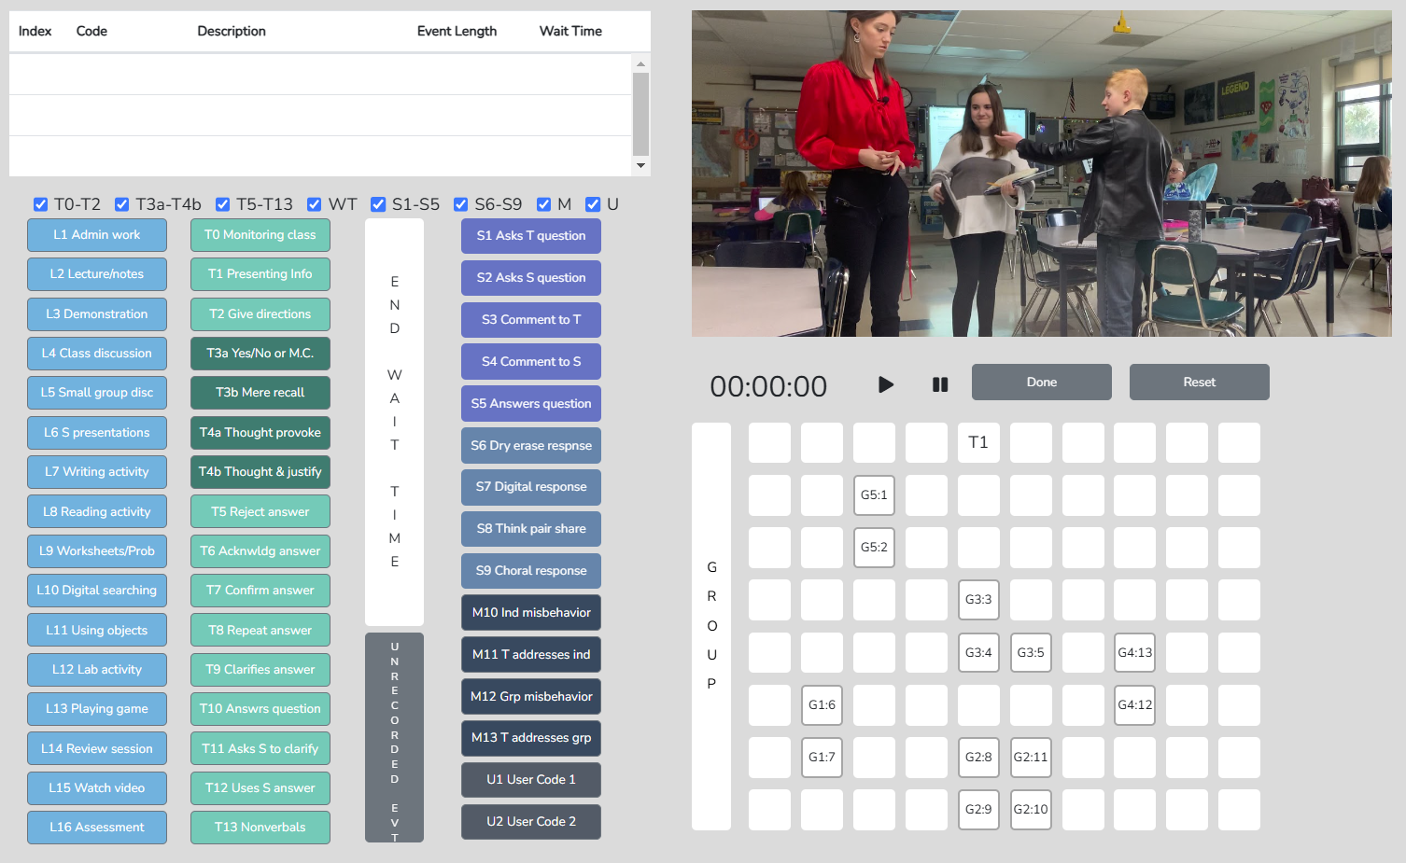

The Small Group Summary data, collected in conjunction with the student seating number, allow for the examination of group dynamics and the number and levels of S code-type interactions that reveal the impact of a lesson on student-to-student interactions. The table shows S codes and M10 event responses coming from specific groups. This data would indicate whether the teacher and observer wondered how the lesson stimulated student actions (S codes) within the small group. The Seating Chart Heat Map would show the level of interaction within that group, with color-coding indicating each member's contributions.

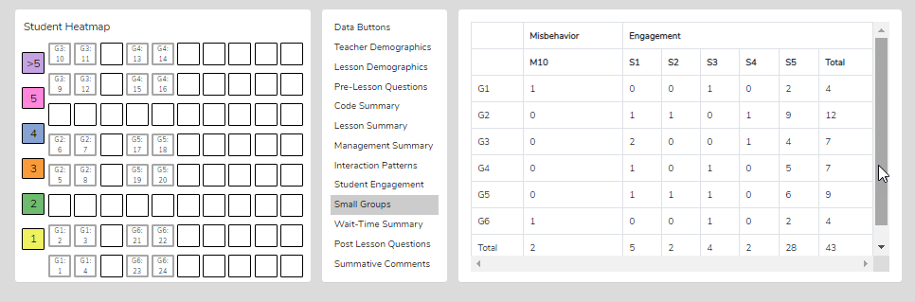
With the Small Group data, the user can consider the following:

- How was the engagement distributed among the group members? If there weren’t equitable contributions from all group members, how might the lesson be altered to achieve such?
- When the teacher approached the small groups and interacted with them, what was their intention? What did they want to accomplish by doing so versus observing the groups in action?
- What was noticed about the teacher’s interactions with the small groups?
- How did the teacher’s interactions foster the goals for the small group and the lesson? In what ways, if any, did the teacher’s interactions lessen the intention of the lesson or weaken the intended purpose of having students work in small groups?
- Small groups are a great place to ask good questions and to foster student-to-student interactions – what did the observer notice regarding this? How might the teacher improve?
- How was the teacher’s ability to pace themselves and get around to all small groups without taking too much time with one of the small groups?
- We know the power of using cooperative learning strategies with small group structures (versus simply students in a group expected to work together). What might the teacher have done differently regarding small group strategies, and what impact might it have had on student engagement, thinking, and learning?

□ □ □ □ □ □ □ □ □ □ □ □ □ □ □ □ □ □ □ □ □ □ □ □ □ □ □ □ □ □ □ □ □ □ □ □ □ □ □ □

Running Record - The Running Record lists all events in sequence from the start of the lesson to its completion. Users can scroll through the events and click any event to view the related video. While SeeMeTeach has built-in data analysis for instant viewing, users can also export the data to a .csv file for use with powerful statistical packages.
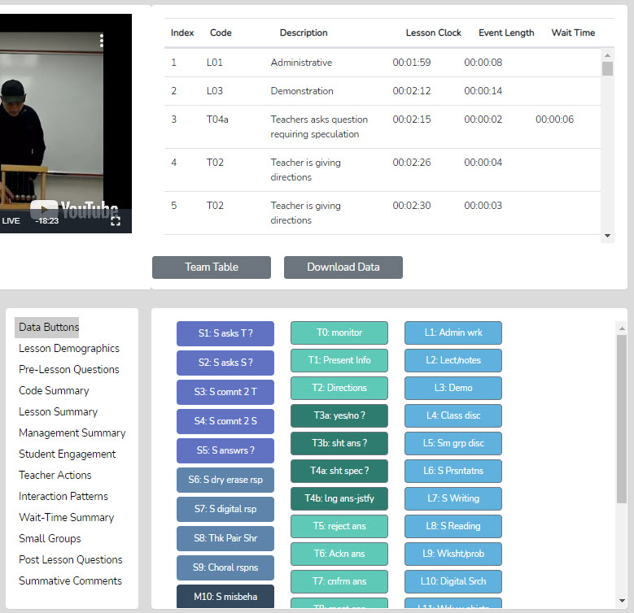

Data Buttons - The Data Buttons feature serves as a Search and Find function, allowing users to quickly locate linked video examples for specific T, S, M, or U events. Clicking on a button finds the first of that particular code/event in the Running Record window, and the linked video begins to play. At the bottom of the Running Record window, there is a note indicating how many events of that type were located. This feature is invaluable for identifying the teacher's habits and tendencies. For example, the observer may notice that the teacher has a habit of asking yes/no questions and then clarifying the answer for the student. In this case, we know that having the teacher adjust their interaction and reaction would be beneficial for gaining a deeper understanding of the student’s thinking. For example, the teacher could have asked the student to clarify their answer. As such, the observer might use that data or video, in whole or in part, to make a point about how a teacher’s choice affects student engagement and the teacher's ability to uncover student thinking.

Lesson Demographics – This contains information about the lesson entered during New Observation lesson setup and can be edited (course name, period, lesson topic, subject, and grade level).

Pre-Lesson Questions – Questions posed to the teacher that will provide context and the lesson's intent.
Pre-Lesson Questions can be accessed from both the Settings and Analysis screens.

- What are the main learning goals/objectives for the lesson?
- Describe the major activities or parts of the lesson to be observed.
- How will you know if the learning goals/objectives have been met? For example, what evidence will you have to support your claim?
- Provide the context for the lesson. How is this lesson connected to the prior lesson? How is this lesson connected to the subsequent lessons? Where is this lesson placed in the current instructional unit?
- Describe the ability levels of the students in this class.
- What will you do to maximize the engagement of all ability levels of students?
- How will you differentiate the lesson for all types of learners?

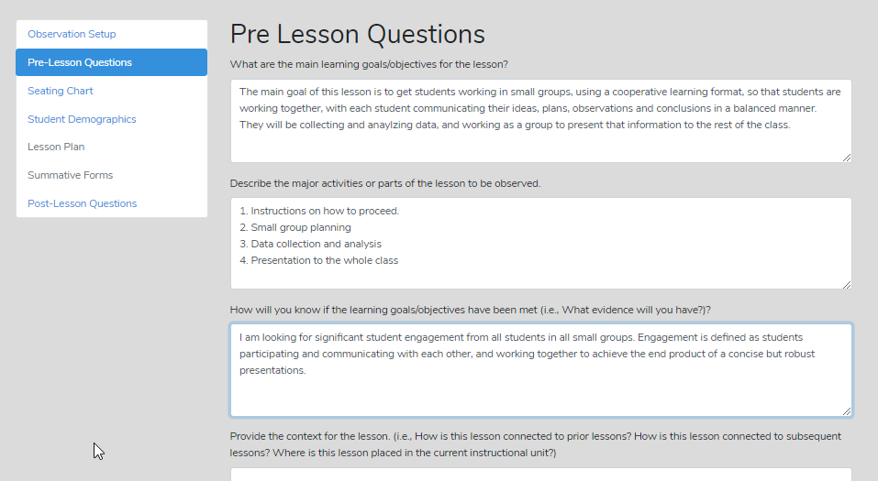

Post-Lesson Questions – Questions for the teacher to respond to following the lesson and observation.

Post-lesson questions can be accessed from both the Settings and Analysis screens.
- Tell me about today’s lesson. Probe: What went well? What needed to be improved? If you taught this lesson over again, what would you change? Why?
- What do you think students learned from today’s lesson?
- What evidence do you have of this learning?
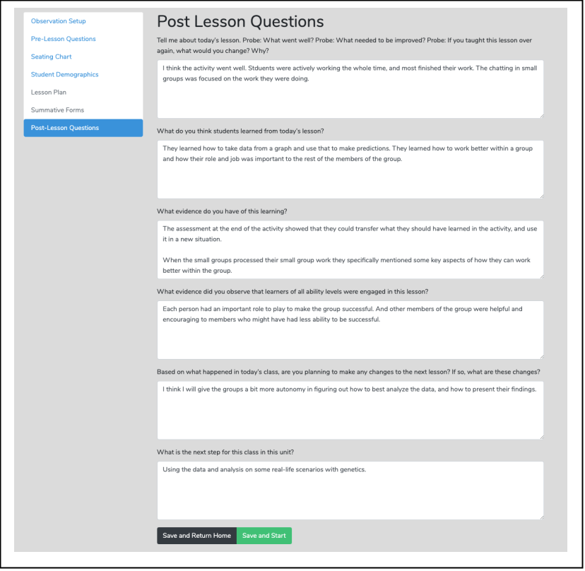
- What evidence did you observe that learners of all ability levels were engaged in this lesson?
- Based on what happened in today’s class, are you planning on making any changes to the next lesson? If so, what are those changes?
- What is the next step for this class in this unit?

Team Unification and Synergy Using Data and Feedback—If another team member has completed the quantitative (or qualitative) coding of the video, then before leaving the data analysis screen (or from the Dashboard), the user can open the Team Table, click, toggle on, and view the data gathered and the analysis by that team member. The user can jump to any team member’s completed quantitative or qualitative observation by clicking on the green checkmark in the expanded Dashboard.
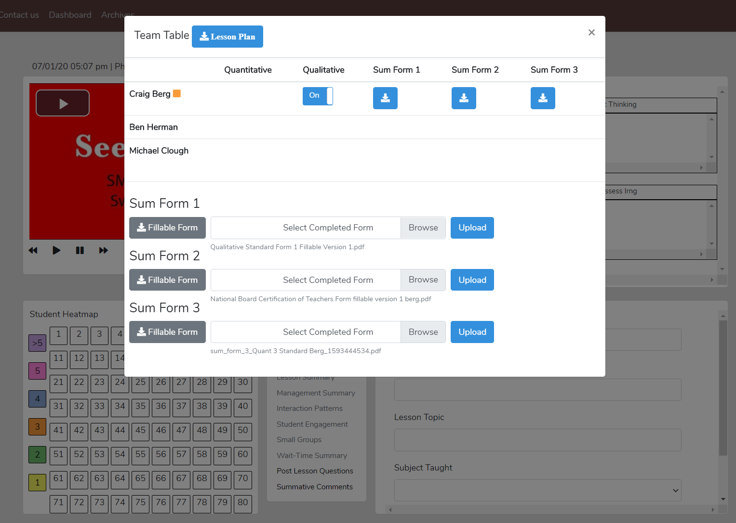

The Summative Forms
A common component of teacher observation is incorporating post-observation summative forms to score performance or provide feedback. These forms are usually completed by the observer, and sometimes by the cooperating teacher or the teacher. The forms vary by institution and may include Likert-scale items, rubrics, ratings, or written comments and recommendations. The SMT observation software is designed so the observer can choose or create the specific post-observation forms used by them or their institution. The forms used within SMT are fillable PDFs. Once the scores are completed, the form is stored and digitally linked to the observation so the teacher or other team members can view it. SMT is designed so that any or all members can contribute their feedback to the observation. As shown above, the Team Table is also where users can upload and store their post-observation fillable PDF forms, such as the forms shown below, which they use for teacher observations at their institution.

- Single Users: Select or upload the forms they wish to use.
- Group Accounts: The Group Administrator uploads the forms that they want available to the group. Team members can complete, upload, and view completed forms.

SMT includes sample Summative Forms, or users may upload forms specific to their district, program, subject area, or grade level. While a group account allows you to add many forms, a maximum of three forms may be used for any observation. Some examples include:

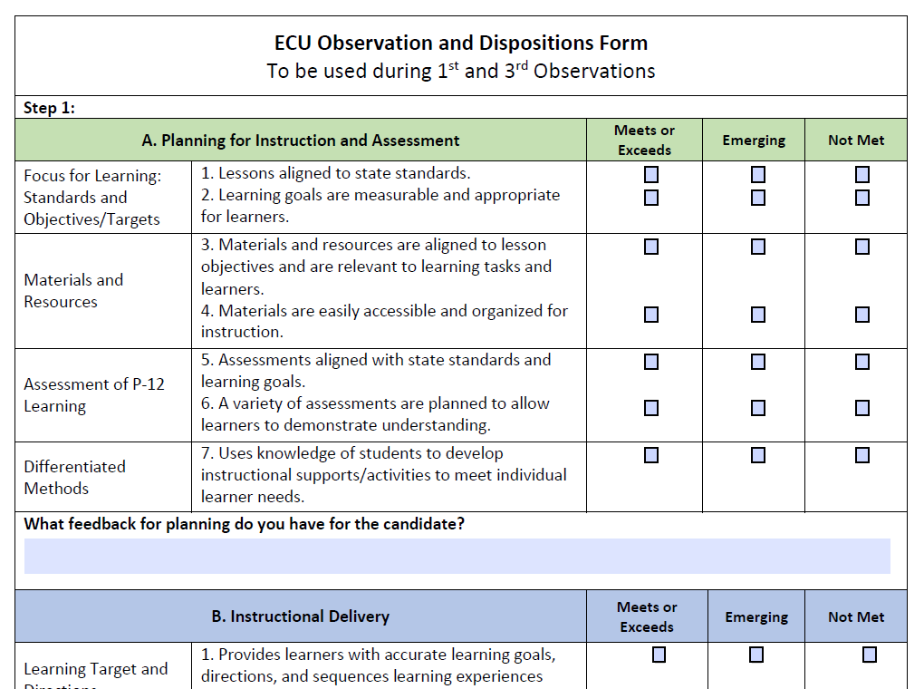

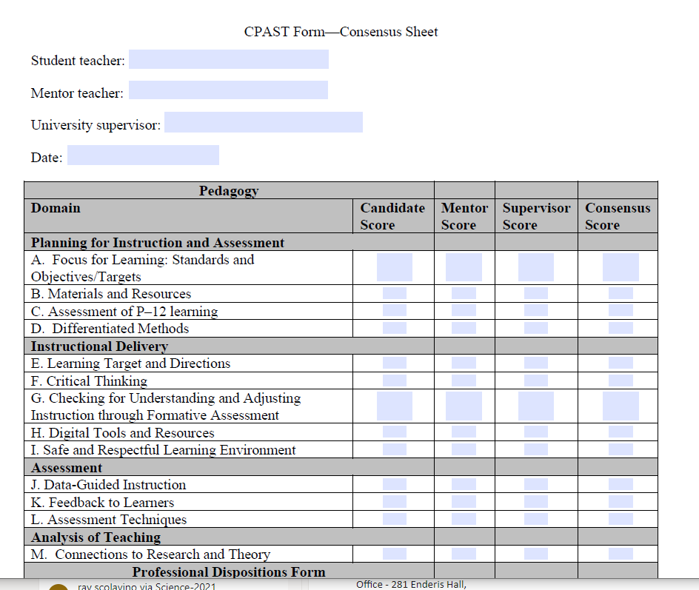

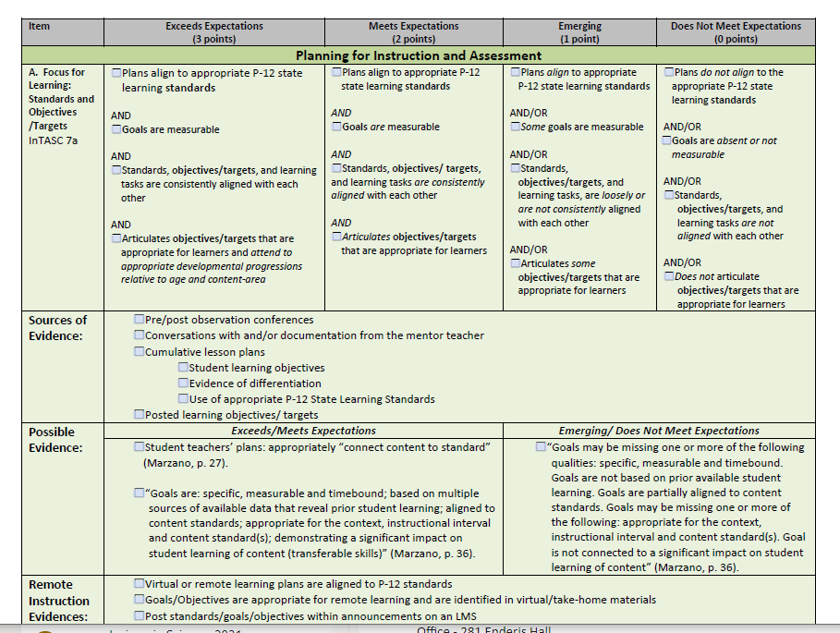

The Mechanics of Using Post-Observation Scoring and Feedback Forms

1. Adding Your Own Summative Forms

From the SMT Dashboard:
- Click your login name in the upper-right corner.
- Select Custom Summative Forms from the dropdown menu (Figure A).
- Enter a form name (e.g., Science Rubric).
- Designate it as Form 1, Form 2, or Form 3.
- Browse your computer and select the fillable PDF.
- Click Submit.
Figure A
- Repeat for additional forms as needed.

You may upload multiple forms for different subjects, grade levels, or purposes, but you may select only three for a specific observation. Single Users select their own forms; for Group Accounts, the Group Administrator determines which forms are available. You can select uploaded forms through Lesson Settings when setting up an observation (Figure B) or through the Team Table after an observation (Figure C).
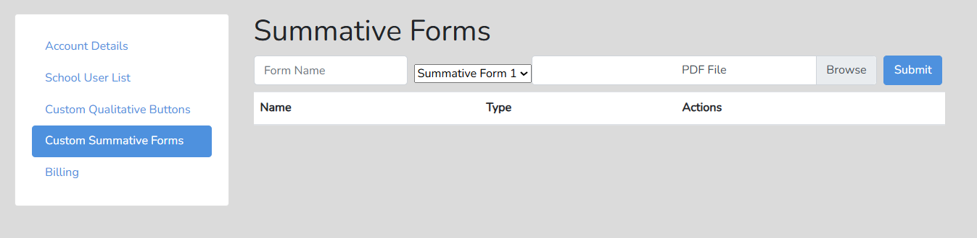

2. Selecting Forms for an Observation
Figure B

From Lesson Settings
When setting up a new observation:
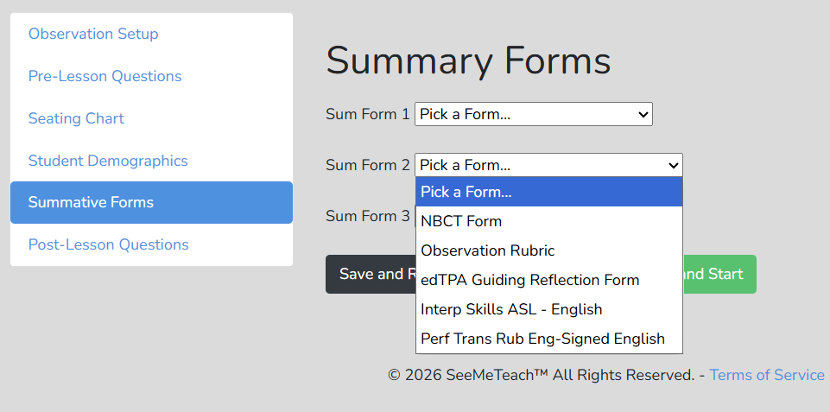
- Click the gear icon on the Dashboard observation line to open Lesson Settings.
- Click Summative Forms (Figure B).
- Select Pick a Form and choose the appropriate form.
- Repeat as needed, up to a maximum of three forms.
- The selected forms are now available for post-observation feedback or scoring.

From the Team Table
Figure C.
Forms can also be selected after completing a Qualitative or Quantitative observation:
- From the Dashboard, click the plus symbol to expand the observation.
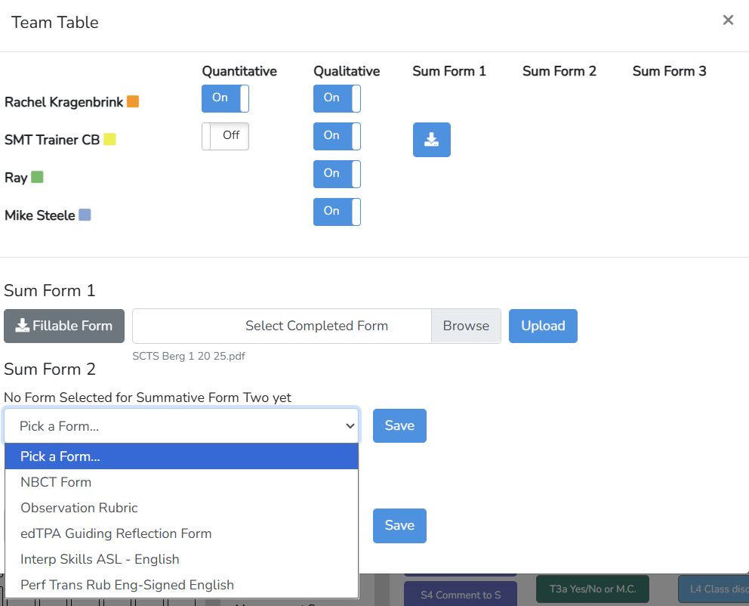
- Click a green Qualitative or Quantitative icon to open the Post-Observation screen.
- Click Team Table to view the summary of team activity and access Summative Forms (Figure C).
- If a form was previously selected, a grey Fillable Form box will appear.
- If no form was selected, click Pick a Form (Figure C), select a form from the dropdown list, and click Save. The grey Fillable Form box will then appear for team use (Figure 4).

3. Completing and Sharing Summative Forms
Figure D
Complete and Save the Form
- Click the grey Fillable Form box to open the PDF.
- Complete the form and save it to your computer.
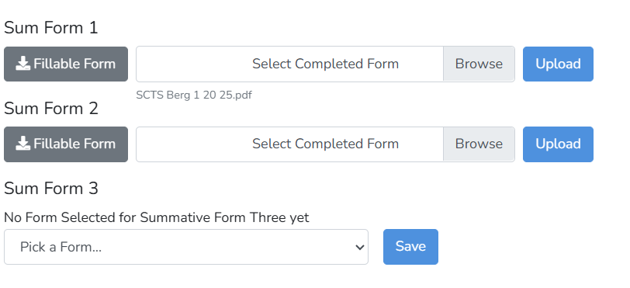
- Use a descriptive file name that identifies the form, person observed, and observation date (e.g., SCTS Berg 1 20 25).
- Keep a digital or paper copy if required by your institution.

Upload the Completed Form
- Click Browse and select the completed PDF from your computer.
- Click Upload.
- The uploaded file name will appear, confirming that the form is available for viewing.
- A blue icon will appear in the appropriate Summative Form column next to the team member who uploaded it (Figures C and D).
- Clicking the blue icon opens the completed form. The teacher being observed and other observation team members can then view the feedback or scoring.

14. Post-Quantitative Data Organization

Post-Quantitative Data Organization
In Chapter 13, the reader was shown the various post-observation analyses and summaries available to the observer and teacher. However, given the plethora of data and numerous summaries, there is a learning curve to effectively use data and observation screens when providing feedback, coaching, and reflection.

SMT novice users and observers who are beginning to gather, analyze, and incorporate data into comments, reflections, and coaching need to learn where the data resides and how to organize and interpret it. The following post-quantitative observation data sheet was created to help users extract the data from the various summaries within the SMT tool. It enables novices to learn where to find the data pertinent to the teaching component they are examining. In addition to finding and recording specific data, they were asked to reflect on their teaching in relation to the data they captured. After using it once or twice, they knew where to find the data they needed for their self-reports and reflections. Having them complete this form enabled them to begin constructing and then refining what resulted in impressive self-reports of their teaching episodes, examples of which you will find immediately after this form.

SeeMeTeach ® Summative Form 3 – Quantitative Analysis Reflection

This form guides the observer and teacher to closely examine and consider data obtained through the quantitative mode, focusing on specific indicators to draw conclusions about actions and discourse that result in high levels of student engagement and robust views and ideas about the content, rather than more teacher-centered actions and discourse. The data you are asked to examine are indicators of how well instruction matches the goals of instruction, and whether the actions of the teacher and students support the intentions of the lesson.

1. General Notions of Teacher-Centered versus Student-Centered Lesson – How much time was noted for teacher actions and discourse versus student actions and discourse?
Code Summary Data
The Overall T Code Duration Time
The Overall S Code Duration Time
The ratio of teacher-student time T/S =
How does this ratio compare with your intentions? For example, an 80/20 lesson looks very different and is more teacher-directed than a 20/80 lesson, in which students contribute to the class at a high level.

How does ratio fit with a) the goals of the lesson, and b) maximizing student thinking and engagement?

What might you have done differently to elevate S code time?

2. More specific indicators of how teachers interact with students, and a teacher’s fingerprint of this interaction consists of:
Code Summary Data
Question Types – Count and Percentages |  |  |  |  | Count %
T3a – yes/no question
T3b – short answer question
T4a – question requiring speculation
T4b – question speculation & justify
How does your use of question types fit with a) the goals of the lesson, and b) maximizing student thinking and engagement?

Response Types – Count and Percentages |  |  |  |  | Count %
T5 – reject answer
T6 – acknowledge answer
T7 – confirm answer
T8 – repeat answer
T9 – Tchr clarifies answer
T10 – Tchr answers question
T11 – Tchr asks student to clarify
T12 – Tchr uses student answer
How does your use of response types fit with a) the goals of the lesson, and b) maximizing student thinking and engagement?

How does your use of response types fit with you developing a good understanding of students’ thinking?

Interaction Patterns Data Using T and S Codes
The most commonly used pattern was
And this is an indicator of?

The second most commonly used pattern was:

And this is an indicator of?

How do your predominant teacher-student interaction patterns fit with a) the goals of the lesson, and b) maximizing student thinking and engagement?

T-T counts were |  | T-S-T counts were |  | S-S counts were
These counts suggest something about the interactions that occurred within this lesson. What is your reaction to this data regarding how the teacher is facilitating interaction in the lesson?

Wait-Time Summary Data |  |  |  |  | Avg Time Range
Average for WT 1 was?
Average for WT 2 was?
Regarding WT – what is your reaction to WT averages and range?

When looking at the WT data per question type – what did you notice about WI and with lower-level questions (T3a, T3b) versus higher-level questions (T3c, T4)?

3. Indicators of students' level of engagement in the lesson, during whole-group or small-group formats, can be found in:
Student Engagement Indicators Data and Heat Map
How many of the students responded to at least one question?

How many of the students responded to each other at least once?

What is the average number of responses per student? [Total of S1-S5 plus (the total of S6-S9 x the number of students in class) / number of students in class]

Using the toggles on the Heat Map - What is the breakdown by particular student demographics such as gender, minority, ELL, Sped – was there equity regarding student engagement? Note – in progress.

Group Engagement and Equity Among Group Members Data
What did you notice about your interactions with the small groups?

Small groups are a great place to ask good questions and to foster student-to-student interactions – what did you notice regarding this? How might you improve?

How was your ability to pace yourself and get around to all small groups without taking too much time with one particular small group?

We know the power of using cooperative learning strategies with small-group structures (versus simply having students in a group expected to work together). What might you have done differently regarding small group strategies, and what impact do you think it might have on student engagement, thinking, and learning?

4. Indicators of student behavior during whole group or small group formats can be found in:
Classroom Management Summary Data and Heat Map
How many classroom management events did the observer note? (M10+M12)

How many of those classroom management events were not addressed by the teacher?
(M11+M13 – M10-M12)

How much time did the teacher spend intervening in management events? (M11 and M13)

a. Where in the classroom are the problems occurring?

b. Are they proximal or distant to where the teacher is located?

b. How was the teacher’s movement around the classroom?

Where in the lesson, or during which lesson type, did the management issues occur?

How many management issues occurred at the start or end of class, or during transitions from one lesson segment to another?

When transitioning from one lesson segment to another, how much time was needed to get all the students settled and begin the lesson?

How did the students behave or misbehave today overall, compared to other days?

With regard to specific students who might have a tendency to misbehave, how was their behavior today?

Was there anything about this lesson that might have contributed to more or fewer management issues?

5. The Synergy Between Teacher Actions and Student Engagement can be found in:
Teacher Actions Plus
When viewing the S1, S3, and probably many of the S5 codes, what do you notice about the students' interaction with the teacher?

When viewing the S2, S4, and possibly some of the S5 codes, what do you notice about students' interaction with each other?

When viewing the S codes, what do you notice about student engagement during the lesson and consistency of engagement throughout the lesson?

When viewing the T codes and the four question types, what can you conclude about the use of higher vs. lower-level questions during the lesson? How does this mesh with the goals of the lesson? How does this facilitate student thinking and student engagement? What would you change?

When viewing the T5 – T12 codes, what can you conclude about how the teacher tends to react to student responses? How does this mesh with the goals of the lesson? How does this facilitate student thinking and student engagement? What would you change?

What else did you notice from the data on Teacher Action Plus, and what other changes might you make to better facilitate the goals of the lesson?

6. Indicators of time used for various lesson segments can be found in:
Lesson (and Time Utilization) Summary Data
Time spent on each part of the lesson was:

If you used more or less time on lesson segments than you intended, why and how did that affect the outcomes of the lesson?

Total class time was:

- How much time did it take to begin teaching?
- Take the amount of time from when the bell rang to when you began actually teaching (not taking attendance or other administrative duties) and multiply by the number of teaching days in the year – this equals the amount of lost teaching minutes at the beginning of class.

What might you do differently in order to begin teaching at the very start of the class period?

- The transitions in-between each part of the lesson added up to how much time?

What might you do to reduce the time needed for transitioning from one part of the lesson to another?

- How much time at the end of the lesson was not used for instruction?

If your lesson ended early, what are some productive things you could have done to soak up the remaining class time?

What was the amount of total lost teaching time – add A+B+C (non-teaching time).
How much time was used for instruction?
Take total class time G and subtract the time calculated in F. This is your lost teaching time. Is it reasonable? If this was the average lost teaching time per class period, calculate how much lost time accrues over the year, and it might concern or surprise you.

Quantitative Data Embedded in Qualitative Comment Example
Earlier, the reader was provided with an example of a qualitative comment observation. From the quantitative mode description, readers know what data can be gleaned from an observation and how such data adds value to the feedback and coaching process. Let’s examine an observation in which the user first completed the quantitative observation mode, then transitioned to the qualitative mode, incorporating comments and recommendations while also directly integrating essential and related data gathered from the quantitative mode into their comments. The benefit of this approach is that comments and recommendations now have high-resolution data as indicators. Let’s look at the following example.

Biology Class – Teacher TM
* Note that general comments are sometimes backed up by using data that is typed within the brackets and bold text for the reader to discern from general comments.
00:00:37 Questions-Response
Class begins with a review of the previous day's content using questions and answers.
00:01:32 Questions-Response
More review using questions, with students answering to see what they recall from yesterday. I like listening to how students answer because it lets me know whether they comprehended (or didn't) the content. [The Teacher Actions Summary data shows I used a lot of recall-type questions from 0-7 minutes, which individual students responded to, but it showed no other type of student engagement. I used 13 recall questions in the first 6 minutes, and the pattern showed that I got only an individual response for each one.]
00:02:58 Instructional Strategy
Quickly reviewing before beginning new content helps students reaffirm what they learned and prepares them for new content that is related to or an extension of what they learned. [From Code Summary and Teacher Actions Plus, I see I was using all recall-type questions, along with acknowledgment, rejection, or repeating a student answer, which tells me that during the first part of the review session, it stayed fixed around some low-level thinking and regurgitation of facts and word meanings. It seems I was using a teacher-centered approach in the first part of class but shifted toward more student-centered thinking later. I need to use more student-centered approaches to the review much earlier in class.]
00:03:41 Instructional Strategy
Encouraging students to use their notes to answer questions reminds them of previous content.
00:04:55 Instructional Strategy
Because students often don't speak loudly, I repeat their answers so everyone can hear them. [That was the origin of most of the many type 8 repeating responses I see in Code Summary]
00:05:13 Instructional Strategy
When a student's answer is close but missing a piece or two, I will respond with a follow-up question that leads them to correct what they previously said.
00:05:54 Instructional Strategy
Stating a student’s name before asking a question helps prepare the student to listen carefully, as they are expected to engage and answer. [But looking at the data, it appears that this also indicates to students that they don’t have to think about an answer to the question]
00:07:01 Teacher Decisions
Occasionally, I stop my lesson dead in my tracks to tell my students a random (but always pertinent) story that relates back to our topic. They love my silly stories and allow for a quick "brain break" from all the questions and review.
00:07:56 Instructional Strategy
I am very animated and sometimes even act out what I am saying to remind students of what I want them to recall from the activity they completed.
00:08:30 Lesson Flow or Pace
Every day, after a quick review, students answer the daily warm-up question. We do this together to ensure every student gets the correct answer. [Looking at the Lesson Summary, it only takes up 5 minutes of class, so it was worth it.]
00:09:10 Assess Student Learning
The daily warm-up helps me see whether new content has stuck or if we need to go over the topic again.
00:09:52 Instructional Strategy
Using everyday examples, such as a family tree, helps make a topic, such as evidence for evolution, more relevant. [From Teacher Actions Plus, I see that around 10 minutes in, I began to see other types of student engagement, such as students asking questions.]
00:10:57 Questions-Response
I appreciate it when students aren't afraid to ask questions and give examples to clarify their understanding of the content. [From Teacher Actions Plus, the data shows this happening around minute 11. I tried a combination of acknowledgment and repeating their answers (in a somewhat questioning manner) to get them to expand on their answers. One thing I can do more of is use T11 responses and ask students to clarify their answer. The data shows I did that only once, but doing it more will foster more student talk. I also didn’t use any T12’s (using a student response and having other students react or compare their ideas). I could use T12’s or more think-pair-share to get students to communicate with each other more, which is a goal of mine for myself.]
00:12:39 Lesson Goals or Plans
Each lesson continues with the agenda slide after the daily warm-up. This allows students to see what they will be doing in class and what assignments they have for homework. The agenda slide is accessible through the unit slides in Google Classroom.
00:13:09 Equity or Special Needs
I always give clear verbal instructions while showing students what they need to do, so they can see and hear and no assumptions are made.
00:13:15 Use of Wait Time
Pausing is important to allow students time not only to think, but to write down necessary information; otherwise, they may miss something if I continue straight into my next thought. [I see that the Wait-Time Summary data shows about 2 seconds of WT for WT 1 and WT2. I am going to put a plan together to remind myself during teaching to use more wait time and try to increase it to about 4 seconds, so it triggers some of the positive effects.]
00:14:10 Instructional Strategy
Asking students to share what a word makes them think of helps them understand it better when they hear the actual definition, because our scientific words often consist of familiar words. [From Teacher Actions Plus at around 14 minutes, I began to use speculation-type questions, which, from that point forward, also stimulated student responses, but unfortunately still were single individual student responses per question.]
00:14:49 Instructional Strategy
Pointing to the diagram and showing students where to write information helps maintain the flow. In addition, telling them helpful words to add to their notes to aid recall is key.
00:15:15 Questions-Response
Students are asked to observe pictures and explain what they see to help them understand the new word before it is introduced. [My data shows some use of Think-Pair-Share, which could be used much more in this type of situation, which will cause all students to be engaged, communicating, and listening to their partner – doing so will raise student engagement considerably, and this data will show up as red lines in Student Engagement Summary. As noted earlier, I can do more of this]
00:17:34 Lesson Content
New content is delivered using questions, discussion, and analysis of diagrams, with students pointing out things they recognize in the diagrams, all before defining the new term. [When I deliver new content, I see from the Code Summary and Teacher Actions Plus data that I am asking speculation-type questions and getting some student responses. But getting one student's response only tells me a fraction of what students in the class are thinking. This is a prime opportunity to use a checking-for-understanding method in which I find out what each student is thinking (dry-erase boards or Chromebooks and this will be evident in the data if I utilize more group engagement strategies.]
00:19:25 Questions-Response
Asking students questions using the diagram
00:19:25 Questions-Response
Asking students questions referring them to the diagram helps them lead themselves up to the answers of the ultimate question, which is learning the new term.
00:21:35 Student Engagement
Think-pair-share allows students to discuss what they learned and come up with additional examples beyond the one stated in the discussion. [From the Teacher Actions Plus, it shows I used two instances of think-pair-share from minute 20-23, and that helps students express what they were thinking to other students.]
00:22:39 Student Engagement
Students share what they discussed during the think-pair-share.
00:23:14 Student Engagement
Students share what they discussed during the think-pair-share.
00:23:33 Student Engagement
Students are sharing what they discussed in the think-pair-share time.
00:24:25 Student Engagement
Student asking a question pertaining to the topic, extending it beyond our discussion.
00:24:44 Instructional Strategy
Taking the students' questions and going slightly off topic to encourage curiosity and engagement.
[Summary – I am already using a good number of open-ended questions, so for the next observation I am going to work on using more acknowledgment types of responses, but also much more wait-time 1 and 2 along with the questions and responses, which will be evident in the Wait-Time Summary. I am going to also use more T11’s (asking students to clarify their answers) and going to use more T12’s and think, pair, share to get students to talk with each other and compare ideas more, which will show up in the Code Summary, Teacher Actions Plus, and Interactions Pattern. This should result in me using less of the teacher-centered approach by getting more than one student to respond to a question, and preferably all students if I use more group-type response strategies, which the data for Teacher Actions will indicate.]

15. Post-Observation Reflection: Helping Teachers To Become Reflective Practitioners

The primary purpose of the SeeMeTeach teacher observation tool is to provide a data collection and analysis platform that enables teacher observations and feedback to incorporate high-resolution data as markers and indicators of teaching growth. Earlier, the reader was provided with examples of qualitative comments, both without and with data, thereby adding high-resolution indicators to support the observations and recommendations, as shown in the previous chapter. The Summative Form 3 document is a helpful guide for users to learn about the existing data, where to find it in the post-observation summaries, and how to begin reflecting on it as they consider ways to improve their teaching.

Chapter 15 provides more in-depth examples of feedback and reflection enabled by high-resolution data. First, a self-report from a future science teacher appears, followed by a self-report from a future mathematics teacher. When the reader reviews the self-reports generated by future teachers, note the extensive analysis and cogent recommendations based on high-resolution data, crafted by novices who are not yet certified to teach. When future or current teachers have developed high-resolution data collection and analysis skills and an understanding of the essential core, their dependence on another observer is significantly reduced, enabling them to complete high-level reflections on their teaching and further reducing their dependence on others.

Example of a Future Teacher’s Self-Observation Report - Science

Contents of this Report: This is a self-report and reflection stemming from a lesson taught by a future science teacher at the end of a semester of clinical experience in a middle school science classroom. The report aims to use data collected and analyzed by SMT to identify strengths and areas for improvement in the future teacher's teaching methods and behaviors. This report focuses on the types of questions posed, student engagement, teacher responses, misbehaviors, teacher-student event ratios, interaction patterns, and, lastly, a summary of the wait time present in the lesson.

Teacher: B. O. Class: Middle School General Science
Topic: Electromagnetism Grade: 6th – 8th combined
Time: 38 minutes
The focus of Data Collection: All L, T, M, and S codes using the seating chart and WT

Goals for the Lesson: Students will review and apply what they have learned about electromagnetism by analyzing the design of an electromagnet that moves steel bearings from one location to another. Students are encouraged to ask questions about the engineering design process and the resulting data to determine the factors that affect the strength of an electromagnetic field.

Data, Analyses, and Indicators: The following tables, timelines, seating charts, or pictures were taken directly from the lesson observation and quantitative analysis screens. The narrative is based on the evidence presented in those tables and graphics, which indicate teacher actions, teacher-student interactions, student actions, and student engagement during the lesson.

Running Record—This is the raw data collected during the teaching episode. Included below is a sample that shows only the first 33 of the 115 data points collected during the observation.
Index | Code | Description | Lesson Clock | Event Length | Wait Time
1 | L01 | Administrative | 00:00:11 | 00:00:17
2 | L04 | Whole class discussion | 00:00:42 | 00:00:31
3 | T03b | Teachers asks a question in short answer format | 00:00:46 | 00:00:12 | 00:00:07
4 | S05 | Student answers teachers question | 00:00:55 | 00:00:21 | 00:00:01
5 | S05 | Student answers teachers question | 00:01:00 | 00:00:03
6 | T11 | Teacher asks student to clarify their answer | 00:01:02 | 00:00:01
7 | S05 | Student answers teachers question | 00:01:04 | 00:00:09
8 | S05 | Student answers teachers question | 00:01:07 | 00:00:13 | 00:00:01
9 | T08 | Teacher repeats student answer | 00:01:12 | 00:00:03 | 00:00:02
10 | S03 | Student comments to the teacher | 00:01:19 | 00:00:03
11 | S05 | Student answers teachers question | 00:01:23 | 00:00:04 | 00:00:00
12 | S05 | Student answers teachers question | 00:01:30 | 00:00:05 | 00:00:02
13 | T03a | Teachers asks a question in yes/no format | 00:01:34 | 00:00:11 | 00:00:03
14 | S09 | Choral response to a teacher question | 00:01:38 | 00:00:00 | 00:00:01
15 | M10 | Student misbehavior | 00:01:45 | 00:00:08
16 | M10 | Student misbehavior | 00:01:57 | 00:00:21
17 | L03 | Demonstration | 00:02:02 | 00:00:26
18 | L02 | Lecture/notes | 00:02:09 | 00:00:06
19 | T01 | Teacher presents information | 00:02:44 | 00:00:34 | 00:00:04
20 | T03a | Teachers asks a question in yes/no format | 00:02:48 | 00:00:01 | 00:00:02
21 | S09 | Choral response to a teacher question | 00:02:52 | 00:00:00 | 00:00:02
22 | S03 | Student comments to the teacher | 00:03:17 | 00:00:22 | 00:00:01
23 | T01 | Teacher presents information | 00:03:37 | 00:00:19 | 00:00:09
24 | L15 | Video | 00:04:10 | 00:00:24
25 | M10 | Student misbehavior | 00:04:50 | 00:00:40
26 | T01 | Teacher presents information | 00:06:19 | 00:02:09 | 00:00:06
27 | S01 | Student asks teacher a question | 00:06:26 | 00:00:04
28 | T06 | Teacher acknowledges student answer | 00:06:29 | 00:00:02 | 00:00:01
29 | T04a | Teachers asks question requiring speculation | 00:06:34 | 00:00:03 | 00:00:30
30 | M10 | Student misbehavior | 00:06:52 | 00:00:19
31 | S08 | Student asked question, think, pair, share | 00:07:04 | 00:00:01 | 00:00:15
32 | S05 | Student answers teachers question | 00:07:23 | 00:00:24 | 00:00:01
33 | T07 | Teacher confirms student answer | 00:07:25 | 00:00:00 | 00:00:07
 |  | Continue – total of 115 data points

Code Summary
Code Summary Graph of Events
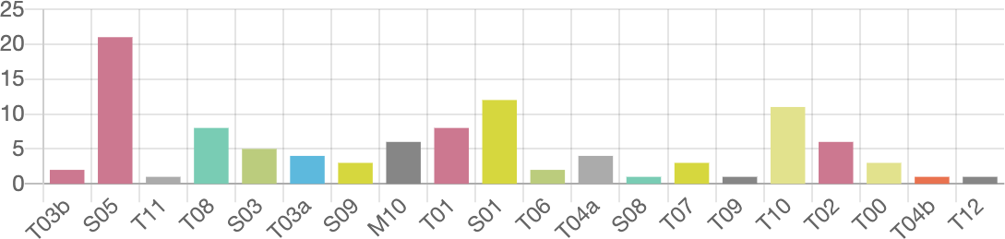

Code Summary Data Table
Code Description Event Event % Duration Duration %
T03b |  | Teacher asks a question in short answer format | 2 | 1.94% | 00:00:29 | 1.79%
 | S05 | Student answers teachers question | 21 | 20.39% | 00:03:29 | 12.90%
 | T11 | Teacher asks student to clarify their answer | 1 | 0.97% | 00:00:01 | 0.06%
 | T08 | Teacher repeats student answer | 8 | 7.77% | 00:00:07 | 0.43%
 | S03 | Student comments to the teacher | 5 | 4.85% | 00:01:00 | 3.70%
 | T03a | Teachers asks a question in yes/no format | 4 | 3.88% | 00:00:20 | 1.23%
 | S09 | Choral response to a teacher question | 3 | 2.91% | 00:00:00 | 0.00%
 | M10 | Student misbehavior | 6 | 5.83% | 00:03:10 | 11.73%
 | T01 | Teacher presents information | 8 | 7.77% | 00:07:33 | 27.96%
 | S01 | Student asks teacher a question | 12 | 11.65% | 00:00:54 | 3.33%
 | T06 | Teacher acknowledges student answer | 2 | 1.94% | 00:00:02 | 0.12%
 | T04a | Teachers asks question requiring speculation | 4 | 3.88% | 00:00:13 | 0.80%
 | S08 | Student asked question, think, pair, share | 1 | 0.97% | 00:00:01 | 0.06%
 | T07 | Teacher confirms student answer | 3 | 2.91% | 00:00:03 | 0.19%
 | T09 | Teacher clarifies student answer | 1 | 0.97% | 00:00:01 | 0.06%
 | T10 | Teacher answers question from student | 11 | 10.68% | 00:00:47 | 2.90%
 | T02 | Teacher is giving directions | 6 | 5.83% | 00:03:29 | 12.90%
 | T00 | Teacher is monitoring students working | 3 | 2.91% | 00:05:13 | 19.32%
 | T04b | Teacher asks question – speculation & justification | 1 | 0.97% | 00:00:06 | 0.37%
 | T12 | Teachers uses a student answer – posed to the group | 1 | 0.97% | 00:00:02 | 0.12%
 |  | Overall T Codes | 55 | 53.40% | 00:18:26 | 68.27%
 |  | Overall S Codes | 42 | 40.78% | 00:05:24 | 20.00%
 |  | Overall M Codes | 6 | 5.83% | 00:03:10 | 11.73%
 |  | Overall U Codes | 0 | 0.00% | 00:00:00 | 0.00%
 |  | Overall Codes | 103 | 100.00% | 00:27:00 | 100.00%

Data Highlighted on the Chart

Questions Posed – 4 yes/no questions, 2 short answer questions, 4 questions requiring speculation, 1 question requiring speculation and justification

Recommendation: For questions that require speculation, it would have been beneficial to follow up with a question that requires justification.

Student Engagement – 3 choral responses to teacher questions, 12 students asking the teacher questions, 21 students answering teacher questions, 5 students commenting to teacher

Recommendation: For the nature of this lesson, this is a good amount of student engagement. There was a lot of interaction, with students answering questions and asking good ones as we went through the design process.

Teacher Responses – The most common teacher response to students was the teacher answering a student question (T10). For student answers to teacher questions, the most common teacher response was repeating the answer (T08). The teacher confirmed student answers on 3 occasions (T07).

Recommendation: Rather than simply repeating or acknowledging students’ answers, the teacher could follow them with clarifying questions to inspire deeper thinking. For example, the teacher could say, “Tell me more about that,” or “Give me an example of what you mean.”

Misbehaviors – There were 6 instances of misbehavior. All of them pertained to students chatting with each other when they should have been listening to others speak. 3 of the 6 codes were for one student in particular, who tends to struggle to pay attention and to avoid chatting with friends when she is supposed to be listening to the teacher or her classmates.

Recommendation: The student with the most misbehavior incidents should probably be assigned a different seat, away from the friend who distracts her when talking.

Teacher-Student Events Ratio – The Overall T Codes vs. Overall S Codes (Percentage of Time) indicate that teacher actions occupied 68.27% of the lesson, while student actions occupied 20%.

Recommendation: To increase student actions, the teacher could ask more follow-up questions to help students think more deeply about their answers and share more of what they know.

Lesson Summary

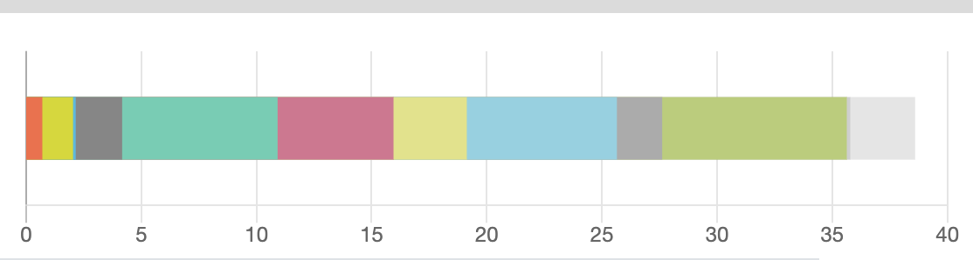

The different shades of color in the above graphic represent the different parts of the lesson. The majority of the class time was spent watching a demonstration, completing a lab activity, and having a class discussion.

Management Summary
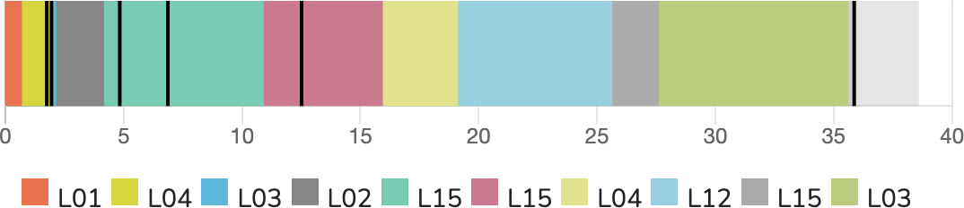

The black lines in the graphic above represent the times during the lesson when misbehavior occurred. All misbehaviors involved students talking to each other when they were supposed to be listening to the teacher or others speaking. Most of these occurred when students were supposed to be watching a video.

Recommendation: Unfortunately, this lab had to be more of a demonstration due to budget restrictions. Because the school could not provide enough circuit sets for students to do this as a hands-on lab, they had to watch a video of one of the science teachers demonstrating it. If the school could reassess its budget and include enough circuit sets for students to work in groups, there wouldn’t really have been a need to redirect talking students toward the TV screen; rather, they would have been actively engaging with each other and the activity.

Student Engagement Summary
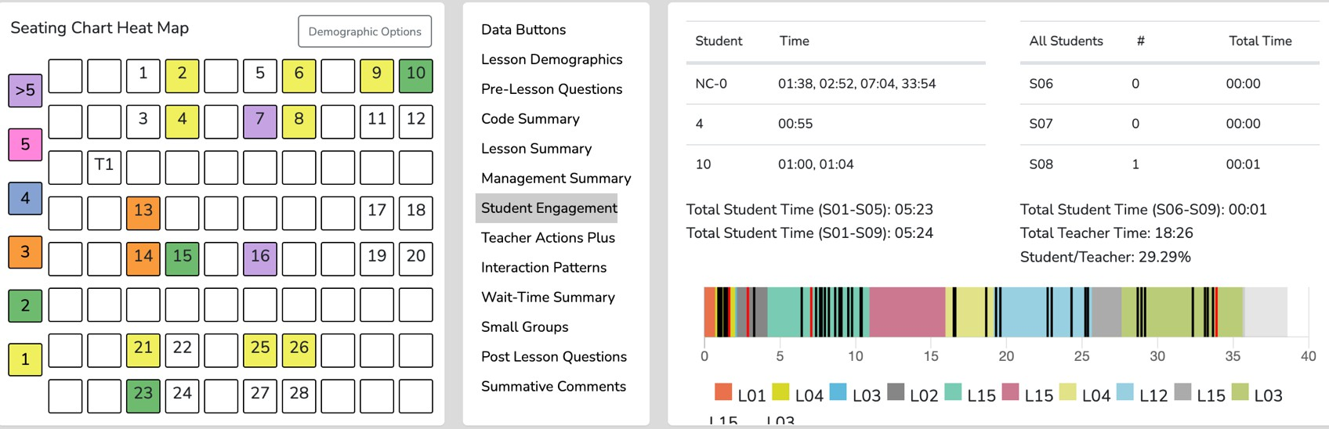

The seating chart heat map indicates that several individual students engaged in either asking a question, commenting to the teacher, or answering a question. A few of the student engagement codes were choral responses, in which several students answered aloud at the same time, which is not indicated on the seating chart heat map. Students 7 and 16 both had more than 5 coded engagements, whereas the other students who engaged did so only 1-3 times. 15/31 students engaged at least once, while 13/31 students didn’t engage at all.

Recommendation: The heat map above is very telling about which students respond quickly and engage, versus those who engage very little or not at all. The recommendation is to call on specific students who are not raising their hands or engaging. Knowing these students well, I am aware that several of them are very shy and do not want to be called on in front of the class. Because of this, an interactive way to share without speaking in front of the class would foster greater student engagement. Given that the students all have their own iPads, it could help to have them write and hold up their answers, or to use an online platform such as Nearpod or Jamboard to collect student answers anonymously.

Teacher Actions Plus
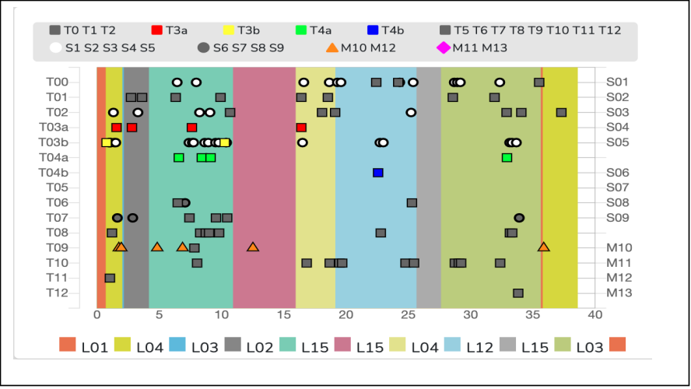

The map above shows the timing of all code occurrences during the lesson. The gray squares account for the teacher’s instruction, directions, and responses. The red, yellow, and green squares account for teacher questions. The gray and white circles account for student actions.

Recommendation: Although there are numerous teacher codes as shown in the map above, it is encouraging to see that they are spread out across the lesson, with student interactions intermingled throughout. The teacher never talks or answers questions for long without a student engaging. I would only recommend allowing students to express their thoughts more by asking follow-up, deeper-thinking-type questions.

Interaction Patterns – 3 Codes in Sequence
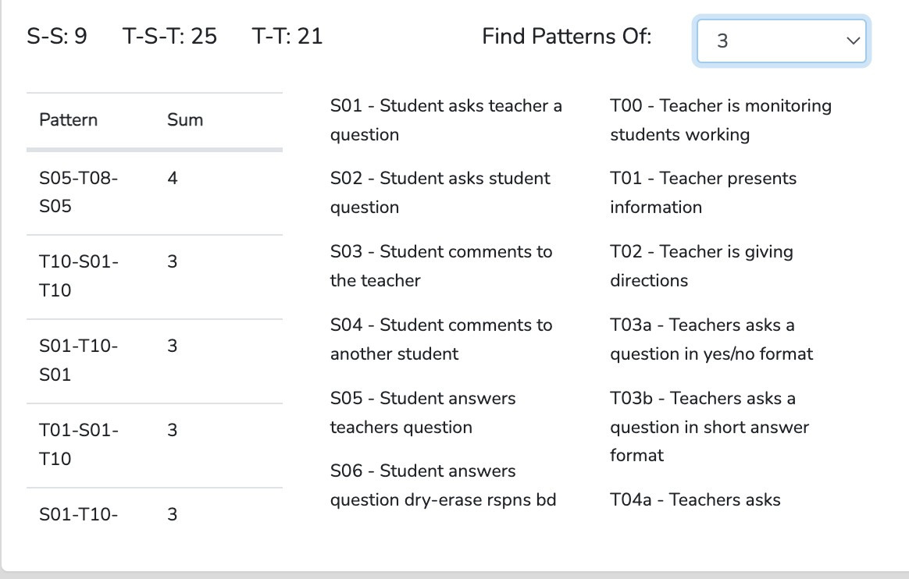

This graphic shows predominant patterns of three codes in sequence. The most dominant pattern involving students is T-S-T, indicating teacher-student-teacher interactions. The predominant pattern overall is T-T, likely because the teacher presents and then poses a question to the class. There are 9 S-S interactions, which are likely students answering questions back-to-back.

Recommendation: To increase the amount of S-T-S, ask the student more clarifying questions, or take a student’s response and ask another student to add to it.

Interaction Patterns – 4 Codes in Sequence
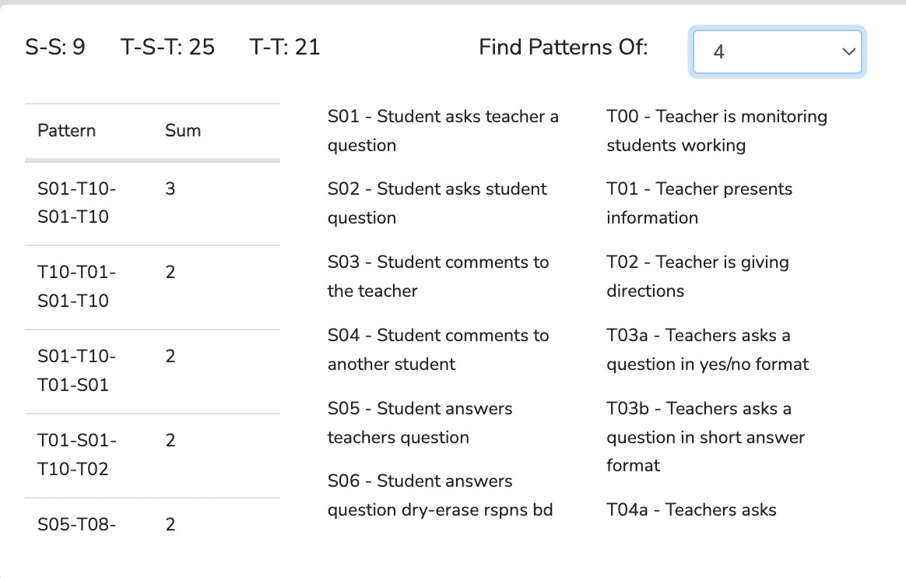

This graphic shows predominant patterns of four codes in sequence. The most common 4-code sequence is S-T-S-T, indicating a lot of back-and-forth between the teacher and the student. Students posed many questions; often, when a student asked a question, the teacher responded, and then the same or another student would ask another question.

Recommendation: It is encouraging to see that the students were comfortable asking questions and engaging more deeply with the content as a result. One recommendation would be to open up their question to the rest of the class, encouraging students to help each other answer it and to see whether others either know the answer or are wondering about the same things.

Wait-Time Summary
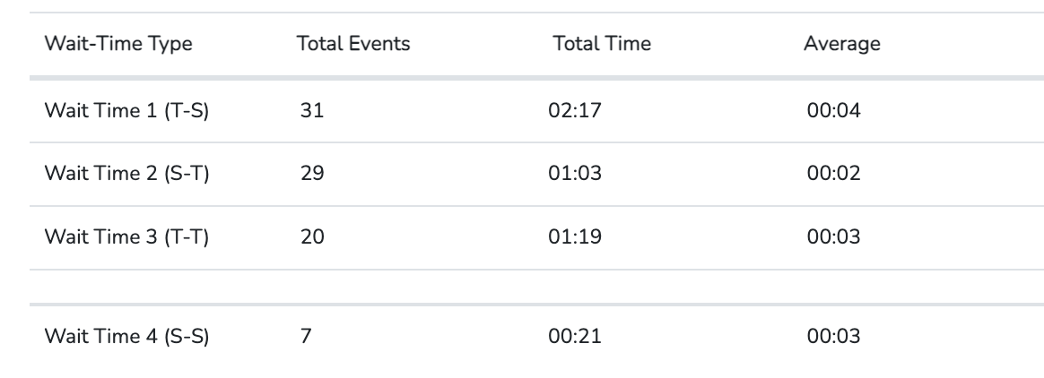

The chart above shows 31 events for Wait Time 1, 29 for Wait Time 2, 20 for Wait Time 3, and 7 for Wait Time 4.
The average Wait Time 1 was 4 seconds, indicating that an average of 4 seconds elapsed between the teacher asking a question and a student responding. The average Wait Time 2 was 2 seconds, indicating that an average of 2 seconds elapsed between a student saying something and the teacher responding.

Recommendations: How quickly students respond to teacher questions is outside the teacher's control unless the teacher asks them not to respond right away; however, how long the teacher waits to answer a question, acknowledge an answer, etc., is within the teacher’s control. The recommendation is to withhold responding so quickly and allow more time to see whether the student will add more before repeating their answer and moving on.

Example of a Future Teacher’s Self-Observation Report – Mathematics

Contents of This Report: This is a self-report and reflection stemming from a lesson taught by a future Mathematics teacher at the end of a semester of clinical experience in a middle school science classroom. The report aims to utilize the data collected and analyzed by SMT to identify strengths and areas for improvement in the teaching methods and behaviors of future teachers. This report focuses on the types of questions posed, student engagement, teacher responses, misbehaviors, teacher-student event ratios, interaction patterns, and, lastly, a summary of the wait time present in the lesson.

Future Teacher: Q. B. Class: 7th Grade Math Topic: Solving Inequalities with a single variable
Time: 27 minutes (Not the whole lesson)
The focus of Data Collection: All T, M, and S codes using the seating chart and WT

Goals for the Lesson: Solving Inequalities with a single variable - The goal of the lesson is for students to be able to decontextualize a real-world situation into terms and operations to construct an inequality. Additionally, students should understand the difference between inequalities and equations and solve for the unknown variable.

Data, Analyses, and Indicators: The following tables, timelines, seating charts, or pics were taken directly from the lesson observation and quantitative analysis screens. The narrative is based on the evidence presented in the tables and graphics, which indicate teacher actions, teacher-student interactions, student actions, and student engagement during the lesson.

Code Summary
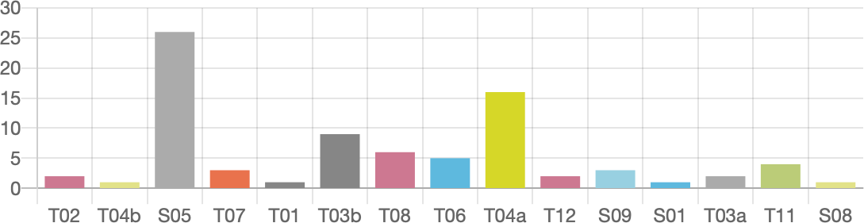

Code Description Events Event % Duration Duration %

T01 Teacher presents information 1 1.22% 00:00:10 00.85%
T03a Teachers asks a question in yes/no format 2 2.44% 00:00:22 1.20%
T03b Teachers asks a question in short answer format 9 10.98% 00:02:05 10.68%
S05 Student answers teachers question 26 31.71% 00:02:54 14.87%
T08 Teacher repeats student answer 6 7.32%. 00:00:25 2.14%
T07 Teacher confirms student answer 3 3.66% 00:00:14 1.20%
T11 Teacher asks student to clarify their answer 3 2.97%. 00:00:10 0.67%
S09 Choral response to a teacher question 3 3.66% 00:00:28 2.39%
S08 Student asked question, think, pair, share 1 1.22% 00:00:39 3.33%
T05 Teacher rejects student answer 0 0.00% 00:00:00 0.00%
T06 Teacher acknowledges student answer 5 6.10% 00:00:14 1.20%
T04a Teachers asks question requiring speculation 16 19.51% 00:09:58 51.11%
T04b Question requiring speculation + justification 1 1.22% 00:01:20 6.84%
S03 Student comments to the teacher 0 0.00% 00:00:00 0.00%
T02 Teacher is giving directions 2 2.44% 00:00:05 0.43%
T12 Teacher using student answer 2 2.44% 00:00:18 1.54%
M10 Student misbehavior 0 0.00%. 00:00:00 0.00%
M11 Teacher addresses misbehavior – student directed 0 0.00% 00:00:00 0.00%
S01 Student asks teacher a question 1 0.99% 00:01:33 6.23%
Overall T Codes 51 62.20% 00:15:19 78.655%
Overall S Codes 31 37.80%. 00:04:11 21.45%
Overall M Codes 0 0.00%. 00:00:00 0.00%
Overall U Codes 0 0.00%. 00:00:00 0.00%
Overall Codes 82 100.00%. 00:19:30 100.00%

Data Highlighted on the Chart
Questions Posed – 17 out of the 28 questions posed were higher-order thinking questions. Two questions were posed as yes/no questions.

Recommendation: The lesson lacked T4b questions. You can try to convert most of the T4a questions into T4b questions, since there were 16 of them. As for the recall and yes/no questions, you could try to change them into higher-order thinking questions. The yes/no questions would be easy to change, but the recall questions used in the lesson are a little more challenging. Most were posted after students were working independently, so changing them is less obvious. One way to change the questioning is to have a student explain a classmate's work rather than their own. This will enable students to think critically about how others approach problem-solving.

Student Engagement – Of the 31 student engagement events, students answered 26 questions, made no comments to the teacher, and asked the teacher 1 question. Notably, one think-pair-share event included students interacting with one another and asking questions about each other's thinking. However, no other student commented outside the think-pair-share.

Recommendation: Increase the number of think-pair-share sessions you use in your lessons. This will increase student-student communication and help your students become more accustomed to commenting on their peers' answers. After implementing this, take it a step further and encourage students to comment on each other's work unprompted.

Teacher Responses – The most common teacher responses following a student’s answer were repeating the student's response (T08) at 6 events and acknowledging the response (T06) at 5 events. After this, both clarifying and using a student's answer tied for the third-most-common teacher response at 3 events. Although these responses are not negative for this type of lesson, one would also expect to see the same number or more T11 codes. This is because the students are just learning these new mathematical concepts, so having them clarify their thinking would help clarify their current grasp of like and unlike terms.

Recommendation: T08 is often used to acknowledge a student's response or to mirror it back to them, anticipating that the student may need to explain or clarify their answer further. This might work for some students; however, the students in this classroom are well known for their lack of verbal participation. Therefore, the instructor might simply acknowledge the student's response (T06) and then follow it up by asking the student to clarify or expand on their answer (T11).

Misbehaviors – The teacher did not need to address any individual student misbehaviors, and no group misbehaviors were noted (M12). Therefore, the teacher spent no class time addressing student misbehaviors.

Recommendation: None

Teacher-Student Events Ratio – The Overall T Codes vs. Overall S Codes (Percentage of Time) indicate that teacher actions occupied 78.55% of the lesson time. In comparison, student actions occupied 21.45% of the lesson time. Classroom management occupied 0.00% of the time. The closer the T/S ratio is to 50%/50%, the more student-centered this lesson becomes. However, there were two points in the lesson where students worked independently and in pairs, which I believe would increase the percentage of students’ actions closer to 30%-35%.

Recommendation: Another strategy for fostering student-student interactions is for the instructor to ask the class to engage in a think-pair-share after hearing a student's response. This is an alternative way to implement think-pair-share in the classroom, distinct from the problem-centered form used multiple times already. For the new method, use a think-pair-share to elicit a reaction to the student's response, allowing all students to participate for a few seconds and expanding time for thinking and communicating, rather than relying on the instructor to respond to student answers. Additionally, changing the question types from T4a (16 events) to T4b (1 event) will give students significantly more time to act, as they will be justifying their responses.

Lesson Summary

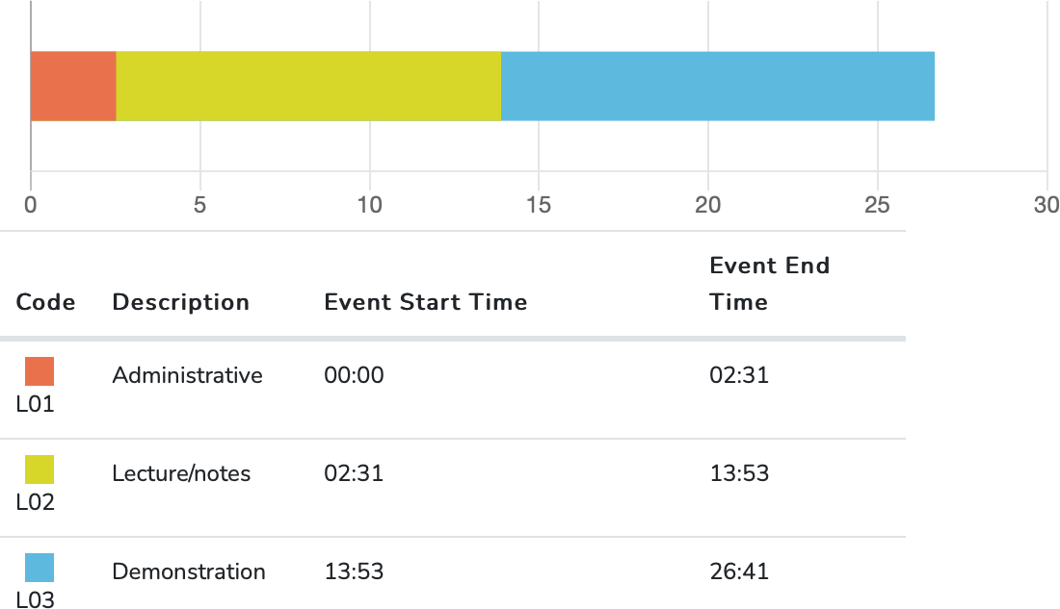

This analysis used a portion of the full lesson. The administrative part of the lesson was removed, leaving two different lecture/notes sections and two different demonstration/try-it-yourself sections.

Management Summary
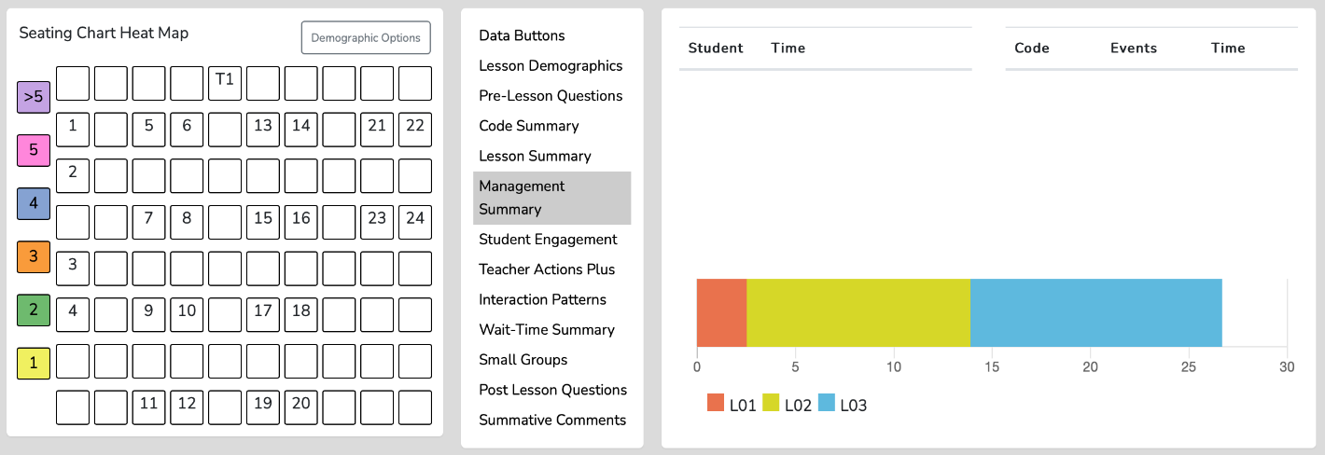

The teacher needed to address zero individual student misbehaviors, and zero group misbehaviors were noted (M12). Therefore, the teacher spent no class time addressing student misbehaviors.

Recommendation: None

Student Engagement Summary

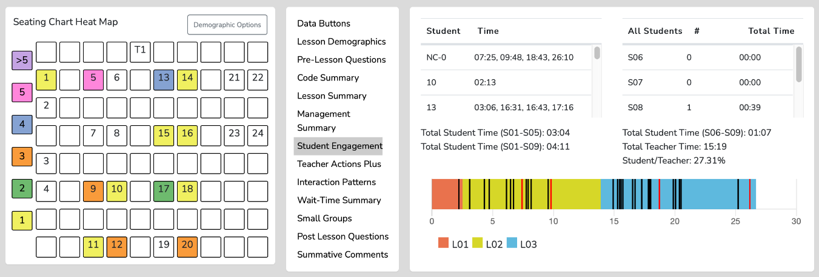

(Seats 8, 21, and 22 were not ﬁlled with students for this lesson)
First, the Seating Chart Heat Map indicates that slightly over half of the students present in the class had the chance to participate in the lesson. Second, the timeline shows that student engagement was, for the most part, distributed throughout the lesson rather than concentrated in one area, except when students worked independently or in pairs to solve a problem or when they were quietly thinking about a question. As shown by the Seating Chart Heat Map and the Student/Time column, students numbered 5, 13, 9, 12, and 20 were the most active when responding to questions.

However, a little under half of those events were voluntary, while the others were prompted by the teacher's request that students answer. In short, student engagement was consistent throughout, but it would have been possible to spread the questions out to engage all students present.

Recommendation: First, the teacher can keep track of students who have already participated and make sure to call on students who have not participated before calling on those who have. Additionally, the teacher can call on students who are not raising their hands to engage all the students. This strategy also allows the teacher to assess quiet students in the class. Another option is to implement group responses using digital devices, dry-erase boards, or think-pair-share to foster more student-to-student interactions.

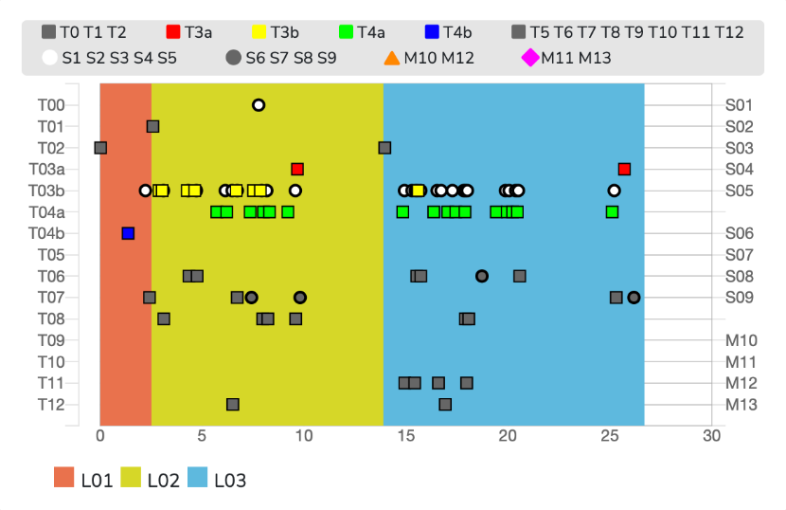
Teacher Actions Plus

Teacher actions plus provide a digital visual story of the whole lesson, merging all teacher and student actions in one timeline from beginning to end. First, the misbehavior and teacher reactions, as indicated by the triangles and diamonds, show that zero misbehavior occurred during the lesson. Second, the white dots represent student actions, indicating that many students answered questions throughout the lesson, as noted by S05. It also shows no S03 events, indicating that students did not ask any questions during the lesson. The chart also shows that the answers were fairly distributed throughout the lesson, except when students were quietly thinking about and working on problems individually or in pairs. The grey dots representing teacher actions indicate that the teacher switched between multiple diﬀerent response types throughout the whole lesson. Next, the colored squares show that the teacher mainly asked higher-level questions (T4a & T4b) and a few recall and yes/no questions (T3b & T3a). The most common teacher responses following a student's answer were repeating the student's response (T08) and acknowledging it (T06), with each occurring in 6 and 5 events, respectively. There were only three instances of asking the student to clarify their answer (actions consistent with an inquiry lesson), spread throughout the lesson.

Recommendation: Some of the T4a questions could have been modified to be T4b questions. The recall and yes/no questions could be modified into higher-order thinking questions. The yes/no questions would be easy to change, but the recall questions used in the lesson are a little more challenging to modify. One way to change the questioning is to have a student explain a classmate's work rather than their own. This will enable students to think critically about how others approach problem-solving. Next, T08 is often used to acknowledge a student's response or to mirror it back to them, anticipating that the student may need to explain or clarify their answer further. This might work for some students; however, the students in this classroom are well known for their lack of verbal participation. Therefore, the instructor might simply acknowledge the student's response (T06) and then follow it up by asking the student to clarify or expand on their answer (T11). Lastly, the gap between T4a and T4b is substantial and can be easily addressed by asking students to justify their reasoning when answering questions.

Interaction Patterns – 3 Codes in Sequence
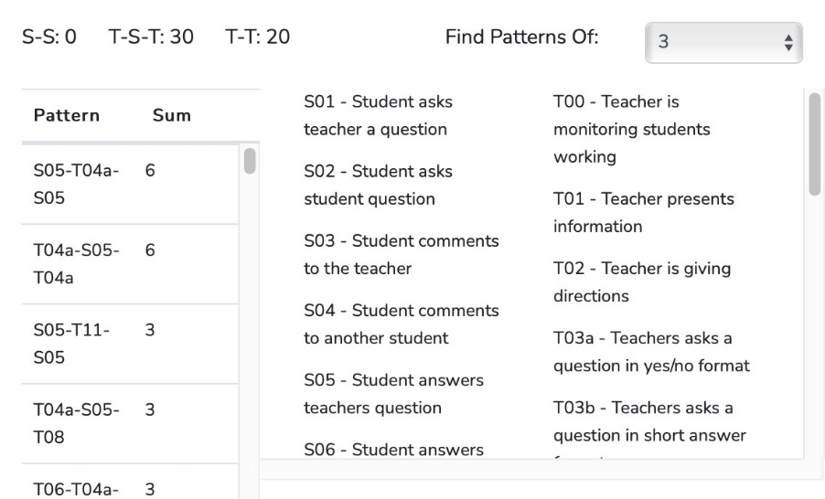

This graphic shows predominant patterns of three codes in sequence. Several data points in this table are worth mentioning. First, two code chains tied as the most common. These two chains are S5-T4a-S5 and T4a-S5-T4a. This shows that a common pattern the teacher used in this lesson was to ask a T4a question, get a student's response, ask another T4a question, and get another student's response. After this, there are three code chains, each with three occurrences. One of these (S5-T11-S5) is very similar to the two most common code chains; it simply replaces the T4a question with a prompt asking the student to clarify their answer. Therefore, each standard code chain shares something in common: the teacher asks a question, a student answers, and the teacher responds. This tie most likely comes from the teacher using an equal number of higher-order questions and about the same number of teacher responses.

Another critical indicator in this data table is that the S-S number is zero. This means that during the lesson, an S code never followed another S code. This strongly indicates insufficient student-student interaction during the lesson. However, there was a think-pair-share activity in which students had the opportunity to interact with one another and ask questions about each other's thoughts. Additionally, there were two points in the lesson when students worked in pairs, sharing ideas and thoughts to solve an inequality problem. Both of these were fantastic examples of student-student interaction, which the codes and code chains do not adequately capture.

Lastly, there were 20 T-T events. This is less than half the number of T-T events reported in the last video reflection. Therefore, the teacher spent less time as the center of the lesson.

Recommendation: It would be a worthwhile goal to foster more student-to-student exchanges in the lesson. Continue using think-pair-shares to increase student-to-student talking, and encourage students to comment on the student boardwalk without being asked first. For example, using a think-pair-share approach to elicit a reaction to the student response engages all students for a few seconds and expands the time for thinking and communicating, rather than having the instructor always respond to student answers. Additionally, you could modify the questioning in the lesson by having a student attempt to explain one of their classmates' work rather than their own. This will help students think critically about how others approach problem-solving and further increase student-student discussion.

Interaction Patterns – 4 Codes in Sequence
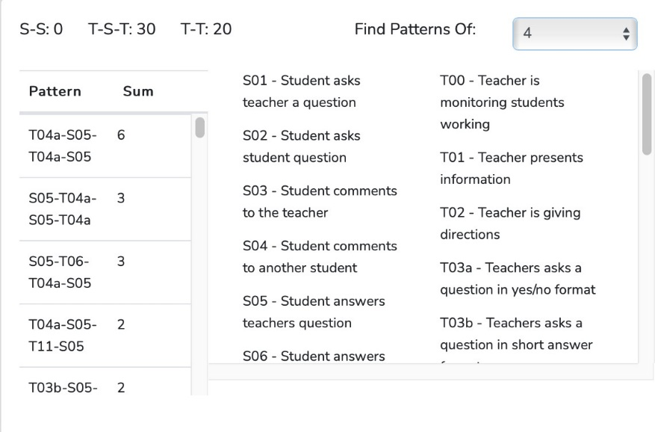

This graphic shows predominant patterns of four codes in sequence. Several data points in this table are worth mentioning. First, the most prevalent four-code sequences center on the teacher asking a T4a question, receiving a student's response, then asking another T4a question and receiving another student's response. Moving on, the following two sets of common sequence patterns were the reverse of the most common chain(S5-T4a-S5-T4a), and the code chain S5-T6-T4a-S5, which is also very similar to the two other mentioned common code chains. Again, this demonstrates that the teacher relied heavily on transitions between T4a questions after receiving a student’s response. One final change this data set shows is that the T-code T11 was present in the lesson. This is an improvement over the last video reflection, which contained no instances of T11 in the commonly used code chains.

Recommendation: To gain a deeper understanding of how your students think, continue implementing more patterns involving T11 so that it appears in more code chains. This will allow the teacher to hear what students are thinking as they work on a problem, rather than only viewing their whiteboard work.

Wait-Time Summary
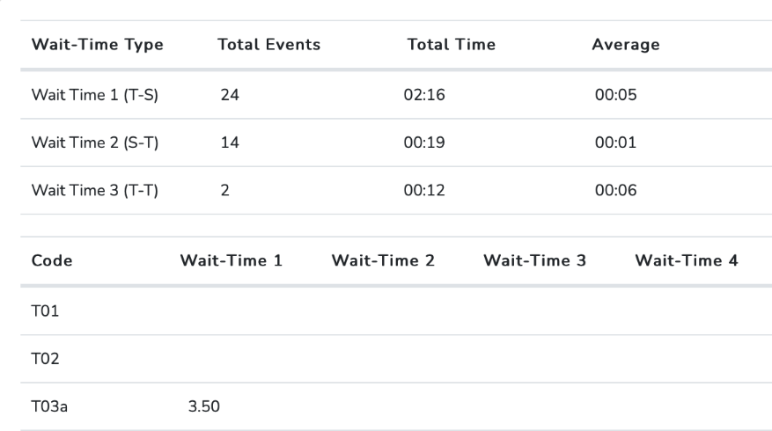

Research has demonstrated the significant benefits of adequate wait time, generally considered to be at least 3.5 seconds. First, the data above shows that the total number of WT events captured in the lesson was 40, which is a good number of entries for this kind of lesson, where students spend time working on problems and then discussing them as a large group. However, there were still several opportunities to implement additional wait-time 2 & 3 in this 27-minute lesson.

Additionally, sometimes wait-time events are so short that the observer does not have enough time to hit the wait-time bar before entering other codes. Looking at the average wait time for each wait-time, WT1 is just above the recommendation at a solid five seconds. This amount of wait time is very good, especially given that 24 WT1 events were coded. However, the WT2 was significantly below the recommended 1 second per entry. Lastly, WT3 was significantly higher, at approximately six seconds per entry. However, as mentioned before, the amount of WT3 used during a lesson should be increased. Finally, WT4 was not present in this lesson.

Recommendations: The teacher should look for opportunities to incorporate additional wait-time events into lessons. Additionally, the teacher can work on increasing their wait time after listening to a student answer a question (WT2). This is important because if the teacher gives the student more time after they talk, the student might continue and expand on their answer or thoughts. The teacher could consider counting on their fingers to ensure they use the appropriate amount of wait time before speaking after a student's response. Additionally, implementing more WT3 would ensure the teacher does not rush the class and takes time to wait for responses before reframing a question or moving on to another problem or topic.

16. Teacher Action Research: How Higher-resolution Data Contributes to
Improving Teaching and Learning

Introduction
Teachers engaged in classroom instruction have a living laboratory and can study their teaching using a research method known as action research. This involves a more personal exploration of their teaching, often involving collecting classroom data on their approach and its impact on students. This process is powerful and practice-altering when teachers use data iteratively to inform observations. Here are some examples of action research using SMT, illustrating how higher-resolution data served as indicators of growth and change in teaching or guided efforts to focus on areas for improvement. Notice the positive growth demonstrated by some after completing two cycles of observation, and the tremendous growth when the observation cycle proceeds through 3-4 cycles.

Classroom Teacher A – An Attempt to Increase Wait-time
This teacher noted, based on the video and self-reflection, that her wait time may be somewhat short. She then conducted four teaching episodes and collected data on wait time and student engagement. Plans were analyzed and adjusted between teaching episodes, with a focus on increasing wait time during lessons. The following presents the data from the four teaching episodes.

Table 7
Wait Time Growth and Changes in Student Engagement
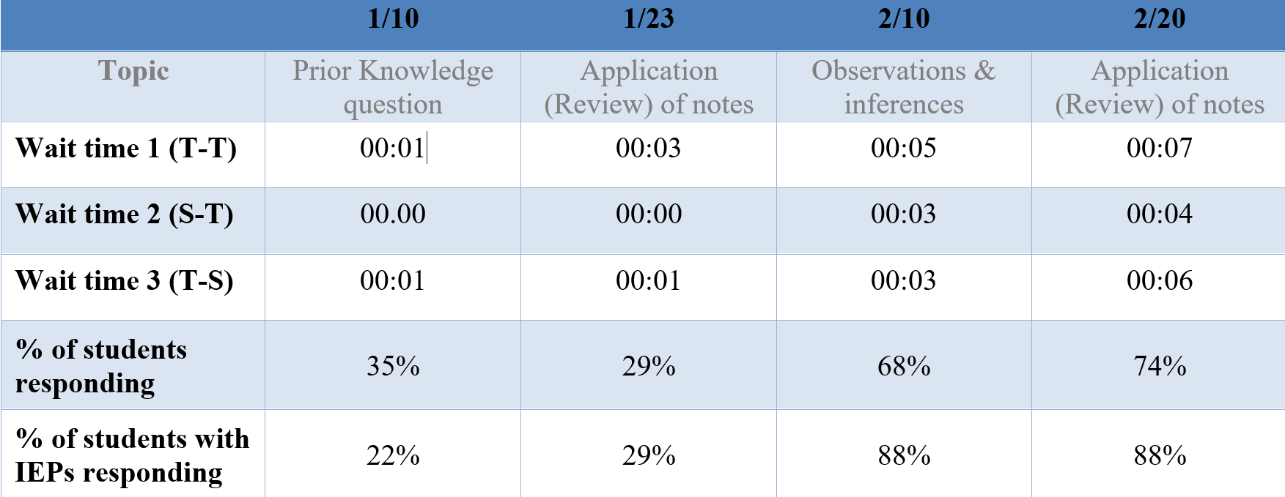

The data gathered and analyzed from these four observations showed continued growth and improvement in wait-time use, exceeding the 3.5 seconds that research (Rowe, 1986) indicates is necessary to observe positive effects on students and the lesson. This teacher-action researcher was also delighted to see that student engagement increased from 35% to 74%, and the percentage of students with IEPs increased significantly from 22% to 88%, as prior research has demonstrated would occur when teachers increase wait time. It is one thing to read about research, but quite another to collect one’s data and observe how changing a teacher-controlled factor, such as wait time, affects student engagement.

Classroom Teacher B – Increasing Student Engagement
The teacher was dissatisfied with the level of student engagement in his classroom and implemented new strategies to increase the number of students contributing during lessons and the number of contributions per student. He collected baseline data on the number of questions each student answered, the number of questions each student asked, and the number of comments each student offered, then aggregated these metrics to calculate total student engagement. He then implemented changes to the lesson and collected additional data. The second lesson demonstrates student engagement following the restructuring and incorporation of new strategies.

Figure 23 Figure 24
First lesson Second lesson
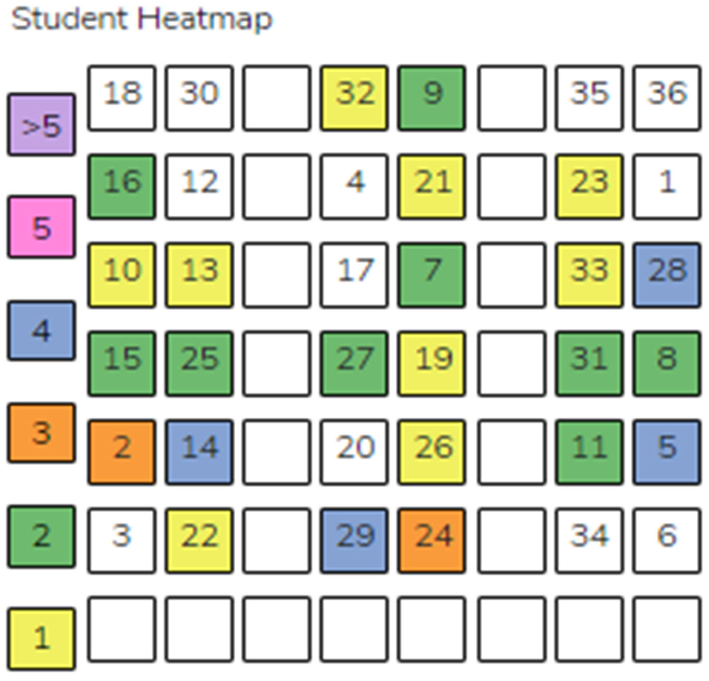
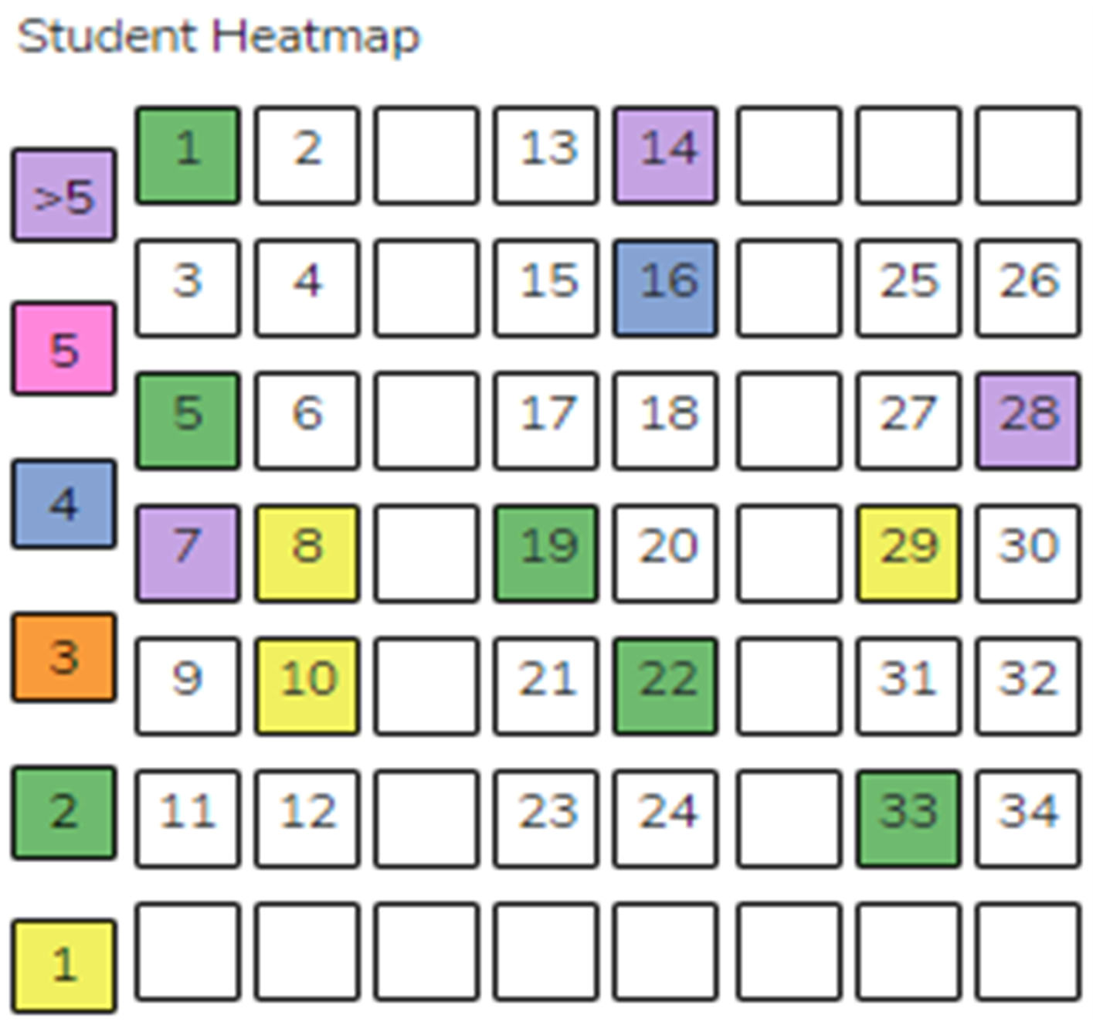

Note that in the baseline lesson, 10 of 34 students responded, while in the revised lesson, 24 of 34 students responded. In the baseline lesson, there were 32 student responses; in the modified second lesson, 49. Using the seating chart, the teacher could readily observe increased student engagement, both quantitatively and visually.

Classroom Teacher C – Wait-time, Student Engagement, Question Type, Cognitive Level of Responses
This summary comes from a high-school Biology teacher and is another prime example of the high-level analysis classroom teachers can conduct through action research, yielding critical and helpful indicators of the effects of their teaching on students. The purpose of their study was to determine how increasing wait time in a ninth-grade classroom would affect student engagement, as measured by the quantity and cognitive level of their responses. As a reminder, prior work by Rowe found positive effects when the teacher used wait time 1 of at least 3.5 seconds.

The data were gathered from four observations, each 25-45 minutes, over twelve weeks in the middle of the school year. The instruction method used for all four lessons was an interactive lecture, with content delivery and questions interspersed throughout. To gather baseline data before attempting to increase wait time, the first two observations were recorded and coded using their standard method of instruction. The teacher then researched ways to deliberately increase wait time during instruction and refine how questions are posed at varying cognitive levels. This was followed by two more video-recorded observations in which they attempted to increase wait-time use.

All four video recordings were used in conjunction with SeeMeTeach to capture and analyze data to determine whether increasing wait time resulted in more student responses and whether those responses were at a higher cognitive level. The SMT teacher observation tool allows the observer to capture data on four different wait times. As a refresher, the sidebar defines wait-time 1-4.
WT1: Teacher action → pause → student action
WT2: Student action → pause → teacher action
WT3: Teacher action → pause → teacher action
WT4: Student action → pause → student action

Data Collected
Table 9 below includes the total number of wait-time 1 events, the average wait-time 1, the number of student responses, and the number of student-student interactions (s-s) for each observation. They also collected the number of student-student interactions during each observation, the level of questions posed, and the resulting level of student response.

Table 9. Average Wait-Time 1 (secs) per Observation and Response

Observation | # of WT Events | Average Time | Responses | S-S Interactions
1 | 39 | 3 | 39 | 3
2 | 29 | 2 | 34 | 5
3 | 50 | 3 | 42 | 7
4 | 47 | 5 | 57 | 16

Wait-Time Results
- The average wait time 1 increased from 3 to 5 seconds over 12 weeks.
- As wait-time 1 increased, the total number of responses increased from 39 student responses to 57 student responses.
- From observation 1 to observation 4, the total number of student-student interactions increased from 3 to 16.

Wait-times 2, 3, and 4 were also recorded and presented in Tables 10-12 below.

Table 10. Average Wait-Time 2 (secs) per Observation

Observation | Number of Events | Average Time
1 | 39 | 2
2 | 29 | 2
3 | 50 | 2
4 | 47 | 1

Table 11. Average Wait-Time 3 (secs) per Observation

Observation | Number of Events | Average Time
1 | 2 | 2
2 | 7 | 1
3 | 5 | 2
4 | 17 | 5

Table 12. Average Wait-Time 4 (secs) per Observation

Observation | Number of Events | Average Time
1 | 54 | 3
2 | 44 | 2
3 | 61 | 3
4 | 59 | 5

Wait times 1, 3, and 4 increased from 3 seconds to 5 seconds between observation 1 and observation 4. When examining the increase in wait-time 1, the statistical analysis yields a P-value of 0.0398 (SD 1.41), indicating that this outcome might occur less than 5% of the time, meaning that the increase in wait-time 1 resulted in a statistically significant increase in the number of student responses.

Question Type and the Number and Type of Student Responses
The type of question posed by the teacher was also compared to the number of student responses. The bar graph below shows the number of student responses for each question type. Recall that a T03a is a yes/no question. A T03b is a short-answer type of question. T03 questions are considered lower-level cognitive questions. T04a questions require speculation, and T04b questions require an explanation and typically begin by asking the student “why?” T04 questions are considered higher-level cognitive questions.

Recall from Table 1 above that average wait time 1 increased from 3 seconds to 5 seconds from observation 1 to observation 4. The figure below indicates that as wait time increased, the number of responses increased, particularly for T04a-type questions, which require speculation. However, responses to T04b-type questions did not increase as wait time increased. However, the number of T04b-type questions posed was quite small in observations 3 and 4.

Figure x: Student Responses Per Type of Question Posed
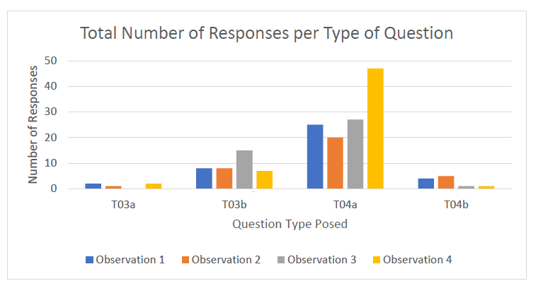

The teacher also examined whether increasing wait time influenced students’ responses, particularly in providing higher-level answers to higher-level questions. Perhaps the teacher simply asked more T04a-type questions in observations 3 and 4, which led to more student responses and therefore negated the impact of the longer wait time. To account for this, one can control for and examine the number of question types posed by the teacher in relation to the number of student responses. Table 13 displays the number of distinct question types (TQ) in each observation, along with the total number of student responses (SA) for each question type.

Table 13
Number of Types of Questions Posed per Observation and Student Responses

Question Type | Observation 1 |  | Observation 2 |  | Observation 3 |  | Observation 4
 | TQ | SA | TQ | SA | TQ | SA | TQ | SA
T3a | 2 | 2 | 3 | 1 | 6 | 0 | 2 | 2
T3b | 9 | 8 | 7 | 8 | 1 | 15 | 7 | 7
T4a | 28 | 25 | 17 | 20 | 21 | 27 | 33 | 47
T4b | 5 | 4 | 5 | 5 | 2 | 1 | 1 | 1

Higher-level questions were coded as T04a and T04b.
- With increased wait-time, the number of responses increased, specifically T04a responses (responses that offer speculation). However, T04b responses (responses that include both the student's speculation and an explanation of their response) did not increase, and not enough T04b questions were posed to generate meaningful data.
- In observation 1, the number of speculation-type questions asked was 28, but student responses were 25. However, in observation 4, 33 speculation-type questions were asked, and 47 student responses were received. This indicates multiple student responses to a single question.

Conclusions
The results showed that increasing wait time allowed students to reflect on the question before responding; they had time to process it, consider their responses, and formulate answers, leading to more thoughtful and detailed responses (Wilem, 1992). In addition, the total number of student responses increased, as did the proportion of higher-cognitive responses.

In addition, although not the study's initial purpose, the data showed an increase in student-student interactions as wait time 1 increased. Increasing student-student interactions helps create a student-centered rather than a teacher-centered environment. When students have time to respond to a question or participate in a discussion, they are more likely to turn to their peers for help or to share their ideas. When students know they have time to respond, they are more likely to listen attentively to their classmates' responses. This creates a positive feedback loop in which students are more engaged in the discussion, thereby increasing interaction among them.

The teacher concluded that: 1) They could successfully collect data using SMT for wait-time, quantity and types of questions posed, and quantity of student responses. 2) They could increase their use of wait time during instruction. 3) They could increase student engagement, as measured by the number of student responses to questions requiring speculation.

□ □ □ □ □ □ □ □ □ □ □ □ □ □ □ □ □ □ □ □ □ □ □ □ □ □ □ □ □ □ □ □ □ □ □ □ □

Teacher Action Research – Conclusions and Summative Thoughts
The three examples demonstrate how teachers can engage in action research and study their teaching. Teachers can make great strides when provided with a means to collect and use higher-resolution data to determine current practice and use it as a marker and indicator of change or improvement. In all cases, how teachers interact with students significantly affects the learning environment and contributes to levels of student engagement.

The conditions and potential for learning can be significantly improved with minimal changes to teaching practice. A case in point is the difference it made with just a few seconds of additional wait time, as demonstrated by Teachers A and C, resulting in significant increases in student engagement. The positive effects of using wait time are well known to educational researchers and practitioners, yet it is often missing from classroom practice. This seems like a clear example of the adage “What gets measured gets attended to.”

The research described above was conducted by experienced teachers who, prior to this study, had not studied or collected data on their use of wait time, questioning, or student engagement. Not knowing about one’s wait-time usage is remarkable, given that wait time is an essential skill in every teacher-student interaction. This is not a reprimand of these teachers, but rather an indication of what is missing from current teacher observation practices for both current and future teachers. As the action research above shows, higher-resolution data yields clear markers of teaching practice that enable teachers and observers to identify areas for improvement, determine whether intended changes were implemented, and assess whether instructional changes produced the desired results.

This same principle applies to teacher education programs, university supervisors, and future teachers: objective data, rather than subjective impressions, are essential for evaluating the development and effectiveness of aspiring teachers. The next chapter will provide a detailed example that illustrates this point.

17. Teacher Action Research, Flipping Teacher Observations, and Teacher
Explorations and Challenges
Flipping Teacher Observations - The Model and Process

In many instances, teacher observation remains a top-down model, with the university supervisor or administrator watching a teaching episode, then leading the analysis and feedback. The administrator. The many underlying issues in current teacher observation processes, and the justification for modifying the usual process and flipping teacher observations, are discussed extensively in the companion book Teacher Observation – A New Lens, in the chapter "The Current State of Teacher Observation: A Case for Flipping Teacher Observations."

In this chapter, a more robust model of teacher observation, feedback, and reflection is proposed in which both the teacher and administrator possess high expertise in using data as the primary source of feedback. This shift represents not merely an improvement, but a long-overdue transformation.

In some schools, administrators, instructional coaches, or mentor teachers may use SMT when visiting classrooms, observing, gathering and analyzing data, and then holding a post-observation conference, with the analyzed data serving as the core of feedback and coaching. The data serve as indicators of current practice and markers of growth and development of teaching skills. This process supports teachers through the challenging early years of practice and embeds the development of data-informed instructional decision-making for current and future teachers into the teacher observation process. This represents a significant step toward using data for feedback and coaching, with data as the core of the feedback process.

In another model, the teacher becomes the primary agent of growth. The teacher takes the lead in determining which components of teaching to examine and which instructional changes might yield more positive classroom outcomes, much like the teacher action research highlighted in Chapter 11. The administrator’s role is more reactive than proactive, serving as a guide, consultant, and co-analyzer of the teaching episode by examining data with the teacher and discussing how to chart a new path forward.

To accomplish this, teacher observation and action research are combined into a mini-study of one’s teaching. Given that many teachers have not conducted action research, SMT has formulated and operationalized the exploration of teaching and the collection and analysis of higher-resolution data on teaching success through action research plans called Teacher Explorations and Challenges. These are mini action-research investigations that facilitate self-study and replace (or supplement) the limited, primarily qualitative feedback and coaching typically provided by most annual evaluations.

This format increases teacher control and responsibility while using higher-resolution data to indicate growth. Each challenge focuses on implementing or analyzing a strategy, teaching model, teacher-student interactions, or an attempt to increase student engagement—components of the essential core of teaching that are integral to and enhance an educator’s impact on learners.

How to Use Teacher Exploration and Challenges
The standard process for using these modules involves teachers observing, gathering, and analyzing data on their own practice and using those data for feedback, self-reflection, and conferencing with administrators. The process provides the data used to document progress as evidence for a Professional Development Plan or the annual evaluation. During the process, teachers:

- Develop self-analysis, feedback, and coaching skills that rival or surpass those found in typical teacher observation scenarios.
- Use data and indicators as the primary lens for planning, teaching, and analyzing lessons to ensure consistency and alignment with instructional goals.
- Use the process to guide instructional changes that elevate student engagement.
- Document discrete actions and events in fast-paced lessons and examine the collected data for trends, tendencies, and patterns to identify critical growth indicators.

When an administrator is involved, a teacher—through consultation—selects and implements a challenge based on a targeted instructional goal, with a clear understanding of which data will be collected as evidence of growth and change and as a foundation for post-observation discussion and feedback.

Engaging in a Teacher Exploration and Challenge can function as action research, self-reflection, assessment, or professional development. In this process, teachers use data from the SMT observation tool to focus attention on discrete teacher decisions made during planning, instruction, or assessment. Data guide feedback and serve as markers and indicators that help teachers adjust or fine-tune instruction to achieve higher levels of effectiveness.

The Typical Flow of Activities
- Reflection
Teachers reflect on their classroom practice by asking:
  - What is one aspect of teaching that could be improved to enhance student engagement or positively impact student learning?
- Teach
  - A lesson containing the component of interest is taught and recorded.
- Complete the SMT Training Modules
  - Completion of the required SMT training prepares teachers to identify key indicators, collect data from video, and analyze the teaching episode.
- Capture and analyze data
  - The recorded lesson and SMT are used to capture and analyze data that serve as indicators of the factor being studied.
- Chart the data
  - Data are recorded on a Data Summary Chart, and specific indicators are selected as measures of change.
- Investigate options and alternatives
  - Information provided in the Teacher Challenge or other resources is used to determine instructional adjustments that better target goals related to student engagement and learning.
- Round two
  - The lesson and pedagogy are modified, and steps 2 through 6 are repeated. Compare data from Round One and Round Two to identify changes or growth in teaching, student engagement, or learning.
- Revise and compare
  - Based on the impact data, decisions are made regarding further modifications or the completion of additional rounds.

Supporting Resources – SMT’s Teacher Exploration and Challenges Modules

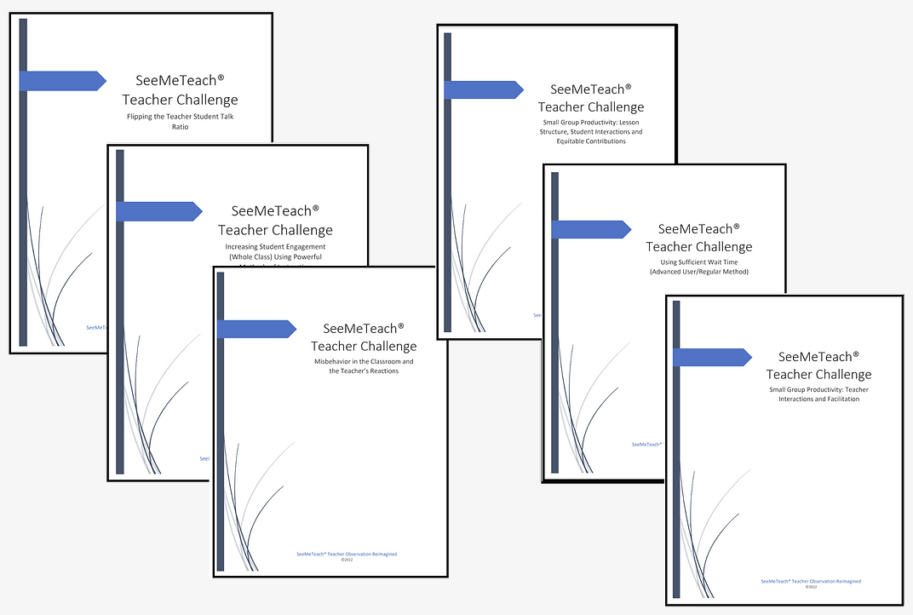

SMT has developed several Teacher Explorations and Challenges. The modules listed below are ordered by increasing skill level required for data collection. The number in parentheses following each title indicates the number of SMT training modules required to complete that challenge. For example, Teacher Challenge 1 – Flipping the Teacher–Student Talk Ratio (3) requires completion of three short training modules. Challenges at the top of the list require less training, while those at the bottom require more extensive preparation.

The many Teacher Explorations and Challenges are offered as options; there is no prescribed pathway or desired particular endpoint other than continuing to improve instructional practice. The emphasis is on facilitating growth and further development of teaching skills, refining the use of powerful models and strategies to enhance student engagement and learning. Teacher Explorations and Challenges are designed for focused study of specific aspects of teaching through systematic data collection and analysis. The process centers on teacher-directed improvement, using data—not impressions—as indicators of success.

Below are several modules available to teachers for studying their practice.

Teacher Exploration and Challenge Modules

​Teacher Challenge: Flipping the Teacher-Student Talk Ratio (3)
Description: This Teacher Challenge involves implementing strategies to reduce the percentage of time a lesson is teacher-dominated and increase the percentage of time students are actively engaged.

Teacher Challenge: Misbehaviors in the Classroom and the Teacher’s Reaction (4)
Description: This Teacher Challenge focuses on minimizing the impact of student misbehavior on student learning, increasing student engagement, and promoting positive contributions from all students.

Teacher Challenge: Using Sufficient Wait-Time (Novice/Simple Method) (4)
Description: This specific Teacher Challenge aims to implement strategies to increase overall wait time utilized in the classroom and analyze the effect of increased wait time on student engagement.

Teacher Challenge: Using Higher Level Questions and More Neutral Responses to Foster Student Thinking (4)
Description: This Teacher Challenge helps teachers learn about discrete teacher actions, including question and response types, to facilitate student thinking and learning what and why of student thinking.

Teacher Challenge: Increasing Student Engagement Using Powerful Methods (Whole Class) (4)
Description: This Teacher Challenge involves modifying a lesson strategy or teaching model to create more opportunities for robust student engagement in a whole-class setting.
​
Teacher Challenge: Fostering Inclusion, Equitable Learning Opportunities, and Experiences in a Diverse Classroom (5)
Description: This Teacher Challenge includes changing a lesson strategy or teaching model to foster increased opportunities for student engagement in a diverse classroom environment.
​
Teacher Challenge: Small Group Productivity - Lesson Structure, Student Interactions, and Equitable Contributions (6)
Description: This Teacher Challenge focuses on enhancing the impact of small-group learning and student contributions by promoting practical strategies to increase student-student interactions and maximize engagement and contributions from all students.

Teacher Challenge: Using Sufficient Wait-Time (Advanced User/Regular Method) (7)
Description: This specific Teacher Challenge aims to implement strategies to increase overall wait time utilized in the classroom and analyze the effect of increased wait time on student engagement.

Teacher Challenge: Small Group Productivity: Teacher Interactions and Facilitation (9)
Description: This Teacher Challenge is about optimizing the impact on student learning in small groups by using powerful teacher-student interactions that maximize engagement and contributions from all students.

An Example - Flipping the Teacher-Student Talk Ratio
To give the reader a more concrete understanding of what occurs during this study of one’s teaching, an example of a Teacher Exploration and Challenge is provided below. Note that each module delineates the specific SMT training needed to collect the data, but all modules have in common the completion of the basics of using SMT – the first three training levels, which the user does not have to repeat once completed.

Other modules may require training beyond the first three levels in order to collect the specific data needed to analyze another aspect of teaching. For example, if a user was going to collect student engagement data for the first time, they would also complete Training Module 6 – Learn About S Codes: Student Actions, Student Engagement, where the user learns to distinguish between different student actions and how to couple those actions with a seating chart while collecting data.

The following chapter provides an overview of the training resources offered by SMT. Registered users have ready access to such resources, as needed.

□ □ □ □ □ □ □ □ □ □ □ □ □ □ □ □ □ □ □ □ □ □ □ □ □ □ □ □ □ □ □ □ □ □ □ □ □

Teacher Explorations and Challenges: Flipping the Teacher-Student Talk Ratio

The minimum required training to complete this challenge includes:
- Training 1: Setting up a lesson observation in SMT
- Training 2: Qualitative Comments Mode
- Training 3: Quantitative Data and Analysis Mode

The focus of data collection for this Teacher Challenge is to use any T code to denote a teacher action and any S code to denote a student action, and to pair S codes with a specified seat on the seating chart.
Introduction
Unfortunately, in today's average classroom, most class time is spent with the teacher talking, mainly through lectures, with only a few questions to initiate student engagement. Lectures are an easier delivery method and allow the teacher to maintain total control of the class and the classroom, making them the go-to for most educators. As a result, it is not uncommon to see the teacher talking for up to 90% of a class period, making the lesson extremely teacher-dominated. As a result, students become passive learners and often disengage with the lesson, which decreases comprehension and excitement for the material.

Because teachers have to cover a lot of content in one year, allowing students more control or say in a lesson can make teachers nervous, as the class may seem more chaotic, unstructured, and time-consuming. This "chaos," however, is mainly where the magic happens, and true learning occurs. Flipping the teacher-student talk ratio and getting kids more involved in a class period is a powerful step in creating an environment that enhances student learning and engagement. When the ratio is flipped, students begin to:
- Ask questions of the teacher and other students.
- Form and voice their ideas and concepts.
- Build self-confidence and self-advocacy skills.
- Be exposed to multiple ideas and opinions.
- Engage with and comprehend the material.
- Learn that knowing and understanding are interactive processes.

When students are engaged, interacting, and contributing, they also feel more capable and connected to the lesson, other students, and the teacher. Flipping this teacher talk/student talk ratio is controlled and directly results from teacher decisions. These purposeful teacher choices and actions used during a lesson, targeting the goal of high student engagement, don't require a high level of skills but simply a change in teacher behaviors or habits. Just altering one (or more) teaching habits can significantly impact student engagement and the T/S ratio.

The Challenge
This Teacher Challenge focuses on implementing strategies to decrease the percentage of time that a lesson is teacher-dominated and increase the percentage of time that students are actively engaged.
Challenge Steps
- Teach a Lesson: First, capture the video and audio of the lesson. Teach the lesson as you normally would, as this lesson will be used for your baseline data.
- Complete the Required SMT Training: If not already done, complete the required training to learn how to collect the specific data required for this challenge. The minimum required training recommended includes:
  - Training 1: Setting up a lesson observation in SMT
  - Training 2: Qualitative Comments Mode
  - Training 3: Quantitative Data and Analysis Mode
Note: The cheat sheets accompanying this training provide an excellent summary of the training and are excellent resources to keep on hand while you code your recorded lessons.

- Collect Data: Use the SMT teacher observation app to collect baseline data specifically focusing on student engagement.
Note: The focus of data collection for this Teacher Challenge is using any T code to denote a teacher action and any S code to denote a student action, as well as pairing an S code with a specified seat on the seating chart.
- Document and Analyze Data: After you have collected your baseline data, plot the pertinent data on the Data Summary and Change Chart.
- Revamp Your Teaching: Implement one change to how you approach allocating teacher/student talk time in your classroom. It is recommended to:
  - Only implement one change or strategy at a time to determine what is making the difference in the teacher/student talk ratio.
  - Fill out the "My Plan of Action" Google Form to document your observations and progress through this teacher challenge. You can use this for your personal development or as evidence for a yearly observation or pre-service teacher certification program.
Note: See the Implementing Growth and Change section in this teacher challenge for additional suggestions on implementing specific changes to your teaching.
- Repeat Challenge Steps 1, 3, 4, and perhaps 5: One cycle through this process might achieve the desired results, but more than likely, it might take more than one cycle. Teaching is complex, with many variables in play, but know that sometimes a very small change can have a noticeable and sometimes very large effect on the learner or the learning environment.

Data Summary and Change Chart
Overall Teacher/Student Talk Time Ratio – Go to the Code Summary page. Look at the table in the screen's lower right-hand corner and scroll down to the bottom of the data screen. Refer to the "Overall T Codes" and "Overall S Codes" and fill in the data table below for each observation.

Data Codes |  | Events | Event % | Duration | Duration %
Observation 1 | Overall T Codes
Observation 1 | Overall S Codes
Observation 2 | Overall T Codes
Observation 2 | Overall S Codes
Observation 3 | Overall T Codes
Observation 3 | Overall S Codes
Observation 4 | Overall T Codes
Observation 4 | Overall S Codes

Student Contributions – Note general observations, trends, and patterns about student contributions. Who and where in the classroom are they coming from? Are the same students being asked to engage? Are only students closest to the teacher engaged? (Data can be pulled from Seating Chart Heat Map and Demographics)

Observation 1

Observation 2

Observation 3

Observation 4

Lesson (Type) Distribution of Student Actions - Note general observations, trends, and patterns of where in the lesson and during what type of lesson (specific L code) student events occurred. Are student contributions distributed evenly throughout the lesson? In which lesson type (L code) do they mainly occur? (Data can be pulled from Teacher Actions Plus or Student Engagement Summary)

Observation 1

Observation 2

Observation 3

Observation 4

Implementing Change and Growth
Guiding Thoughts: Lessons vary, and so do the possibilities for optimizing student engagement. However, many things can be done to modify the learning environment to decrease teacher talk time and increase student talk time.

- Employ the 1-2-3 method at various points throughout your lesson or lecture. After every 5 minutes or 4 PowerPoint slides (or another allotted time or number of slides), use the 1-2-3 method to engage more students. First, ask ONE question to the class. Wait at least TWO whole seconds (or more) before calling on any student. Then, choose THREE students to contribute their answers or comments, making sure to acknowledge each student's contribution but not affirm or deny their answer before all three students have contributed.
- Try adjusting the questions you ask your students to make them more substantial by rephrasing them to include words like "why" and "justify." You could also follow up on a student's response by asking them to elaborate. Some examples could include the following:
  - Why do you think….?
  - Tell me what you think might happen if … and tell me why you think that might happen?
  - Tell me more.
- Like the first strategy, try to get students to respond and react to one another rather than just interacting with the teacher. For example, if one student answers a question, get another student to respond to the first student's answer by asking them a question like "What do you think about so-and-so's (the first student) response?" Or "How could you add something else to their response?" Trying to create conversation in class leads to cooperation and collaboration among students, shifts attention to them, and promotes involvement. In this sense, the teacher becomes the facilitator of learning rather than the director.
- Use strategies like Think-Pair-Share to get the whole class involved. In Think-Pair-Share, the teacher asks a question to the class, and each student thinks about or writes down their answer; then they turn to a partner to share and discuss their answers. Pairs can then share their combined answer with the class.
- Don't be afraid to call on students randomly. The surprise element will help keep students on their toes and more apt to pay attention if they know they may be called on consistently and randomly instead of the teacher talking for the entire period. Some strategies that can help with this include:
  - Writing all of the students' names on popsicle sticks and drawing a stick randomly to have a student answer the question.
  - Numbering each desk in your room. The student sitting at the desk with the number the teacher calls out has to answer the question.
- Don't take "I don't know" as an answer. If students know they can say "I don't know" and be done with it, most will take the easy way out. Create a classroom expectation that students must attempt to answer the question. If a student says, "I don't know," you could respond with:
  - "Well, give me your best guess."
  - "Saying I don't know is not an option here, so why don't you try again."
  - Have them rephrase what they have learned already and then ask them to pull bits of information out of the summary that pertain to the question being asked.
  - Incorporate manipulatives and have students summarize what they are experiencing.
- Use a "parking lot" for student responses. A parking lot consists of a large piece of paper or whiteboard section dedicated to the "parking lot." There can be one or many "parking lots" for any given class, as each one is dedicated to a specific question. The teacher poses one or a few questions about the material. Each student, pair, or group writes their answer(s) down on multiple sticky note(s) and puts it up on the correlating "parking lot." The teacher can read all the answers to start a discussion or ask specific groups/students to elaborate on their answers. This gets students to discuss content with one another and up and out of their seats for a bit.

Modules That May Help Modify Instruction and Specific Interventions to Increase Checks for Understanding

See the following modules on the SMT website for teaching tips and strategies that may engage more learners during the lesson.
- Module 1: The Teacher Decision-making Framework - Understanding the teacher-student synergistic relationship and how the critical decisions work together for the targeted outcomes of instruction.
- Module 3: Maximizing Student Engagement in the Classroom - Using whole-group response tools and strategies to learn about students' understanding and provide maximum feedback to the teacher.

□ □ □ □ □ □ □ □ □ □ □ □ □ □ □ □ □ □ □ □ □ □ □ □ □ □ □ □ □ □ □ □ □ □ □ □ □

Alternatives to the Modules
Consider the Modules as organized templates, available for teachers to use when studying their practice. Or, teachers who are adept at action research may wish to formulate a challenge based on a specific focus of inquiry and the general process of action research.

Documentation Resource
The My Action Plan Google Form serves as a template for documenting observations and progress through a Teacher Challenge. This documentation may be used for personal professional development, annual evaluations, or pre-service teacher certification requirements.

18. Capturing and Storing Video and Audio

Capturing Quality Audio and Video - If the user is not doing a live observation, then the video used for the observation should have:
- A video with a wide-angle view of the room with most students and the teacher is desired, as the observer always has a fixed reference point. Placing the camera at the back of the room, perhaps higher than head height, will keep most of the action within the shot, allowing the person(s) to connect actions and events to the individuals involved or speaking.
- Audio ideally captures everything the teacher said and most of what the students are saying.
  - Note: If the teacher is talking and the room is quiet, most microphones capture the teacher’s voice and most of the students’ questions and answers. However, capturing audio of teacher-student interactions can be challenging during a lab activity or when the class is working in small groups, as the teacher walks around and interacts with various groups. Usually, the class is videotaped from a fixed position, capturing the entire panorama. Therefore, the camera microphone is also fixed in place, making it challenging to collect good audio and, thus, data in small groups. Small groups are a good source of teacher-student dialogue. Such interactions should be collected and analyzed, as teacher-student interactions can often be improved. Therefore, relying on the microphone of the video-recording device may not be ideal. See Lavalier Microphone Bluetooth to Phone for a solution.

Lavalier Microphone Bluetooth to Phone for Recording Audio and Video
- To capture high-quality audio, secure an omnidirectional Lavalier microphone that will connect via Bluetooth to your phone or camera source. There are several options, so reading reviews helps you choose a microphone that captures clear audio. When working with individuals, small groups, or whole groups, the teacher will want to record their own audio and the students'. An omnidirectional microphone picks up sound from any direction. A unidirectional microphone picks up sounds only from one direction. The user will want an omnidirectional microphone to capture sounds from both close and distant sources. Some microphone lavalier packages come with more than one microphone. The reason for purchasing more than one microphone is that the teacher might want to wear one and place the other at the center of a small-group table to capture the conversation of the small group or a group working together during a lab activity. Both microphones can connect to the phone via Bluetooth, and if the teacher wants to record small-group conversations, they only need to remain silent or cover their microphone when speaking with other small groups.

Solutions to Audio Issues
- Teachers can wear an omnidirectional Lavaliere microphone that feeds back to the camera's audio input. For example, teachers can use a product called Swivel, which uses an iPad placed on a swivel mechanism that tracks the teacher around the classroom and captures video. This product also uses a lavalier microphone that the teacher wears, which feeds audio back to the iPad. SMT has found that the quality of the captured video and audio is quite good (but has no affiliation with the company or the recommended product).
- Teachers can also get a lanyard attached to a plastic sleeve. A smartphone can be placed into the plastic sleeve with the camera and microphone exposed and facing outward. The video will capture what the teacher sees when they walk around and interact with individual students and small groups. Acceptable audio will also be obtained, but the downside is that the video rapidly changes direction and perspective. It is much easier for an observer watching the video if the footage comes from a stable, fixed position, with all the students and the teacher visible, from the perspective of an observer in the back of the room.
- Computer webcams can also be oriented in the classroom to capture most video and audio.
- Any other type of digital device can be placed in the front or back of the room to capture video and audio.

Hardware
Recommended tools for capturing quality video and audio of teaching segments (from least to most $):
- Phone with a lavalier microphone connected via Bluetooth to the phone's audio jack. This option captures high-quality audio from the teacher and most of the students.
- Web Camera with microphone—a quality way of capturing audio and video; the web camera feeds directly into the computer, and the audio captured is only what the device picks up from the location of the web camera and computer.
- Swivel – Place your iPad on the Swivel, attach the Lavalier microphone to your shirt, and it collects excellent audio and video as it pans along with your movement while you teach.

Video Segments
- Editing Video Down in Size to a Key Segment
  - The user must only upload the video segment they wish to observe and analyze. For example, the user may have captured 45 minutes of footage but only wants to view and comment on the 20-minute segment of the lab activity. Therefore, the user should edit the video to remove everything except the desired portion and then upload it.

- Storing the Video – Two options exist for adding video during lesson observation setup.
- Uploaded to SMT Secured Cloud Storage
  - When using a phone to capture video, the user either needs a small tripod or props the phone to get the correct view.
  - The video is attached and sent to the user’s email, which is then opened and downloaded to the user’s computer.
  - When creating a New Observation, the video is loaded using the choice “Classroom Observation From Video File”
- Upload to YouTube
  - The video should be stored with a URL address that the user and/or team member(s) can access. SMT suggests using a YouTube channel for this purpose unless the school district or institution has an accessible server that won't block users from accessing the video. Or the video can be stored in SMT’s secure cloud storage. Various options are available when creating a New Observation.
  - When uploading the video to YouTube, it is essential to do the following:
  - Choose the toggle for an unlisted video – do not select private or public.
    - Videos should not be listed for public consumption due to privacy laws regarding children. Additionally, if a video is marked as “private,” other team members will not be able to view it because SMT will not have access.
    - As an “unlisted” video (without adding tags or keywords and with a non-descript title), the video should be accessible only to the team members.
  - After initiating the upload of the video to YouTube, the owner must toggle some choices. Toggle on the following:

- Toggle “No, it’s not made for kids” so the circle is dark, then click SHOW MORE, which presents more options.

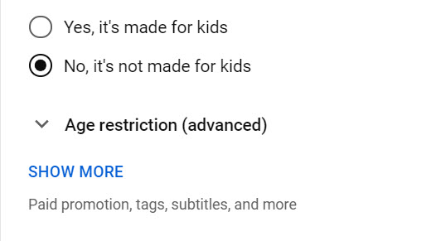

- Then, toggle on “Allow embedding” but leave the other choices unchecked.
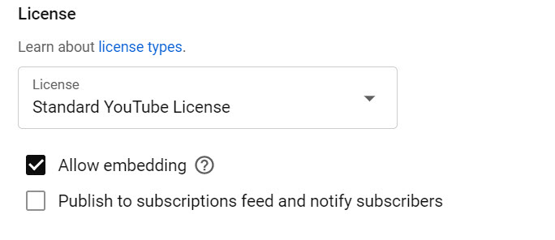

- The video URL on the right side of the YouTube page needs to be copied and pasted into the SMT New Observation URL window. The “Visibility” setting is also noted; in this case, it is set to “Unlisted,” and if not, use the drop-down to change it to “Unlisted.”
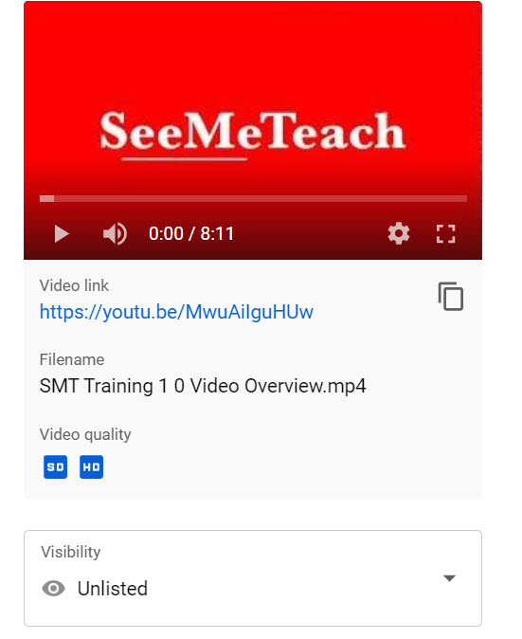

- Storing the Video - SMT’s Cloud Storage
  - Another option for linking video to the SMT New Observation is to use SMT’s cloud storage. When choosing this option, the user will be asked to choose the file to upload to cloud storage. This is a file upload process similar to others. Unlike YouTube, there are no toggles to consider.

- Storing the Video Elsewhere
  - If the video is stored someplace other than YouTube or SMT’s cloud storage, the user must check to ensure that SeeMeTeach ® can access the video for the user and other team members. Server protection and security software on school servers may make it challenging to store video locally.

Setting Up the YouTube Channel
Does each person in a teacher education program or a school district need a YouTube account, or should all videos be uploaded to a single channel?
  - Option A: Each user loads their own (unlisted) video to their own YouTube account (as an unlisted – not public or private). From there, they can copy and paste the URL into the video window when setting up a New Observation.
    - This has an advantage as the individual is responsible for the uploaded video.
  - Option B: An administrator or program leader may or may not choose to control the videos used to set up the New Observations. Therefore, they upload all (unlisted) videos to their YouTube channel and share the video URL with specific persons at their discretion.

Indemnification and Protection of the Video
- To abate concerns about capturing video of classrooms and the privacy of teachers and their students, SMT registration, Terms of Use, policies, and procedures were designed and created to minimize these concerns. For example:
  - Only two people control the video used for the observation: the teacher and the observer. The teacher or primary observer captures and stores the video in a safe and secure location with controlled access. Users can store the video on their private YouTube channel or SMT’s cloud storage.
  - The other two potential team members can view the video but have no rights regarding control of the video.
    - Note: Before using SMT, the teacher, primary observer, and any other team members (a maximum of 2) will have both agreed to the Terms of Service, stating they will not show or share the video with any party or person who does not have routine contact with the students demonstrated on the video.

Using Audio-Only When Video Is Not Allowed
- Suppose the school policy prevents videotaping in a classroom, but teachers are allowed to audiotape. If the teacher is wearing a Lavalier microphone, the audio of teacher-student interactions should be high enough quality for the observer to code much of the data. Store the audio file where it can be uploaded to SMT servers when setting up a New Observation. Then, the audio file and data collection will function much like a video file.

- When necessary to capture audio-only, there are three options:
A. Capture and upload an audio file, such as an MP3 file. During a New Observation setup, the user can choose a Classroom observation from an audio file and load it, which will play in the video window.
B. Capture an MP4 file using a video camera with the lens covered, so no images of students are captured, but the audio is captured. Then, follow the instructions for uploading the file to YouTube and link the YouTube video to SMT by selecting 'Observation Type – Classroom observation' from YouTube. A second option is to select 'Classroom Observation' from a video file, locate and link that file on your computer, and then store the MP4 file in secure cloud storage.
C. If your video contains both video and audio, you cannot publicly show the video. However, you still want to use the audio in an SMT observation and analysis:
- Create a blank videotape that is longer in time than the audiotape of the lesson recorded. When filming on blank tape, keep the lens cover on and set the audio to 0 or turn the sound off completely.
- In your video editor (Camtasia or other), import the blank video file and place it on the timeline. The user may want to overlay a title screen with the teacher’s name or identifier. Separate the audio track from the video track. Delete the audio on the original “blank” tape and keep the blank video portion.
- Import the video file of the teaching and place it on a second and different track from the blank video. Separate this tape's video and audio portions and delete the video portion.
- Now, on the timeline, there should be a blank video track and the audio of the teaching track.
- Trim down the length of the tracks until they are just a second or two longer than the classroom audio track, or the file you are creating will be unnecessarily longer than what the user needs to place into SMT for analysis.
Save and export to an MP4 file, then upload it to the user’s YouTube (unlisted) channel or save it on the computer and upload it to cloud storage when setting up a New Observation.
19. Individual Users – Frequently Asked Questions

FAQ: If I have an individual account, whom can I invite to my observation team?

Answer: Any other user with an SMT-registered account can accept an invitation to join an observation. You need to know the email address they use for their SMT account. A member of a group account (such as Teacher Education or a K-12 School) cannot join your account if they are already part of another group account. To join your observation team, they would need a separate individual SMT account using an email different from their group account. This prevents crossover observations from individual to group accounts and is in place for security and confidentiality reasons.

FAQ: Since four is the maximum number of observers per observation, does that mean I am limited to only four colleagues to select from and add to a specific observation?

Answer: No. While you can only have three other colleagues joining an observation (with you making a total of four on the team), your list of potential colleagues to choose from is limited only by how many people you know who have a registered SMT account. From that list, you can choose any three to join an observation. You can choose a different three for the following observation. When choosing observation partners, if using video, consider the confidentiality and protection of minors when deciding who can view the video.

FAQ: I have an individual account, but my school will now use SMT for observation. Can I keep my individual account and still participate in the school’s group account?

Answer: Yes, you can keep the individual account, but for the group account, you will need to use a different email than the one used for the individual account. Most individual account users registered for SMT with their personal email addresses rather than their school email addresses.

FAQ: Does the registration cost cover me for how much time?

Answer: Each registration is good for one year from the registration date. For the user's convenience, registration will automatically roll over unless the user cancels it. SMT provides ample notice before the new registration period begins. The user will receive an email 30 days before the rollover, giving them enough time to cancel before renewal.

FAQ: Can I cancel my initial registration, or cancel it after the renewal has taken place?

Answer: Once registration or renewal is finalized, the user can cancel at any time by going to SMT, logging in, and clicking the "Cancel Account" button under Billing. If the registration or renewal has already occurred, no refunds will be given. However, since the user paid for their registration, they can still access and use that account until that initial registration or renewal period ends. Because the user canceled the account, the next renewal will not occur. Registration renewal emails are automatically sent to the SMT user's account email.

20. Teacher Education - Frequently Asked Questions

FAQ: How can I set up an SMT account for myself (as a methods instructor) and the 35 future teachers in my class?

Answer: Go to www.seemeteach.com. Under Plans and Pricing, you will find the link to register and pay for a school or teacher preparation plan. The class leader or administrator who sets up the account can participate in the group and is not counted toward the group's paid slot limit. At registration, they must specify and enter the number of paid accounts (teachers or other administrators) they want in their group, as well as the group leader's email address. Once registered, the group leader can invite users to their group.

FAQ: What do I do if I have a group consisting of the clinical experience supervisor and 25 fieldwork students, and I want to add four more fieldwork students and cooperating teachers?

Answer: The group administrator should log in to SMT and, in the drop-down menu, locate Billing. Here, you can increase the number of users in the group. If that doesn’t work, email support@seemeteach.com and let them know how many more users to add to your group account. Include the institution's name, department, program, group leader or administrator's name, email used for the group SMT account, and phone number. SMT will add those additional slots to your account and invoice the administrator for the registration change, based on a prorated fee depending on how much time remains until the end of the year license period.

FAQ: I have 21 users in my group, but one person left the program and will no longer be a part of our SMT group. Can I fill that slot with another person?

Answer: Yes, you can fill that slot with another person. Go to SMT Login, Contacts, and Remove the user who left the group. That should free up a slot and show how many more users you can invite to the group before you reach the paid registration limit. Ask a new user to join the group if that number is one or more. They will receive an email invitation that they must click to accept (and create a password, etc.). The new user, of course, doesn't pay because the group administrator has already paid for the group members. If the administrator requires more slots than initially needed, refer to the FAQ above and contact support@seemeteach.com for assistance.

FAQ: I am the university supervisor for ten fieldwork students. I want to form a group of 10 students, plus myself. How do we pay for SMT registration?

Answer: There are a couple of things to consider.

- First, a typical "group" registration (see alternative group formation below) can be paid by:
  - one credit card payment that covers all members of the group, or
  - The group administrator initiates payment via purchase order (email to support@seemeteach.com, and SMT generates an invoice to send to the group administrator.

Remember, when forming a group, the group administrator has a free account. So, with 1 group admin and 10 students, the request to SMT is for 11 users, but the cost is only for 10 users.

- Second, if each student in the group is paying for their registration, how can the group administrator collect the money from the ten fieldwork students?
  - Some universities add a course fee per student to cover the cost of SMT registration. Then, when the fieldwork supervisor (and the administrator of the SMT group) registers themselves and their students, they pay with a department credit card or print the invoice, process it (adding the associated Purchase Order number), and mail the payment check to SMT.
  - Note that sometimes teacher education programs pay for the registration cost for the cooperating or mentor teacher so they, too, can participate and collaborate in observations and feedback.

- Third, if the two group payment suggestions above are not feasible, then perhaps the alternate group registration via a single-user plan process works better. An alternative way to establish a group is to set up an informal group in which the university supervisor and fieldwork students register as Single Users, then invite each other (and accept the invitation) as collaborators. Also, read the response below to understand why this might be preferable.

FAQ: In a teacher preparation program, if I am a methods instructor who has assignments linked to Fall semester fieldwork placements and my students who are registered SMT users finish my course and their fieldwork, then enter a different course in the Spring semester with a course instructor/fieldwork supervisor who wants them to use SMT to process their student teaching observations, is it best to form registered groups or best to have all the students and the instructor/supervisor register as single users – the alternative group registration?

Answer: Unlike teachers in a school who stay within that group for the whole school year, teacher education students start and finish courses or start and complete fieldwork or student teaching experiences during a semester. In some scenarios, it's best for teacher education students to register as single users and pay the registration fee, which covers them for one year. Then, for the 1st semester, each user can invite those who need to be part of their collaborative teams, such as their methods instructor (or vice versa), their cooperating teacher, their university supervisor, and fellow fieldwork students if they work together at a school placement. This process may also be suitable for an assignment from the methods instructor, which requires small groups to collaborate on observations and provide feedback. When the semester ends and the teacher education students are in different classes or have new collaborators, under their Contacts List, they can Remove users who no longer should be collaborators and add new collaborators as needed. The benefit of all those users being in a single formal group using the group plan, rather than a single-user plan, is that no group user can invite someone who shouldn't have access. As such, if videos are used for observation, they remain accessible only to the group members and the instructor – the people who usually have access to those classrooms.
FAQ: Given the power of SMT and the built-in potential for collaboration among the university supervisor, student-teacher, and cooperating teacher, how can we encourage more cooperating teachers to use SMT and join the collaborative team by sharing observation notes, data, and summative forms?

Answer: Universities highly value cooperating teachers for feedback and mentoring. Some universities secure grants and gifts from donors to cover cooperating teachers' registration costs. Some institutions consider it an expense, while others have the fieldwork student or student-teacher pay a course fee that covers the cooperating teacher's SMT registration.

FAQ: If I am in a school group or a teacher education group, I know that I can only have collaborators from a select group of people that the group administrator has invited to the group. How can I do so if I want colleagues outside the group to collaborate with me on observations and feedback?

Answer: You are correct. You cannot collaborate with anyone outside the group using that group account. First, remember that privacy rules would likely prevent you from sharing any video of K-12 students with people who do not usually work with them. Always check your school’s policy regarding this. In addition, consider school district policies and laws, particularly in the United States, where the Children's Online Privacy Protection Act ("COPPA") applies to children under 13 and requires parental consent to record or store any video of children under 13.

However, suppose you sign up as a single user. In that case, you can invite any person you would like to include as collaborators on observations unless they are part of a group account, in which case that email cannot be used for both accounts. If so, use their alternate email when collaborating with you. Remember that SMT will allow only a single email address for either a group or a single user, not both. For example, if you use your school email address with your school group, you must use a different email address, such as @gmail or @yahoo, when registering for your single-user account.

FAQ: How much time does the registration cost cover?

Answer: Each registration is good for one year from the registration date. For the user's convenience, registration will automatically roll over unless the user cancels it. SMT will provide ample notice before the new registration period begins. The user or administrator will receive an email 30 days before the rollover, giving them enough time to cancel before renewal. The renewal email will be sent to the administrator who established the group for schools or teacher education groups that paid for the group members.

FAQ: Can I cancel my initial registration, or cancel it after the renewal?

Answer: Once initial registration or renewal is finalized, the user can cancel at any time by going to SMT, logging in, and clicking the "Cancel Account" button under Billing. If the registration or renewal process has already occurred (a reminder that registration will renew is automatically sent to the email associated with the SMT user's account), no refunds will be given. However, since the user paid for their registration, they can still access and use that account until that initial registration or renewal period ends. Since the user canceled their account, the next renewal will not take place.

21. K-12 Schools – Frequently Asked Questions

FAQ: How can I set up a school account for myself (the Principal) and my 35 teachers?

Answer: Go to www.seemeteach.com. Under Plans and Pricing, you will find the link to register and pay for a school or teacher preparation plan. The administrator who sets up the account can participate in the group and is not counted toward the group's paid slot limit. At registration, they need to know and enter the number of paid accounts (teachers or other administrators) they want in their group. They will be asked to enter the group leader's email address.

FAQ: What should I do if I have a school group consisting of the Principal and 25 teachers and I want to add 4 more teachers to it?

Answer: At this time, email support@seemeteach.com and let them know how many more users to add to your group account. Include the school district name, the school, the group administrator's name and email used for the group SMT account, and a phone number. SMT will add those slots to your account and invoice the administrator for the registration change.

FAQ: I have 21 users in my group, but one teacher left the school and will no longer be a part of our SMT group. Can I fill that slot with the teacher who takes their place?

Answer: Yes, you can fill that slot with another person. Go to SMT Login, Contacts, and remove the user who has left the group to free up space for the new person. Then, SMT will show how many more users can be invited into the group before reaching the paid registration limit. Invite a new user to the group if that number is one or more. They will receive an email invitation that they must click to accept (and create a password, etc.). The new user, of course, doesn't pay because the group administrator has already paid for the group members. If the administrator requires more slots than initially needed, refer to the FAQ above and contact support@seemeteach.com for assistance.

FAQ: Given SMT's power and the built-in potential for collaboration among the university supervisor, student-teacher, and cooperating teacher, how can we encourage more university supervisors and student-teachers to use SMT and join the collaborative team by sharing observation notes, data, and summative forms?

Answer: Universities highly value collaboration between the university supervisor and the cooperating teacher for feedback and mentoring. The school might suggest that the teacher education program use SMT as an observation platform because it collects a wealth of data for feedback, recommendations, growth indicators, and informed decision-making. Some universities secure grants and gifts from donors to cover registration costs for the university and cooperating teachers. Others build it into the course expense, while other universities have the fieldwork student or student-teacher pay a course fee for the cooperating teacher's SMT registration.
FAQ: If I am in a school group or a teacher education group, I know that I can only have collaborators from a select group of people that the group administrator has invited to the group. How can I do so if I want colleagues outside of the group to collaborate with me on observations and feedback?

Answer: You are correct. You cannot collaborate with anyone outside the group using that group account. First, remember that privacy rules would likely prevent you from sharing any video of K-12 students with people who do not usually work with them. Always check your school’s policy. In addition, consider school district policies and laws, particularly in the United States, where the Children's Online Privacy Protection Act ("COPPA") applies to children under 13 and requires parental consent to record or store any video of children under 13.

However, if you sign up as a single user, you can invite anyone you want to collaborate on observations. Remember that SMT will allow only one email address for either a group or a single user, but not both. For example, if your school email address is used for your school group, you must use a different email address, such as @gmail or @yahoo, when you register for your single-user account.

FAQ: How much time does the registration cost cover?

Answer: Each registration is good for one year from the registration date. For the user's convenience, registration will automatically roll over unless the user cancels it. SMT provides ample notice before the new registration period begins. The user or administrator will receive an email 30 days before the rollover, giving them enough time to cancel before renewal.

FAQ: Can I cancel my initial registration, or cancel it after the renewal?

Answer: Once registration or renewal is finalized, the user can cancel at any time by going to SMT, logging in, and clicking the "Cancel Account" button under Billing. If the registration or renewal has already occurred, no refunds will be given. However, since the user has paid for registration, they will still have access to and can use that account until the initial registration or renewal period ends. Because the user canceled the account, the next renewal will not occur. Registration renewal emails are automatically sent to the SMT user's account email. The renewal email will be sent to the administrator who created the group for schools or teacher education.

22. Terms of Service Agreement

Before using SMT, you must read and agree to the complete Terms of Service/Privacy Agreement. The TOS/PA was provided during registration and is also located at the bottom of each page on the SMT website. Note that the TOS/PA may be modified when necessary; modifications may occur after your initial reading during registration, so you are advised to periodically read the TOS/PA for changes that may apply to you.

The following is a condensed version, but is NOT a substitute for reading the complete TOS/PA document.

In short, SMT was designed and priced to make it accessible and usable by anyone. The once-per-year registration fee covers the registrant’s personal use for one year. Registration will automatically renew to allow continued SMT usage unless the user cancels the renewal.

If you are a participant in a school or teacher preparation group, your institution may pay your fee. For those in a group, such as a school or a teacher education program, your participation may depend on continued employment at that school or district, or whether you are an active student in a teacher preparation program or have completed teacher training at that school or institution. If you are moving to employment at another school, the group administrator should remove you from their User List so you can be added to the new school group, or use it independently by registering as a single user.

As a single user, you may invite others to join your observation team at your discretion, in accordance with the TOS/PA. A single user may choose to continue using SMT independently of their school, teacher education program, or as an adjunct to their observations. If the user is part of a school or teacher education group and wants to use SMT independently outside the group, they must also register as a Single User with an email different from the one used and associated with the group.

Whether you pay the registration fee or your school or teacher education program pays it, SMT is for non-commercial use only. You, as a registered user or any user, may not use SMT in any manner related to a consulting contract, for any commercial purpose, for-profit, or for performing a paid service without first establishing a written agreement with SeeMeTeach ® before any such intended use. The definition of the use of SMT includes:

* Any work related to consulting or as a grant evaluator
* Any teacher or future teacher-related observation
* Any evaluation provided to a teacher, school, district, school board, university, or any teacher preparation program (formal or informal) while serving as a consultant or independent contractor.

In other words, you may not make money by using SeeMeTeach ® in any manner without first procuring a written agreement and a licensing agreement between SeeMeTeach ® and yourself/your company.

23. Billing, Renewal and Cancellation

Throughout this document, "Group Administrator" refers to the individual responsible for managing the SMT license, billing, and membership.

During the Current License
- Unused Licenses - Unused licenses may be assigned to new users at any time during the current license period, provided the maximum licensed group size is not exceeded.
- Changing Group Size
- Increase Group Size - You may increase your group size at any time during the current license period. How many additional members are needed for the current license period? Additional users are billed on a prorated basis for the remaining months of the annual license. Payment may be made by Credit Card or Institutional Invoice.
- Group size cannot be reduced during the current license period. Reductions may be made at renewal.
- Replacing Users
- Go to your User List (upper-right dropdown) where you can add and remove members. For example, if your group has 30 of 30 licenses assigned, and two teachers leave while two new teachers are hired, remove the departing teachers from the User List. This increases Invitations Remaining to two. Then invite the two new teachers. The User List is for adding, removing, or replacing users.

Important: Removing a user from the User List permanently removes any observation in which that individual was identified as the teacher being observed. It also removes the user's qualitative and quantitative contributions to any collaborative observations.

- Cancellation of SMT license
If you cancel before your license expires:
- Your account remains active until the expiration date.
- No refunds are issued for unused time.
- Your data and videos remain available for 30 days after expiration.
- After 30 days, all data and videos are permanently deleted.

At Renewal
- Renewal Notification - 30 days and 15 days prior to the license period end date, the group administrator will receive an email notification indicating that the license will expire on the renewal date. The group administrator will have the following options:
- Keep the same group size.
- Increase group size
- Decrease group size
- Cancel or Not Renew the license.

Note that the decision to renew or cancel will take effect immediately following the Renewal/End Date.

- Renewal Unchanged – If all members of the group are going to remain the same, then no changes to the User List are required. If the member list changes, go to the User List and use the Remove or Add New User function to update it.
- Increase in Group Size - If you increase group size, the User List and the Invitations Remaining number will indicate how many more members can be invited to the group. If the group administrator is removing some members and adding new ones, go to the User List, use Remove, then Add New User to achieve the desired list of members.
- Decrease in Group Size – Determine your new group size, then PRIOR to renewal, go to the User List and Remove any user who should not be on the list for the upcoming new license period, or remove until the desired maximum user number has been reached. Keep in mind that once you are licensed for the year, the group administrator can add or remove users from the list as long as they have not exceeded the maximum number of users.

After Non-Renewal
- If the Group Administrator Canceled or Did Not Renew
- Account Freeze - At the end of the year license renewal date, if no action has been taken to cancel the account, or the group administrator has not renewed, the account will freeze, and no member of the group will be able to view the teacher observations. Members who attempt to log in will receive a message instructing them to contact their group administrator.
- Last Chance to Renew and Resume - Note that any time up to 30 days after the License End Date, the Group Administrator will still be able to log in to SMT, go to Billing, and reactivate their SMT license by clicking on Resume. They will have the option to stay with the same-sized group or increase or decrease it. See the notes in 6, 7, and 8 pertaining to changes to group size or group members for the new license period.
- Last Notice - SMT will send a reminder email 15 days after the renewal date, informing the Group Administrator that only a few days remain to renew before permanent deletion of the account and all associated data. If the Group Administrator wants to create an account later, it must be a new account with no previous observations on the Dashboard and no videos or data saved or attached to the account.
- Renewing and Payment - Following the decision to renew, the group administrator has two choices for payment:
  - A Credit Card
  - An Invoice – the fillable PDF invoice will be displayed on the screen (complete the form and print it), and a copy of the Invoice will be emailed to the group administrator, as well as SMT. The Group Administrator is responsible for initiating the ACH payment process at their institution, as SMT considers this document the official request for payment of services.

24. Users Inviting Other Users to Collaborate

Single Users
Single Users may invite other Single Users, but cannot invite someone who is part of a Group Account unless that person also has a separate Single User membership registered under a different email address.

Group Administrators
Only the Group Administrator can invite, add, or remove Group Account users.
The User List shows:
- The maximum number of users allowed in the group.
- The number of invitations remaining.

Inviting a User
- Before sending an invitation, let the person know to expect an email from support@seemeteach.com and to check their Spam/Junk folder if it does not appear in their inbox.
- Click Add New User and enter the person's email address.
- A yellow dot beside their name indicates the invitation has been sent.
- The invited user opens the email, enters their name, creates a password, and accepts the invitation.
- Once accepted, the dot turns green, indicating the user can log in to SeeMeTeach.

Important: School email systems may block or filter invitation emails. If the invitation does not arrive, the school's technology staff may need to allow emails from SeeMeTeach.

Replacing Users
Users can be removed and replaced without increasing the group's licensed capacity.
For example, if 30 of 30 licenses are assigned and two teachers leave:
- Remove the two departing teachers from the User List.
- Invitations Remaining will increase by two.
- Invite the two replacement teachers.

Important: Removing a user also removes that person's observations.

Increasing Group Size
If the group has reached its maximum number of users and you need additional licenses, go to Billing and follow the process for increasing the group size.

