SeeMeTeach®
Training Manual
SeeMeTeach - Teacher Observation Reimagined
6

Table of Contents

- SMT Training Pathway from Novice to Expert User

- Graphic of Training Pathway(s)

- More Detailed Training Level Information

- Training Elements: Video Overviews, Practice Videos, Cheat Sheets, and Extended Practice Keys

- Training Lessons and Practice Sessions

Foundational Training
Training 1 - Acclimating to SMT: Setting Up a Lesson
Training 2 - The Qualitative Comments Mode
Training 3 - Basic Information for Using the Quantitative Mode

Intermediate Options
Training 4 - Learn About M Codes: Student Misbehaviors and Teacher Reactions
Training 5 - Wait-time Simple Method
Training 6 - Learn About S Codes: Student Actions, Engagement, and Using the Seating Chart
Training 7 - Learn About Teacher Action Initiating Question Codes: T3a, T3b, T4a, T4b
Practice 6/7 - Merging Student Actions and Teacher Questioning
Training 8 - More About T Codes: Teacher Actions 0, 1, 2, and 5 – 12

Black Belt 1
Training 9 - Wait-time Regular Method: T, M, and S Codes with Seating Chart, and Wait-Time

Black Belt 2
Training 10 - Learn About G Codes: Small Group Interactions

SMT Trainer Status
SMT Trainer: All Data Collection with Verified Increased Speed and Accuracy

Appendix A: Questions to Ponder Compilation

Appendix B: Capturing and Storing Video and Audio

SMT Training Pathway from Novice to Expert User
Introduction - This Training Manual mirrors what the user will find on the SeeMeTeach.com website under the heading Training. But this manual also includes details and guidance written out for users who prefer to have something to also read vs. video.
Foundational Training
Training 1 - Acclimating to SMT: Setting Up a Lesson
Training 2 - The Qualitative Comments Mode
Training 3 - Basic Information for Using the Quantitative Mode

SMT Training
In just a short amount of time, you can learn to set up a lesson observation using the SeeMeTeach app.
​
Then in 20 minutes, you will know how to complete an observation using the qualitative comments mode to
add comments and recommendations tagged to the timeline and/or video.
​
In just 20 more minutes, you will know about all the data and analysis features of the quantitative mode and can begin to collect and analyze data. The proceed to more training for more extensive data collection and analysis, which is presented to you one step at a time.

Each training has a Video Overview with a Cheat Sheet that highlights important features and components of the training and guides the user when practicing data collection or analysis skills. Each training from T3 on also has an Extended Practice option and an Extended Practice Key so the novice user can compare their data and analysis to an expert user's to determine if more practice is warranted.
Intermediate Training – Any of these trainings can follow the Foundational Training

- Training 4 - Learn About M Codes: Student Misbehaviors and Teacher Reactions (collected by
itself or collected at the same time as student or teacher action data.)

- Training 5 - Wait-time Simple Method (a stand-alone data collection and not merged with
another data collection whereas Training 9 connects Regular Wait-Time data
collection with specific teacher and student actions.)

- Training 6 - Learn About S Codes: Student Actions, Student Engagement

- Training 7 - Learn About Teacher Action Initiating Question Codes: T3a, T3b, T4a, T4b

- Practice 6/7 – Merging T6 (S codes) and T7 (Four Question Types)

Intermediate Capstone
- Training 8 – Learn About Teacher Action Responding Codes and Merging with Training 4 (M
Codes), Training 6 (S Codes), and T7 (T Codes – Question Types)

While the quantitative mode involves more training, it is well worth the small amount of time used when considering the plethora of data and evidence obtained and the analyses produced, which can be used for self-reflection, feedback and coaching purposes, or program or grant evaluation.

Ultimately, to proceed forward on the preferred pathway for becoming an SMT user who can collect all types of data, the SMT Team has laid out a path that begins with Training 1 and continues on to Training 9 which provides the teacher and observer with a complete palette of data and analyses that results in robust feedback and coaching based on evidence, which both the teacher and observer can used to determine growth and chart progress.
Black Belt 1 - Training 9 – Collecting Wait Time along with S, T, and M codes

Black Belt 2 - Training 10 – Small Group Student Interactions and Teacher-Student Interactions

SMT Trainer - Validation of Data Collection and Analysis Skills for SMT Trainer Status

Figure 1: Training Options and Pathway

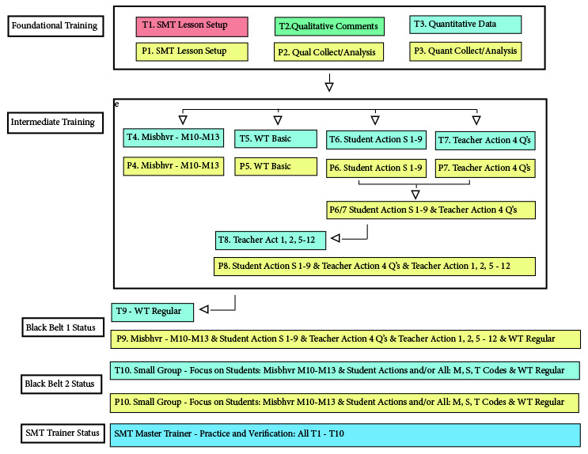
Training Elements - Each training has a Video Overview with a Cheat Sheet that highlights important features and components of the training and guides the user when practicing the data collection or analysis skills. Each training from T3 on also has an Extended Practice option and an Extended Practice Key so the novice user can compare their data and analysis to an expert user's to determine if more practice is warranted.

Training Video Overview | Cheat Sheet | Extended Practice Key
Training 1 – Setting Up a Lesson | Cheat Sheet 1 | NA
Training 2 – The Qualitative Mode | Cheat Sheet 2 | NA
Training 3 – Basics of the Quantitative Mode | Cheat Sheet 3 | Extended Practice Key 3
Training 4 – Misbehaviors and Teacher’s Reactions | Cheat Sheet 4 | Extended Practice Key 4
Training 5 – Wait Time (Simple Method) | Cheat Sheet 5 | Extended Practice Key 5
Training 6 – Student Actions (S Codes) | Cheat Sheet 6 | Extended Practice Key 6
Training 7 – Teacher Actions (4 Question Types) | Cheat Sheet 7 | Extended Practice Key 7
Practice 6/7 – Merging S Codes and 4 Question Types  (no video – use Cheat Sheet for practice instructions) | Cheat Sheet 6/7 | Extended Practice key 6/7
Training 8 – Merging S Codes and All Teacher Actions | Cheat Sheet 8 | Extended Practice Key 8
Training 9 – Wait Time and M, S, and T Codes | Cheat Sheet 9 | Extended Practice Key 9
Training 10 – Small Group Data | X | X
SMT How to add a Lesson Plan | X | X
SMT How to add Summative Forms and Rubrics | X | X

Videos Used in Training and Extended Practice
SMT Practice Video Swinging Spheres https://youtu.be/XlPKXIkeHMA
SMT Practice Video Float Sink M * https://youtu.be/uLJ3Jvn0jHw
SMT Practice Video Float Sink A - Wait Time https://youtu.be/BaznvpVUx-U
​ SMT Practice Video Float Sink A https://youtu.be/oxxazkrBChg

Videos for Additional Extended Practice
Regular
SMT Practice Video Float Sink B https://youtu.be/k38GViRMJIM
Practice Video Truck Hill L (75% speed) https://youtu.be/A76fVcYo6ks
​
Misbehaviors
SMT Practice Video Truck Hill M * https://youtu.be/YSD7mNBbZ1Q
​
Note the * indicates a practice video more suited to misbehaviors and practicing M codes.

More Detailed Training Level Information
Black = Narrative Overview and Instructions Blue = Video Overview Green = Practice

Training 1 – New Observation Lesson Setup
Lesson 1.0: Video Overview - Acclimating to SMT
Lesson 1.1: Learning About New Observation Settings
Lesson 1.2: Practice - Setting Up a New Observation

Training 2 - The Qualitative Comments Mode
Lesson 2.0: Video Overview - Using the Qualitative Mode
Lesson 2.1: A Quick Look at Specific Features of the Qualitative Comments Mode
Lesson 2.2: Practice - Completing a Qualitative Comments Observation
Lesson 2.3: A Quick Look at Specific Features of the Qualitative Analysis and Feedback Mode
Lesson 2.4: Completing a Qualitative Analysis

Training 3 - Basic Information for Using the Quantitative Mode
Lesson 3.0: Video Overview - Quantitative Data Collection Screen
Lesson 3.1: The Quantitative Data Collection Screen
Lesson 3.2: Two Types of Codes for Collecting Data
Lesson 3.3: Basic Rules and Options
Lesson 3.4: L Codes – Type of Lesson in Play

Training 4 - Learn About M Codes: Student Misbehaviors and Teacher Reactions
Lesson 4.0: Video Overview - M Codes
Lesson 4.1: M Codes Defined
Lesson 4.2: Setting Up a New Observation
Lesson 4.3: Practice - Data Capture Using M Codes
Lesson 4.4: M Code - Student Misbehavior and Teacher Reaction Data Analysis

Training 5 – Wait-time Simple Method
Lesson 5.0: Video Overview – Collecting Wait-time Data Using the Simple Method
Lesson 5.1: The What and Why of Using Wait-time
Lesson 5.2: The How-To of Collecting Wait-time Data
Lesson 5.3: Analyzing Wait-time Data

Training 6 – Learn About S Codes: Student Actions, Engagement and Using the Seating Chart
Lesson 6.0: Video Overview - Using M and S Codes, Seating Chart and Data Analysis
Lesson 6.1: S Codes Defined
Lesson 6.2: New Observation Setup and Seating Chart
Lesson 6.3: Practice - Data Capture Using S Codes with a Seating Chart
Lesson 6.4: S Code – Student Engagement Data Analysis
Lesson 6.5: Practice - Data Capture Using M and S Codes with a Seating Chart
Training 7 – Learn About T Codes: Teacher Actions and Behavior – The Four Question Types
Lesson 7.0: Video Overview - Using and Remembering T Codes
Lesson 7.1: T Codes Defined/Examples
Lesson 7.2: Learning and Practicing Identifying T Codes on Paper
Lesson 7.3: Practice - Data Capture Using T Codes with Video
Lesson 7.4: Video Overview - T Code Data Analysis
Lesson 7.5: T Code - Teacher Actions Data Analysis

Practice 6/7 – Merging Data Collection of Both Student Actions and Teacher Questioning
Lesson 6/7.1 Instructions for Practice
Lesson 6/7.2 Practice Merging Student Actions and Teacher Questioning
Lesson 6/7.3 S Code and Question Type Data Analysis

Training 8 – More About T Codes: Teacher Actions and Behaviors - 0, 1, 2 and 5 – 12
Lesson 8.0: Video Overview - Data Collection and Data Analysis Using T, M, and S Codes
Lesson 8.1: Practice - Data Capture Using T, M, and S Codes at Slower Speed
Lesson 8.2: Data Analysis Using T, M, and S Codes
Lesson 8.3: Collecting Data Using U Codes - User-Identified Labels
Lesson 8.4: U Code - Data Analysis

Training 9 – Wait-time Regular Method: Incorporating T, M, and S Codes, Using a Seating Chart, and
Wait-Time
Lesson 9.0: Video Overview - Using T, M, and S Codes, Seating Chart and Wait-Time
Lesson 9.1: About Collecting Wait-Time
Lesson 9.2: Practice - Data Capture of T, M, and S Codes, Seating Chart and Wait-Time
Lesson 9.3: T, M, and S Data Analysis Using Seating Chart and Wait-Time

Training 10 – Learn About G Codes: Small Group Interactions
Lesson 8.0: Video Overview - Data Collection and Analysis Using G Codes
Lesson 8.1: Introduction to Group Setup
Lesson 8.2: Setup for Groups in the Seating Chart
Lesson 8.3: Collecting Group-related Data
Lesson 8.4: G Codes - Group Actions Data Analysis

SMT Trainer Practice and Verification - Black Belt Plus More Speed: T, S, M, and U Codes Seating Chart, Wait-time with Increased Speed and Accuracy

Training 1 - Setting Up a New Observation
In this lesson, the user will learn:
- How to create a new observation and navigate the dashboard of SMT.
- The “settings” required before the observation begins.
- Factors to consider in terms of which member of the team should set up an observation.
- When it is best to set up the observation.
- How the quantity of time available before the lesson affects who sets up the observation.
- Whether it is necessary to input all the information for a regular start or just the minimal information needed to get started quickly.
- How to invite multiple users to observe and analyze a lesson observation.
Training Elements
Lesson 1.0: Video Overview – Setting up a New Observation

Cheat Sheet 1

Steps to Take – First, watch the video overview. The video highlights key areas of the screen and describes features and functions. Have Cheat Sheet 1 open while watching the video. After watching the video, read through the sections below for a thorough overview of SMT functions.

Lesson 1.1: Learning About New Observation Settings

Initial Login - After logging in, the main operational page, the Dashboard, contains a listing of observations that have been set up and perhaps completed, and the option to create a new observation using the New Observation button. If the user is a first-time user, no observations will be listed.

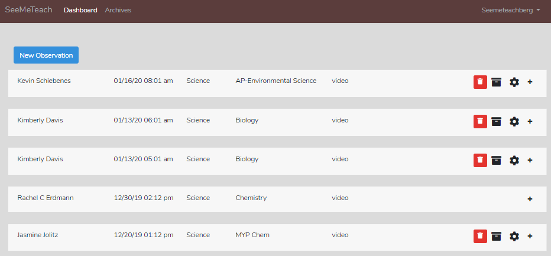

New Observation: Screens, Choices, and Minimal Information - When clicking the New Observation button from the Dashboard, the first screen presented is labeled Create a New Observation. See the figure below, and note that this screen includes the minimal information needed before the setup can be saved or the user can start an observation. This primary information will be displayed on the dashboard or before the user can start an observation.

- Video Type: At the top of the New Observation screen, the user is prompted to choose whether the observation is video- or audio-based or a real-time classroom observation.
  - If the observation is video-based, the URL of the video is entered.
    - Video-based has two storage options: YouTube or uploaded directly into SMT’s secure cloud storage.
    - Audio-based means the user captures audio (without video), which is stored on SMT’s secure cloud storage. The analysis is completed while listening to the teacher and student interactions.
      - Note that there is a section at the end of this manual on options and how or where to store the video or audio.
  - Real-time means either the observer is in the classroom using SMT or watching the classroom virtually using an online platform in one window and SMT in another window. No video is captured or saved, and comments or data are not linked to video segments as they are when using a video.
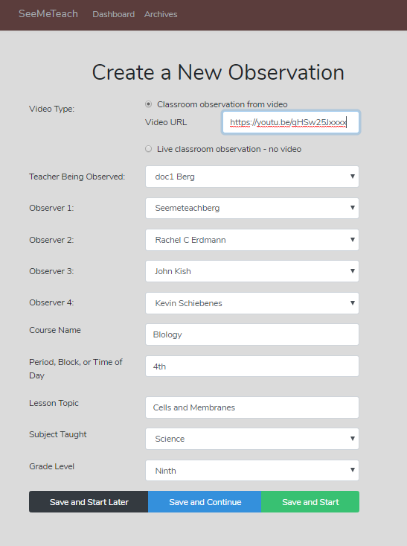
- Team member names: To save a New Observation, the user, at minimum, must enter the name of the Teacher Being Observed and the name of Observer 1. Note that the user who is logged into SMT and doing the initial setup will, by default, be listed as Observer 1. Select the person teaching the lesson as the Teacher Being Observed. At this point, the user can start a lesson observation after entering these two pieces of information.

Suppose there is a second, third, or fourth observer. In that case, the user can enter other team members’ names or choose names from the dropdown menu if that person was part of the user’s team in an earlier observation, accepted your invitation to join SMT so they could be a collaborating colleague with you, or if their name was included as part of your teacher preparation or school group team.

Note: The person teaching should always be listed as Observer 1 or Observer 2 because only Observers 1 and 2 have set-up rights and can enter or change the setup information or delete an observation from the Dashboard. If the user is the only person viewing and completing the lesson observation, their name would be listed as the teacher and as Observer 1.
Note: At any time, even after an observation has been completed, the user can add more team members to the observation (up to four total team members).

Following input of this minimal information needed to begin an observation, the user can:
- Save and Continue (goes to the next screen of settings, which contains a list of additional considerations like pre-lesson questions, seating chart, etc.)
- Save (saves information that was selected or typed)
- Save and Start (the user is asked to choose a qualitative or quantitative mode and then is taken to the screen of the mode they chose, then starts the observation).
- Save and Return to Dashboard (returns the user to the Dashboard)

Starting and Continuing the Setup of a New Observation from the Dashboard
If the teacher (or observer) sets up the lesson observation ahead of time, then clicks Save and Return to the Dashboard, the lesson will be listed on their Dashboard and on the Dashboard of the other members of the observation team who were identified when setting up the lesson (or other members could be added later). At this point, the user could either:

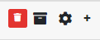
  - Depart from and log back into SMT when ready for the observation.
  - Click on the gear symbol to go directly back into settings to add more information, such as a seating chart. (Shown below)
  - Click on the plus symbol (+) to see the expanded dashboard for that observation and view the basic information regarding the teacher’s name, time/date of the lesson, observer names, and the state of observation(s) completion for the various observers. (Shown below)

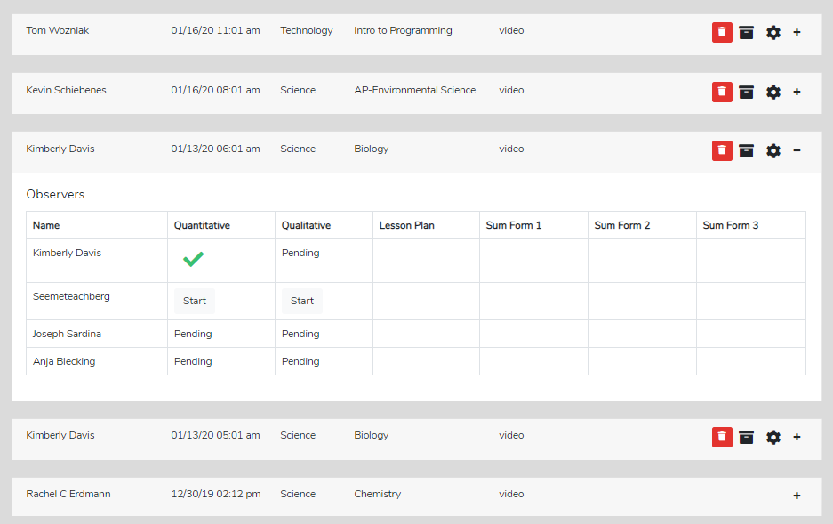

When viewing the expanded dashboard, they can click the Start button to begin an observation. Or, to view another team member’s results, they can click the green checkmark. Note the graphic above and the three various stages of observation shown under the quantitative and qualitative columns.

  - Start – The user can click this button and start the observation. Don’t start the observation unless you have time to finish it. You can briefly pause while in the observation, but if you leave the observation and return to the dashboard, you cannot get back into the observation and do more.
  - Green Checkmark – This mark means the observation has been completed. Clicking the green checkmark opens the data analysis for that observation.
  - Pending – This means the other team member (or team members) must still log in to their account and begin the observation.

Adding Additional Information to a New Observation
If the user wants to add more information after filling out the minimum information on the Create a New Observation screen, they should click Save and Continue. The next screen presents various options (listed in the upper left-hand corner) to include Pre-Lesson Questions, Seating Chart, Student Demographics, Lesson Plan, Summative Forms, Teacher Demographics, and Post-Lesson Questions (shown below).

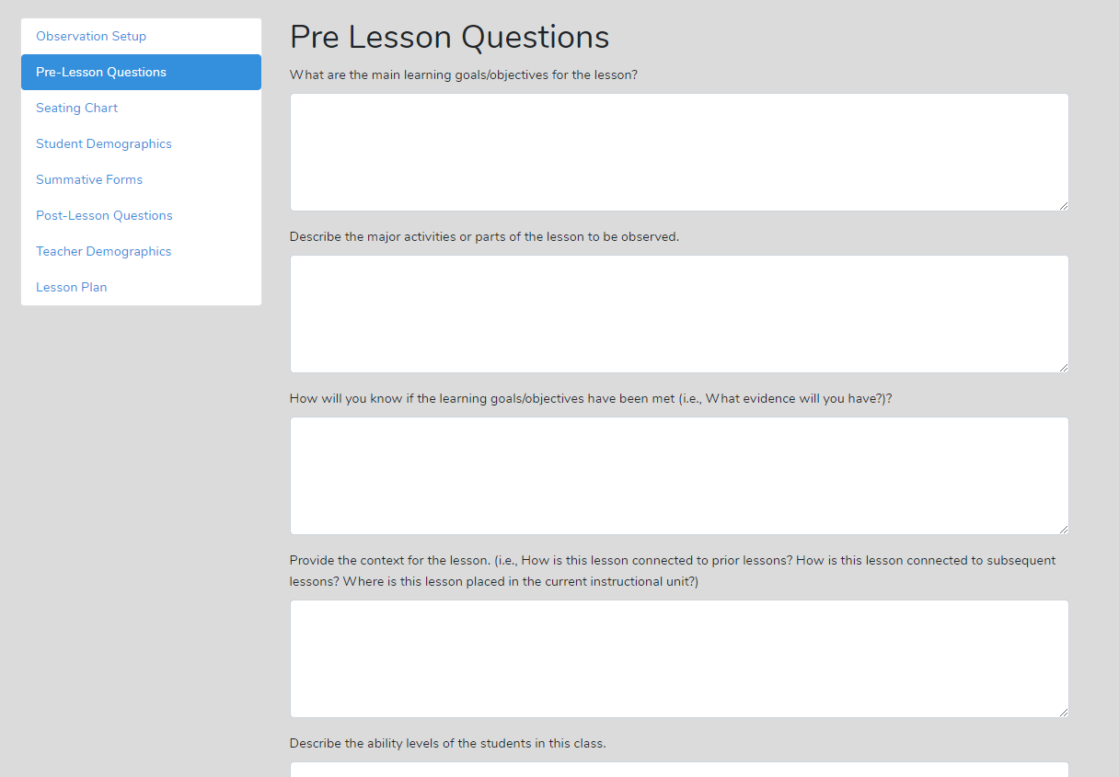

The person teaching the lesson can fill this out or click on any of the other choices in the box at the top left of the setup screen and proceed in or out of order as needed.

- Pre-Lesson Questions – These questions are posed to the teacher being observed before the lesson, including:
  - What are the main goals and objectives of the lesson?
  - Describe the significant activities or parts of the lesson to be observed.
  - How will you know if the learning objectives have been met? What evidence will you have?
  - Probe the content of the lesson.
    - How does this lesson connect to prior learning, and how does it connect to subsequent learning?
    - Where is this lesson placed in the current instructional unit?
    - Describe the ability levels of the students in the class.
  - What will you do to maximize the engagement of all ability levels of students?
  - How will you differentiate the lesson for all types of learners?

- Seating Chart – For each observation, the user can set up a specific seating chart for display and use during the qualitative or quantitative collection modes. If a specific seating chart is not created, a generic seating chart is displayed with an 8x10 grid.

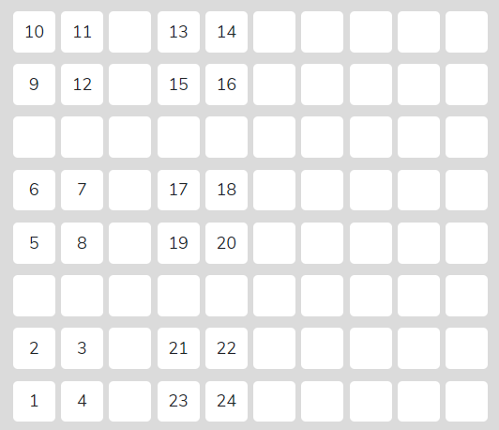
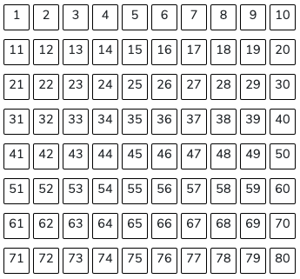

Seating Chart with Student Numbers Generic Seating Chart

Individual Student Data
  - Individual student data can be captured using the seating chart and the S code (student response) and M code (behavior management) buttons in a situation where the goal is to better understand how individual students respond or behave in class. This allows the user to capture data on how these students are:
    - Engaged (or not engaged) in answering questions.
    - Interacting with the teacher and/or other students.
    - Behaving (or misbehaving).

Setting up a Seating Chart for Individual Students
  - First, to identify where students are seated, click on the STUDENT icon so it turns blue. Then click on a square to identify where the first student is seated. Then click on the next square for the second student and repeat until all student seats have been identified. Finally, click on the STUDENT icon again to deselect it.
    - Note: Click carefully, but if you make a mistake, the Clear button will allow you to erase seat numbers one step at a time.
  - To place an indicator for where the observer is sitting in the classroom, click the TEACHER or OBSERVER icon to turn blue. Then click on a square to identify where the teacher’s desk is, or where the observer is seated. Placing these on the seating chart can help both the observer and the teacher orient themselves to the seating chart.
    - Note that the seating chart cannot be added or changed once an observation has started.

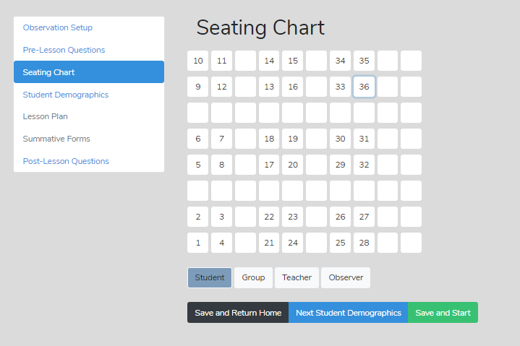

Group Summary
A common pedagogical strategy in classrooms is grouping students for labs, discussions, cooperative learning, problem sets, and many other purposes. All educators hope for rich, equitable interactions and that all small-group members are involved in the work and conversation. But small groups are often notorious for having a subset of the group doing most of the work, resulting in the other group members playing a passive role in the conversation and diverting their focus to non-lesson-related topics. The goal of instruction is to get ALL students involved equitably and productively related to the goals and objectives for that lesson. SMT can help collect data on whether this goal is achieved, and at what level, by collecting data linked to groups identified in the seating chart using Group Setup.

Group Setup – When setting up a new observation, the user can designate small groups of students by group number, along with an individual student number, so student behavior and management code data can be prefaced by a group number and the student number within that group. After designating student and group numbers, student number 2 in group 1 would have a square that reads G1:2 (Group 1, student number 2, or a student number 15 in group 3 would have a designation of G3:15 (Group 3, student number 15) as shown below.

Also, note that when Gs represent small groups in the seating chart, student engagement or misbehaviors can be coded to a specific group (if the question or comment was targeted to the group) or coded to a specific student within that group. What can be learned when collecting individual student interactions within a group? We know that one or two students often dominate the conversation in some small groups. We also know that a lesson can be structured using roles so most group members are equally engaged and contribute to the lesson. Using the S codes with a specific G number allows you to examine these dynamics and look at specific within-group communication and engagement.

Setting up a Seating Chart for Groups
- To identify where students are seated in groups, first set up your seating chart with individual students using the directions listed above for Setting up a Seating Chart for Individual Students.
- When you have finished setting up your seating chart, select a specific number or grouping of individual students in the same group, and then click on the Group icon again.
- Then select all of the students in the next group and click on the Group icon to denote the second group. Repeat this process until you have identified all groups.

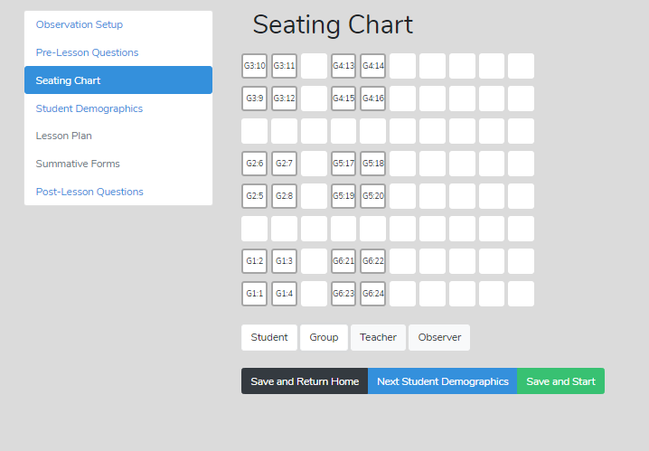

- Student Demographics – This feature notes gender, minority, special education needs, or ESL/ELL status for each student. It is embedded into the seating chart heat map feature and used to help determine the equity of student engagement or isolate the origins of classroom management issues.

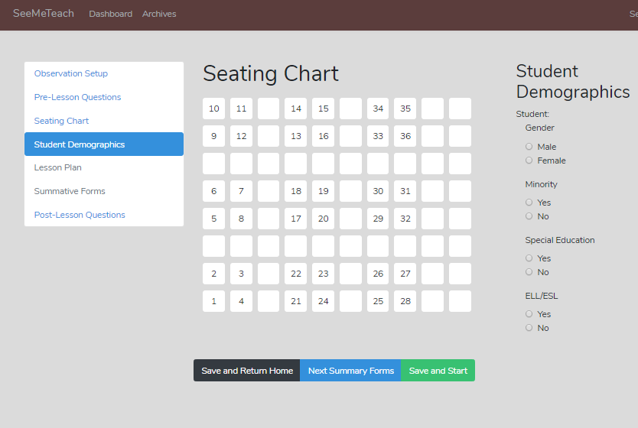

- Lesson Plan – The teacher’s lesson plan is added during the initial lesson setup or later by going back into settings using the gear symbol and then clicking on Lesson Plan. Using Browse, the user locates the PDF file of the lesson plan on their computer, then Uploads the lesson plan, which needs to be in PDF format. The lesson plan can be viewed before an observation via the Expanded Dashboard or after an observation within the Team Table.

Lesson Plan How-To Video – https://youtu.be/lPKZZgcyk44
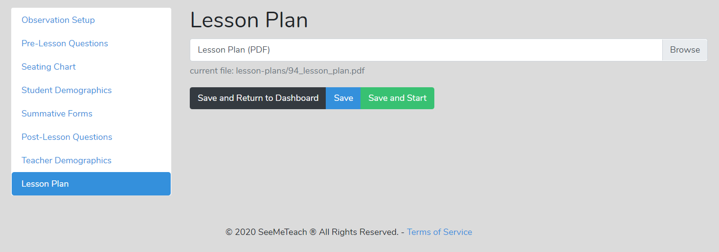

- Teacher Demographics – This is optional and not used in data analysis, but contains some background information about the school and the teacher’s educational background.

- Post-Lesson Questions – The teacher can fill out these questions after the lesson has been taught and the observation has been completed. You can answer this set of questions from within Settings or from the Qualitative/Quantitative Analysis screen. The Post-Lesson questions include:

  - Tell me about today’s lesson.
Probe: What went well?
Probe: What needed to be improved?
Probe: What would you change if you taught this lesson over again? Why?
  - What do you think students learned from today’s lesson?
  - What evidence do you have of this learning?
  - What evidence do you have that learners of all ability levels were engaged in this lesson?
  - Based on what happened in today’s class, are you planning to make any changes to the next lesson? If so, what are these changes?
  - What is the next step for this class in this unit?

- Summative Forms – The summative forms function allows the observer and team members to provide summative remarks, feedback, or complete scoring using standard forms designed by SMT or user-designed, fillable PDF forms. Up to three different forms could be used and included for each observation. Once filled out and uploaded to SMT, any observation team member can complete or view them via the Expanded Dashboard or the Team Table.

Summative Forms: Single User vs. Groups - With a single user plan, each user decides which Summative Form(s) they wish to use for a lesson observation they establish. With a group plan, the group administrator determines which forms the group can access and use for observations.

There are three quick steps the user takes to incorporate summative forms into an observation.
Step 1 - Loading Summative Forms Into Your SMT Account
Step 2 - Choosing Which Forms to Use for a Specific Observation
Step 3 - Using the Summative Forms Post-Observation

The how-to video and directions below explain this process.

Summative Forms How-To Video - https://youtu.be/FtG7p1AZf3w

Step 1 - Loading Summative Forms into Your SMT Account
1.1 Forms Must Be Fillable PDFs: A form must be in the format of a fillable PDF document. The user may use standard forms embedded in SMT or create their own form(s). School districts or teacher preparation programs may use a unique set of observation forms, which the user must convert into fillable PDF forms before uploading them to their SMT account, as described below. More detailed instructions for creating fillable PDF forms are at the end of this section.

1.2 Upload Forms to SMT Account: The fillable PDF forms are uploaded to the user’s SMT account. When the user (single or group administrator) wants to upload the forms to their account for themselves and/or their team of observers, they:
* Log in to SMT
* Click on the login name drop-down in the top-right corner, and
* Click on Custom Summative Forms.

A Summative Forms page is displayed. Note that first-time users will see the following screenshot, which shows no forms listed.
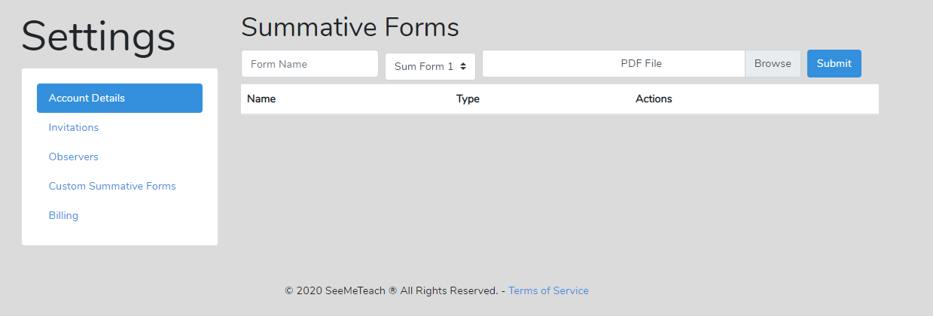

  - The user should identify whether the form will be used for Sum Form 1, Sum Form 2, or Sum Form 3. Note: If the user always wants their observation rubric as the primary form, they should choose Sum Form 1 and type a name for the form into the box labeled Form Name - perhaps a short name such as Obs Rubric.
  - Browse to locate the fillable PDF file on the user’s computer and click Submit. Note: It is helpful if the file name of the form stored on the computer is close to or matches what the user labels it for use in SMT.
  - Clicking Submit adds the form to the column by name and type of form (1, 2, or 3), as seen below.

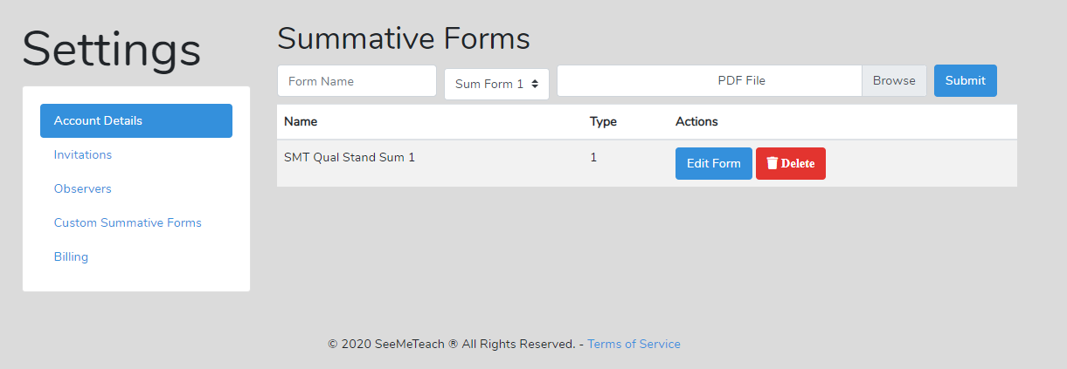

1.3 Changing or Deleting - If the user wishes to change the Form Name or the category from Sum Form 1 to Sum Form 2, they click on Edit Form. If they do not want that form listed as one of the choices presented when setting up a lesson, they can choose Delete.

1.4 Different Forms Used at Different Times - Some teacher preparation programs might use an observation rubric form and have a mid-term or final summative form used only once during field placement. SMT is designed so the user may load more than one form for each Form 1, 2, or 3, as they may need different forms at different times. For example, in a teacher observation program, the observer might use a rubric for Form 1, then a Likert scale with comment boxes for Form 2, and a mid-term or final form for Form 3. If both the mid-term and final forms are loaded under Form 3, the user can switch from the mid-term to the final form when needed when setting up a new observation. In short, users can choose whatever forms they wish to use for a specific observation (next section below) if they have loaded the desired forms into their accounts.

Step 2 - Choosing Which Forms to Use for a Specific Observation
2.1 When setting up a New Observation, after completing the initial and basic lesson information entry, the user can click on Summative Forms. Dropdown choices for Summative Forms 1, 2, and 3 will be listed.

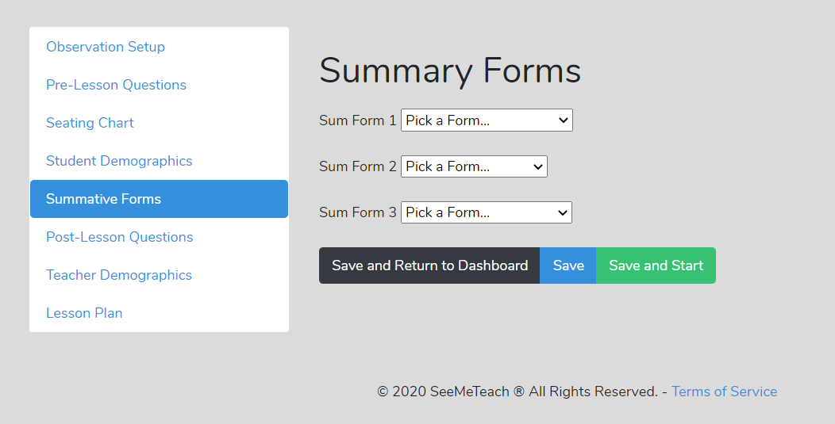

Note that the form in the dropdown depends on what the user loaded into their SMT account. If no forms appear in the drop-down choices, the user must complete Step 1 above.

2.2 If summative form choices are in the dropdowns (shown below), the user can choose which form(s) to use for the observation. For each observation, the user may choose only one form for Sum Form 1, Sum Form 2, and Sum Form 3.

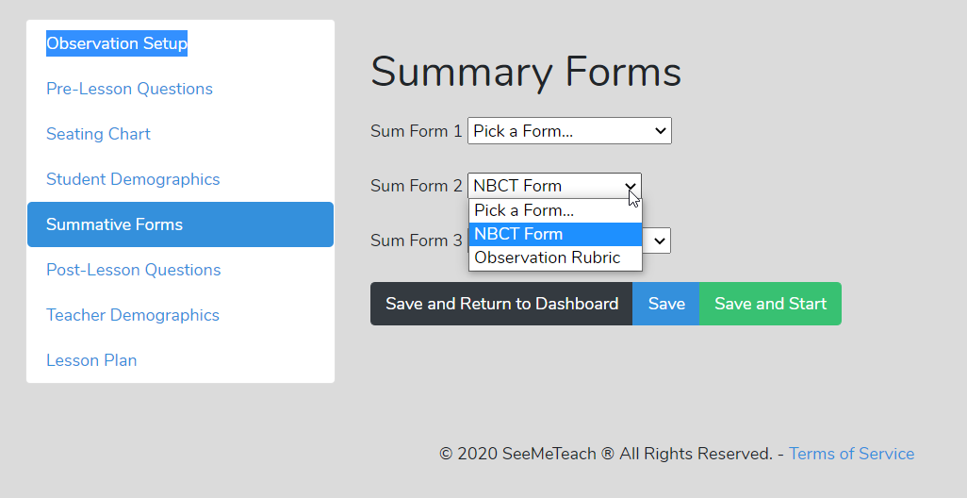

Step 3 - Using the Summative Forms Post-Observation
Following the observation, the observer’s goal is usually to provide feedback on strengths and weaknesses and to offer suggestions for improvement. Well-planned forms help the observer accomplish this goal. In this last step, the user will learn to fill in the blank fillable PDF form with final comments, summative remarks, or rubric scores, then connect it to the SMT observation so any team member can access it by clicking the icon in the Team Table or within the Expanded Dashboard.

3.1 To fill in a summative form after the observation phase is completed, click on the Team Table when the user has either the quantitative analysis or qualitative analysis screen open. The user should see the figure below.
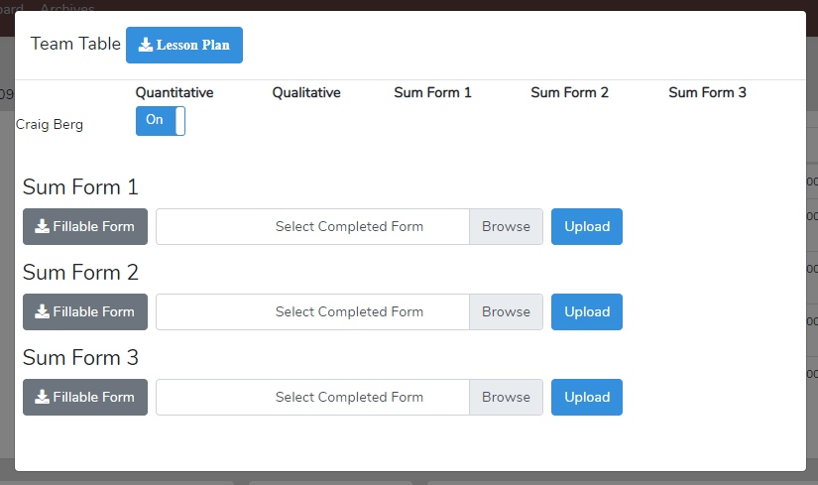

Note that if the user who set up the lesson, when completing a New Observation, did not choose which summative forms to use for the lesson observation (as described above in Step 2 - Choosing Which Forms to Use for a Specific Observation), then when any member of the observation team gets to the Team Table, they will see the following screen showing No Forms Selected. In this case, the user who set up the lesson must complete Step 2.

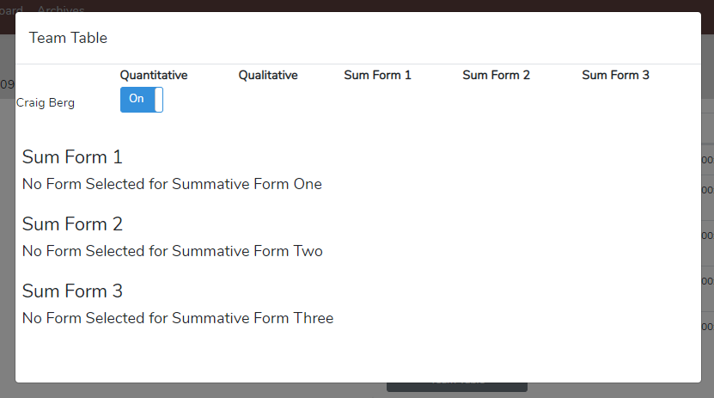

3.2 Note: The next and last step requires the user to have the form on their computer to fill in the PDF, save it, and upload it to SMT. They may or may not already have this form.

User does not have the form - If the form is not yet on the user’s computer, they should first click on the grey box labeled Fillable Form (see below). It will open in a separate browser window, but this is NOT where users fill in their scores or comments. Note – it must first be downloaded to the user’s computer to fill it in – filling it in within this open window will not save the text or numbers the user adds. The user should download the form to their computer by right-clicking on the form in the window that just opened and Select, then Save As, the file on the computer. (On a MAC, go to File and Save Page As.) Then, locate the file where it was downloaded on the computer, open the fillable PDF file, enter comments and numbers, or click on checkboxes. Then save it to the computer with a name that represents the teacher and observation.

Back in the Team Table, the user can use the Browse button (see below) to locate the file name on their computer, click Upload, and after the current quirk of bumping out of the Team Table, they can re-enter the Team Table to view the icon in the appropriate form column. Now, when the user or any team member clicks on the Sum Form Icon, the PDF will display the form's contents.

User has the form - If the user already has the blank fillable PDF form on their computer (because they created it or because an institution distributed the required forms), they simply fill it in and save it with a name representing the observation. Then the user can then Browse to locate the file and then Upload it. Once uploaded in the Team Table, an icon will now reside under the column for that summative form (see the figure below). If needed, repeat this process for each of the three forms. Note, as seen below, that the file name for each summative form used has been added to the Team Table to help identify which form has been uploaded. For example, C. Berg Science Midterm.pdf.

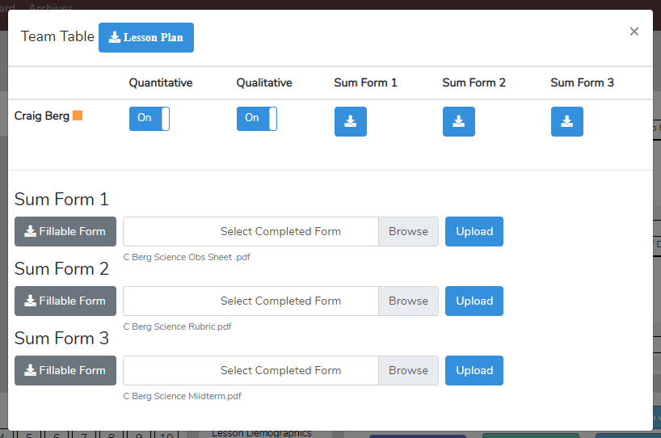

Once finished, the summative form icons will also appear in the Expanded Dashboard for that lesson, as shown in the figure below. Clicking on an icon opens the summative form for viewing only.
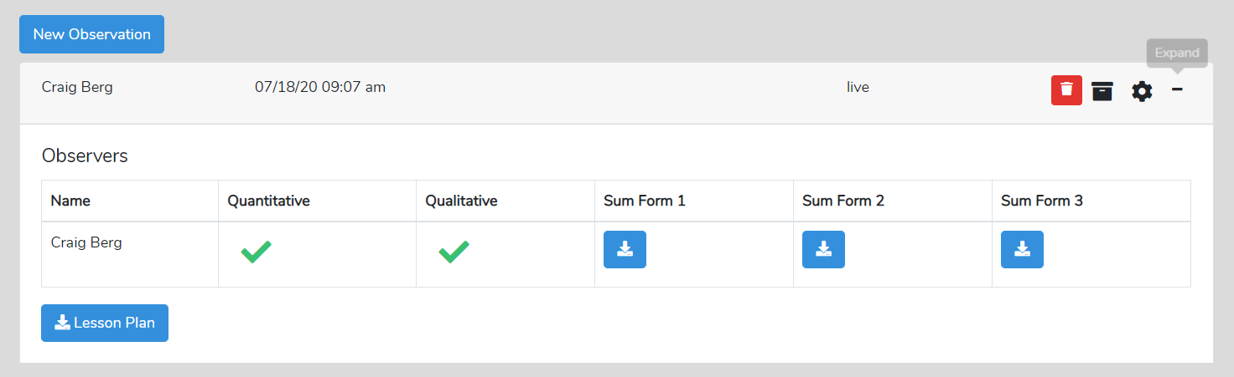

Standard Forms for School Districts or Teacher Preparation Programs
A school district or a teacher education program probably uses standard observation forms. SMT is designed so that the school or institution's group administrator (group leader) can create and add forms to the group account or choose which forms the group members can use for observations. The group administrator is responsible for creating and uploading the fillable PDF forms using the process described in Step 1 - Loading Summative Forms into Your Account. Only the group administrator can add forms for the group. The other group members cannot add new forms for the group. Therefore, group members are limited to the Summative Form options the administrator has chosen. To identify which forms will be used for a specific observation, the user who sets up the observation will choose the Summative Forms while setting up a New Observation. Then all observation team members (post-observation via the Team Table) can fill in and upload the form. Observation team members can then view these forms from the Team Table or the Expanded Dashboard.
Creating digital fillable PDF forms
Most people have heard of a PDF format for a document. A fillable PDF is just like it sounds. The document has boxes for typing text or checkboxes for making checkmarks or boxes for making an X. To create a fillable PDF form, the user must first create a document (probably in Word), then turn it into a fillable PDF document using software such as Adobe Acrobat DC, MAC pdf Element, Microsoft Print to PDF, or Foxit PhantomPDF. Adobe Acrobat DC is a subscription-based app for creating and managing PDF files, offering Standard and Pro plans. There is also a free trial subscription. As you might expect, many resources show how to create a fillable PDF, including Wiki and YouTube videos.

Who Can Create a New Lesson (Setup) Observation? Can setting up a new observation be completed before starting the observation? Factors to consider are:
1) How much time the observer has available before the start of the lesson
2) How much the observer knows about where students will be seated in the classroom and knowledge of students’ demographics
3) Whether a specific seating chart with student demographics is important for the observation or if a generic seating chart without student demographics will suffice.

The answers to questions 1-3 will determine whether the teacher or the primary observer is better positioned to set up the lesson. However, while the teacher being observed might do the initial setup, the primary observer can, if desired, complete any remaining parts of the setup before the observation, or vice versa.

There are some advantages to having the teacher set up the new observation. For example, the teacher knows the students' classroom seating chart and demographics, whereas the observer probably does not know this beforehand. Once within the classroom, the observer can see where students are seated and perhaps note some of the demographics, but if special education or ELL is an important factor, and that factor is present for analysis, then the teacher, not the observer, is most likely the person who should enter the complete demographic information. Only when a specific seating chart has been created can student demographic information be entered (before or after the observation), and then, in the future, student demographic information will be used for analysis in association with the heat map of the seating chart. The heat map is simply a color-coded student seating chart showing levels of student engagement or misbehaviors from zero to > 5. Note: The generic seating chart does not allow for student demographic-specific analyses.

Time Available Before the Start of the Observation
Suppose the user needs to start a lesson observation in a short amount of time. In that case, they can do a “quick-start” by entering only the minimal information on the first screen of New Observation and quickly starting the observation. If more time is available, the user can do a regular start and enter as much information as desired.

Quick-Start for a Live Observation – This feature is designed for the observer who is planning a live observation and has very little time before class starts. This setup takes about one minute and quickly gets the user into the live classroom observation, bypassing some teacher demographic information, which can be entered after the observation.

A quick start can be used:
- Suppose the teacher completes the minimal setup required to establish an observation on the Dashboard ahead of time. In that case, another team member can log in to their Dashboard and start the observation immediately.
- When a generic seating chart without student demographics is suitable for the observation, the observer arrives at the classroom 1 - 2 minutes before the start of the class and wants to input minimal information to set up a new observation in time for when the bell rings.

Steps to Begin a Quick-Start Observation
- Click on New Observation
- Enter the minimal information needed to begin an observation:
  - Choose whether the observation is video-based or a real-time classroom observation.
    - If video-based or audio-based, enter the URL of the video or audio
  - Team member names: Minimally, the user must enter the name of the teacher and primary observer (or choose from dropdowns).
  - Add the course name, period, lesson topic, subject topic, and grade level.
- Then click Save and Start if the user wishes to begin the observation. Or, if time allows, Save and Continue to continue with the lesson setup. Or, if starting the observation later, click Save and Return to Dashboard.
  - If Save and Start is chosen, the user is then prompted to choose Quantitative or Qualitative mode. Once a mode is chosen, the observation and data collection screen opens, and the user begins.

Regular-Start – Use this when the observer has roughly 5-10 minutes before the observation. The teacher being observed or the observer can enter most of the Settings information before the observation.

Post-Observation
Once the observation is complete and the user clicks Done, various steps can be taken, such as viewing data analysis for quantitative and/or qualitative data.
- If a specific seating chart was created before the observation, but student demographics were not added at that time, student demographics information could be added at any time post-observation.
- Additional team members’ names could be added post-observation, allowing them to complete a quantitative and/or qualitative observation if the lesson was set up as a video-based observation.
  - To add either student demographics or additional team member names, the user can go back to Settings on the Dashboard, click on the Settings icon (gear symbol), and add the information. Note that post-lesson questions are also found in Settings or can be accessed from the Post Lesson Questions button on the analysis page.
- Note: If the user completed a live observation, additional team members could view the data analysis and feedback from that observation, but without video, no video would be linked to the data. The additional team members could also view pre-lesson and post-lesson question responses and could fill out summative forms. For example, suppose the university supervisor was doing a live observation. In that case, the student-teacher (who taught the lesson) and their cooperating or mentor teacher (who watched the lesson) might fill out their reactions and comments using the summative form(s).
Using Video or Audio Recording Presents More Options - Observers can choose either the qualitative or quantitative mode for a live observation. For an observation that uses video or an audio recording, however, an observer can use qualitative, quantitative, or both modes, as once the lesson is set up, the observer can complete one mode and then the other. This also means that when using video or an audio recording, all team members can complete a qualitative and/or quantitative observation, resulting in rich data, analysis, and feedback.

Dashboard – Archiving Observations – the file folder symbol is used to archive a lesson observation when the observer wants to retain it but reduce clutter and the number of observations on their Dashboard. Only Observer One and Observer Two can delete or archive a lesson. Note that, once archived, the lesson cannot be brought back to the main Dashboard. So, think twice before archiving any lesson.

Lesson 1.2: Practice Creating a New Observation – Before the user creates their first new observation, they should have read the preceding pages and watched the video overview: https://youtu.be/i1WNYupuSqs

After reading this section and using Cheat Sheet 1, the user should use SMT to set up a practice observation, which will entail completing a qualitative observation in Level 2 Training.
- Click on “Create a New Observation”
- Choose “Classroom Observation from Youtube”
  - Input the following link into the text box: https://youtu.be/XlPKXIkeHMA
  - Then fill in the preliminary information according to the Cheat Sheet 1
- Then click “Save and Continue”
- Set up a Seating Chart like the one on the Cheat Sheet.
- Click on “Student Demographics” on the upper lefthand corner
  - Practice assigning student demographics to each student.
- Click “Save and Start”
- Click “Qualitative”
  - Choose “Standard” option for the subset of buttons and then choose “Start” to begin the observation.
Since you are not going to do an observation, click Dashboard from the page header to immediately return to your dashboard page

This is the end of Training Level 1. Congratulations, you just set up your first observation!

Looking Ahead to the Next Lesson
You will use the completed lesson setup in Lesson 2.2, where you will be asked to start and complete a qualitative observation.

Training 2 – The Qualitative Comments Mode
Introduction – The qualitative comments mode allows the user to observe and make comments. With SMT, the comments are:
- time-stamped and labeled/organized by comment categories
- color-coded to the specific team member who is making the comment
- linked to the video segment related to the comment (if using a pre-recorded lesson)
- locatable using a search and find function to help locate comments of a specific type
- also noted via symbols on the timeline below the video so immediately the user can see who and how many comments are attached to the lesson, then click to read the comment and play the video segment

In addition, a team member feature allows any team member to view any other observer’s comments.

Suggested Uses - The team member’s qualitative analysis might be useful regarding:
- The teaching observation of a fieldwork student or student-teacher by the teacher preparation program supervisor - After the observation, the qualitative analysis page is available to the student-teacher, who can view comments, respond to post-questions, post their reactions and commentary, and fill out the self-reflective Summative Form(s).
- When using video for the observation, team interaction and communication can be enhanced. Any team member can do a qualitative analysis of that lesson and view any other team member’s running commentary and summative comments.
- When using video, all comments are linked to specific video segments so the viewer can see any particular action as it occurred in the classroom.
- Methods of teaching instructors can view the video of pre-service teachers implementing suggested strategies, view pre-service teachers’ analyses and reflections, and add their comments or suggestions.
- For a classroom teacher’s yearly observation, a teacher can capture a video of their teaching and complete a self-analysis while an administrator completes their own, merging their commentary with the teacher's. A conversation then follows this whole process. When using video, comments are linked to the video, making it easy to locate any part of the observation and showcase events being discussed.
- Research team members can share data and analysis screens by printing the data and analysis screens or by exporting the raw data to a .xls spreadsheet for more refined and custom analysis (coming soon).

In this lesson, the user will learn:
- Which of the many qualitative comments button sets to use for your intent of the observation.
- How to complete a qualitative observation by adding qualitative comments that are timestamped and linked to the video segments.
- Post-observation, how to view the comments and watch the video segments linked to the data.
- How to search and find comments headed by comment labels and categories.
- How to use the Team Table to toggle on or off other users’ comments.
- How to react to other users’ comments.
- How to enhance qualitative comments by incorporating data gathered from the quantitative mode.
Training Elements
Lesson 2.0 - Video Overview of Qualitative Mode

Cheat Sheet 2

Steps to Take - To complete Level 2 training, watch the Video Overview of Qualitative Mode while having Cheat Sheet 2 open. Then, read the specific features section below to reinforce what was presented in the video. Complete the practice suggested in the video or follow the training lessons to complete a short qualitative observation and learn the mechanics of using SMT's qualitative mode.

Lesson 2.1: A Quick Look at Specific Features of the Qualitative Comments Mode

Note the following main quadrants of the screen that show a completed observation.
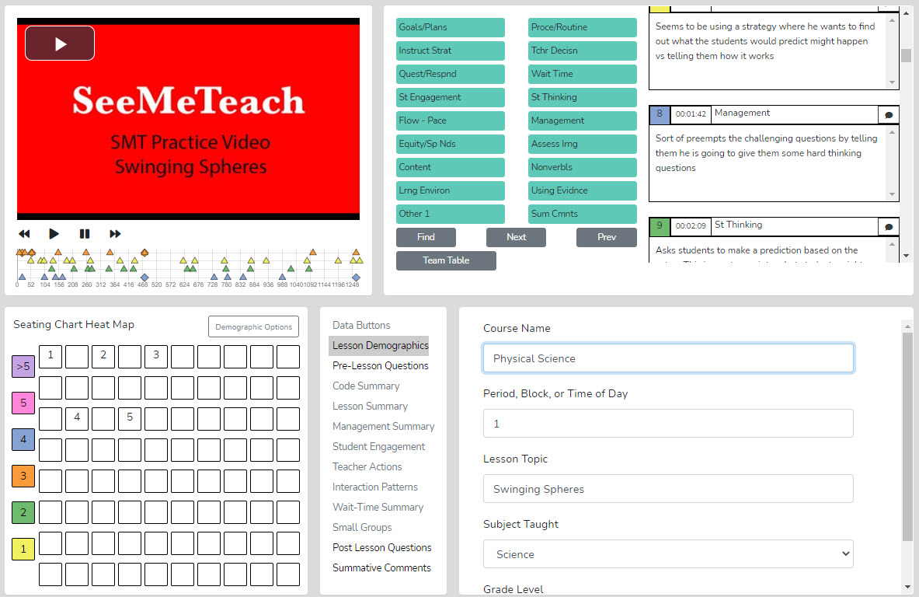

If the observation was video-based rather than a live observation, the top-left window contains the play and pause buttons and a lesson clock synced to the video. Again, when using video, any team member can observe, enter the qualitative analysis mode, and individually view, comment, and provide feedback.

Steps to Collecting Data in the Qualitative Comments Mode
The top, far-right window contains the running commentary boxes. Each comment entered is time-stamped and has a category label attached to it. For example, when viewing the video, if the observer notices something about the lesson, teacher, or students and wants to enter a comment about “questioning,” they first click the quest/respond button. When this occurs, the timing clock and the video pause; the time is noted, and the sequence number of the comment is added along with the comment category heading. The user can type the feedback into the comment window, as shown below. Note that the user can use the back or forward arrow to rewind or jump ahead 10 seconds during the observation or while in qualitative analysis mode.
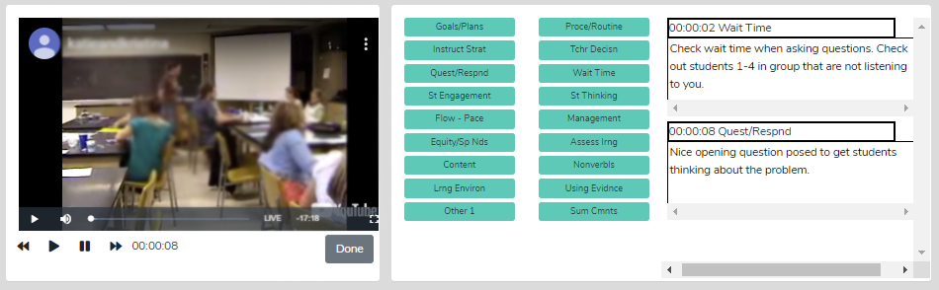

When finished typing the comment, the user clicks Play to resume the observation. If the user needs to go back to the starting point of a comment-worthy event, they can rewind using the 10-second back button (once or more) or jump forward in 10-second increments using the double-arrow forward video control. If the observer is doing a live observation, they obviously cannot press pause, so they would continually click on categories and enter comments on the fly.
When the observation has ended (but before the user clicks DONE), the user can enter some final thoughts using the summative comments category button (Sum Cmnts).
Suggestions for First-Time Users - When first using Qualitative Mode, novice users may be unfamiliar with the various comment buttons. When users want to comment, they can click the pause button to stop the video, giving them time to decide which comment button applies. The alternative is letting the video play until determining which comment button to click – in the meantime, teaching continues. So, for the novice who is only becoming familiar with the comment buttons, using the pause feature is probably necessary until qualitative mode skills are developed.
Note: The software is set up so that each comment is linked to the video but is programmed to start the video 30 seconds ahead of when the comment was entered, so when viewing playback of the video, the noted event is more likely to be seen without having to use the rewind button.

Comment Buttons Defined or Explained – Generally, the buttons are defined as follows, and what is typed into the comment box is an observation, comment, or recommendation regarding such.
1. Standard Set – Labels for Comment Buttons
Lesson Goals or Plans – Goals or Plans: These comments pertain to the goals of the lesson, objectives, learning targets, or plans for the class. For example, the observer may make a comment about how the actions, events, or activities of the class relate to the goals of the class or standards of instruction.
Instructional Strategy - Instructional Strategy: These comments relate to an instructional strategy the teacher chooses to use in class. For example, the 5 E model in science or modeling in math. These comments could also pertain to how much the teacher lectures vs. uses small groups or cooperative learning.
Questions-Response – Questioning and Responding: Comments in this category highlight how a teacher asks questions, how they respond to student answers, patterns of interaction, or other aspects of teacher-student interaction. Classroom management interactions, however, would fall under the Management category button.
Student Engagement – Student Engagement: Comments in this category highlight how much or how little student engagement is present, methods of increasing student engagement, whether student engagement is concentrated among a few students, or if most students are engaged and in what manner.
Lesson Flow or Pace – Flow or Pace of the Lesson: Comments in this category highlight how the lesson is flowing and at what pace - too fast, too slow, just right, and indicators of such.
Equity or Special Needs – Equity or Special Needs: Comments in this category highlight students with special needs and their level of engagement, adaptations for the lesson, or suggested modifications. These comments can also be used to track the inclusion of all students and highlight equity regarding gender, race, etc.
Lesson Content – The Content and Subject Matter: Comments in this category highlight certain aspects of the content or subject matter of the lesson.
Learning Environment – The Learning Environment: Comments in this category highlight aspects of the learning environment – is it conducive to learning? Do students feel safe contributing and interacting with each other, and taking risks and leaving their comfort zone? Has the teacher developed good relationships with students?
Other 1 – Comments in this category pertain to miscellaneous comments that don’t necessarily fall under any other categories.
Procedure or Routines – Procedure or Routines: Comments in this category highlight how the teacher uses procedures or has developed routines that help the class function better.
Teacher Decisions – Teacher Decisions: Comments in this category highlight specific teacher decisions witnessed in the observation. Perhaps a child was misbehaving, and the teacher chose not to address the misbehavior. The observer's comment would address ignoring the misbehavior.
Use of Wait Time – Using Wait-time: Comments in this category highlight the teacher’s use of wait-time 1 or wait-time 2 as it relates to teacher-student interactions, questioning, and responding.
Student Thinking – Student Thinking: Comments in this category highlight student thinking, ideas uncovered, misconceptions identified, or teacher actions or strategies that help uncover student thinking.
Behavior Management – Classroom Management: Comments in this category highlight student misbehaviors and whether/how the teacher reacts or is proactive in response.
Assess Student Learng – Assess Learning: Comments in this category highlight assessing student learning.
Teacher Nonverbals – Teacher Non-verbals: Comments in this category highlight the teacher's non-verbal behavior that affects the classroom learning environment, student engagement, or the teacher's ability to be more effective. Examples might include the teacher jiggling coins in his pocket, stroking a beard, taking glasses off and putting the stem in their mouth, positioning themselves in a standoffish manner with arms folded and across their chest in a non-inviting manner, scrunching their eyes when listening to a student response, and consequently students and the observer interpret that look as negative feedback to the student.
Using St Evidence – Using Student Evidence: An essential component of the EdTPA assessment requires the applicant to describe their teaching using evidence. Moreover, student evidence shows they have met the lesson's objective in the form of a student-generated artifact.
Summative Cmnts – Summative Comments: When the observation reaches the endpoint and all things are considered, the user can add some significant concluding and summative comments about the lesson.
Other Sets of Comments Buttons
When choosing “qualitative” as the type of observation, there are many button sets, including a Standard set and sets for Special Education, High Leverage Practices, edTPA, NBCT, Signing and Interpreting, World Languages, and ESL/Bilingual. However, more sets of comment buttons are being developed to accommodate observers who use specific schema when observing or who want to use another mainstream set of observational categories when making and linking comments. For example, another set of buttons is being created for those who are focusing on teachers of students with special needs.

Lesson 2.2 - Quick Look at Specific Features of the Qualitative Analysis and Feedback Mode
Once the user finishes adding their qualitative commentary and clicks DONE, the screen changes slightly. The following features are added to the screen, turning the qualitative data collection mode into qualitative analysis mode.

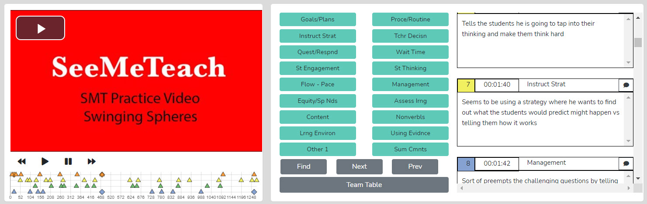

Things The User Can Do
- View and Scroll Through the Observer’s Comments – Any comments made during the observation by any of the four possible observers are displayed in the comments window, color-coded by the observer, time-stamped, and with the comment category heading shown.

- Identify Who Made the Comments - Team Table - Unification and Synergy Using Data and Feedback – The Team Table contains links for team members’ observation results. Suppose multiple team members have completed the observation using a video of the lesson. In that case, the user can open the Team Table, identify the observer’s comments by color, and toggle other team members' color-coded comments on or off in the comments window by clicking the qualitative data button. The figure below shows the qualitative comments option for all four observers toggled on. Therefore, all users’ comments would be displayed.

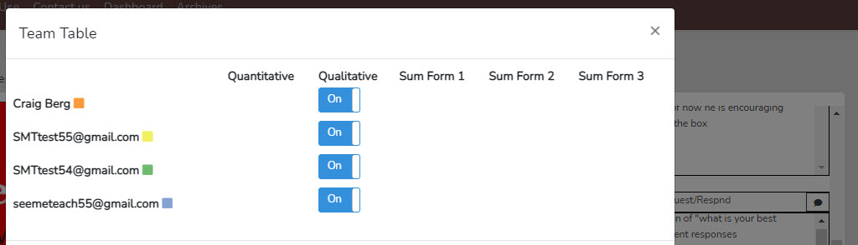

- Search and Find - The user can search and find comments headed by a specific comment category by clicking on the FIND button, then clicking on a specific comment button. The first comment with that heading and the section of the linked video that correlates with that specific comment will begin playing. Clicking NEXT locates the next comment in that category type. Clicking PREVIOUS will locate a prior comment, and the video segment linked to that comment will play again.
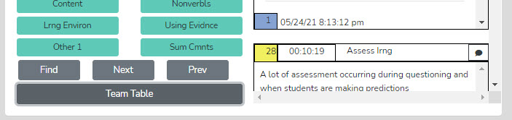

- View the Timeline and Which Observer Made Comments, When, and Where – The timeline below the video window shows the lesson from beginning to end with comments noted by a color-coded triangle. With the mouse wheel, the user can zoom in or out when the symbols become crowded or reset the zoom to normal by clicking the Reset button. Clicking on the triangle or diamond shape in the timeline underneath the video window highlights that comment in the comments window.
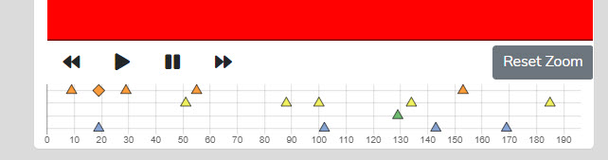

- Links to the Video – All comments are time-stamped and linked to the video. Besides using the Find function, the user can also watch the linked segment of the video by clicking on the time box in the specific comment window.

- Team Members Can React to Comments – Each comment has a thought bubble symbol on the right side of the comment box header. Any team member can click this bubble symbol and type something about that comment. A team member could continue or add to the comment by clicking on the symbol and typing to ask for clarification, ask a question, answer a question, or respond to the person who left the original comment. In other words, this feature allows for a mini-exchange between observation team members. Any reaction is color-coded, so users know which team members are leaving comments or reactions to comments. The blue user left a comment for the orange user above. Note that the original comment is noted on the timeline by a triangle. If a user reacts to a comment, the symbol changes to a diamond shape. A quick scan of the timeline alerts any user to reactions in the set of comments and who left them.
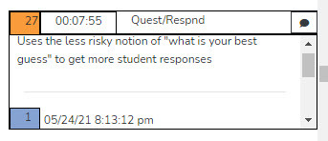
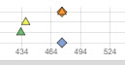

Exit to the Dashboard – After analyzing the qualitative data collected during the observation, the user can return to the Dashboard by clicking the Dashboard heading at the top of the page.
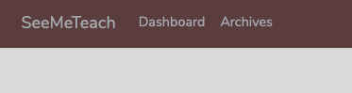

Lesson 2.3 – Practice Completing Qualitative Comments Observation and Analysis – In this lesson, the user will become familiar with using the features of the qualitative comments data collection and analysis mode they read about in Lesson 2.2. Very little training is required to use the SMT qualitative comments mode. However, before observation, the user might want to review the comment category buttons and refresh their memory of which button to click for each type of action they wish to comment on.

Steps to Complete a Qualitative Comments Observation and Viewing the Data Analysis Page
- If continuing directly from Training 1, the SeeMeTeach ® web page should be open to the Dashboard screen with a lesson identifier “SMT Practice 1,” and then clicking the plus symbol to view the Expanded Dashboard, the user can choose qualitative or quantitative. Follow the steps laid out in Cheat Sheet 2. Choose Qualitative, then select Standard, and practice the qualitative comments collection mode. When you complete the qualitative commentary for the short video, click DONE, and the screen will change to qualitative analysis mode.
- If you don’t have an existing lesson observation created from Training 1, you need to set up a new observation. Follow the instructions on Cheat Sheet 2, which begins as follows: click on New Observation, and on the screen with a heading that says “Create a New Observation,” choose video-based observation, then copy and paste this URL https://youtu.be/XlPKXIkeHMA for SMT Practice Video Swinging Spheres, and continue with the instructions for setting up a lesson observation.
- Now that the qualitative analysis mode is on the screen, USE the features described in Lesson 2.3 to familiarize yourself with their functions.

Need More Practice?
If the user wants more practice, set up a New Observation and copy and paste any URL from the master list of Practice Videos at the beginning of the training section into the video window in New Observation. We recommend using the Truck Hill L video. https://youtu.be/pjv0FSyR5sw

Enhancing Observations Using Quantitative Comments
Qualitative comments and recommendations are valuable to the teacher, and they often come from observers with years of experience observing classrooms and providing feedback. Yet, professionals should give feedback, make decisions, and draw conclusions based on evidence and data when able. As such, the quantitative mode of SMT (next in training) provides a plethora of data that can support or refute observations or fine-tune comments and recommendations.

When the team user and/or member completes the quantitative mode first, the data can bolster the qualitative commentary. For example, wait-time data from the quantitative mode can support more general and subjective comments made during the qualitative comment phase. For example, instead of just typing “Consider increasing your wait-time,” the observer could refer to the quantitative wait-time data and supplement the comment with “Your wait-time one average is 1.6 seconds, and your wait-time two average is .89 seconds. Try to increase your wait time to an average of more than 3.5 seconds. Let’s think of something you can do when interacting with students to help you remember to use more wait time. Perhaps put your hand behind your back and count to five on your fingers.” This is only one example of many where quantitative data can bolster qualitative commentary.

Next in the Training Sequence
The training levels will prepare the user to collect rich, robust quantitative data that indicate effective instruction and serve as mile markers for the growth and improvement of teaching.
Introduction to the Training for Quantitative Data Collection Mode Levels 3 – 10
Introduction
SMT collects and then analyzes quantitative data on teacher and student actions during a lesson. This data is coupled with the specific lesson type in play to show when and where student and teacher actions occur in the lesson. The raw data is time-coded and linked to events as they occur in the video. Note that data collection can also occur live in the classroom without video. Data collection can be limited and focused on a single factor or be more complex and encompass many elements. The goal of the data collection determines which options the observer will choose to use and, therefore, what data to collect to fulfill the intent of the observation. The user can also choose to observe and code a specific desired length of time. As with the qualitative mode, the amount of class time coded varies depending on the length of the targeted lesson segment, such as small group work versus a lab activity versus a whole class discussion.

The Richness of the Observation and Quantitative Data Collection
There are a surprising number of teacher and student actions within an entire lesson, or even just a section of it. An observer collecting data on the teacher and students might easily enter 200-plus data points in 20 minutes of observation. Why is that? When a teacher is cognitively immersed in the flow state of teaching, they think, weigh options and choices, make decisions, and take action based on many factors. They need to consider and attend to many variables such as student mood, students’ actions and behaviors or misbehaviors, interactions with students, time constraints, and the next steps of the lesson. Given everything happening in this chaotic environment, it is remarkable that teachers control this constant state of flux. The teacher absorbs this information, recalibrates, adjusts the lesson, or alters interactions with students based on what they see and hear. In short, there is a plethora of teacher decisions, and some or many turn into discernible and distinct teacher actions. These teacher actions are designed to and do affect student action. This combination of teacher and student action data tells the tale of the lesson and helps the observer and teacher come to conclusions about the teacher’s teaching skills. The teacher's and student actions indicate pedagogical effectiveness and offer clues about what to change or improve to have a more positive impact on the learner.

When using SeeMeTeach ®, a quantitative observation consists of clicking buttons corresponding to teacher and student actions in the classroom. While no system is perfect for all, most discrete, observable teacher and student actions can be linked to one of the buttons. Therefore, collecting this data provides a footprint and a fingerprint of the story that unfolded during the lesson observation. The story is clarified further when the data analysis uncovers teacher action trends, patterns, and tendencies and showcases student involvement and engagement in the lesson. The data collected are limited to visible, discernible, discrete, and recognizable teacher and student actions - what the observer can view and note in their comments. A pre-lesson discussion with the teacher or a look at a well-crafted lesson plan will help clarify both intent of delivery and expected outcomes. Yet, the observer doesn’t know the teacher’s reasoning behind the actions until the post-lesson discussion, when the observer and teacher can debrief and contextualize the decision-making during the lesson.

Using SMT, observations can be simple and focus on one factor, or complex and collect data on many factors. The fun begins when the observation is completed, and the instant analysis is viewable for cogitation. This is when some aspects of teacher and student actions become more apparent, displayed in seating chart heat maps, graphs, tables, and charts with counts and patterns. This extensive analysis helps the teacher and observer reach data- and evidence-based conclusions about the teaching being observed and the extent of student engagement during the lesson. It is difficult to discount the data, and even more difficult to ignore the video segments linked to it, which turn an opinion into a concrete example of a teaching strength or an area for improvement.

Now, look at the quantitative data collection screen below and read about the various chunks of data collection buttons and their functions.

Read This First – The power of the quantitative mode is immense, something you will realize as you progress in skill development and begin to collect data beyond the first few levels of training. As you view the graphic below of the quantitative data collection screen, remember, it is your first look - very little will make sense and it might seem visually overwhelming. That will quickly change.

Here is what should be remembered about training. All these codes and features are options that you will learn in chunks, beginning with rudimentary and easier levels of use. However, after seeing the tremendous power of SMT and the benefits of the data and analysis, you will be inspired to work towards using more of the options. This inspiration will be your fuel to continue to quickly move through the levels of training and learn the “buttons” and “controls” ultimately acquiring the skills of a “black belt SMT user” regarding data collection and analysis.

Remember – you are going to learn SMT in chunks – you can do this!

An Overview on Training for the Quantitative Data Collection Mode

Introduction to Training for the Quantitative Data Collection Mode - While preparing for and using the qualitative mode of SeeMeTeach ® (SMT) takes very little start-up time, the quantitative mode takes a bit more time to become proficient, but completely worth the training time when considering the valuable data and information one can glean from such an observation. Training helps the user progress through various levels, beginning with a simple level and then capturing more teacher and student actions, resulting in more extensive data and analysis and providing rich opportunities for feedback and reflection.

Progression of Training for the Quantitative Data Collection – Training for the quantitative mode is set up to develop skills at various progressive levels. The user will rapidly progress through levels 3–6, which cover basic information, types of codes, rules for operation, L codes (lesson type), M codes (T4 - misbehaviors), and S codes (T6 - student action). Training 7 focuses on identifying the types of questions posed by the teacher. Then in Practice 6/7, the user observes a lesson and collects data on students’ actions (Training 6) and identifies question types (Training 7). In Level 8, the user learns to identify the remaining teacher actions and then practices a lesson observation using M, S, and all T codes. Training 9 focuses on capturing wait-time while simultaneously capturing T, S, and M codes with seating chart numbers during an observation. Anyone examining their teaching (and certainly those whose job involves teacher observation) should strive to reach this level, as wait-time data is extremely valuable when analyzing ways to improve teacher-student interactions and student engagement. Completing Training 9 allows the user to claim SMT Black Belt status and is a level every teacher can reach with little effort. Using these features maximizes SMT's capabilities and produces a vibrant, robust dataset, enabling optimal and extensive data analysis and feedback for the teacher being observed. In Training 10, the user learns how to observe and code G Codes and small-group interactions and examines how teachers interact with small groups and the equity of individual contributions within small groups.

The highest level of skill development is something called SMT Master Trainer. An SMT Trainer has demonstrated a high level of proficiency by using all the data collection features with increased coding speed that matches even the fastest-paced classroom. This level is reached only through a practical exam given by SMT. Upon passing, the user is officially endorsed as SMT’s certified stamp of approval for collecting data with the high validity and reliability necessary for consulting, program evaluation, or training others to use SMT.

Training 3: Overview and Features of the Quantitative Data Collection Mode
In this lesson, the user will learn:
- The layout of the data collection screen and specific data collection buttons
- How to toggle off or on data collection buttons
- That all the data is linked to video segments
- The general operation of data collection and two rules for data collection
- What raw and analyzed data are available post-observation
- The features and examples of the quantitative analysis options
- Questions about teaching that the data help to answer
Training Elements
Lesson 3.0 Video Overview of Quantitative Data Collection Screen

Cheat Sheet 3

Extended Practice Key 3

Steps to Take – First, watch the video overview and have Cheat Sheet 3 open. The video highlights key areas of the screen and describes features and functions. After watching the video, read the sections below for a thorough overview of SMT functions. Note the guidance for completing an Extended Practice on what was learned in this training and the Extended Practice Key 3, which allows the user to compare their efforts with those of an expert user.

Lesson 3.1: Quantitative Data Collection Screen Features

The graphic below shows where the quantitative codes reside on the data-collection screen.

While observations might use only one type of data button, the specific data collected can include the following:
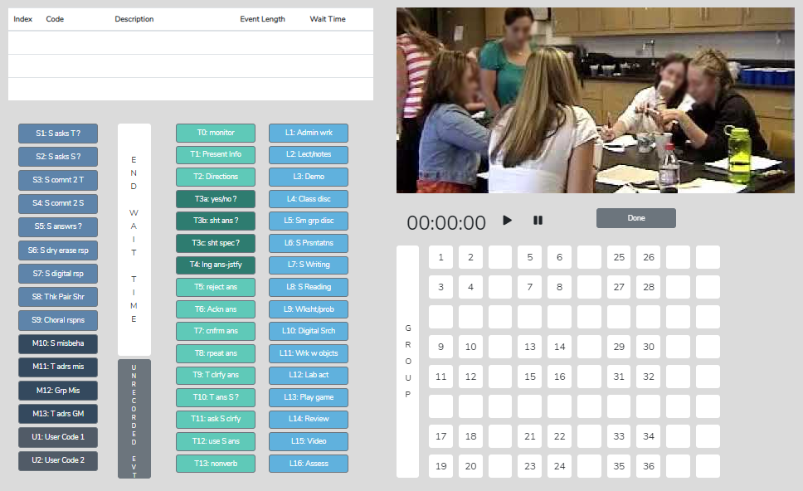

L Codes – There are 16 choices for Lesson Type, which describe what is generally occurring during a lesson, such as lecturing, lab activity, small group discussion, etc. The lesson type typically changes only a few times during the lesson. Still, this feature is essential because it places other collected data, such as student engagement and misbehaviors, in the context of the lesson-type activity.

T Codes – These 14 codes represent teacher actions while instructing. They help paint a vivid picture of how the teacher interacts with their students and help uncover tendencies and patterns that make a difference in student engagement, learning, or behavior. Before attempting to code using T codes, we highly recommend completing the Training – Level 6 Learn About T Codes. This will help the user develop skills to recognize noteworthy teacher actions, increasing their ability to collect more accurate data during the observation.

S Codes – These nine codes represent student actions when interacting with other students or the teacher. The S codes paint a vivid picture of class dynamics and interactions and help examine student engagement in the classroom. S1-S5 are for individual student responses, while S6-S9 are used when the whole group responds (dry erase, digitally, think-pair-share, or choral responses).

M Codes – These four codes collect data pertaining to student misbehavior and subsequent teacher reactions.

U Codes – These two codes are optional and user-labeled for collecting data concerning actions or events not covered by the existing T, S, and M codes.

Wait-time Bar – This button is used to determine average wait times, the range of wait times, and the specific type of wait-time(s) for T or S codes. This is a significant feature, as wait time significantly impacts student learning and engagement.

Toggle On/Of to Simplify Data Collection – Located above the data collection buttons are small boxes serving as clickable toggles that the SMT user can use to show or hide any of the S, T, U, M, and Wait-Time buttons. A novice or experienced user, if collecting only a subset of possible data, may want to shade out and disable buttons they won’t need for that teacher observation, as this reduces what the user is viewing.

Other Features of the Coding Window Include the:

Emergency– Note that this shows up only when doing a live observation and is used when an activity occurs that the user does not want to code and needs to pause coding. For example, maybe there is a fire drill, and the user can use this button to pause coding without leaving the data collection screen.

Unrecorded Event – This shows up only when using video. If a section of the video does not want to code, they can click Unrecorded Event; the video will keep playing, but the coding clock will pause until the user presses L to restart the coding clock. The video will remain synced with the data, but the paused coding time will not skew the data.

Note: the previous two features are the same, but the labels change depending on whether the user is doing a live observation vs. using a recorded video.

Lesson Clock – Begins at zero at the start of the lesson and counts in minutes and seconds.

Timing of Events - All coded events are linked to the lesson clock, noting when they occur in the lesson and (for most) the duration of the event.

Video Window – If using a video instead of a live observation, the video is displayed here.

Scrolling Running Record Window – The window at the top is the running record of data being collected. It displays the events as coded in the window. Each time the user clicks a code, it is recorded and noted in the running record window. This window mainly functions as feedback, letting the user know the code was entered.

Student Seating Chart – If set up, this shows where the students are seated in the classroom, represented by a clickable number, and can be tagged to specific S or M codes. Small groups can also be identified and noted on the seating chart. If not set up, the seating chart shows an 8 x 10 grid with numbers but without specific students’ seats designated. The user can still use this generic chart and click a seat number, then click an S code to generally show where the action is occurring. Remember that no student demographics are tagged to that seat number since it is a generic seating chart. Note that all student action data can be linked to video segments and the Seating Chart Heat Map for post-observation data analysis; as such, there is a big payoff in using the specific seating chart numbers with the data.

Group Data Collection – The Group button is to the left of the seating chart. If the user clicks this button before clicking on any seat containing that specific group number, the running record will record the data prefaced by that group number. For example, clicking G2 before clicking S1 records the event as G2:S1.

Student Demographics - Also present but not visible on this data-collection screen are the underlying demographics regarding gender, minority, ELL, or special education status that can be displayed and examined during the post-data-collection analysis phase (coming soon).

Like its namesake, the DONE Button is clicked when the user wants to end the observation. A second-chance warning pops up if the user wants to continue. It is placed on the far right so the user won’t accidentally click it; it should remain untouched until the user has completed collecting data. When the user clicks DONE, the screen changes to the quantitative data analysis screen.
Remember - All these codes and features are options, that the user will learn in chunks, one step at a time. The user only needs to learn a few things to begin data collection. Note that the user can toggle on or off any set of T, S, M or U codes as well as the wait-time bar to reduce the complexity of the data collection screen.

Lesson 3.2: Quantitative Analysis and Feedback Options

SMT helps the user collect and then analyze data related to teacher and student actions during a lesson. This data is coupled with the specific lesson type in play to show when and where student and teacher actions occur. Collecting and analyzing data provides a record of teacher and student actions during the lesson. The raw data is displayed and time-coded, and linked to the events as they took place in the video. The resulting raw data and analysis of data offer substantive insights into the activity and events of the lesson. The analysis and feedback options described below will highlight how beneficial it is to use quantitative data during the feedback process.

Power of Video-linked Data - When using video, much of the data collected is linked to the specific video segments representing that data and the type of action or event by both teacher and students. In the analysis screens, the observer, teacher, or team member can go directly to the video linked to specific data points and see examples in action.

Running Record - The Running Record lists all events in sequence from the start to the end of the lesson. The user can scroll through the events and click on any event to see the related video. While SeeMeTeach ® has significant built-in data analysis for instant viewing, the data can be exported to a .csv file for analysis with powerful statistical packages.
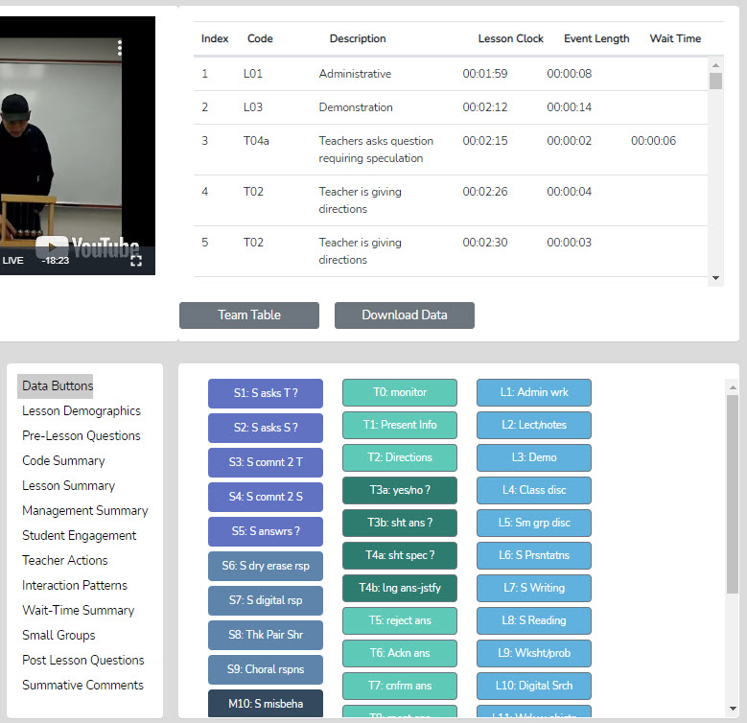

Data Buttons - The Data Buttons feature serves as a Search and Find function, allowing the user to quickly locate linked video examples of specific T, S, M, or U events. Clicking on a button finds the first of that specific code/event in the Running Record window, and the linked video begins to play. And at the bottom of the Running Record window, there is a note indicating how many events of that type were located. This feature is particularly helpful for identifying the teacher's habits and tendencies. For example, the observer may notice the teacher has a habit of asking yes/no questions, followed by clarifying the answer for the student. In this case, we know that having the teacher change how they interact and respond would be beneficial for learning more about the student’s thinking. For example, the teacher could have asked the student to clarify their answer. As such, the observer might use that data or video, all or some, to make a point about how a teacher’s choices affect student engagement and their ability to uncover student thinking.

Lesson Demographics – This contains information about the lesson that was entered during New Observation lesson setup or can be edited (course name, period, lesson topic, subject, and grade level).

Pre-Lesson Questions – Questions posed to the teacher that will provide context and the lesson's intent.
- What are the main learning goals/objectives for the lesson?
- Describe the major activities or parts of the lesson to be observed.
- How will you know if the learning goals/objectives have been met? For example, what evidence will you have?
- Provide the context for the lesson. How is this lesson connected to the prior lesson? How is this lesson connected to the subsequent lessons? Where is this lesson placed in the current instructional unit?
- Describe the ability levels of the students in this class.
- What will you do to maximize the engagement of all ability levels of students?
- How will you differentiate the lesson for all types of learners?

Code Summary – This feature provides a graph of the number of events of each code used during data collection and shows the relative and specific use of T, S, M, and U codes. Underneath the graph is a data table that displays data for each specific code by event frequency, event frequency compared to the total number of events, time coded by the specific event, and time accrued for that event compared to the total time of all events. The T code data is tallied underneath this data table, as are the S, M, and U codes. This data is also recorded as a percentage of total events and total time.
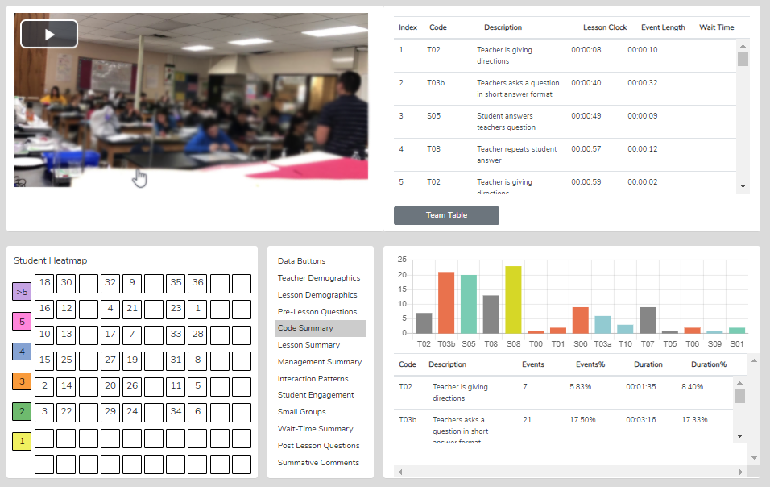

Lesson Summary – When coding a lesson, the observer notes the type of lesson in play by clicking an L button at the very start of the observation and a different L code each time the lesson type changes within the observation. As such, lesson segment types are noted and displayed in quantitative analysis mode in the Lesson Summary data window as a timeline showing the order and length of each lesson segment. This lesson segment display serves as a time-context reference when viewing other data, such as Student Engagement or Management Summary, so the user can see where misbehaviors or students’ responses occurred in the lesson.
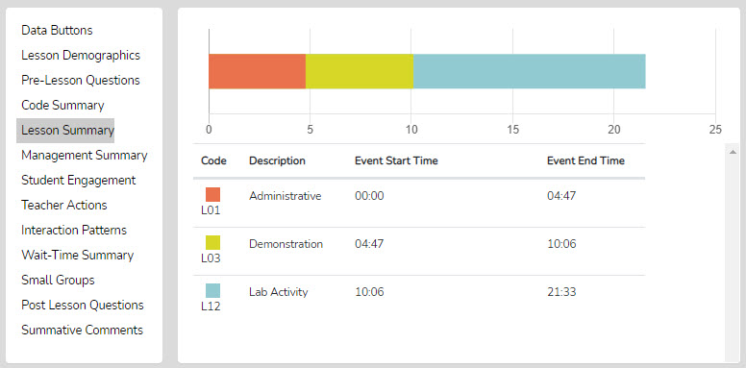

Management Summary – Displays the misbehavior events (M codes), noted specifically by student seating number, or generically if seating chart numbers were not used, and when the events occurred. It also shows when and how long the teacher reacted to and addressed the misbehaviors. The lesson-type timeline displays the specific times of student and teacher data, with black bars for student events and red bars for teacher reactions. Clicking a bar starts playing the video linked to that event. In addition, the seating chart heat map shows, by color code, how many events are linked to specific students.

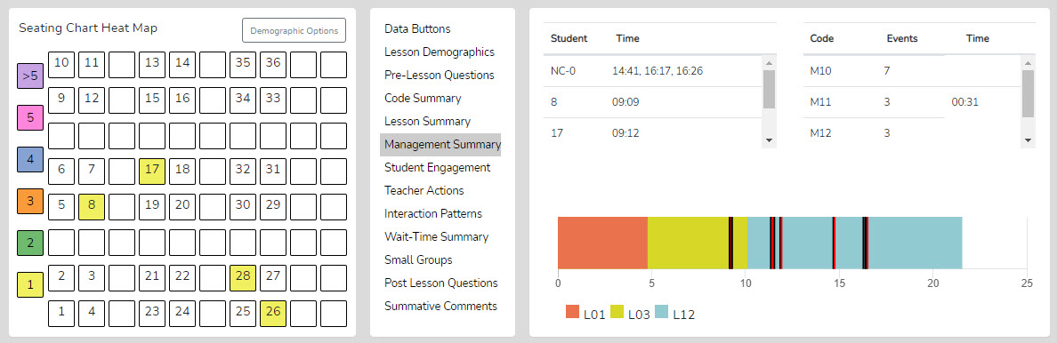

Demographic Highlighting in the Seating Chart Heat Map - In addition, if data is collected for specific students using the student seat number before entering the M code, the data can be displayed and toggled on or off by clicking the Gender, ELL, SPED, or Minority buttons. If the observer wonders how the students with special needs are disengaged during the lesson, toggle this information to find out. If the observer or teacher is concerned about equity of participation regarding gender, minority, ELL, or students with special needs, then this data is available.

Interaction Patterns – Using all the teacher actions (T codes) and student engagement actions (S codes), the user can view the predominant patterns of interaction between the teacher and students. In addition, numbers show how often students interact with each other (S-S), how often the traditional teacher-student-teacher pattern (T-S-T) is used, and how often one teacher action follows another (T-T).

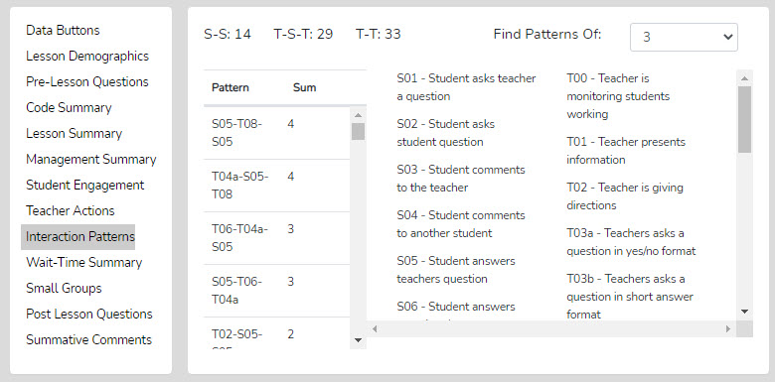

Student Engagement – Displays student engagement events (S codes), noted by student seating number (or generically if seating chart numbers were not used), and when the events occurred. It also shows when and how long the teacher reacted to and addressed the misbehaviors. The specific times of student and teacher events are displayed on the lesson-type timeline, with black bars for student events and red bars for teacher reactions. Clicking a bar starts playing the video linked to that event. In addition, the seating chart heat map shows, by color code, how many events are linked to specific students.

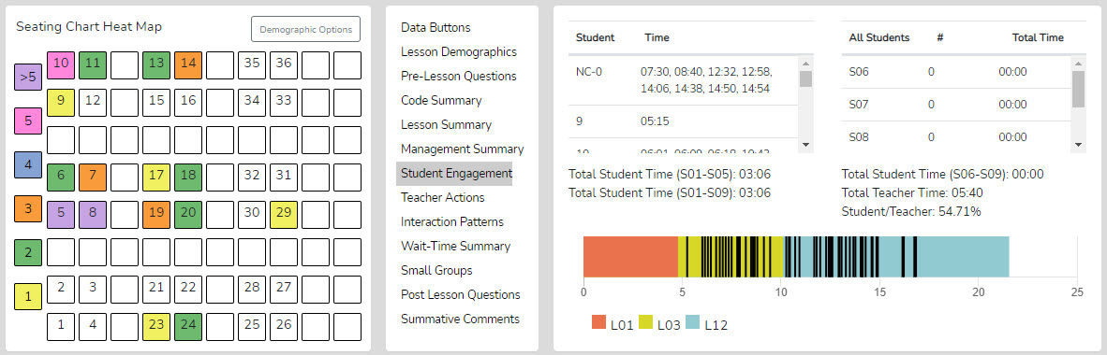

Demographic Highlighting in the Seating Chart Heat Map - In addition, if data is collected for specific students using the student seat number before entering the S code, the data can be displayed and toggled on or off by clicking the Gender, ELL, SPED, or Minority buttons. If the observer wonders how the students with special needs are engaged during the lesson, toggle this information to find out. If the observer or teacher is concerned about equitable participation by gender, minority, ELL, or students with special needs, this data is available.

Teacher Actions Plus Summary – Teacher Actions Plus Summary is a timeline from the beginning to the end of the lesson that displays on a backdrop of the lesson type (colors) in play and shows symbols for when the teacher exhibited various T code actions, so the user can follow the sequence of teacher actions throughout the lesson. This timeline also displays M and S code data; in fact, almost all collected data are represented on the timeline, providing a robust set of teacher and student actions. The user can easily see when any management issues occur in the context of the rest of the teacher and student actions in the lesson. Since this is a visual display of teacher actions, student actions, and misbehaviors, as well as the teacher’s reaction to misbehaviors, it provides the user with a visual of the flow of action from the beginning to the end of the lesson and visually brings forth sequences, predominance, or absence of teacher or student actions. For example, if the teacher is curious about their use of questioning, it is easy to see when each of the four questioning codes was used and what codes occurred before or after. The user may find a complete absence of higher-level questions. The user can easily see what they do after a student's response. The user can target specific codes by toggling the display of any T, S, or M codes. Aside from wait-time data, all data is shown on this summary screen, which is often a large chunk and may clutter the screen.
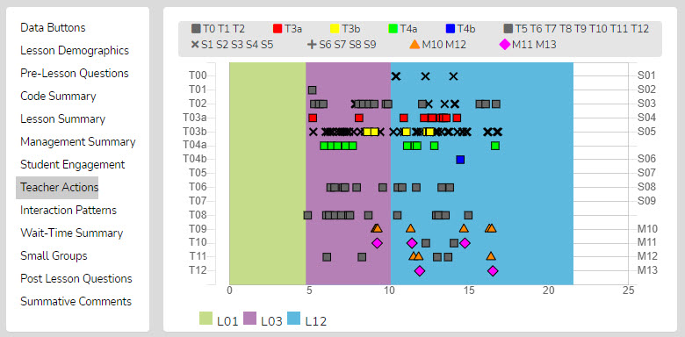

As shown below, the viewer can zoom in or out to allow data points to be separated from each other.

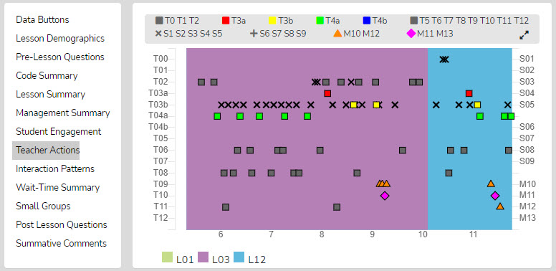

Finally, as with other data points in SMT, the user can click on any data point (symbol), and the linked video will play.

Small Groups – When completing a quantitative observation and student engagement or misbehavior data is collected and tagged by an individual or group number, the observer can then use the Student Engagement, Management Summary, Seating Chart Heat Map, and Small Group analysis displays to examine the results and determine various things about how the lesson impacted small groups.
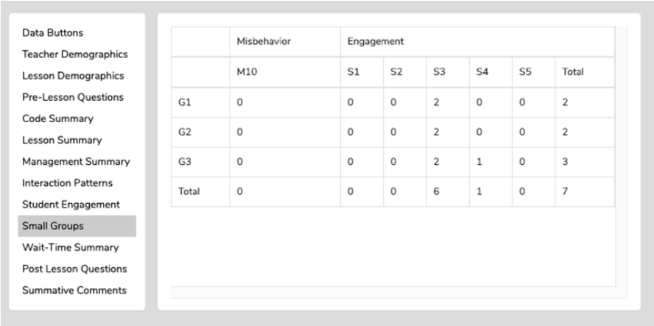

The Small Group Summary data collected, in conjunction with the student seating number, allows examination of group dynamics and the number and levels of S code types of interactions that reveal the impact of a lesson on student-to-student interactions. The table shows S codes and M10 and M12 event responses coming from specific groups. This data would indicate whether the teacher and observer wondered how the lesson stimulated student actions (S codes) within the small group. The Seating Chart Heat Map would show how much interaction occurred within that group, with color-coding to show each member's contributions.
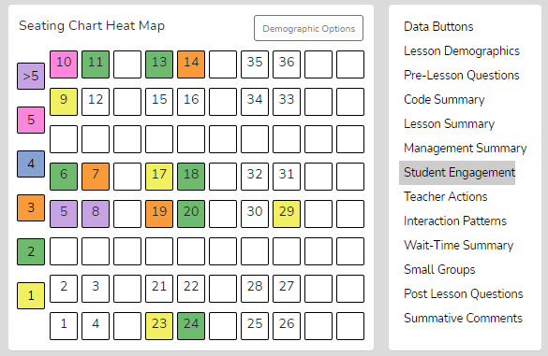

Wait-Time Summary – The wait-time data is located only in the Wait-Time Summary. Within the Wait-time Summary are general summaries of wait-time by wait-time type, events, total time, and averages for each wait-time. In addition, the lower half of the summary provides wait-time averages according to specific teacher or student actions. For example, the user can determine whether more wait time is allowed for higher-level questions that require deeper thinking than for lower-level questions.

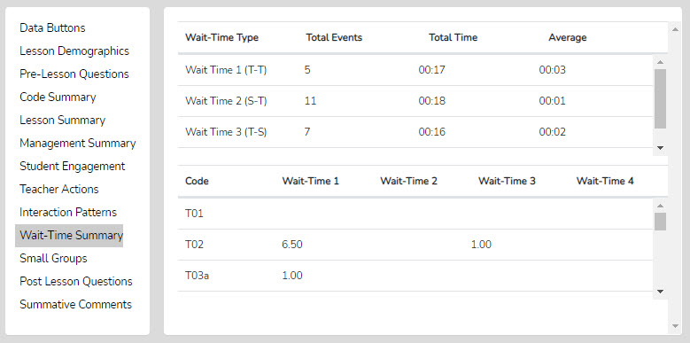

Post-Lesson Questions – Questions for the teacher to respond to following the lesson and observation.
- Tell me about today’s lesson. Probe: What went well? What needed to be improved? If you taught this lesson over again, what would you change? Why?
- What do you think students learned from today’s lesson?
- What evidence do you have of this learning?
- What evidence did you observe that learners of all ability levels were engaged in this lesson?
- Based on what happened in today’s class, are you planning on making any changes to the next lesson? If so, what are those changes?
- What is the next step for this class in this unit?

Summative Comments – A place for the observer or team member to add some final thoughts, conclusions, or recommendations regarding the observation.

Team Unification and Synergy Using Data and Feedback – If another member of the team has completed the quantitative coding of the video before leaving the data analysis screen (or from the Dashboard), the user can open the Team Table, click, toggle on, and view the data gathered and the analysis by that team member. Or the user can jump to any team member’s completed quantitative or qualitative observation by clicking on the green checkmark in the expanded Dashboard.

Lesson 3.2 Two Types of Codes for Collecting Data - Two types of codes are used in the SMT observation tool. One type of code is an event-only code. The second type of code is the event/timing code.

Event-only Codes - An “event-only” code can only be clicked at any time, and it is added to the running record, but no timing is associated with it other than simply noting when it occurred on the lesson clock. There are only four event codes in SMT, which are M10, M12, U1, and T13. M10 – single student misbehavior - is an event-only code used to note that student misbehavior occurred and when it happened during the lesson, but not for how long the student was misbehaving, nor does it disrupt the timing of the current code in play. For example, let’s say the teacher is lecturing, and a student is somewhat disruptive – the observer can note this misbehavior by tapping the M10 code (or the student’s number and then the M10 code). The misbehavior is noted without disrupting the timing of the lecturing event. The remaining event-only codes are explained later.

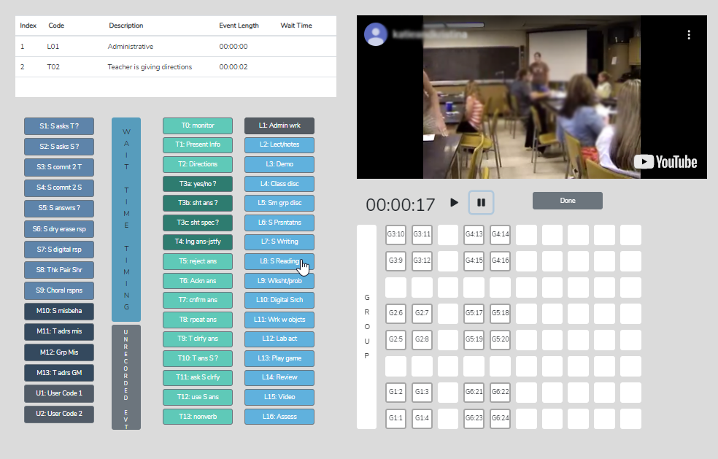

Event and Timing Codes - An event and timing code notes the event, when it occurred in the lesson, and how long it lasted.

- Except for the four event-only codes listed above, all the other codes used for SMT data collection are event and timing codes that note how long that event lasted. For example, how long did it take for the teacher to ask the yes/no questions? How long was the student’s response? How much time was spent giving directions for the activity?

Lesson 3.3 Basic Rules and Options – SMT is designed to maximize the quality and quantity of classroom observation data that an observer can collect IF the user follows some basic rules.

- Rule #1 – Always click an L code button first. L codes designate what type of lesson is in play. Clicking the L code starts the timer and clock, and only then can the user enter T, S, M, or U codes. That specific L code remains until the lesson type changes and a new L Code is entered.

Tap the L codes at the very beginning of the lesson and at the front end of any change in lesson type. Usually, the first L code clicked in any observation is L1 - short administrative tasks that teachers often do at the start of class, like taking attendance, collecting papers, or introducing the plan for the day. Each time the lesson type changes, the observer notes it by clicking a different L Code as soon as they notice. For example, suppose the teacher starts with administrative tasks. In that case, the observer clicks L1, then follows with a lecture and students taking notes; the observer would tap L2: Lecture/notes and would not tap another L code until the teacher changes to a different lesson type, such as moving into small group discussion (L5).

* When using video, click PLAY and immediately click an L code to start.

* When NOT using video (while doing a direct observation in the classroom). Click an L code to begin the timing clock and collect data – an L code always starts the timing clock.

- Rule #2 - Always tap the T and S code buttons (and two of the M code buttons) at the end of the event.

Since T0 to T12, S1-S9, M11, M13, and U2 are event and timing buttons, the observer needs to tap the button at the end of the event. For example, when the teacher asks a question, the observer taps the T code as soon as they finish asking. Or the S code is tapped when the student finishes responding, or the M11 code is tapped when the teacher finishes addressing the misbehaving student. Tapping at the end of the event gives the observer time to determine what type of question is being asked or what category/code the statement or response falls under. Tapping the button at the end of the event also starts timing for the next code entered.

Let’s start with a close look at L codes and how they are used in data collection and analysis.

3.4 Learn About L Codes: Type of Lesson in Play

L Code Training Steps –
  - Read the L Code definitions below and familiarize yourself with the various L codes.
- As with any of the codes or buttons, these codes do not have to be memorized, as the labels are on the buttons. However, the user should be somewhat familiar with the choices available.
  - Read how the lesson summary information is shown as a graph to examine student engagement and misbehavior data.

L Code Definitions

L1: Admin wrk – Administrator work: The teacher is doing some administrative work like taking attendance, collecting, or handing back papers, providing an overview of the class, etc.

L2: Lecture/notes – Lecture or notes: The teacher is dispensing notes and information using the smartboard, overhead projector, or simply talking or drawing on the board

L3: Demonstration – Demonstration: The teacher is doing a whole-class demonstration

L4: Class discussion – Class discussion: The whole class is having a discussion with the teacher and students contributing; at times, the teacher may ask pairs of students to interact briefly with each other – but the main focus discussion occurs as a whole group

L5: Small group disc – Small group discussion: The class has been broken up into small groups, perhaps by tables or a cluster of desks, and the primary discussion takes place within the small groups.

L6: - S presentations – Student presentations: Individual or small groups of students presenting their work or findings to the rest of the class.

L7: Writing activity – Students are writing: writing narratives or another writing activity, etc.

L8: Reading activity – Students are reading: Students have been asked to read a section of the chapter or an article, etc.

L9: Worksheets/prob – Worksheets or practice problems: Students are working on a worksheet or completing practice problems.

L10: Digital Searching – Digitally searching for information: Students are working in the computer lab or using phones, laptops, or iPads to search for information.

L11: Using objects – Working with objects: Students are using math or science manipulatives or 2d or 3d objects such as maps, globes, etc.

L12: Lab activity – Lab activity: Students are completing a lab activity, collecting and organizing data.

L13: Playing game – Playing a game: Students are playing an academic game.

L14: Review session – Reviewing materials: Students are reviewing for a quiz or test, either individually, in small groups, or as a whole class.

L15: Watch Video – Video: Students are watching a video in class.

L16: Assessment – Assessment: Students are taking a quiz, test, or another type of assessment

Lesson Summary on the Analysis Page – After completing a lesson observation and entering the analysis screen, the Lesson Summary data window displays a timeline showing the order and length of each type of lesson used during the observation as a horizontal graph. The sequence shown in the Lesson Summary (below) is L1-Admin Work, L4 – Whole Class Discussion, and L06 – Student Presentation. This information can be helpful when wondering how much time the teacher used per lesson type. More importantly, the lesson-type graph serves as a time-context reference when examining Student Engagement Summary and Student Misbehavior Summary data to show where those events occurred in the lesson.

How Can SMT Users Utilize the L Code (Lesson Type) Data?
After collecting and viewing L code data, teachers can use this information to move toward highly effective teaching. The most important aspect of the lesson type data is that Student Engagement and Management Summary data are overlaid within the context of the lesson type, so the SMT user can see where behavior problems or student engagement occurred during the lesson or lesson type.

In addition, the user can consider the following:

- Teachers can view how much time was spent on each segment of the lesson and think about if more or less time was used on lesson segments than intended and how the use of time affected the outcomes of the lesson.
- After the bell rings and the class period begins, teachers can analyze how much time it took to start teaching and then decide what to do differently to begin teaching right at the start of the class period.
- Teachers can examine how much time was used for each lesson segment and the time needed for transitions between each part of the lesson. This allows the teacher to consider what changes should be made to reduce the time needed to transition from one part of the lesson to another.
- If the lesson ended early, teachers could view that the time at the end of the lesson was not used for instruction and think about some productive things to insert into the lesson to utilize the remaining class time.
- Teachers can consider the whole class period and what might have been done to use the time more productively.

3.5 Practice using T0-T2 and S1-S5

First, use the lesson observation created in Training 1 and proceed as shown.
1. Click the plus sign next to the lesson observation that you previously created and used in Training 1 and 2 to
view the Expanded Dashboard.
2. Click Start under the Quantitative column.
3. Toggle off all buttons except S1-S5 and T0-T2.
4. Hit Play, followed by the L3 code.
5. Begin collecting baseline data.
o Choose any T codes available (T0, T1, T2) to represent the teacher talking.
o Choose any S codes available (S1-S5) to represent a student talking.
o Remember: Click the T and S code buttons at the END of the event
6. After 5 minutes of collecting data, hit “Done” and “Yes, I am Done.” And now the analyses page should be open.
Or create a New Observation using these instructions.
1. Click on “Create a New Observation”
2. Choose “Classroom Observation from YouTube”
3. Copy and paste the link into the text box: https://youtu.be/XlPKXIkeHMA
4. Fill in the following information:
a. Teacher Being Observed: Avatar Teacher
b. Observer 1: You (by default)
c. Observer 2: Avatar Teacher
d. Course Name: SMT Training
e. Period: 1
f. Lesson Topic: SMT Practice 1
g. Subject: Science
h. Grade Level: 8
5. Then click “Save and Continue”
6. Set up a Seating Chart (like the one to the right) by following the directions below:
a. Click on the “Teacher” data button. Then click on a square in the seating chart template to place the
teacher (indicated by a T1 icon).
b. Click on the “Student” data button then click on a square in the seating chart template to place a
student. Keep clicking on squares until all students are placed on your seating chart (indicated by
sequential numbers).
7. After your seating chart is set up, click on “Student Demographics” in the menu located in the upper left-hand
corner of the screen.
a. Practice assigning student demographics to each student by clicking on a specific student on the
seating chart and then choosing one option for each of the four categories.
b. Repeat this for each student.
8. Click “Save and Start”
9. Choose “Quantitative” and begin. When finished click on “Done” and now the analyses page should be open.

3.6 Data and Analysis Options
Keep the analysis page open. Use Cheat Sheet 3 and the notes above that explain the various analysis summaries. Learn what data and analyses are possible and displayed even with the very limited amount of data collected during this lesson observation. The amount of data gathered, and the richness of the analyses will be greatly expanded as you move to higher levels of training.

Use the Expanded Practice Key 3 to check your results with those from an expert SMT user. Remember, a novice's results will probably vary a bit, and that is OK.

Training 4 – Learn About M Codes: Student Misbehaviors and Teacher Reactions
Management Summary –We all know how student misbehaviors can devastate teaching and learning to the point where they can tank a lesson or drive teachers out of the classroom. Therefore, examining student and teacher classroom management behaviors is critical.
Case Study: In an observation of a 40-minute lesson, 140+ misbehavior events were noted. This was normal for that classroom. The teacher coped by loudly talking over the noise and distractions created by non-engaged and chatting students and “taught” to the six students wanting to learn who had moved to the front of the classroom next to the teacher. This is not quite a worst-case scenario - it can get worse!


We know that proactive teacher actions, such as having rules and teaching procedures, are an ingredient of an optimal learning environment, but misbehaviors can still occur. Not the whole class - Just one student can disrupt learning. And just a few students misbehaving can create the sense that the whole class is “bad.” So, for student misbehaviors, it is critical to identify who, where, and when to pinpoint the issue.

Using SMT, a user can learn how the start of class, lesson type, or transitions might affect student behavior. This data, plus a visual representation of specific student misbehavior events and a summary of teacher response (or lack thereof), sheds light on the complex issues surrounding misbehaviors. We might wonder if a certain table of students, a specific classroom area, or one student generates most of the misbehavior in class. We might wonder how many misbehaviors occur without the teacher intervening, or how much time is spent when the teacher pauses instruction to address misbehavior. How teachers react to misbehaviors can escalate or de-escalate the situation. As such, we need a clear picture of how and when the teacher reacts and the total time spent reacting to student misbehaviors.


In this lesson, the user will learn:
- How to collect data on student misbehaviors and teacher’s reactions to misbehaviors
- How to link data to the student seating chart
- How to view the raw and analyzed misbehavior data
- How to use the demographic toggles to parse data by student characteristics
- How to view the misbehavior events and teacher reactions that are linked to video
- Questions to ponder regarding data collected and analyzed
Training Elements
Lesson 4.0: Video Overview of M Codes

Cheat Sheet 4

Extended Practice Key 4

Steps to Take - First, view the video and have Cheat Sheet 4 open while watching. During the video, the narrator will ask you to stop the video and set up a lesson observation using the cheat sheet to practice the skills presented for collecting data on misbehaviors and the teacher’s reactions. The Extended Practice Key allows the user to compare the results of the lesson observation with those from an expert user.

The user will set up a new observation during this training and add a seating chart. The user will then practice entering M codes using seating chart numbers while viewing a pre-recorded lesson teaching five avatars. Finally, the user will view and explore the analysis of the M Code data collected in the observation under Management Summary.

Lesson 4.1: M Codes – To improve classroom management, four M codes are used to provide a picture of student misbehaviors in the classroom and how a teacher reacts.

M10 – This code highlights single student misbehavior. It is an event-only code that notes when a student's misbehavior occurred during the lesson. However, it does NOT note how long the student was misbehaving, nor does it disrupt the timing of the current code in play. For example, let’s say the teacher is lecturing, and a student is somewhat disruptive – the observer can note this misbehavior by tapping the M10 code, and the misbehavior is noted without disrupting the timing of the lecturing event. If the behavior is prolonged, the user can tap M10 periodically to note that it continues. The M10 button can be used by itself or with a specific student number. For example, the user can tap a student number before M10, such as 8-M10. If a student’s number is used before tapping an M code, the analysis page will show rich data about who, when, and where misbehavior occurs in the classroom. Note that it is up to the observer to determine whether something is misbehavior. Still, generally, misbehavior might be defined as any action that disrupts the learning of the individual or other students in the class.

M11 – This code is used when a teacher addresses a single student's misbehavior. It is an event and timing code specifically used when the teacher recognizes the student's misbehavior and somehow decides to stop teaching and address it. The data will show when the teacher addressed the misbehavior in the lesson and how long the event lasted. For example, if the teacher stops teaching to talk with an individual student who is misbehaving, stops teaching to send non-verbal signals/verbal cues, or reprimands the student, the teacher’s efforts to lecture have ended. At this time, the observer would click the code that signals the end of the current teacher action, such as lecturing (T1), and after the teacher finishes addressing a single student, the observer clicks M11.

M12 – This code is used when a group of two or more students is misbehaving. It is an event-only code used when a small or large group of students is misbehaving and notes that a group-sized management event occurred. Like the M10 code, it does NOT, however, note how long the students were misbehaving, nor does it disrupt the timing of the current code in play. This misbehavior incident might involve the whole class, a small group at a table, or a variety of students who are off-task and misbehaving in one form or another. Note that for small-group events, a G code could be inserted in front of the M12 to indicate which small group or groups are off task.

M13 – This code is used when the teacher stops teaching to speak to a group of misbehaving students. This event and timing code is used when the teacher addresses a small group of students or the whole class. This code tracks the time the teacher stops teaching, addresses the misbehavior(s), and attempts to get the small or entire group of students back on track.

Lesson 4.2 Practice Coding and Analyzing M Codes
1. Create a New Observation
2. Observation type: Classroom observation from YouTube.
3. Enter or copy and paste the following YouTube link into the URL box: https://youtu.be/uLJ3Jvn0jHw
4. Fill in the following information for this observation:
● Teacher being observed: Avatar Teacher
● Observer 1: Yourself
● Observer 2: Avatar Teacher
● Lesson Topic: M-Code Practice 1
5. Then click “Save and Continue.”
6. Create a Seating Chart, as shown in the image on the right.

(The avatar names are included to help you identify which student
avatar is engaged during the lesson.)
7. Then click “Save and Start.”
8. Choose “Quantitative” observation, then click “Start.”
a. Note: For this lesson, you will focus on using the M10-M13 codes. Therefore, toggle all other coding
buttons off.
9. Hit play and begin your observation by clicking the appropriate L code.
a. Remember, clicking the L code at the start of the lesson starts the timer for the observation. For this
practice lesson, choose L3: Interactive Demo.
b. Practice using the seating chart with the M10 code to get more data specific to individual
students.
10. Simply click on the seating chart number of the misbehaving students before clicking on M10. Or, to keep it
simple, just click on M10 or M12 each time a student or the group misbehaves and then click on M11 after the
teacher addresses the individual student or M13 after the teacher addresses group misbehavior. However,
using student numbers before M10 provides more specific misbehavior data and a seating chart heat map
visual of who and how many times regarding misbehavior.
11. When finished with the observation, click DONE, and the screen will display the Quantitative Analysis screen.

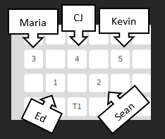

Optional Second Practice Observation - If you wish to do another practice lesson using M codes, then use SMT Training Practice Video Float Sink M for the video. https://youtu.be/uLJ3Jvn0jHw

Note: You can also access data analysis for all observations from the Dashboard by selecting a previously created observation, clicking the plus symbol (+), and clicking the green checkmark in the quantitative or qualitative column. This will bring the user to the correlated Quantitative or Qualitative Analysis screen for that observation.

Lesson 4.3 - Quantitative Data Analyses Mode Features
Like the Qualitative Data Analysis mode, the Quantitative Data Analysis mode includes various features that help break down data and highlight trends in teacher and student actions in the classroom.

Code Summary – As shown below, this feature shows how many times each code was used during data collection, including relative and specific use of the M codes. For this lesson, the user will only have M code data to examine. Underneath the graph is a data table that displays data for 1) each of the specific codes by frequency of an event, 2) the frequency of an event compared to the overall total number of events, 3) the amount of time for each type of event, and 4) time accrued for that event compared to the total time of all the events. At the bottom of the data table for your practice observation, you can see that the M code data has been tallied and turned into percentages of events and time.
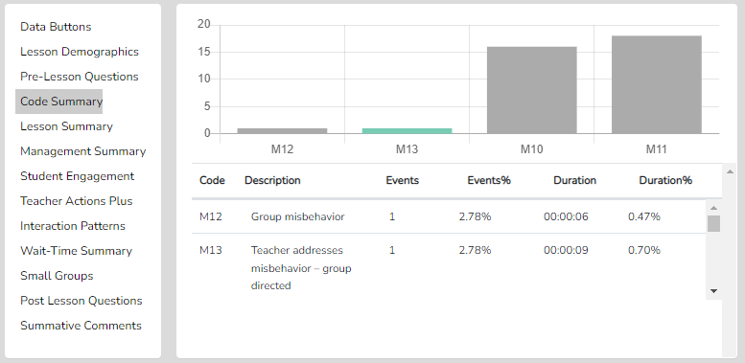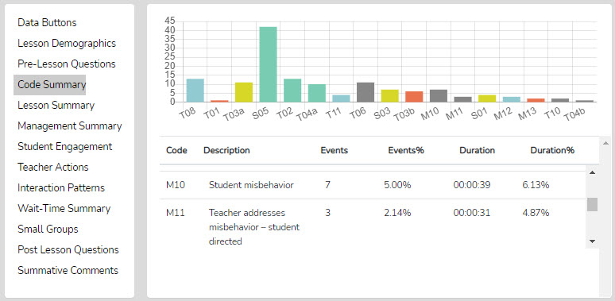

Management Summary Features
The Management Summary displays events of individual student misbehaviors and group misbehaviors, when the teacher intervened or responded to the behavior issue, and how much time was used for the intervention.

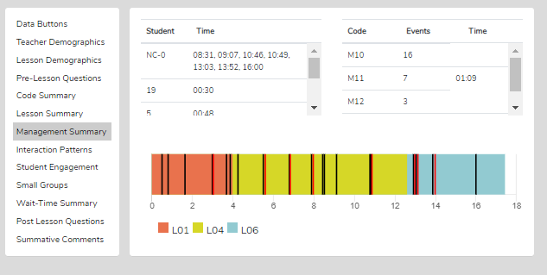
As shown in the figure on the right, when you first click Management Summary, each student misbehavior (M10) or group misbehavior (M12) event has a corresponding black vertical bar on the lesson timeline graph, indicating when it occurred in the lesson segment. In addition, any teacher reactions to student misbehavior (M11) or group misbehavior (M13) are also shown on the lesson timeline graph, but as a vertical red bar.

With the mouse wheel, the user can zoom in or out when the bars become crowded or reset the zoom to normal by clicking the Reset button and the double arrows (top right, above the timeline).

If the M10 events were coded with a student seating number, all those M10 events are displayed in the top left of the Management Summary window, separated by specific student numbers. If the user coded an M10 code without using student seating chart numbers, the quadrant in the Management Summary window would include NC-0, meaning Non-seating Chart coded M events. The times below show when the event or events occurred in the lesson. For example, NC-0 1:18 means an M code event, without a seating chart number attached, happened at 1:18 into the lesson. 19 – 00:30 means that student 19 misbehaved at 00:30 in the lesson.

The far-right side of the window contains the total counts of the M10-M13 codes. These show the number of events for each code and how much time was accrued (in minutes and seconds) while the teacher responded to classroom misbehavior. The compiled data and time indicate how much teaching time was lost while the teacher addressed misbehavior.

Links to Video – Student misbehaviors and the correlating teacher response data points collected during the observation are linked to the clock on the video and are presented as vertical bars on the lesson timeline graph. As such, the user can click on any vertical bar to view the correlating video segment. In addition, the user can isolate a particular student's misbehaviors. For example, to view all episodes of student 15’s misbehaviors, In that case, they can click on student 15 in the Management Summary window or on the Seating Chart Heat Map, which will cause all the vertical bars to disappear from the lesson timeline graph except for the data points linked to student 15. The red bars (teacher interventions) are also clickable and linked to the video segments.

Seating Chart Heat Map - If a specific student seating chart was defined (or when using the generic seating chart), the management data is visually represented in the seating chart heat map by colors representing misbehavior events ranging from 0 to >5. This visual representation provides the user with a map of who, where in the classroom, and how many misbehaviors each student had during the lesson. This is useful information when attempting to analyze and reduce misbehaviors that impede the teacher’s ability to teach and students' efforts to learn.

Also, when group data (Gs in the seating chart) are collected, Student Misbehaviors (M10) can be coded to a specific group (or still coded to a specific student within that group). An analysis of the small group behaviors and misbehaviors can be found under Group Summary – more on this in Training Level 8 – Small Groups.

Demographic Highlighting in the Seating Chart Heat Map - In addition, if data is collected for specific students using the student seat number before entering the M code, the data can be displayed and toggled on or off by clicking the Gender, ELL, SPED, or Minority buttons. If the observer wonders how the students with special needs are engaged during the lesson, toggle this information to find out. If the observer or teacher is concerned about equity of participation regarding gender, minority, ELL, or students with special needs, then this data is available.
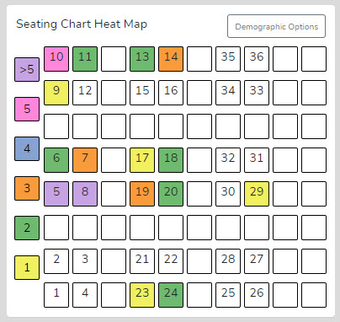

Running Record - At the top right of the quantitative analysis screen is the Running Record window, which shows all events documented throughout the observation in sequence from the start to the end of the lesson. The user can scroll through the events and click on any event (including behavior management issues) to see the related video. The user can export the data to a .csv file for use with powerful statistical packages.

Data Buttons and Locating M Code Events in the Running Record - The Data Buttons and Find feature work as follows: If all qualitative results are toggled off in the Team Table, the top-right of the screen shows the Running Record for the quantitative data-collection episode. If the user clicks on the Data Buttons, the buttons/codes from the quantitative data-gathering phase pop up in the bottom-right quadrant. Suppose the user wishes to locate linked video examples of a specific code. In that case, they can click a specific M button, which finds the first instance of that event type in the Running Record window and prompts the linked video to play. A note at the bottom of the Running Record window indicates how many events of that type were located.

Note: The video begins playing at the start time for that data event. If the user needs to see the video before that starting point, they can use the left arrow to rewind the video – each click is 10 seconds of rewind. Clicking NEXT takes the user to the next example of that specific event type. Clicking PREVIOUS takes the user to the previous example of that code, and the video begins playing. Clicking a different data button brings up the first example of that data type.

Things to Ponder - How Can SMT Users Utilize the Specific M Code – Student Misbehavior Data?
Here are some guiding statements to ponder when analyzing the misbehavior data from the Code Summary, Management Summary data, and related Seating Chart Heat Map, which will help the user focus on specific data and analysis features.

- How many classroom management events were noted by the observer? (Code Summary)
- How many of those classroom management events were not addressed by the teacher? Note that if the number of M10 events is added to the number of M12 events, and that number is greater than the number of M11 and M13 events, the teacher is probably ignoring some of the student misbehaviors, either intentionally or due to the frustration of not having an impact when they do intervene.
- How much time did the teacher use to intervene in management events? (M11 and M13)
- Check the map to see where the problems are occurring and if they are proximal or distant to the teacher's location. (Seating Chart Heat Map)
- Are behavioral issues proximal or distant to where the teacher is located? (Seating Chart Heat Map)
- Think about how the teacher moved around the classroom or stayed in one place. (Noted from watching the video)
- Where in the lesson, or during which lesson type, did the management issues occur? (Vertical bars on the lesson segment timeline)
- How many management issues occurred at the start, end of class, or during transitions from one lesson segment to another? (Vertical bars on the lesson segment timeline)
- How much time was needed to get all the students settled and begin the lesson when transitioning from one lesson segment to another? (video)
- How did the students behave or misbehave today as a whole, compared to other days in general? (teacher’s impressions)
- Regarding specific students who might tend to misbehave, how was their behavior today? (teacher’s impressions)
- Look at the data for specific students who might misbehave and consider their behavior in this specific lesson vs. other lessons. (Counts of misbehaviors)
- Was there anything about this lesson that might have contributed to more or fewer management issues? (Teacher speculation)
- When using the Seating Chart Heat Map and the Demographics toggles, what can you determine about behavior issues regarding select groups of students?

Training 5 – Collecting Wait-Time Using a Simple Method
Wait Time – The What and Why: Knowing about and using wait-time is important when examining teachers’ actions and how they affect student engagement and learning. Wait-time is one of those “laws” of teaching. Like gravity, it works, but when it is not in place, the results are predictable and unproductive. Wait-time has been practiced knowingly or unknowingly since “teaching” began – at least by some teachers. It is the same today – wait-time is practiced by some but should be a part of every teacher’s repertoire of teacher behaviors. The identified and documented benefits of wait-time are a relatively recent contribution (Rowe, 1963), with a flurry of studies following the initial reporting and documentation of wait-time.

What is wait-time? Generally speaking, wait-time is the pause, the think time, when neither the teacher nor students are talking, that occurs between comments, statements, responses, or questions posed by either the teacher or student(s). If the goal is to get students to think, and teachers ask questions that require thoughtful answers, speculation, and justification for their ideas, then students may need time to think about the question and construct a response. As such, research indicates that if teachers increase their average wait time to at least 3.5 seconds, many positive outcomes may occur when the average wait time is 1 second or less. A few of the predictable and positive results of using sufficient wait-time are increases in:

* The length of students’ responses increases between 300% and 700%, and in some cases, more depending upon the study
* More inferences are supported by evidence and logical argument
* The number of questions asked by students increases, and the number of experiments they propose increases
* Student-student exchanges increase; teacher-centered “show and tell” behavior decreases.
* Failures to respond decrease.
* Disciplinary moves decrease.
* The number of appropriate responses increases
* The number of low achievers contributing increases
* Different students begin contributing

When combined with better questioning, wait time is a potent package that gives students ample time to think, allows them to keep thinking without being pulled out of their thinking by more teacher or student talk for a second or two, and therefore keeps them thinking and engaged in the lesson. When students remain engaged in the lesson, the cycle of learning continues to new heights. When the quickest-thinking student is called on right away, the thinking process of the other students is squelched, and when the fastest students (by a few seconds) get the recognition, it creates an impression of not being capable and not up to par regarding expectations. We know that sometimes the “best” answers are those that are allowed to ruminate for a bit, and with average wait-times of less than one second, there is simply not enough rumination time for creative and well-thought-out answers to form and take shape.

In short, knowing the average wait-time can be very helpful. Wait-time 1 gives students a chance to think: after asking a question, teachers pause and give students the time needed to think about an answer (not the typical few milliseconds, but 3-5 seconds or more). Even if some students raise their hands, the other students can still think for a few seconds. Wait-time 2 is waiting 3-5 seconds or more after the student has responded (refraining from reacting to that student’s response, restating, repeating, or rephrasing the response, or calling on another student). Beyond the initial wait-time research, and only because SMT can measure it, the developer of SMT drew on Fowler's (1975) and Tobin's (1987) research by using four distinct categories of wait-time that may indicate rich classroom discussion and engagement. The following are the functional definitions of how SMT captures wait-time data and differentiates between WT 1, 2, 3, and 4.

- Wait-time 1 (WT1; T-S) is the pause between a teacher action (T0 - T12) and a student action/response occurring (S1 – S9).

- Wait-time 2 (WT2; S-T) is the pause between a student action/response (S1 – S9) and the teacher following up the student response with a statement, response, or another question (T1 – T12).

- Wait-time 3 (WT3; T-T) is the pause between a teacher action such as statement, response, or a question (T1 - T12) followed by another teacher action (T1 - T12). WT3 is like WT1, but the teacher action ends the pause, not the student’s action.

- Wait-time 4 (WT4; S-S) is the pause between a student action/response and another student action/response begins. WT4 is like WT2, but ends with a student action, not the teacher’s action.

This training will show the SMT user how to collect wait-time only, without collecting any other data, using a simple, fast method.

In this lesson, the user will learn:
- About the different types of Wait Time
- How to collect quantitative wait time data using the simple method
- How to analyze quantitative data about average wait time used in a lesson
Training Elements
5.0 – Video Overview of Collecting Wait-time Data Using the Simple Method

Cheat Sheet 5

Extended Practice Key 5

Steps to Take – To complete Level 5 training, watch the Video Overview of Collecting Wait Time Data Using the Simple Method while having Cheat Sheet 5 open. Then, read the specific features section below to reinforce what was presented in the video. The user should complete the practice suggested in the video and compare their results with those of an expert using Extended Practice Key 5.

5.2 The How-To of Collecting Wait-time Data the Simple and Fast Way – SMT Beginning User
If the user only wants to collect wait time, it is quite simple, and the user doesn’t have to learn or use any specific T or S codes.

- To collect WT simply, repeat the following actions. After a T, S, M11, or M13 action ends, the user taps ANY T button to note the end of a T action or ANY S button to note the end of an S action. This triggers the wait-time bar to indicate “Wait-time Timing.” The clock will keep timing until the user clicks the wait-time bar (now showing Wait-Time Off) as soon as the teacher or a student begins to vocalize something. This is one cycle of wait-time, and the whole data-collection period of the lesson repeats those actions. Now the wait-time for that incident has been recorded, and the next cycle begins with the user’s next action when they click on a T, S, M11, or M13 button as soon as that person is done talking. The wait time will be summarized in quantitative analysis mode under the Wait-Time Summary tab.
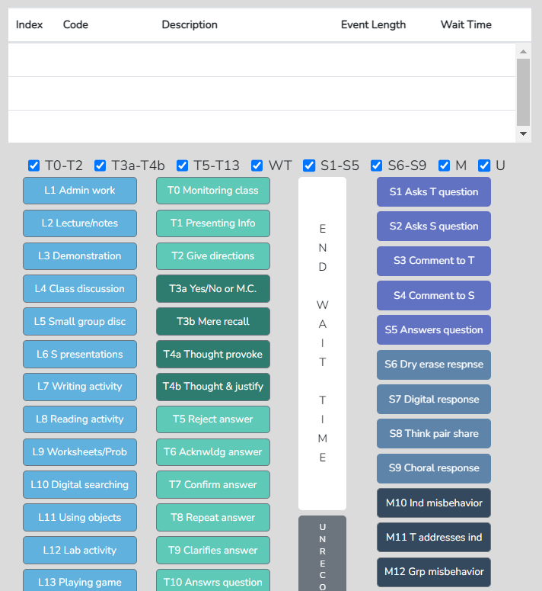

- There is a bonus set of data when WT is recorded in such a manner. The total T time vs. total S time will be listed under Code Summary. This ratio shows how much of the lesson was teacher talk vs. student talk. This ratio is important because a T to S ratio of 90%/10% is a very teacher-centered lesson with very little student engagement. A 60/40 lesson has much more student engagement, and a 40/60 lesson looks very different in terms of student engagement.

Lesson 5.3 Practicing Collecting Wait-Time Data
1. Create a New Observation
2. Observation type: Classroom observation from YouTube.
3. Enter or copy and paste the following YouTube link into the URL box: https://youtu.be/XlPKXIkeHMA
4. Fill in the following information for this observation:
● Teacher being observed: Avatar Teacher
● Observer 1: Yourself
● Observer 2: Avatar Teacher
● Lesson Topic: Wait Time Practice 1
5. Then click “Save and Start.”
6. Choose “Quantitative” observation and then click “Start”.
a. Toggle off all coding buttons except S1-S5 and T0-T2 codes and the Wait Time Bar.
7. Hit play and begin your observation by clicking the appropriate L code.
a. Remember clicking the L code at the start of the lesson starts the timer for that observation. For
this practice lesson, choose L3: Interactive Demo.
8. Begin collecting Wait Time data.
9. After 5 minutes of collecting data, click “Done” and the “Yes, I am done.”

Lesson 5.4 Analyzing Wait-time Data

Wait-Time Summary – Wait-time data is located only in the Wait-Time Summary. Within the Wait-Time Summary are general summaries of wait-time by type, events, total time, and averages for each wait-time (shown below). As noted above, increasing the average wait-time to the threshold of 3.5 seconds or above has many positive effects on the learner and the classroom discourse.

Note that wait-time averages can also be broken down by specific T and S code types (learned in Training 10), and this type of critical data summary can answer questions and identify tendencies in the classroom, such as: does the teacher use more wait time when they pose a higher-level question requiring more think time?

The screenshot below shows the total number of events and total time for each type of wait-time, with the average for each displayed. The text in parentheses reminds the user what action (Teacher or Student) precedes the pause and what action ends the pause. For example, Wait-Time 1 (T-S) reminds you that the Teacher was talking, a pause occurred, and Student talk ended the pause.

While wait time 2 is approaching the 3.5-second threshold that tends to reap benefits, the other data displayed here indicates a need for significantly increasing wait time during this lesson.

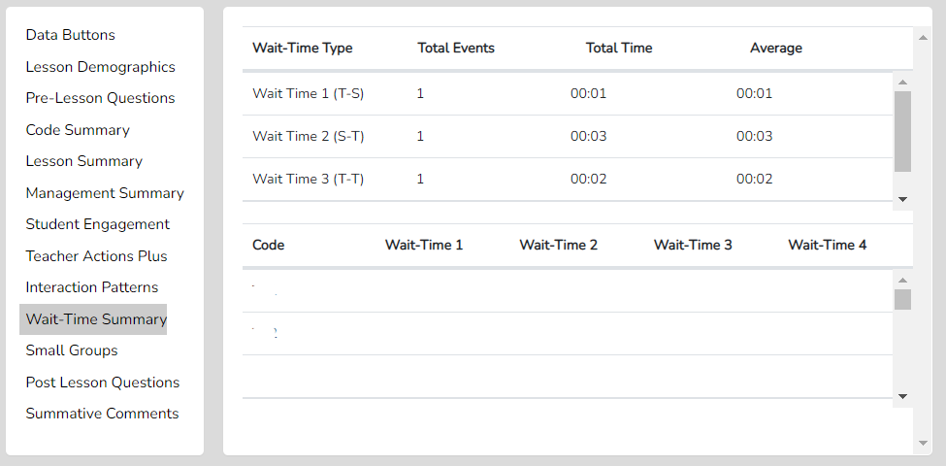

Training 6 – Learn About S Codes: Student Actions and Using the Seating Chart
Introduction - Student engagement is key to learning. Some changes to instruction are visibly obvious, as in this case, where all students are responding, and the teacher knows for sure that all are engaged. Other changes to instruction are not so apparent. In a typical lesson, some students respond to questions while others are passive. Some research indicates that when teachers pose questions to the class, about 6 of 10 students are not even thinking of an answer, as they know the core group of five students who most often answer will buffer them from having to think about the question. If they are called on, they often defer and deflect attention with “I don’t know.” This common disengagement can be quickly countered with strategies and tools that ensure student engagement.

Determining student engagement during a lesson is a key indicator of the power and success of a lesson, and the default assumption that all or most students are engaged, as they look like they are listening but not contributing, is not accurate. This is one reason SMT has built very powerful student action and engagement data collection into the app. As such, during this training, the user will learn the student action codes and then practice entering S codes using seating chart numbers while viewing a pre-recorded lesson of someone teaching five avatar students. S codes are used when the observer wants to capture student actions, perhaps to profile how students respond individually, within a small group, or with the whole class. This allows the user to capture data on which students are engaged in answering questions, teacher-student communication, or student-student communication, including the quantity and type of discourse. Finally, the user will view and explore the analysis of the S Code data collected in the observation under Student Engagement Summary.

The user will learn:
- The various individual and whole group student action codes (S codes)
- How to collect S codes with or without seating chart numbers
- How to look at both raw and analyzed student engagement data
- How to view the color-coded levels of engagement in the Seating Chart Heat Map
- How to use the Demographic toggles to parse data using student characteristics
- How to view the video linked to each of the data points
- Questions to ponder about teaching when examining the S code data and analysis
Training Elements
Training Module 6 – Student Actions (S Codes)

Cheat Sheet 6

Extended Practice Key 6

Steps to Take – First, watch the Lesson 6 video and have Cheat Sheet 6 on hand. The user will be asked to complete a lesson observation, collect data on S codes, and then compare their results with those obtained by an expert user, as shown in the Extended Practice Key 6.

Overview of S Code Data Collection - For level 6 training, the user will learn how to use the nine S codes. Specifically, the first five relate to individual student responses (S1-S5) (which can be used with the seating chart), and the final four relate to whole-group responses (S6-S9). Capturing this data provides a rich picture of student engagement in the classroom.

To accomplish this goal, the observer can click the S1-S5 codes (at the end of the event) or first click a student number before clicking the S1-S5 codes (at the end of the event): 1-S5, 4-S3, 15-S5. The S6-S9 codes are not used with a student number because they refer to the whole class generating responses, such as when the teacher asks students to write on the dry-erase boards. Using all the S codes allows the user to capture individual and whole-class responses and helps determine the full extent of student engagement and interactions during the lesson.

Student Engagement Summary – This specific data can tell the user:
- If a few students are responding versus many students contributing responses
- If responses are forthcoming from students who sometimes are left out, such as students with special needs.
- How much of the lesson involves students who are actively contributing - communicating by responding, asking questions, or commenting to the teacher or other students vs. passive and hunkered down in their seats?
- The whole picture regarding student engagement in the classroom, individually and as a whole class, compared to time used and centered on the teacher’s actions.

Training Progression – First, the user will collect data and then learn how to look at the analysis pages to develop a rich sense of student engagement in the classroom, which sets the foundation for improving student engagement.
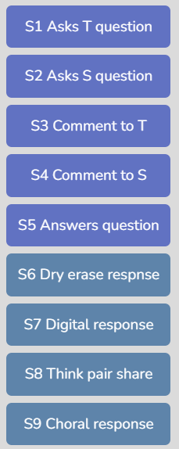
Lesson 6.1 S Codes – The S Codes are:

S1: Asks T question - A Student asks the teacher a question.
S2: Asks S question - A Student asks another student a question.
S3: Comment to T - A Student makes a comment to the teacher.
S4: Comment to S - A Student makes a comment to another student.
S5: Answers question - A Student answers a question (from the teacher or a student).
S6: Dry-erase response - All or most students answer a question using a dry-erase
response board, or all write an answer on paper.
S7: Digital response - All or most students answer a question using a digital device
such as a phone, computer, or using group response software
such as Pear Deck or Kahoot.
S8: Think-pair-share - All or most students are asked a question, think, pair up, and
share responses.
S9: Choral response - All or most students respond as a group to a question.
Lesson 6.2 Practice Data Capture Using S Codes and Student Numbers - In this training, the user will learn to use S codes 1 - 9 with seating chart numbers by coding a video of someone teaching five avatar students while using the seating chart.
1. Create a New Observation
2. Observation type: Classroom observation from YouTube.
a. Enter OR copy and paste the following YouTube link into the URL box:
https://youtu.be/XlPKXIkeHMA
3. Fill in the following information for this observation:
● Teacher being observed: Avatar Teacher
● Observer 1: Yourself
● Observer 2: Avatar Teacher
● Lesson Topic: S-Code Practice 1
4. Then click “Save and Continue”
5. Create a Seating Chart as shown in the image on the right. (The avatar names are included to help you
identify which student avatar is engaged during the lesson.)
- Practice using the seating chart with the S codes to get data specific to individual students.
- Identify individual student responses by clicking on a student seating chart number prior to using an S1-S5 code. For the S6-S9 codes, no student seating chart numbers are used.
6. Then click “Save and Start.”
7. Choose “Quantitative” observation, then click “Start”.
a. Note: For this lesson, as you will focus on using the S1-S5 codes, toggle all other coding buttons off.
8. Hit play and begin your observation by clicking the appropriate L code.
a. Remember clicking the L code at the start of the lesson starts the timer for that observation. For
this practice lesson, choose L3: Interactive Demo.

Note that the user can toggle on or off any set of T, S, M or U codes as well as the wait-time bar to reduce the complexity of the data collection screen. For practicing S codes, the user might want to have only the S codes displayed.

Lesson 6.3 S Code – Student Engagement Data Analysis Options

Introduction - In this lesson, the user will learn to examine the details and meaningful information displayed on the quantitative analysis screens and how S Code data is linked to the video.

Training Steps:
- If you continued from lesson 6.2, you would already be at the quantitative analysis screen. If not, go to your Dashboard, select the lesson you created, click the plus symbol (+), and click the green arrow in the quantitative column to go to the quantitative analysis screen.

Student Engagement Summary Features
The Student Engagement summary displays events of individual student code events (S1-S5), whole-group engagement (S6-S9), and how much time was coded for student engagement versus teacher talk.

When first clicking on Student Engagement, like the M code data analysis page, the user will notice the lesson timeline graph containing black and red vertical bars and a couple of tables above the graph.

Code Summary –As stated before and shown below, this feature provides a graph of how many times each code was used during data collection, including relative and specific use of the S codes. Underneath the graph is a data table that displays data for each of the specific codes by frequency of an event, frequency of an event compared to the overall total number of events, amount of time for each type of event, and time accrued for that event compared to the total time of all the events. At the bottom of the data table for your practice observation, you can see that the S code data has been tallied and turned into percentages of events and time.

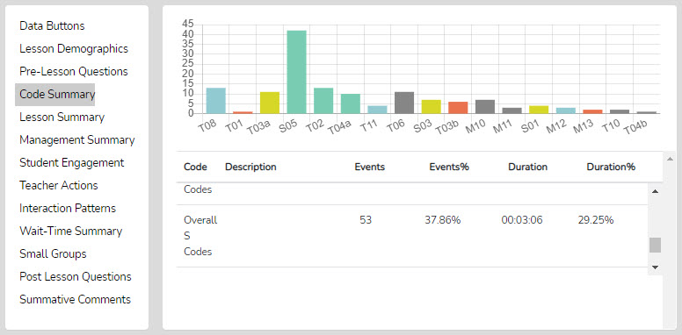

Student Engagement Summary – The Student Engagement Summary displays data on individual student code events (S1-S5) and whole-group engagement (S6-S9), and how much time was coded to student engagement versus teacher talk.
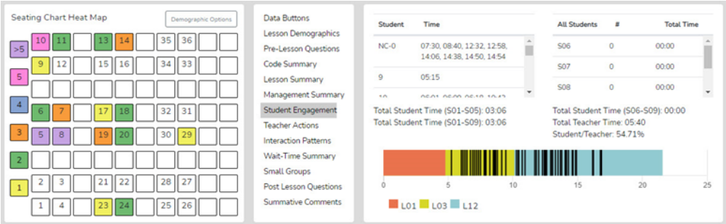

Tables Above the Graph - Like the Management Summary, if the S1-S5 events were coded with a student seating number, all those events are displayed in the top-left of the Student Engagement summary window, separated by specific students. The student seating chart number is displayed, followed by the times that specific students were coded as contributing to an S code event. If the user coded an S code without using student seating chart numbers, the quadrant would include NC-0 (followed by clock times), meaning non-seating chart-coded S events. For example, NC-0 1:18 means an S code event occurred at 1:18 into the lesson, without a seating chart number attached.

Whole class responses and engagement are represented by codes S6-S9. Suppose the teacher asks a question directed to the whole class or gives directions for students to act related to thinking or answering a question. In that case, the S6–S9 codes are used to gather data on whole-class engagement in responding using dry-erase boards, digital responses on Chromebooks, iPads, or another device, think-pair-share, or choral responses. The upper right window provides a breakdown of each of the S6-S9 codes by the number of events, the amount of time that is related to each S code, and the tally for all the S6-S9 codes. In the example above, no S6-S9 codes were used during this lesson observation.

Graph and Vertical Bars - Below the table is the lesson timeline graph, displaying the lesson segments with vertical bars. When clicking Student Engagement, black bars appear for each student number-coded action (S1-S5) and red bars for group responses (S6-S9). This allows the user to see where in the lesson timeline students contributed and showed student engagement. With the mouse wheel, the user can zoom in or out when the bars become crowded or reset the zoom to normal by clicking the Reset button and the double arrows (top right, above the timeline).

If the user wants to see only the events on the timeline for a specific student, first click a specific student number in the upper-left table above the graph. In that case, all bars disappear except for the black bars (events) for that specific student. The red bars for that specific data appear on the graph when clicking on any of the S6, S7, S8, or S9 labels in the upper right table. If users want to switch from a specific data set to the full dataset, they can click Student Engagement.

Links to Video – Student engagement data points collected during the observation are linked to the video's clock and presented as vertical bars on the lesson timeline graph. As such, the user can click on any vertical bar to view the correlating video segment. In addition, the user can isolate a particular student's engagement. For example, suppose the user wishes to view all episodes of student 15’s engagement. In that case, they can click on student 15 in the Student Engagement window or on the Seating Chart Heat Map, which will cause all the vertical bars to disappear from the lesson timeline graph except for the data points linked to student 15.

The Ratio of Student to Teacher Time - Immediately above the graph is the tally for total S1 - S5 time (individual student engagement events), the total time for S1-S9 codes (total student engagement time for the lesson), total teacher time (T1 through T12 – to be covered in a subsequent lesson), and the percentage of total student engagement time vs. total teacher time. Not coding T codes yet, the S code ratio should show 100%. When coding a lesson using both S and T codes, if the S-to-T ratio is greater than 50%, students contributed at least 50% of the time in class. If the ratio is 5%, it means students contributed very little. Note that this ratio is a rough indicator of student engagement in the classroom. A class resulting in a 10/90 ratio looks very different compared to a class with a 90/10 ratio.

Student Seating Chart Heat Map - The Student Engagement data is also visually represented in the seating chart window by a color-coded heat map indicating which students were coded for engagement and the number of engagement events connected to them. This visual nature of the seating chart heat map gives the user an instant picture of student engagement – who and how many events are occurring in the classroom, whereas the timeline provides the “when” during the lesson.

Demographic Highlighting in the Seating Chart Heat Map - In addition, if data is collected for specific students using the student seat number before entering the S code, the data can be displayed and toggled on or off by clicking the gender, ELL, Sped, or Minority buttons. If the observer wonders how the students with special needs are engaged during the lesson, toggle this information to find out. If the observer or teacher is concerned about equity of student participation and engagement regarding gender, minority, ELL, or students with special needs, then this data is available.

Data Buttons and Locating S Codes in the Running Record – In the prior training level, the user learned how to locate specific code events in the Running Record. This is simply a reminder that the user can locate specific S code events in the Running Record and view the linked video using this function.

Things to Ponder Using S Code – How Can SMT Users Utilize the Specific S Code – Student Engagement Data?
- Consider how many students responded to at least one question and how many were not part of the conversation. (Heat Map)
- Think about your teaching, how many students responded to each other at least once, and what you might change to produce more student-to-student interactions. (Interaction Patterns S-S #)
- Think about the average number of responses per student, how that fits your student engagement goals, and how that number might be increased. [Total of S1-S5 plus (the total of S6-S9 x the number of students in the class) / number of students in class]
- Look at the various parts of the class or type of lesson segment and determine if or how students were engaged, as evidenced by vertical bars. Think about parts of the lesson that were absent of student contributions and engagement and how your lesson might be altered to produce more student engagement.
- Using the demographic toggles on the Seating Chart Heat Map, examine student engagement by demographics such as gender, minority, ELL, and Special Education – think about what the data suggests regarding equity in student engagement.

Need More Practice Using S Codes with the Seating Chart?
If you wish to practice another lesson using S codes and seating chart numbers, create a new observation using the same seating chart, but use the URL for the video labeled SMT Practice Video Truck Hill L https://youtu.be/pjv0FSyR5sw.

Training 7 – Teacher Actions: Four Question Types
Introduction - Teacher actions are one of the most important data to collect and analyze when examining indicators of effective teaching. Teachers greatly impact the classroom learning environment. Most sources acknowledge that the teacher is the most important factor affecting student learning (if the student comes to class). Research clearly shows that teacher behaviors and actions significantly affect student learning, student behavior, student self-efficacy, and more. As such, examining teacher behaviors and actions in the context of lessons and teacher-student interactions is critical.

This lesson focuses on a subset of teacher actions, probably the most important aspect of teacher-student interactions – how teachers pose questions to students. Hence, this lesson examines the four question types an SMT user can note while observing a teacher interact during a lesson. This training leads to more powerful data collection and analysis, as in Practice 6/7 the user will collect the four question types alongside data on student actions. Then in Training 8, the other eleven teacher actions will be added in, and the user will collect data that represents rich data that represents the complete picture of how teachers ask questions, students respond, and what the teacher does following the student response that greatly affects learning and student engagement. So, for now, we will focus solely on identifying and collecting the four question types.

Why only four question types? Because in the often fast-paced arena of a classroom and teacher-student interactions, the observer has enough time to discern four question types but not enough time to sort out more complex schemes that contain seven or eight types of questions without missing important actions taking place in the lesson. The four question types come from a well-established teacher observation system dating back to Abraham and Schlitt (1972), who devised and used the SATIC Coding system for classroom observations.

The user will learn:
- How to recognize and collect data on the four question types
- How to view both raw and analyzed data.
- Questions to ponder about teaching when examining the question-type data and analysis.
Training Elements
Training 7 Video Overview of Teacher Actions - Four Question Types

Cheat Sheet 7

Extended Practice Key 7

Steps to Take – First, read the introduction to teacher actions noted below. Then, watch the Lesson 7 video and have Cheat Sheet 7 on hand. The user will be asked to complete a lesson observation, collecting data on T codes – the four question types- then compare their results with those obtained by an expert user, which is found in the Extended Practice Key 7.
  - The user will read a short introduction to collecting data on teacher actions within the training supplement in SMT Training 7 – Module 2: Learning the Teacher Action Codes. This material provides some insights into why studying and collecting data on teacher actions is so critical. This reading will also be applied to Training 8, where the user learns more about teacher actions that might follow a student’s response.

  - The Four Question Types - read the following definitions of the four question types.
T3a. Asks Yes/No or Multiple-choice (M.C.) Question: This code is used when the teacher asks a question that requires a yes/no answer or offers a couple of choices from which the student chooses an answer. For example, the teacher might ask, “Does 100 kg or 50 kg have more mass?”

T3b. Asks Mere Recall Question: This code is used when the teacher asks a question framed to recall information, facts, or a procedure they completed. For example, “Someone tell me what we did in yesterday’s lab” simply asks the student to recall an event.

T4a. Asks Thought-provoking Short Answer Question: This code is used when the teacher asks a question that requires deeper thinking, perhaps in the form of speculation. While it might be answered with 1-2 words, a T4a is any question that requires some thought process to generate an answer, some critical thinking, and may be open-ended, with multiple possible responses from students. For example, the question might be posed as “What are some ways we might solve this dilemma?” The answer could be a few words, but to respond, students had to think more deeply than what is required for a recall, multiple-choice, or yes/no question. Examples include hypothesizing what will happen when you release a balloon filled with nitrogen or explaining which equation would most effectively help solve a given word problem. This question does not ask for justification or explanation of the answer, just an answer. Some examples include: a. Predict what you think will happen when I ... b. What might happen to the system when I raise the pressure? Another example is, “If we put a heavier load on the cart and let it roll downhill, what might be the effect on the speed of the cart?” This is clearly a T4a because we are asking the student to speculate but didn’t explain how they arrived at that response. How does this differ from T4b? A T4a question does not ask for justification or explanation for how they arrived at that response.

T4b. Asks Thought-provoking Extended-answer Question: This code is used when a question requires both deep thinking, perhaps in the form of speculation, cannot be answered with 1-2 words, AND a justification or an explanation for how they arrived at their answer. For example, the question from T4a “If we put a heavier load on the cart and let it roll downhill, what might be the effect on the speed of the cart, and why do you think so?” becomes a T4b because of the ending of the question, which asks the student to explain their thinking to tell us how they arrived at that conclusion. Another example is: “Given the results of the last two experiments, which of the two metals were in solution and how do you know?” This could look like a student being asked to explain why they performed a particular test on an unknown substance to try and determine its composition, or just about any question with a “why” portion to it.

  - Practice identifying question types using a document with examples to hone their recognition before moving on to identifying question types from the video. Click on the link to access the practice document: Identifying Teacher Questions Practice Document.

  - Practicing identifying question types using this practice sheet and the Training Module 7 Cheat Sheet

  - Practice Using SMT and Video
- Create a New Observation
2. Observation type: Classroom observation from YouTube.
3. Enter or copy and paste the following YouTube link into the URL box:
https://youtu.be/XlPKXIkeHMA
4. Fill in the following information for this observation:
● Teacher being observed: Avatar Teacher
● Observer 1: Yourself
● Observer 2: Avatar Teacher
● Lesson Topic: T3-T4 Practice 1
5. Then click “Save and Start.”
6. Choose “Quantitative” observation and then click “Start”.
a. Toggle off all coding buttons except T3a-T4b.
7. Hit play and begin your observation by clicking the appropriate L code.
a. Remember clicking the L code at the start of the lesson starts the timer for that observation.
For this practice lesson, choose L3: Interactive Demo.
8. Begin collecting data.
9. After finishing the video and collecting data, click “Done” and the “Yes, I am done.”

  - Post-data Collection Analysis - Finally, post-data collection, the SMT user will learn to examine the raw and analyzed data displayed in Code Summary and Teacher Actions Plus in relation to the goals for instruction.
- See Cheat Sheet 7 for guidance and examples of data and analyses.
- Also, review the notes above for analysis possibilities.
- Use the Extended Practice Key 7 to compare results obtained with those from an expert SMT user. Note once again that your data and results should be similar but won’t be exactly the same, and that is OK.

Practice 6/7 – Merging Student Actions and Teacher Questioning
Introduction – Practice 6/7 merges the skills you developed and what you learned from both Training 6 and Training 7. Practice 6/7 has the user practice collecting data on both student actions and the four question types. This is a stepping stone toward developing speed, becoming more accurate when clicking codes to match the action, and learning more about data analysis to dig deeper into the data and provide higher-quality, more sophisticated feedback to the teacher being observed.

The user will learn:
- To learn to collect data on student actions while collecting data on the four question types.
- What the raw data and analysis show about student actions, teacher questions, and the relationships between them.
- Develop speed and accuracy of observing and coding.
- Learn more about the analysis from the many data points and the data analysis, heat maps, graphs, and charts.
Training Elements
Instructions for Practice 6/7

Extended Practice Key 6/7

Steps to Take – First, read the instructions for Practice 6/7The user will be asked to complete a lesson observation, collecting data on S codes and the four question types (T codes 3a, 3b, 4a, 4b), then compare their results with those obtained by an expert user, which is found in the Extended Practice Key 6/7.

Practice Capturing Student Actions and Four Question Type T Codes at Slow Speed: Data analysis can be very robust and powerful when both T and S codes are collected; therefore, observers and teachers will benefit greatly if both T and S codes are used during the observation. You have already learned to separately capture S codes and the four question types, so in this lesson, you will collect both during an observation.

Optional - If student misbehavior is an issue in a classroom with off-task chatting or other student misbehaviors, using M codes helps uncover trends and patterns in misbehaviors and the teacher’s reactions. Since the SMT user is now working at this level, they may have progressed through Training 4, which covers M codes and student misbehaviors. This additional M code data collection can be incorporated with any other data collection (except the Wait Time simple method), and it may be good practice to add M code data collection during this practice. Yet, during this training sequence, SMT scaffolds the level of difficulty and layers on new skills, so it is up to the SMT user to either add M codes during the observation or keep it simple by doing only the S codes and four question types. Looking ahead, the user will be asked to incorporate M code data collection along with all the T and S Codes in Practice 9.

Practice 6/7.1 Lesson Observation Using S Codes and Four Question Types
- Create a New Observation
- Observation type: Classroom observation from YouTube.
- Enter OR copy and paste the following YouTube link into the URL box: https://youtu.be/XlPKXIkeHMA
- Fill in the following information for this observation:
- Teacher being observed: Avatar Teacher
- Observer 1: Yourself
- Observer 2: Avatar Teacher
- Lesson Topic: Practice 6/7
- Then click “Save and Continue”
- Create a Seating Chart as shown in the image on the right. (The avatar names are included to help you identify which student avatar is engaged during the lesson.)
  - Practice using the seating chart with the S codes to get data specific to individual students.
- Then click “Save and Start.”
- Choose “Quantitative” observation, then click “Start”.
  - Note: For this lesson, as you will focus on using the S and T3a-T4b codes, toggle all other coding buttons off.
- Hit play and begin your observation by clicking the appropriate L code.
  - Remember clicking the L code at the start of the lesson starts the timer for that observation. For this practice lesson, choose L3: Interactive Demo.

When finished with the observation, review page 2 of the Cheat Sheet for a reminder of the analysis categories and what useful information can be found in each summary. Use the Extended Practice Key 6/7 to compare your results with those obtained from an expert user and once again note that while results should be somewhat similar, they will not be exactly the same – and that is OK.

Additional Videos for Practicing Observations

SMT Practice Video Float A - https://youtu.be/oxxazkrBChg

SMT Practice Video Float Sink B - https://youtu.be/k38GViRMJIM

SMT Practice Video Truck Hill L - https://youtu.be/pjv0FSyR5sw

Lesson – Data Analysis Using Student Action Codes and Four Question Type T Codes

Introduction - Understanding teaching strengths and weaknesses is the linchpin for continued growth in the skills needed to become a highly effective teacher. The lesson targets knowing what data can be used to provide more specific teacher feedback. Collecting question types and student actions data compounds the level of rich analysis possible when using SMT.

Once accurate data has been collected, this tool offers many analysis features from which to draw conclusions or establish new targets for modifying teaching to move toward the highly effective teacher level. Read through the following section to better understand the potential analysis when using the T and S codes.

Questions to Ponder About Question Types and S Codes – The Combined Actions Data

Since this observation included T Codes – Four Question Types and S code data, the user could contemplate all the “Questions to Ponder” from the previous S Code and Four Question Types - T training. While SMT can capture much more information, this data alone is a rich trove.
In addition, now that T actions are coded and analyzed alongside S actions, there are additional considerations due to the interaction and dynamics between the teacher and student. For example, users could consider how a change in teacher questioning actions might:
- Stimulate more individual student engagement.
- Stimulate more student-to-student exchanges.
- Reduce behavior issues.
- Encourage students to offer up more questions that would clarify their thinking.
- Help the teacher understand where the student is faltering.

Training 8 – Learning About the Remaining Teacher Actions and Behaviors
Introduction – This level will require a bit more effort and practice. But the whole set of teacher actions (T codes) is probably the most important data to collect and analyze. Teachers have a huge impact on the classroom learning environment. Most sources acknowledge that the teacher is the single most important factor affecting student learning (if the student comes to class). Research clearly shows that teacher behaviors and actions significantly affect student learning, student behavior, student self-efficacy, and more. As such, examining teacher behaviors and actions in the context of lessons and teacher-student interactions is critical. After mastering this level, the SMT user will be able to collect a wide range of critical T- and S-related data that result in a rich, robust analysis, laying the foundation for evidence-based commentary, feedback, and suggestions for improving teaching.

During this training, the user will practice identifying actions representing T codes, then practice data collection by entering T codes while viewing a pre-recorded lesson of someone teaching five avatar students. Finally, the user will view and explore the analysis of the T Code data collected in the observation under Code Summary, Teacher Actions Plus, and Interaction Patterns.

The user will learn:
- The additional eleven T codes that make up the set of fifteen teacher action codes (T codes) and what they represent
- How to view both raw and analyzed teacher action data when collecting T codes
- How to view the video linked to each of the data points
- How to use Code Summary to examine Teacher Actions (T codes) vs. Student Actions (S codes) total time and the ratio of T to S times
- How to use Teacher Actions Plus to view a digital footprint of all the data collected in the observation and discern key information and tendencies.
- How to view the Interaction Patterns data that show tendencies and predominant teacher-student interactions.
- Questions to ponder about teaching when examining the T code data and analysis
Training Elements
Lesson 8.0 Video Overview of Merging S Codes and all Teacher Action Codes

Cheat Sheet 8

Extended Practice Key 8

Steps To Take – First, watch the Lesson 8 video, have Cheat Sheet 8 on hand, and refer to 8.1 below as needed. Because the user will need practice identifying examples of teacher actions at a slow pace before completing a lesson observation from videotape, SMT has provided numerous paper/pencil or electronic forms to serve as practice sheets. Do not skip this phase of the training. When the user has developed confidence identifying discrete teacher actions, the user will be asked to complete a lesson observation, collecting data on T codes (and simultaneously M and S codes), then compare their results with those obtained by an expert user, which is found in the Extended Practice Key 8.

- Watch the video overview of using the T codes and read 8.1 to learn what each T code button represents regarding teacher actions. Training 8 – Merging S Codes & All Teacher Actions
- Read the subsequent pages in the manual pertaining to T codes and become familiar with the T code definitions shown in Lesson 8.1.

Lesson 8.1 The T Codes - Sixteen codes are used to indicate teacher actions and behaviors. All codes (except T13) are event/timing codes, and the T Codes are:

T0. Monitoring class: This code is used when students are working, and the teacher monitors the classroom or perhaps does administrative work, such as taking attendance.
T1. Presenting Information: This code is used when the teacher lectures or presents information through extended, teacher-initiated commentary. This teacher's talk is more than the one to two sentences that characterize a T2 below. One rule of thumb is if the teacher is not giving directions but making statements or providing information that goes on for about 15 seconds, they have moved into a “presenting information” phase and are coded as a T1.
T2. Give Directions: Gives Directions, Makes a Statement, or Asks a Rhetorical Question: This code is used when teacher-initiated statements such as directions, statements, or a rhetorical question to which no answer is expected are used. “Statements” can normally be thought of as one to three sentences.

Four Question Types (learned in Training 7)
T3a. Asks Yes/No or Multiple-choice (M.C.) Question: This code is used when the teacher asks a question that requires a yes/no answer or offers a couple of choices from which the student chooses an answer. For example, the teacher might ask, “Does 100 kg or 50 kg have more mass?”
T3b. Asks Mere Recall Question: This code is used when the teacher asks a question framed to recall information, facts, or a procedure they completed. For example, “Someone tell me what we did in yesterday’s lab” is simply asking the student to recall an event.
T4a. Asks Thought-provoking Short Answer Question: This code is used when the teacher asks a question that requires deep thinking, perhaps in the form of speculation, and cannot be answered with 1-2 words but does not ask for justification or explanation.
T4b. Asks Thought-provoking Extended-answer Question: This code is used when the teacher asks a question that requires deep thinking, perhaps in the form of speculation, cannot be answered with 1-2 words, and requires a justification for the answer.

Eight Things Teachers Might Do After Students Respond
T5. Reject Student Comment, Answer, or Question: This code is used when the teacher rejects a student’s response, indicating that the student's answer is wrong or that the teacher cuts off the student’s response.
T6. Acknowledges Student Comment or Answer: This code is used when the teacher acknowledges the student without evaluation. For example, the teacher might give a neutral response indicating the student was heard but does not confirm or reject the student’s answer.
T7. Confirms Student Comment or Answer: This code is used when the teacher evaluates a student's response positively and the teacher clearly indicates the student was correct. This might also be in the form of praise.
T8. Repeats Student Comment: This code is used when the teacher repeats the student's response.
T9. Clarifies or Interprets What Student Said: Use this code when the teacher rewords or interprets a student's response. This technique may be used to clarify, emphasize, or improve a student's response.
T10. Answers Student Question: This code is used for short, succinct responses to student questions.
- Note: If the response becomes long-winded and extends beyond 15 seconds, a T1 should be used to indicate that the teacher responded with a mini-lecture when responding to the student's question.
T11. Asks Student to Clarify or Elaborate: Use this code when the teacher asks a student to extend, repeat, or clarify a student's response.
T12. Uses Student Question or Idea: Use this code when the teacher redirects a student’s question to another student, the small group, or the whole class.
Other
T13. Annoying Verbals or Non-Verbals: T13 is an event-only code to be used when noting something nonverbal, such as an annoying habit worth noting and relaying to the teacher. Use this when the teacher displays annoying verbals or non-verbals that detract from instruction or perhaps distract students.

  - Practice Learning T Codes Using the Google Form
Identifying Teacher Actions Practice – Google Form
- Directions - Click on the link below to be taken to a google form where you can complete the recommended practice on identifying teacher actions before using T codes in a SMT observation:
Identifying Teacher Actions Practice - Google Form

8.3 Practice Learning T Codes on Paper: When observing someone teach, there is a lot of action taking place, and the observer doesn’t have much time to sit and think about which teacher action they just saw because the next teacher or student action is taking place. Therefore, learning to recognize a particular T code quickly is important. The SMT team has developed a set of training exercises to develop this skill set and scaffold your skill to a level that will allow you to keep up with the pace of instruction in the classroom. It begins at a slow pace, first with practice on a transcript to develop accuracy in coding T codes before using video. The appendices of this manual contain the practice sheets needed to improve the recognition of teacher actions. At the front of this section, read about the “Teaching Fingerprint” and read about the examples of each code while using the mnemonics to help you remember each code. Then complete the practice sheets by coding the teacher’s actions on the transcripts, checking your answers with the key, and practicing until attaching a code to a teacher's action becomes easy and fast. Learning the T codes on paper is an important step to recognizing a specific teacher action and coding it to one of the 15 categories. When you feel confident recognizing T code actions, proceed to Level 8.4.

Identifying Teacher Actions – SATIC Practice (SMT Manual)
- Directions - Click on the link below to be taken to the SMT training manual where you can complete the recommended practice on identifying teacher actions before using T codes in a SMT observation:
Identifying Teacher Actions - SATIC Practice (SMT Manual)

  - Practice identifying T and S codes Using Video
Note that the user can toggle on or off any set of T, S, M or U codes as well as the wait-time bar to reduce the complexity of the data collection screen. When first practicing T codes, the user might want to have only the T codes displayed (toggle off the other codes).

- Create a New Observation
- Observation type: Classroom observation from YouTube.
  - Enter OR copy and paste the following YouTube link into the URL box: https://youtu.be/XlPKXIkeHMA
- Fill in the following information for this observation:
- Teacher being observed: Avatar Teacher
- Observer 1: Yourself
- Observer 2: Avatar Teacher
- Lesson Topic: Practice 8
- Then click “Save and Continue”
- Create a Seating Chart as shown in the image on the right.
(The avatar names are included to help you identify which student
avatar is engaged during the lesson.)
  - Practice using the seating chart with the S codes to get data
specific to individual students.
  - Code both T and S codes during this observation.
- Then click “Save and Start.”
- Choose “Quantitative” observation, then click “Start”.
  - Note: For this lesson, as you will focus on using the S and T codes. Toggle all other coding buttons off.
- Hit play and begin your observation by clicking the appropriate L code.
  - Remember clicking the L code at the start of the lesson starts the timer for that observation. For this practice lesson, choose L3: Interactive Demo.
- When finished with the observation use Cheat Sheet 8 and look below for a reminder of the analysis categories and what useful information can be found in each summary.

Additional Practice Options

SMT Practice Video Float Sink A - https://youtu.be/oxxazkrBChg

SMT Practice Video Float Sink B - https://youtu.be/k38GViRMJIM

Practice Video Truck Hill L - https://youtu.be/A76fVcYo6ks
8.4 T Codes – Teacher Actions Analysis Options

Introduction – Using this section and Cheat Sheet 8, the user will learn how to analyze the T code data and look for indicators that help identify a teaching fingerprint, as well as other indicators that can be used to improve teaching and provide evidence-based feedback to others. Examine the raw data and analysis from the 8.3 observation that was coded using T codes and S codes.

Code Summary – As stated before, the Code Summary provides a graph of the number of events for each code used during data collection, in this case showing the relative and specific use of T or S codes. Underneath the graph is a data table that displays data for each of the specific codes by frequency of an event, frequency of an event compared to the overall total number of events, amount of timecoded by the specific event, and time accrued for that event compared to the total time of all the events. At the bottom of this data table, the T and S codes data have been tallied and again turned into percentages of events and time. The Code Summary data provides indicators of teacher tendencies and helps to answer questions such as:

- What are the counts, percentages, and total time for each T or S code?
- What were the predominant T codes exhibited in this lesson, and how does this match your expectations?
- What were the counts of S1 – S5, which indicate the number of student contributions during the lesson?

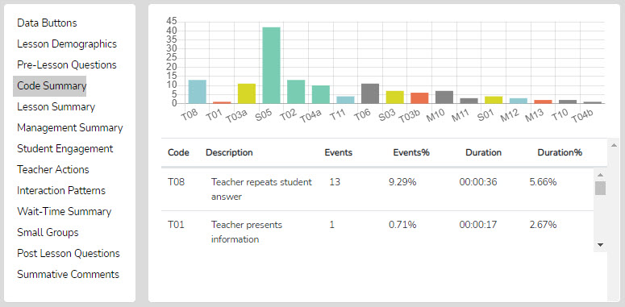

Interaction Patterns – Teachers have teaching habits, tendencies, or overt patterns of interacting with students. These habits are often the same regardless of the lesson or class and may repeat year after year unless specific analysis and intervention occur. These well-ingrained ways of interacting with students are like fingerprints, an interaction fingerprint (Berg, 2019). Research has demonstrated that some patterns are more productive for getting students to think deeply, take risks, listen to other students’ ideas, pose more creative answers, or be more thoughtful about the task. The interaction pattern data analysis SMT provides helps to identify predominant patterns displayed by the teacher.

To do this, SMT takes all the T and S codes, looks for sequential patterns, and displays those from most to least. This allows the user to compare interaction patterns with instructional goals. For example, if the most predominant code is T3b-S5-T7 and has a Sum of 19, the teacher exhibited that sequence of three codes 19 times during this lesson observation. The teacher asked a yes/no question, followed by a student response, then confirmed the answer.
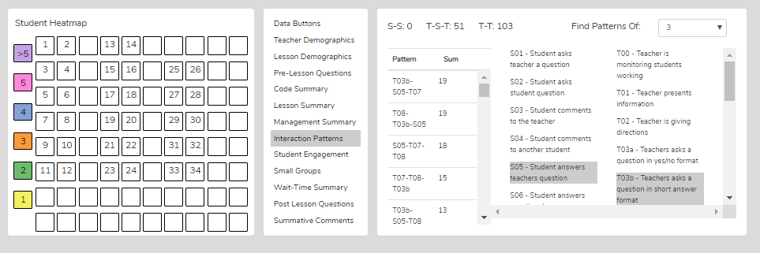

Why Are Interaction Patterns Important? - Examining the most to least predominant patterns helps us understand how or if our teaching matches our goals for instruction. For example, if our goal of the lesson is to get students to think deeply about the subject matter or processes of science, but we don’t find a pattern that includes T4a or T4, or no T11 or T12, then doubt is cast on whether we are facilitating this goal of student thinking, or not.

Identifying Predominant Patterns of Interaction – To look for predominant patterns of interaction in your observation:
- Go to Interaction Patterns and, first, choose the length of the pattern (from 3-6 events in sequence – it is suggested to begin with a pattern of 3).
- Look at the left-hand column showing Pattern and Sum (which shows the number of events in that sequence).
- Click on that pattern, and the descriptions of codes within that sequence are highlighted on the right-hand side (this way, the user doesn’t have to remember what a code represents).
  - For example, if the most predominant code is T3a - T7 - T9 with a Sum of 21, it means that the teacher used that sequence of three codes 21 times during this lesson observation. The teacher asked a yes/no question, followed by a student response, followed by confirming the response.

Other Predominant Patterns of Interaction - In addition, at the top of this section of data are counts for how many times:
- T-T was exhibited in the lesson (teacher action followed by teacher action; for example, the teacher asked a question, then rephrased the question).
- S-S was counted (how many times a student's action was followed by another student's action, such as a student responding to a teacher-posed question followed by another student asking that student a question)
- T-S-T was counted (teacher action, followed by student action, followed by teacher action – this is the normal interaction in class, but this pattern could be any number of things; therefore, the pattern count helps identify the predominant fingerprint of the teacher.

What does this information tell us as observers and teachers being observed? In this case, an S-S pattern occurred zero times, indicating that a student did not respond to another student. This essentially is a lesson devoid of student-to-student interactions. When there is a number for S-S, check the Code Summary to determine whether that number includes any S2 (student asking another student a question) or S4 (student making a comment to another student). Otherwise, the number would probably mean a student action directed to the teacher. Fifty-one times the teacher responded after a student response (T-S-T, the normal classroom interaction pattern that is often less effective), and one hundred and three times, the teacher followed up with another statement or question (T-T). This rough measure of classroom interaction tells us that the teacher is the main communicator in the classroom; students are somewhat passive and do not interact with each other in any manner.

How SMT Users Can Utilize the Interaction Patterns – Teacher and Student Interactions Data
- The longer the lesson, the higher the probability that the predominant patterns stand out. This allows the user to easily identify the teacher’s most frequent patterns of interacting with students.
Consider how these patterns support or do not foster the goals and intentions of the lesson.
- Identify what patterns should be present to best support the goals and intentions of the lesson.
- Look at the S-S counts and consider how that amount of student-student interaction fits with the goals of the lesson and the strategy used for the lesson. Identify how changing the interaction pattern might have fostered more student-to-student interaction.
- Look at the T-S-T counts and consider how this number balances with the S-S counts.

Data Buttons and Locating T Codes in the Running Record - To search for specific examples of T codes or S codes exhibited in the video, go to Data Buttons, click on a T or S code that you wish to view on the video, and the video segment should show the teacher displaying that specific code. For more of that specific code example, click on Next to view the video of the next example in the Running Record.

Teacher Actions Plus Summary – The Teacher Actions Plus summary is a timeline showing all the data collected during the observation or the digital teaching story from the beginning to the end of the lesson. The data are displayed on a backdrop of the lesson type (colors) in play and show symbols for when the teacher exhibited various T code actions, so the user can follow the sequence of teacher actions throughout the lesson. The timeline also displays M and S code data; in fact, almost all collected data are represented on the timeline, providing a robust set of teacher and student actions. The user can easily see when any management issues occur in the context of the rest of the teacher and student actions in the lesson.

Since this is a visual display of teacher actions, student actions, and misbehaviors, as well as the teacher’s reaction to misbehaviors, it provides the user with a visual of the flow of action from the beginning to the end of the lesson and visually brings forth sequences, predominance, or absence of teacher or student actions. For example, if the teacher is curious about their use of questioning, it is easy to see when any of the four questioning codes were used and what codes occurred before or after. The user may find a complete absence of higher-level questions. The user may readily see what they tend to do following a student's response. The user can target specific codes by toggling the display of T, S, or M codes on or off. Aside from wait-time data, all the data is represented on this summary screen, which is often a large chunk of data and may clutter the screen. With the mouse wheel, the user can zoom in or out when the symbols become crowded, or reset the zoom to normal by clicking the Reset button (double arrow, top right).

As shown below, the viewer can zoom in or out to separate data points. Finally, as with other data points in SMT, the user can click on any data point (symbol), and the linked video will play.

Things to Ponder About T Codes – How Can SMT Users Utilize the Specific T or S Code Data
- Looking at the Code Summary, the data table, and the graph:
  - What were the predominant T codes exhibited in this lesson?
  - When looking at the data for the four question types (T3a, T3b, T4a, and T4): what is the tendency of the teacher to ask open-ended questions requiring students to think more deeply, to speculate, and construct answers vs. asking questions that require a yes/no or short-answer memory-type response?
  - If the goal was to dig into student thinking at a deep level, consider the type and number of questions asked (and your memory of the teacher asking questions in the video). What might you conclude?
  - Look at how many and what types of questions were asked. How did this affect the amount and type of student engagement?
  - Looking at the T5-T12 counts, what can you conclude about how the teacher responds following a student's response if their goal was to encourage student responses and keep digging into what students were thinking?
  - Look at the quantity of S5 events (students answering a question) as well as the other S code events that indicate the level of student engagement.
  - Note any S6 or S7 events that offer students (and the teacher) an opportunity to share their thinking.
  - Note any S8 events (think-pair-share) that provide an opportunity for students to interact with each other and share and compare ideas.
- Looking at Interaction Patterns, examine the 3-code pattern tendency, then the 4-code pattern tendency. How are the most common patterns consistent with the goals for the lesson? What are some changes to how the teacher interacts with students that would be more consistent with the intentions of the lesson?
  - How did the teacher initiate questions and then respond to student thinking? How did the teacher’s tendencies encourage or discourage student responses and engagement?
  - When students respond – what does the teacher tend to do? Do they tend to judge responses, acknowledge them, and then clarify for the student, or instead, ask the student to clarify? Different tendencies are more effective depending on the goals of instruction and the level of thinking or engagement the teacher wants from students.
- Looking at the Teacher Actions Summary screen:
  - What question types were used in the lesson? What followed questions in terms of S codes – one student response, or was it more than one student response? After the student(s) responded, what did the teacher do next?
  - How did the teacher use the whole-group response engagement S codes (S6-S9) to generate answers and provide maximum feedback to the teacher? If S6-S9 were not used, what evidence exists indicating the teacher is attempting to increase students’ oral contributions to the lesson?
  - Knowing that T codes (teacher responses) T6, T11, T12, and sometimes T8 tend to help get and keep students thinking more so than T5, T7, T9, and T10, what does the visual tell you about the teacher’s use of the various response codes?
  - What stands out about the student misbehavior actions M10 and M12, and then how would you characterize the teacher’s reaction to student misbehaviors M11 and M13?

Training 9 – Collecting Wait-time AND T, S, and M Codes with Seating Chart
Note the SMT User – If you completed Training 5 – Wait Time Simple Method, then some of the narratives below will be redundant.

Wait Time – The What and Why: Knowing about and using wait-time is important when examining teachers’ actions and how they affect student engagement and learning. Wait-time is one of those “laws” of teaching. Like gravity, it works, but when it is not in place, the results are predictable and unproductive. Wait-time has been practiced knowingly or unknowingly since “teaching” began – at least by some teachers. It is the same today – wait-time is practiced by some but should be a part of every teacher’s repertoire of teacher behaviors. The identified and documented benefits of wait-time are a relatively recent contribution (Rowe, 1963), with a flurry of studies following the initial reporting and documentation of wait-time.

What is wait-time? Generally speaking, wait-time is the pause, the silence, the think time, the time when neither the teacher nor students are talking, that occurs between comments, statements, responses, or questions posed by either the teacher or student(s). Wait time is the intentional silence a teacher provides to allow students to think, reflect, and develop a well-thought-out answer. It can also be the silence that students afford other students when pondering the question or responses. If the goal is to get students to think, and teachers ask questions that require thoughtful answers, speculation, and justification for their ideas, then students may need time to think about the question and construct a response. As such, research indicates that if teachers increase their average wait time to at least 3.5 seconds, many positive outcomes may occur when the average wait time is 1 second or less. A few of the predictable and positive results of using sufficient wait-time are increases in:

* The length of students’ responses increases between 300% and 700%, and in some cases, more depending upon the study
* More inferences are supported by evidence and logical argument
* The number of questions asked by students increases, and the number of experiments they propose increases
* Student-student exchanges increase; teacher-centered “show and tell” behavior decreases.
* Failures to respond decrease.
* Disciplinary moves decrease.
* The number of appropriate responses increases
* The number of low achievers contributing increases
* Different students begin contributing

When combined with better questioning, wait time is a potent package that gives students ample time to think, allows them to keep thinking without being pulled out of their thinking by more teacher or student talk for a second or two, and therefore keeps them thinking and engaged in the lesson. When students remain engaged in the lesson, the cycle of learning continues to new heights. When the quickest-thinking student is called on right away, the thinking process of the other students is squelched, and when the fastest students (by a few seconds) get the recognition, it creates an impression of not being capable and not up to par regarding expectations. We know that sometimes the “best” answers are those allowed to ruminate for a bit, and with average wait-times of less than one second, there is simply not enough rumination time for creative and well-thought-out answers to form and take shape.

In short, knowing the average wait-time can be very helpful. Yet, during a teacher observation, wait-time feedback is often subjective and based on the observer’s impression. To negate this subjectivity, SMT automatically tracks and distinguishes between types of wait time and separates wait time according to the various T and S codes, meaning the user can instantly view whether the teacher uses more wait time with higher-level questions than lower-level questions. SMT distinguishes four types of wait time, as shown in the table below.

Wait-time 1 gives students a chance to think: after asking a question, teachers pause and give students the time needed to think about an answer (not the typical few milliseconds, but 3-5 seconds or more). Even if some students raise their hands, the other students can still think for a few seconds. Wait-time 2 is waiting 3-5 seconds or more after the student has responded (refraining from reacting to that student’s response, restating, repeating, or rephrasing the response, or calling on another student). Beyond the initial wait-time research, and only because SMT can measure it, the developer of SMT drew on Fowler's (1975) and Tobin's (1987) research by using four distinct categories of wait-time that may indicate rich classroom discussion and engagement. The following are the functional definitions of how SMT captures wait-time data and differentiates between WT 1, 2, 3, and 4.

Now let's look at some examples of high-resolution feedback that teachers can provide when SMT is used to collect wait time data.
Category | Definition
Wait Time 1 | Wait-time 1 (WT1; T-S) is the pause between a teacher action (T1 - T12) and a student action/response occurring (S1 – S9)
Wait Time 2 | Wait-time 2 (WT2; S-T) is the pause between a student's action/response (S1 – S9) and the teacher following up the student's response with a statement, response, or another question (T1 – T12).
Wait Time 3 | - Wait-time 3 (WT3; T-T) is the pause between a teacher action such as a statement, response, or a question (T1 - T12) followed by another teacher action (T1 - T12). WT3 is like WT1, but the teacher action ends the pause, not the student’s action.
Wait Time 4 | Wait-time 4 (WT4; S-S) is the pause between a student's action/response and another student's action/response begins. WT4 is like WT2, but ends with a student action, not the teacher’s action.

Wait Time Category | Specific Feedback
Average Wait Time 1 | “Students tend to respond very fast (2 seconds) which doesn’t allow other students much time to think.”
Average Wait Time 2 | “After a student responded to your question, on average you waited one second before reacting. If you increase your wait time 2, other students will also offer up answers or perhaps respond to what the first student said.”
Average Wait Time 3 | “When you asked a question and students did not put their hands up or volunteer an answer, you waited, on average, less than 2 seconds, then changed the question or called on someone to answer it.”
Feedback Pulled From Specific T and S Code Data | “Your WT for speculation-type questions was 2.5. Your WT for yes/no questions was 2.6. Higher level questions should be accompanied by more thinking time, so students have a chance to think more deeply about a response.”

Notice how each of these examples uses both quantitative AND qualitative aspects to provide tangible feedback for the recipient and help them improve their teaching methods without constant observation.

Since wait-time is a critical factor that significantly impacts student engagement, it is worth including it in the data collection. Therefore, at this level of training, the focus is on learning how to collect wait-time data and using all the other codes. At this level of training, the SMT user will collect the maximum amount of data using the L, T, S, and M codes using a seating chart AND collecting wait-time data. For any observation, collecting wait time is optional. But once the user learns how to use the wait-time bar, they can easily develop a rhythm for incorporating it into the sequence of buttons.

The user will learn:
- The different types of wait-time.
- How to collect wait-time data in association with T codes and S and M codes in association with seating chart numbers.
- How to analyze wait-time averages and wait-time specific to T and S codes.
- Questions to ponder about the teacher’s use of wait-time.
Training Elements
Lesson 9.0 Video Overview of Using T, S, and M Codes, Using Seating Chart, Wait-Time, and Speed

Cheat Sheet 9

Extended Practice Key 9

Steps to Take – First, watch the Lesson 9 video, have Cheat Sheet 9 on hand, and consider the information below. The user will be asked to complete a lesson observation and collect wait-time data while collecting T code and S and M code data using seating chart numbers. Then the user will compare their results with those obtained by an expert user, as shown in Extended Practice Key 9.

Regular Method for Collecting Wait-Time Data:
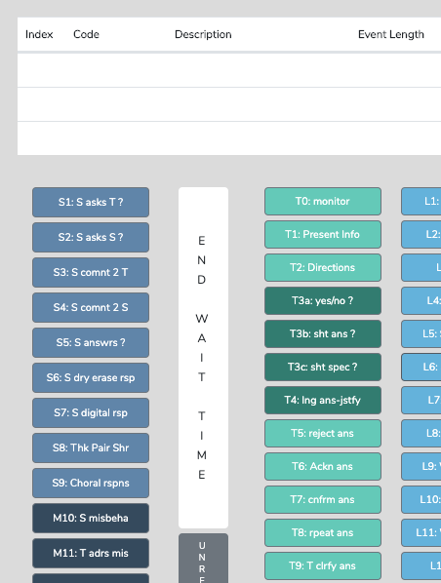

Steps for Collecting Wait-Time Data
- During the lesson, when a T or S code is tapped at the end of an event, the wait-time bar changes from white to blue, and the bar now displays “Wait Time Timing.”
- Timing will continue until the observer notes that the teacher or a student begins to talk. To do this, as soon as either the teacher or any student begins to speak, the observer taps the WT bar to turn off timing, which also changes the label on the WT bar to “Wait Time Off.”
- WT is recorded for the preceding code in the Running Record.
- The cycle begins again with the user ready to tap a T or S code as that person finishes talking.

Since all T and S codes are tapped at the end of an event, tapping the wait-time bar to turn off wait-time also starts timing for the next code.

Note: The observer does not have to worry about which WT they are capturing. If they tap the WT bar to turn off WT timing, WT data is collected, and the software knows whether the pause is WT1, 2, 3, or 4.

Unlike the easy wait-time gathering method shown in Training 5, in this case, the user also notes the type of T actions or S actions taking place in the lesson. Therefore, instead of tapping any old T or S code, they tap the specific T or S code being exhibited. The value of this method is that the software will give the user averages for WT 1-4 and report the WT in association with the T or S codes that preceded the WT. This can be important data because it might show the user using more WT for higher-level questions than for lower-level questions, or it might show very little WT associated with some types of teacher responses versus others.

How to Collect Wait-Time Using Student Numbers
- When the teacher has finished asking a question and the T code is tapped, the W-T bar turns blue and starts timing.
- As soon as a student begins to respond, the user clicks the W-T bar, turning off the wait-time, and then clicks the student number.
- When the student finishes speaking, the appropriate S code should be clicked.

Lesson 9.2 Practice Collecting Wait-Time and T, M, and S Codes Using a Seating Chart

Follow the instructions on Cheat Sheet 9 for setting a New Observation or follow the instructions below.
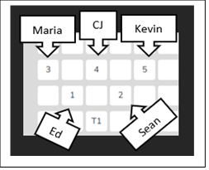
- Set up a New Observation using the following URL.
SMT Practice Video Float Sink A – Wait Time https://youtu.be/BaznvpVUx-U
- Fill in the following information for this observation
- Teacher being observed: Avatar Teacher
- Observer 1: Yourself
- Observer 2: Avatar Teacher
- Lesson Topic: Practice 9
- Then click “Save and Continue”
- Create a Seating Chart (see image on cheat sheet for reference)
- Then click “Save and Start.”
- Choose “Quantitative” observation and then click “Start”.
- Hit play and the appropriate L code
- Remember clicking the L code at the start of the lesson starts the timer for that observation. (For this practice lesson, choose L3: Interactive Demo.)
- Instead of doing five minutes practice, because you are a seasoned SMT user now do an extended practice using the whole practice video listed above.

Finally, compare your results of the observation you just completed to the Extended Practice Key 9

Lesson 9.3 Analyzing Data Including Wait-time Analysis

Wait-Time Summary – The wait-time data is located only in the Wait-Time Summary. The Wait-Time Summary includes general summaries of wait time by wait-time type, by events, by total time, and averages for each wait-time (shown below).

Wait-time averages are also broken down by specific T and S code types. This type of critical data summary can answer questions and identify classroom tendencies, such as whether the teacher uses more wait time when posing a higher-level question that requires more thinking time. Below is an example of wait time data showing type, total events, total time, and average WT.

The next portion of the Wait-time Summary page to examine is the lower table that breaks down average wait-time usage associated with each T and S code. From here, users can get a detailed picture of how wait-time is used in a classroom specifically related to types of questions asked and teacher-student interactions. For example, you can see in this data that the average wait-time use when asking T3a or yes/no questions is around 2 seconds. The average wait time for more in-depth critical-thinking questions for T4a is almost 2.5 seconds. From this, one can start a conversation with the teacher to determine whether the wait time for these questions should be extended or whether these questions should increase or decrease in difficulty for the students. Another item to note, however, is that there are also 2.5 seconds of wait time associated with WT 3 when asking a T4a question. This means that the teacher would wait, on average, 2.3 seconds for an answer from a student and only 2.5 seconds before changing the question or interrupting the thinking time. These small details can provide teachers with thorough feedback they can use and reflect on to improve their teaching on their terms, in a tangible way, by seeing hard, concrete, quantitative data broken down to the second.

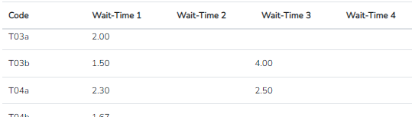

Questions to Ponder and How SMT Users Can Utilize the Wait-Time Data – Student and Teacher Think Time
- How does the WT1 average correspond to the teacher’s intention for using wait-time to give students ample opportunity to think about the teacher’s question?
- How does the WT2 average correspond to the teacher’s intention to use wait time to give students ample time to think about a student's response and respond to that student? (Look at the relationship between WT2 average and the S-S count in Interaction Patterns.)
- How does the average WT for question types differ when comparing lower- and higher-level questions where students need more think-time to generate an answer?
- If the WT average is lower than expected or desired, what is the teacher’s concrete plan for increasing their WT? How will they know if they have improved their use of WT?

Training 10 – SMT Black Belt 2 - Learn About G Codes: Small Group Interactions
Introduction - A common pedagogical strategy used in classrooms is to group students for labs, discussions, cooperative learning, working problem sets, or a variety of other reasons. All educators hope that rich and equitable interactions occur among small group members and that all members are involved in the work and conversation. However, small groups are often notorious for a subset of the group doing most of the work, or for one or two members taking control of the work or discussion, resulting in the other group members playing a very passive role or the conversation diverting to non-lesson-related topics.

The goal of instruction is to get ALL students involved equitably and productively related to the goals and objectives for that lesson. We know that there are ways to make group work more productive by structuring a lesson using cooperative learning roles. This pedagogically sound strategy keeps most or all group members equally engaged and contributing to the lesson. But how do we know that our plans were effective in this regard? Student numbers are also present when groups are set up in SMT using the seating chart. When using a group code to collect any S or M code data, the data includes both the group and student numbers. For example, G1:8 is group 1, student 8. Observing and collecting this data can be useful when examining group dynamics and engagement, analyzing individual student engagement, or examining individual student misbehaviors or misbehaviors that arise as part of a group.

The user will learn:
- How to first collect and analyze S code and M code associated with the small group seating chart numbers to develop a data set indicating the richness and equity of interactions between small group members.
- How to collect T, S, and M code data that adds the factor of the teacher's actions and interactions with small groups.
- Questions to ask to determine if small groups are functioning with equity between group members and efficiency.
- Questions to ask and data to examine regarding the effectiveness of the teacher’s interactions with small groups.
Training Elements
Lesson 10.0 Video Overview of Data Collection and Analysis Using G Codes

Cheat Sheet 10 – in progress

Extended Practice Key 10 -in progress

Steps - First, the user will learn to collect S code data using small group seating chart numbers. Then the user will view and explore the analysis of the S code data within each group shown within the Group Summary and learn how the indicators may suggest how to elevate student interactions or approach more equitable interactions within a group.

Lesson 10.1 Introduction to Group Setup – When setting up a new observation in the Seating Chart, the user can design small groups of students by group number after entering individual student numbers on the seating chart. Therefore, while capturing data during an observation, M and S code data can be prefaced by a group number and the student number within that group.

Lesson 10.2: Practicing Setup for Groups in the Seating Chart - This lesson will ask the user to set up student numbers on a seating chart and then identify which students belong to specific groups.

Steps
- Use New Observation to set up a lesson – in this case, use Live Observation since there is no specific video for this. For lesson topic type, Lesson 10.3
- Set up the seating chart as follows with four groups of 4 students.
  - Reminder: Click on the Student icon, and it should turn blue. Then click on seats to identify where students are sitting.
- Click on the Group icon, and then click on the students in the same group.
- Click on the Group icon again, then click on the students in the next group and repeat until groups are identified.
- If time permits, click on Save and Start, Quantitative, and view how the seating chart is displayed on the observation screen.
  - Note: If you wish to see how the group number is tagged to an S code, practice clicking on the Group button prior to clicking on a student seating chart number, then click on an S code and view the Running Record in the data analysis screen.

Lesson 10.3 Collecting Group-related Data - When listening to the teacher interact with small groups and members, or when examining how small group members interact with each other, the data collection sequence is similar to entering a student number before an S code. The user can enter a group number (G5) before an S code (S5) to indicate the answer came from the group (G5-S5), a student-to-student comment came from within that group (G5-S4), or a student in Group 2 asks the teacher a question (G2-S1).

Conversely, to examine student participation within a group, the user could code student numbers as S1-S5, and the seating chart heat map would show how much interaction occurred within that group.
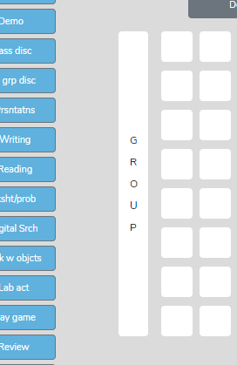
Note: As shown in the image to the right, to designate that a specific interaction came from a specific group number, click on the Group Bar before clicking on any student within that group. Then click the specific desired S code.

Lesson 10.4 Data Analysis Using G Codes
After finishing the lesson observation and proceeding to the analysis page, check out the Seating Chart Heat Map in association with Student Engagement to look at the data per student and the visual representations per seating chart.

Note: Small groups might easily generate more than five events per student. If the number of events per student exceeds five, the user can get a count of all the events for a particular S code by going to the Group Summary. The number of S code events is displayed here for each small group. Use the .xls export function to export the data to statistical analysis software.

What Can Be Learned When Collecting Individual Student Interactions Within a Group? We know that one or two students often dominate the conversation in some small groups. We also know that a lesson can be structured using roles so most group members are equally engaged and contribute to the lesson. Using the S codes embedded within a particular G number allows for an examination of these dynamics and a look at specific within-group communication and engagement.

Significant features in the Quantitative Data Analysis for G codes (groups) and S codes (individuals) are:

In the Group Summary section:
- A table shows S code and M10 event responses coming from specific groups.

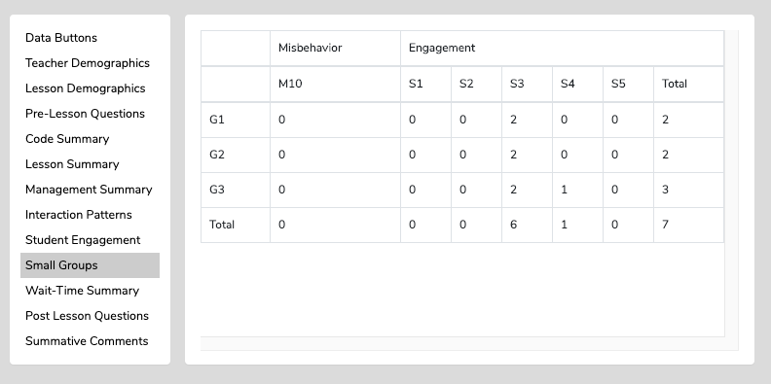

In the Seating Chart Heat Map quadrant:
- Seating chart heat map showing individual student responses or misbehaviors in the context of which group they were a member.
In the Student Engagement section:
- A table showing individual student engagement (S1-S5) and whole-class responses (S5-S9).
- A graph showing where in the lesson segment the actions occurred with vertical black bars for individual student responses (S1-S5) and vertical red bars for whole-class responses (S6-S9).
In the Code Summary section:
- A graph and table displaying a summary of the predominant use of the nine S codes, which indicates the frequency of events and quantity of time associated with the specific S codes.

Questions to Ponder Regarding Group Engagement and Equity Among Group Members Data
- What was their intention when the teacher approached the small groups and interacted with them? What did they want to accomplish by doing so versus observing the groups in action?
- What was noticed about the teacher’s interactions with the small groups?
- How did the teacher’s interactions foster the goals for the small group and the lesson? In what ways, if any, did the teacher’s interactions lessen the intention of the lesson or weaken the intended purpose of having students work in small groups?
- Small groups are a great place to ask good questions and to foster student-to-student interactions – what did the observer notice regarding such? How might the teacher improve?
- How was the teacher’s ability to pace themselves and get around to all small groups without taking too much time with one small group?
- We know the power of using cooperative learning strategies with small group structures (versus simply students in a group expected to work together). What might the teacher have done differently regarding small group strategies, and what impact might it have on student engagement, thinking, and learning?

Lesson 10.6 Adding T codes to M and S codes data collection for small groups.
While the SMT can just focus on collecting S code (student engagement data) using the group or individual seating chart tags, the user may also collect T and M code data during the same observation. If so, all the summaries containing and related to T, S, and M code data would be available for post-observation self-reflection, feedback, or coaching purposes.

Lesson 10.7 Collecting Data Using U Codes - User-Identified Labels

Introduction – The following are short lessons that focus on learning about U Codes, which are codes the observer can define to document another type of action or event not defined by existing S, T, or M codes. This lesson is information-only, so it will only take a short time to complete.

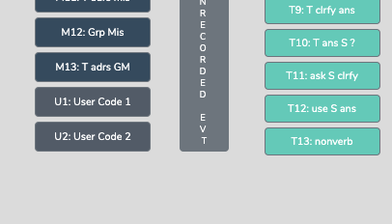
Types of U-Codes - One of the U codes is an event-only code (U1), and one is an event/timing code (U2). Which U code is chosen depends on whether the user wants the action timed for how long it lasts. If the length of the event is essential, then the user should use the U2 code. If the user only wants to note that the event happened and mark when it occurred on the lesson clock, the U1 code will suffice.

Why Would the User Need to Use a U-Code? Suggestions include:

a. Since using “praise” is common and is not the same as T6 “acknowledging” or T7 “confirming,” then the user could use and click U1 to note the number of times praise was used and when (as U1 is an event and timing code) or instead use code U2 to include how much time was spent praising the student.
b. The U2 code (event and timing code) can be used to note how much time was used to transition from one part of the lesson to another.

Note: You can put student numbers in front of either U1 or U2 codes if you feel it is important to tag the action to a specific student.

Lesson 10.8 U Code Data Analysis – There are a couple of places to find U code data in the quantitative analysis.

- Running Record – In Data Buttons, the user can click on U1 or U2 (the Find function) to locate U code data in the Running Record window.

- The Code Summary also has data on the count of U1 since it is an event-only code, and the count and timing of U2.

SMT Master Trainer Verification: T, S, M Codes, Seating Chart, Wait-time, Speed and Accuracy of Coding
SMT Master Trainer can only be achieved by passing a practical exam offered and proctored by SMT. Candidates will be given a video URL link at a specific time. Within a limited time, they will be required to code the video using T, S, and M codes, a seating chart, and the wait-time bar. Their data must be accurate and reliable to a certain degree before being considered passing. Evidence-based analysis, feedback, and recommendations provided to the teacher must be substantive and use most or all pertinent data. To achieve this certification, contact SMT for instructions.

At this certified level, the user can/has:
- Used the L, T, S, and M codes.
- Tagged M and S codes to student numbers and group numbers.
- Used a seating chart heat map with student demographics.
- Collected wait-time data.
- Captured data at the rate of normal classroom interaction.
- Captured data that falls within the boundaries of acceptable validity and reliability.
- Fluently discussed the data analysis screens.
- Used the evidence and analysis to provide high-quality feedback to the teacher.
- Collected data for use in a research study.
- Has completed an inter-rater reliability check, comparing the user’s data to an expert user’s data.
- Provided outstanding feedback and recommendations that are evidence-based.

The user will learn:
- Nothing new. The SMT Trainer candidate completes a test to determine speed, the accuracy of coding, and level of understanding when examining the raw and analyzed data as incorporated into feedback and coaching

Steps – When the user feels ready to take a practical exam using SMT for observation, they first contact SMT to schedule an exam. When the user performs within the boundaries of acceptable practice, they will receive a certificate of SMT Master Trainer, which means the user is SMT-qualified to train others and consult for SMT.

Why does SMT offer an SMT Master Trainer Certification? There are three reasons:

1. Many people or companies offer program evaluation services to institutions that have received grants to provide effective professional development for teachers or design and implement a new curriculum purporting to effect positive change in classrooms or classroom activity. SMT can be used to collect rich data and indicators of the effect of funded activities on teachers and classrooms. Someone will want to know if the observer is collecting valid and reliable data and if they can use the data and analysis to provide evidence-based recommendations. SMT offers this certification to validate the evaluator’s claim that they can collect valid and reliable data.

2. SMT will consider someone with SMT Master Trainer certification suitable for becoming an SMT Master Trainer. SMT Master Trainers work with school districts or institutions to train and develop the observation skills of other teachers and administrators in schools or higher education for faculty and pre-service teachers.

3. Teachers, administrators, teacher education faculty, future teachers, graduate students, education consultants, or program evaluators may want the highest level of training and SMT certification as they want or need to show professional skill levels concerning evidence-based observation. For example:

- Teachers can bring their SMT observation to a conference with the administrator to demonstrate professional skills and strengths and areas they are working to develop.
- Teacher candidates for NBCT can embed the data collected using SMT into the narrative of their teaching.
- Administrators can offer remediation plans to teachers based on data and evidence gathered from SMT.
- Teacher education faculty working with future teachers can document levels of growth for the student, their program, and for oversight agencies, such as the Department of Public Instruction, which looks for documented evidence of program effectiveness.
- Future teachers can use data collected with SMT as evidence when submitting their high-stakes edTPA video and written analyses of their teaching or use them in their end-of-program portfolio.
- Program evaluators or teaching improvement consultants can use SMT when providing their services.

Appendix A: Questions to Ponder Compilation
The following are the Questions the Teacher Can Ponder, compiled from each training section.
Questions to Ponder When Viewing the Code Summary Data - The Code Summary data provide general indicators of teacher tendencies, student actions, and misbehaviors and help to answer questions such as:
- What were the predominant T codes exhibited in this lesson?
- When looking at the data for the four question types (T3a, T3b, T4a, and T4), what is the tendency of the teacher to ask open-ended questions requiring students to think more deeply, speculate, and construct answers vs. asking questions that need a yes/no or short-answer memory-type response? If the goal was to dig into student thinking at a deep level, considering the type and number of questions asked, what might you conclude?
- What does the teacher tend to do following a student's response? Do they tend to judge responses, acknowledge, and then clarify for a student, or instead ask a student to explain?
- Considering the type and number of questions asked, what might you conclude if the goal was to dig into student thinking at a deep level? What changes would foster more of this?
- What is the total % of T codes vs. % of S codes? (This indicates whether the teacher is doing most of the talking and events or if the talking is balanced between the teacher and students, and at what level the students are contributing to the teacher-student or student-student interactions in that lesson.)

Questions to Ponder When Viewing L Code Data – Type of Lesson in Play
- After the bell rings and the class period begins, how much time did it take to start teaching?
- What might the teacher do differently to begin teaching at the start of the class period?
- How much time was spent on each segment of the lesson?
- If the teacher used more or less time on lesson segments than intended, why did that occur, and how did that affect the outcomes of the lesson?
- How much time did the transitions in between each part of the lesson add up to?
- What might the teacher do to reduce the time needed for transitioning from one part of the lesson to another?
- How much time at the end of the lesson was not used for instruction?
- If the lesson ended early, what productive things could the teacher have done to utilize the remaining class time?
- Considering the whole class period, what might the teacher have done to use the time even a bit more productively?

Questions to Ponder When Viewing the M Code - Student Misbehavior Data
When Viewing the Code Summary:
- How many times did the observer note classroom management events?
- How many of those classroom management events were not addressed by the teacher?
  - Note that when the number of M10 events is added to the number of M12 events, if that number is greater than the number of M11 and M13 events, the teacher is probably ignoring some of the student misbehaviors either intentionally or due to the frustration of not having an impact when they do intervene.
- How much time did the teacher use to intervene in management events? (M11 and M13)

When Viewing the Seating Chart Heat Map:
- Where in the classroom are the problems occurring?
- Is there a small group or table of students who are exhibiting most of the misbehaviors?
- Are behavioral issues proximal or distant to where the teacher is located?

When Viewing the Management Summary:
- Where in the lesson, or during which lesson type, did the management issues occur? (Vertical bars on the lesson segment timeline)
- How many management issues occurred at the start, end of class, or during transitions from one lesson segment to another? (Vertical bars on the lesson segment timeline)

When Viewing the Video:
- How much time was needed to get all the students settled and begin the lesson when transitioning from one lesson segment to another?
- How was the teacher’s movement around the classroom?
- How did the students behave or misbehave today as a whole, compared to other days in general?
- Regarding specific students who might tend to misbehave, how was their behavior today?
- Was there anything about this lesson that might have contributed to more or fewer management issues?

Questions to Ponder Using S Code – Student Engagement Data
When Viewing the Code Summary:
- Compare the quantity of each type of S code exhibited during the lesson.

When Viewing the Seating Chart Heat Map:
- The heat map provides a visual distribution of student contributions – how would the teacher summarize this data, and how do the contributions match the teacher’s intentions and expectations?
- How many students responded to at least one question, and how many were not part of the conversation?
- Using the demographic toggles on the Seating Chart Heat Map, examine student engagement by demographics such as gender, minority, ELL, and Special Education – think about what the data suggests regarding equity in student engagement. How might you increase equity regarding student engagement?

When Viewing Interaction Patterns:
- Think about your teaching, how many students responded to each other at least once, and what you might change to produce more student-to-student interactions. (Interaction Patterns S-S #)

When Viewing Student Engagement:
- What is the average number of responses per student? How does that fit your student engagement goals, and how might you increase that number? [Total of S1-S5 plus (the total of S6-S9 x the number of students in the class) / number of students in class]
- During which part of the class or type of lesson segment were students engaged, as evidenced by vertical bars? Which parts of the lesson lacked student contributions and engagement, and how could you alter your lesson to produce more student engagement?

Questions to Ponder About T Codes – Teacher Actions Data
When Viewing the Code Summary:
- What were the predominant T codes exhibited in this lesson?
- When looking at the data for the four question types (T3A, T3B, T4A, and T4B), what is the tendency of the teacher to ask open-ended questions requiring students to think more deeply, to speculate, and to construct answers vs. asking questions that require a yes/no or short-answer memory-type response?
- If the goal was to dig into student thinking at a deep level, considering the type and number of questions asked, what might the user conclude?
- Look at how many and what types of questions were asked. How did this affect the amount and type of student engagement?
- Looking at the T5-T12 counts, what can the user conclude about how the teacher responds following a student response if their goal was to encourage student responses and keep digging into what students were thinking?
- Look at how the teacher-initiated questions and then responded to student thinking - think about how the teacher’s tendencies encouraged or discouraged student responses and engagement.
- When students respond – what does the teacher tend to do? Do they tend to judge responses, acknowledge and then clarify for the student, or instead ask the student to clarify?

When Looking at Interaction Patterns:
- Look for a 3-code pattern tendency, then a 4-code pattern tendency. How are the most common patterns consistent with the goals for the lesson? What are some changes to how the teacher interacts with students that would be more consistent with their intentions for the lesson?

Questions to Ponder About the Lesson After Collecting T, S, and M Codes
When Viewing the Code Summary:
- Examine the quantity of T, S, and M codes. Then consider any of the questions above in the sections looking at only T, S, or M codes.
- Compare the percentage of T codes vs. S codes and conclude if this lesson was more teacher-centered or student-centered, or balanced regarding such. Then consider how this result met the teacher’s intentions or goals for the lesson. What was consistent or inconsistent with their intentions and your chosen strategy for this lesson?

When Viewing the Interaction Patterns:
- Examine the counts for S-S, T-S-T, and T-T. What does the data indicate if the teacher wanted to achieve more S-S interactions?
- Examine the most predominant patterns of interaction with students. What types of questions are in the most predominant patterns? What types of teacher reactions to student responses are in the most predominant patterns? How do the types of questions and responses fit with the teacher's goals for instruction, and what might the teacher modify to achieve questions or responses that are more consistent with their intentions?

When Viewing the Seating Chart Heat Map:
- Looking at the quantity of student engagement in the class, how is it distributed, and what would the heat map look like if you raised student engagement to an optimal level?

Looking at the Teacher Actions Plus screen:
- What question types were used in the lesson? What followed questions in terms of S codes – one student response or was it more than one student response? After the student(s) responded, what did the teacher tend to do next?
- How did the teacher use the whole-group response engagement S codes (S6-S9) to engage all students in generating answers and providing maximum feedback to the teacher? If S6-S9 were not used, what evidence is there that the teacher attempted to increase students’ oral contributions to the lesson?
- Knowing that T codes (teacher responses) T6, T11, T12, and sometimes T8 tend to help get and keep students thinking more so than T5, T7, T9, and T10, what does the visual tell you about the teacher's use of the various response codes?
- What stands out about the student misbehavior actions M10 and M12, and then how would you characterize the teacher’s reaction to student misbehaviors M11 and M13?
- How was the distribution of S codes and student contributions to the lesson?
- What was the mix of S codes? How many S1-S4 codes were present during the observation?

Questions to Ponder Regarding Group Engagement and Equity Among Group Members' Data
- What was their intention when the teacher approached the small groups and interacted with them? What did the teacher want to accomplish by doing so versus observing the groups in action?
- What did the user notice about the teacher’s interactions with the small groups?
- How did the teacher’s interactions foster the goals for the small group and the lesson? In what ways, if any, did the teacher’s interactions lessen the intention of the lesson or weaken the intended purpose of having students work in small groups?
- Small groups are a great place to ask good questions and to foster student-to-student interactions – what did the user notice regarding this? How might the teacher improve?
- How was the teacher’s ability to pace themselves and get around to all small groups without taking too much time with one small group?
- We know the power of using cooperative learning strategies with small group structures (versus simply students in a group expected to work together). What might the teacher have done differently regarding small group strategies, and what impact might it have had on student engagement, thinking, and learning?

Questions to Ponder About the Wait-Time Data – Student and Teacher Think Time
- How does the WT1 average correspond to the teacher’s intention for using wait-time to give students ample opportunity to think about the teacher’s question?
- How does the WT2 average correspond to the teacher’s intention to use wait-time to give students ample time to think about a student's response and respond to that student? (Look at the relationship between the WT2 average and the S-S count in Interaction Patterns.)
- How does the average WT for question types differ regarding higher-level questions needing more think-time to generate an answer?
- If the WT average is lower than expected or desired, what is the teacher’s concrete plan for increasing their WT?

Appendix B: Capturing and Storing Video and Audio
Capturing Quality Audio and Video
If the user is not doing a live observation, then the video used for the observation should have:
- A video with a wide-angle view of the room with most students and the teacher is desired as the observer always has a fixed reference point. Placing the camera at the back of the room, perhaps higher than head height, will put most of the action within the camera shot, allowing the person(s) to connect the actions and events with the individuals involved or speaking.
- Audio ideally captures everything the teacher said and most of what students are saying.
  - Note: If the teacher is talking and the room is quiet, most microphones capture the teacher’s voice and most of the student’s questions and answers. But capturing the audio of teacher and student interactions can be difficult during a lab activity, when the class is working in small groups, or when the teacher is walking around interacting with various small groups. Usually, the class is videotaped from a fixed position and captures the whole panorama of the class. Therefore, the camera microphone is also fixed in place, making it challenging to collect good audio arising from small groups. Yet, small groups are a good source of teacher-student dialogue, and such interactions should be collected and analyzed as the teacher-student interactions can be analyzed and often improved. Therefore, relying on the microphone of the video-recording source may not be the best. See Lavalier Microphone Bluetooth to Phone for a solution to this problem.

Lavalier Microphone Bluetooth to Phone for Recording Audio and Video
- Secure an omnidirectional lavalier microphone that will connect via Bluetooth to your phone or camera source for capturing high-quality audio. There are several options; therefore, reading the reviews helps steer one to a microphone that might capture clear audio. When working with individuals, small groups, or whole groups, the teacher will want the audio of themselves and the students. An omnidirectional microphone will pick up sounds from any direction. A unidirectional microphone will pick up sounds coming from mostly one direction. The user will probably want an omnidirectional microphone that will capture sounds from close and far away. Some microphone lavalier packages come with more than one microphone. The reason for purchasing more than one microphone is that the teacher might want to wear one and place the other in the middle of a small group table to capture the conversation of the small group or a group working together during a lab activity.

Solutions to Audio Issues
- Teachers can wear an omnidirectional lavaliere microphone that feeds back to the camera's audio input. For example, teachers can use a product called Swivel, which uses an iPad placed on a swivel mechanism that tracks the teacher around the classroom and captures video. This product also uses a lavaliere microphone the teacher wears, which feeds audio back to the iPad. SMT has found that the video and audio captured quality is quite good (but has no affiliation with the company or the recommended product).
- Teachers can also get a lanyard attached to a plastic sleeve. A smartphone can be placed into the plastic sleeve with the camera and microphone exposed and facing outward. The video will capture what the teacher sees when the teacher walks around and interacts with individual students and small groups. Acceptable audio will also be obtained, but the downside is the video which rapidly changes direction and perspective. It is much easier for an observer watching the video to have the footage originate from a stable and fixed position so that all the students and the teacher are on the video and from the perspective of an observer who is placed in the back of the room.
- Computer webcams can also be oriented in the classroom to capture most video and audio.
- Any other type of digital device can be placed in the front or back of the room to capture video and audio.

Hardware
Recommended tools for capturing quality video and audio of teaching segments are:
- Swivel – Place your iPad on the Swivel, attach the lavalier microphone to your shirt, and it collects great audio and video as it pans along with your movement while you teach.
- Logitech Web Camera w/Microphone – a quality way of capturing audio and video.
- Phone with lavalier microphone blue toothed into the audio jack of the phone.

Video Segments
- Editing Video Down in Size to a Key Segment
  - The user must only upload the video segment they wish to observe and analyze. For example, perhaps the user captured 45 minutes of footage but only wants to view and comment on the 20-minute lab activity segment. Therefore, the user should edit the video to cut out everything but the desired portion and then upload the video to the user’s YouTube Channel or other means of storage to where team members can get access.

- Storing the Video on SMT Cloud Storage
  - When setting up a New Observation, one of the options for video is to upload the video to SMT cloud storage. This option is much easier than the YouTube option. When choosing this option, the user will be asked to choose the file to upload into cloud storage. This is a file upload process similar to other file upload processes. Unlike YouTube, there are no toggles to consider.

- Storing the Video Elsewhere
  - If the video is stored someplace other than YouTube or SMT’s cloud storage, the user must check to ensure that SeeMeTeach ® can access the video for the user and other team members. Server protection and security software on school servers sometimes make it difficult to store video locally.

- Storing the Video - Upload to YouTube
  - The video should be stored so it has a URL address that the user and/or team member(s) can access. SMT suggests a YouTube Channel for such purposes unless the school district or institution has its own server that is accessible and won't block users from accessing the video. When uploading the video to YouTube, it is important to do the following:
  - Choose the toggle for an unlisted video – do not select private or public.
    - Videos should not be listed for public consumption due to privacy laws regarding children. In addition, if it is listed as “private,” other team members will not be able to view the video as SMT will not be able to access the video.
    - As an “unlisted” video (without adding tags or keywords and with a title that is non-descript), the video should be accessible only to the team members.

  - After initiating uploading the video to YouTube, the owner must toggle some choices. Toggle on the following:
    - Toggle “No, it’s not made for kids” so the circle is dark, then, click SHOW MORE which presents more options.
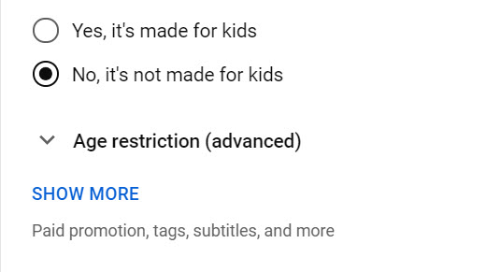

Then toggle on “Allow embedding” but leave the other choices unchecked.
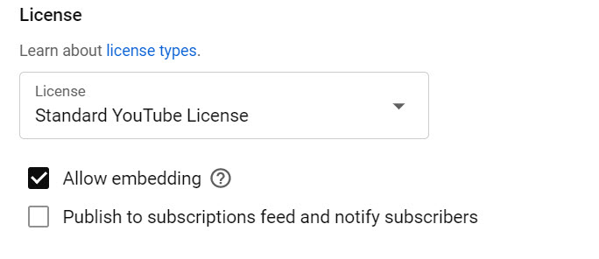

On the right side of the YouTube page is the video URL that needs to be copied and pasted into the SMT New Observation URL window. The “Visibility” is also noted; in this case, it is “Unlisted,” and if not, then use the drop-down to make it “Unlisted.”
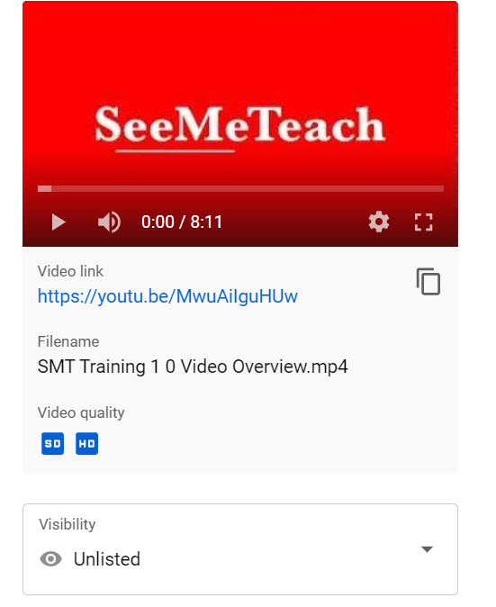

Setting Up the YouTube Channel
For a Teacher Education Program or a School District, does each person need their own YouTube account, or do all the videos get uploaded into one Channel?
  - Option A: Each user loads their own (unlisted) video to their own YouTube account (as an unlisted – not public or private). From there, they can copy and paste the URL into the video window when setting up a New Observation.
    - This has an advantage, as the individual is responsible for the uploaded video.
  - Option B: An administrator or program leader may or may not choose to have control of the videos used to set up the New Observations. Therefore, they upload all (unlisted) videos to their YouTube channel and share the video URL with specific persons at their discretion.

Indemnification and Protection of the Video
- To abate concerns about capturing video of classrooms and privacy of teachers and their students, SMT registration, Terms of Use, policies, and procedures were designed and created to minimize these concerns. For example:
  - Only two people control the video used for the observation, the teacher and the observer. The video is captured and stored by either the teacher or primary observer in a safe and secure location that has controlled access. The user can store the video on their private Youtube Channel or on SMT’s cloud storage.
  - The other two potential team members can view the video but have no rights regarding control of the video.
    - Note: Before any use of SMT has taken place, the teacher, primary observer, and any other team members (maximum of 2) will have both agreed to the Terms of Service, stating they will not show or share the video with any party or person that does not have routine contact with the students shown on the video.

Using Audio-Only When Video Is Not Allowed
- Suppose the school policy prevents videotaping in a classroom, but teachers can audiotape. If the teacher is wearing a lavalier microphone, the audio of teacher-student interactions should be of high enough quality for the observer to code much of the data. Have the audio file stored where it can be uploaded to SMT servers when setting up a New Observation. Then the audio file and data collection will function much like using a video file when doing data collection.

- When necessary to capture audio-only, there are three options:
A. Capture and upload an audio file such as an mp3 file. During a New Observation setup, the user can choose Classroom observation from an audio file and load the file, which will play from the video window.
B. Capture an mp4 file using a video camera with the lens covered, so no images of students are captured, but the audio is captured. Then follow the instructions for uploading the file to YouTube and link the YouTube video to SMT by choosing Observation Type – Classroom observation from YouTube. Or a second option is to choose Classroom observation from a video file, locate and link that file on your computer, which then stores that mp4 file in secure cloud storage.
C. If your video contains both video and audio, but you cannot publicly show the video, yet you want to still use the audio in an SMT observation and analysis:
- Create a blank videotape that is longer in time than the audiotape of the lesson recorded. When filming the blank tape, keep the lens cover on and turn down the audio to zero or completely turn off the sound.
- In your video editor (Camtasia or other), import the blank video file and place it on the timeline. The user may want to overlay a title screen with the teacher’s name or identifier. Separate the audio track from the video track. Delete the audio on the original “blank” tape and keep the blank video portion.
- Import the video file of teaching and place it on a second and different track from the blank video. Separate this tape's video and audio portions and delete the video portion.
- Now on the timeline, there should be the blank video track and the audio of the teaching track.
- Trim down the length of the tracks until they are just a second or two longer than the classroom audio track, or the file you are creating will be unnecessarily longer than what the user needs to place into SMT for analysis.
Save and export to an mp4 file that can then be uploaded to the user’s YouTube (unlisted) channel or simply save on the computer and upload to cloud storage when setting up a New Observation.

References

Abraham, M. & Schlitt, D. (1972). Verbal interaction: A means for self-evaluation. School Science and Mathematics, 78, 678-686.
Clough, M., Berg, C., and Olson, J. (2009). Promoting effective science teacher education and science teaching: A framework for teacher decision-making. International Journal of Science and Mathematics Education. 7(4):821-847. DOI: 10.1007/s10763-008-9146-7

Fowler, T. W. (1975, March). An investigation of the teacher behavior of wait-time during an inquiry science lesson. Paper presented at the Annual Meeting of the National Association for Research in Science Teac

Penck, J., Crow, L., Bonnstetter, R. (1996). Questions are the Answer: A logical questioning strategy for any topic. The Science Teacher. 63(1):27-29.

Rowe, Mary B. (1986). Wait Time: Slowing down may be a way of speeding up! Journal of Teacher Education, Jan-Feb. Pp. 43-50.

Tobin, K. (1987). The role of wait time in higher cognitive level learning. Review of Educational Research, Vol. 57, 1, pp. 69-95.

