Teacher Observation Reimagined!

SeeMeTeach®
Quick Start Guide

SeeMeTeach – Teacher Observation Reimagined
A Web Based Teacher and Classroom Observation App
© 2023 V.03.5.23
SeeMeTeach ® Quick Start Guide

Table of Contents
The Basics and Getting Started Using SMT
Logging Into SMT
The Dashboard
The Qualitative Mode – Highlights and Important Features
Providing Comments and Recommendations
Post-Observation Screen
Lesson Plans
Pre-Lesson Questions
Qualitative Observation Categories and Comments
Seating Chart
Post-Observation Questions
Team Table
Using Data and Evidence in Conjunction with the Qualitative Observation
Summative Comments and Summative Forms
Suggested Uses
The Quantitative Mode – Highlights and Important Features
Data Collection Screen
Post-Observation Data Analysis Screens
Code Summary
Lesson Type Summary
Management Summary
Student Engagement Summary
Teacher Actions Plus Summary
Interactions Patterns Summary
Small Group Summary
Wait-time Summary
Running Record
Data Buttons Search
Lesson Demographics
Pre-Lesson Questions
Team Unification and Synergy Using Data and Feedback
Summative Comments and Summative Forms
For More Information
Registering to Use SMT
Terms of Service
Teacher Education – Frequently Asked Questions
Schools, Teachers and Administrators – Frequently Asked Questions
Supporting Documents
SMT Professional Development Modules
SMT Teacher Challenges
SMT edTPA
SMT NBCT
SMT Cooperating Teacher
SMT and Teacher Education
SeeMeTeach ® Quick Start Guide

The Basics of SeeMeTeach

A Quick Tour and Highlights of the SMT Tool - If the user wishes to quickly see the power and highlights of using SMT for observation, they should go to the SMT homepage and view the short video that provides an overview of both the qualitative and quantitative modes of SMT. This video is updated periodically to keep up with the additions and changes to SMT.

Logging Into SeeMeTeach - Following registration, the user goes to seemeteach.com to log in with their username and password, then clicks on Dashboard. First-time users would probably see a blank Dashboard unless a team member has included them on an observation.

The Dashboard - After logging into SeeMeTeach, the user would first see their Dashboard, which is their operations center. From here, the user can set up a New Observation and collect qualitative comments, quantitative data, or both, as once a lesson is set up, both can be completed separately. The Dashboard is also a pathway to the lesson plan or post-observation summative forms. Below is an example of a lesson in which a team member completed both the quantitative and qualitative observations, and two other team members completed a qualitative observation. Clicking a green checkmark takes the team member to the post-observation screen. Training Level 1 covers setting up a new lesson, creating a seating chart, adding a lesson plan, using post-observation forms, and more.

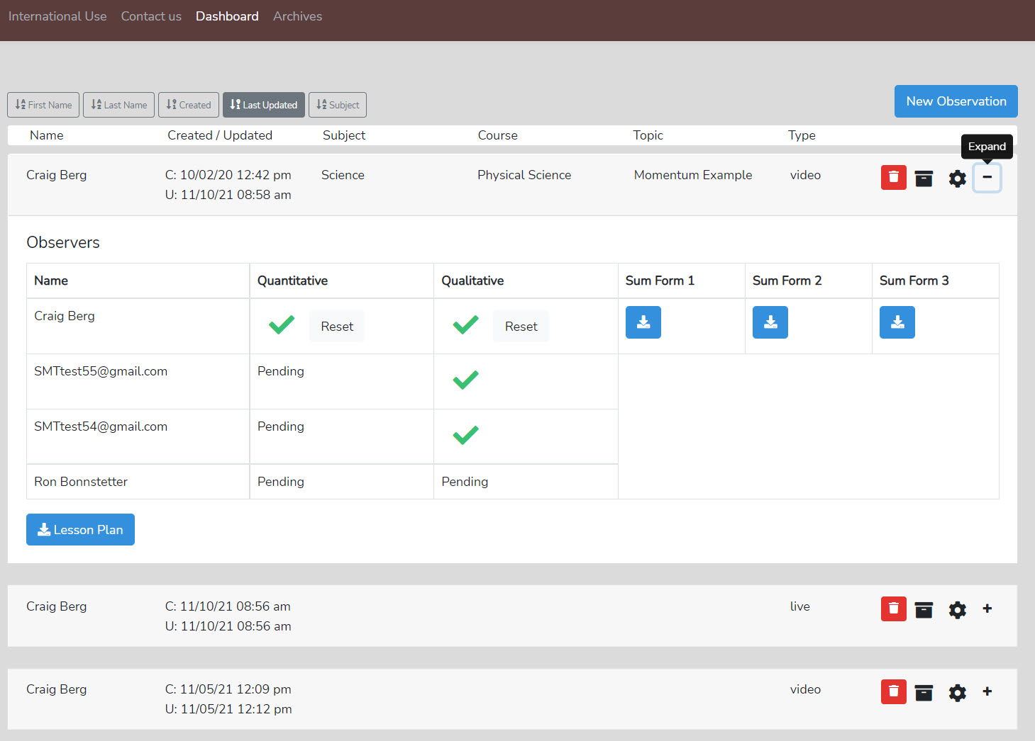

Getting Started Using SeeMeTeach

Registering to Use SMT

Users must register to use SMT, either as a single user who may also have colleagues as team members or as a user in a teacher education, school, or research group. More information on the registration procedures is at the end of this document.

Training Level 1 - Setting Up and Completing a Lesson Observation

Setting up a lesson observation is common in both qualitative and quantitative observations. For a quick look, see the following videos. For a "quick start," view the videos for the training level below.

- SMT Training Level 1 Video Overview and Setting UP a New Observation https://youtu.be/i1WNYupuSqs
SMT Training - How To Add a Lesson Plan https://youtu.be/lPKZZgcyk44
SMT Training – How To Use Summative Forms https://youtu.be/FtG7p1AZf3w

Training Level 2 - Qualitative Comments Mode

Learning to use the Qualitative Comments mode is fast, and the following video provides an overview.

- SMT Training Level 2 Qualitative Comments Mode https://youtu.be/GEVt6DCljEc

Training Level 3 - Quantitative Data Collection Mode

Learning to use the Quantitative Data Collection mode takes a bit of training. But the following video provides essential information and an overview of this mode's powerful features.

- SMT Training Level 3 Quantitative Mode Basic Info https://youtu.be/WT08eaivgPw

Training Levels 4 - 10

Users can pick and choose the type of data they wish to collect. After learning how to set up a new observation and completing Training Level 3, a user can choose student engagement data to collect, go directly to Training Level 6, read how to collect that data, and collect it in a matter of minutes. The same is true with student misbehavior data – Training Level 4. Note that registered users have access to all the levels of training for the quantitative mode that will help the user to develop data collection and analysis skills regarding teacher actions, tendencies, and interaction patterns; student engagement; student misbehaviors, and teacher reactions; and small group analysis, that they can use for feedback, reflection, and coaching. The User's and Training Manual includes extensive documentation and associated videos to support progression through the training levels.

The Qualitative Mode
Qualitative Mode - Highlights and Important Features
- Observations can be completed live in the classroom or by using a pre-recorded video or audio.
- The user generates a time-stamped set of observation notes that can include comments and suggestions, color-coded to the specific team member that is making a comment, labeled, and organized by category.
- The user(s) can search and find comments by category.
- Comments are also noted via symbols on the timeline below the video so the user can see who left comments and how many comments are attached to the lesson, then click to read the comment and play the video segment.
- The user can create and tag comments to a student seating chart, thereby noting events and actions by individuals or groups of students.
- When using video, comments are linked to video segments, so the teacher or observer can provide feedback with video examples of the teacher or student actions.
- Summative commentary forms can be filled out, attached, and viewable by any team member. SMT provides some standard forms, or users can also upload and use their own personalized forms as well.
- Provides a platform for the observation team (of up to four people) to collaborate and communicate, and a team member can react to and respond to another team member’s comments.

Qualitative Mode - Providing Comments and Recommendations: The user views the lesson live or via video or audio and clicks a related comment category (which adds a timestamp), then adds comments or recommendations linked to the video for viewing, feedback, and coaching post-observation.
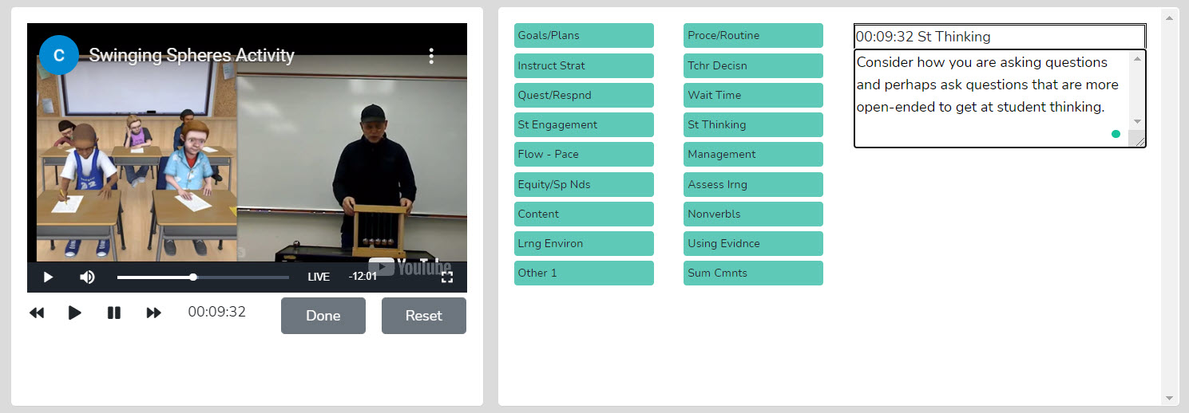

Post-Observation Screen - When the observation is complete, the following screen displays both the comments and the timeline of comments below the video. In the example below, four team members commented on the lesson. Clicking on a triangle symbol highlights that comment. Clicking on a diamond symbol highlights someone's response to an initial comment. You can find comments by type using the search feature.

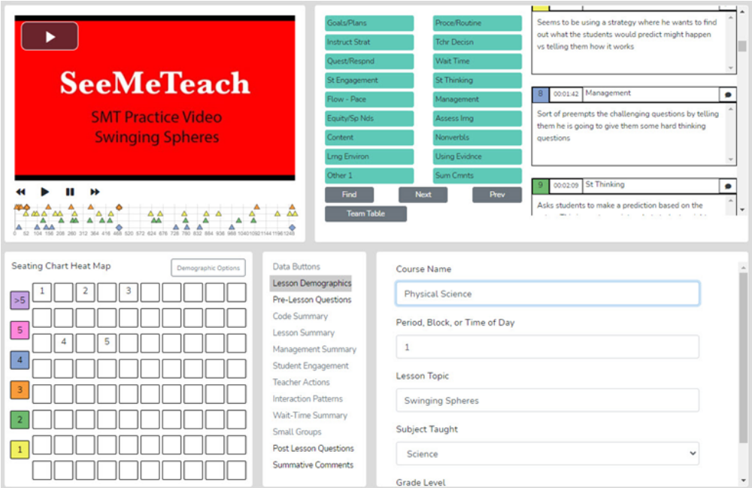

Lesson Plans - Before, during, or after the observation, the observer can quickly access the teacher's Lesson Plans via the Dashboard or the Team Table.
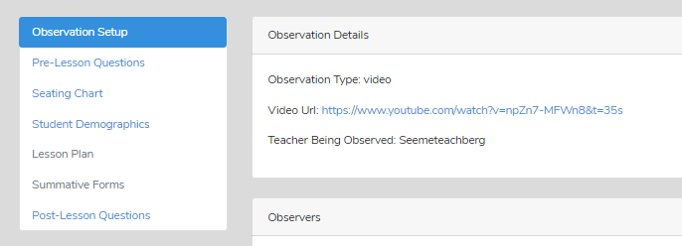

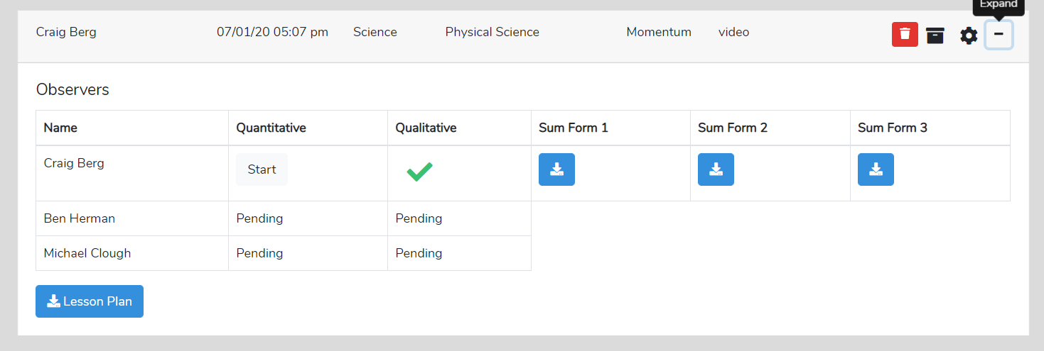

Pre-lesson Questions - To provide the observer with some context and information about the upcoming observation, the teacher can respond to the Pre-lesson Questions, which the observer can see via the Dashboard or the observation pages.
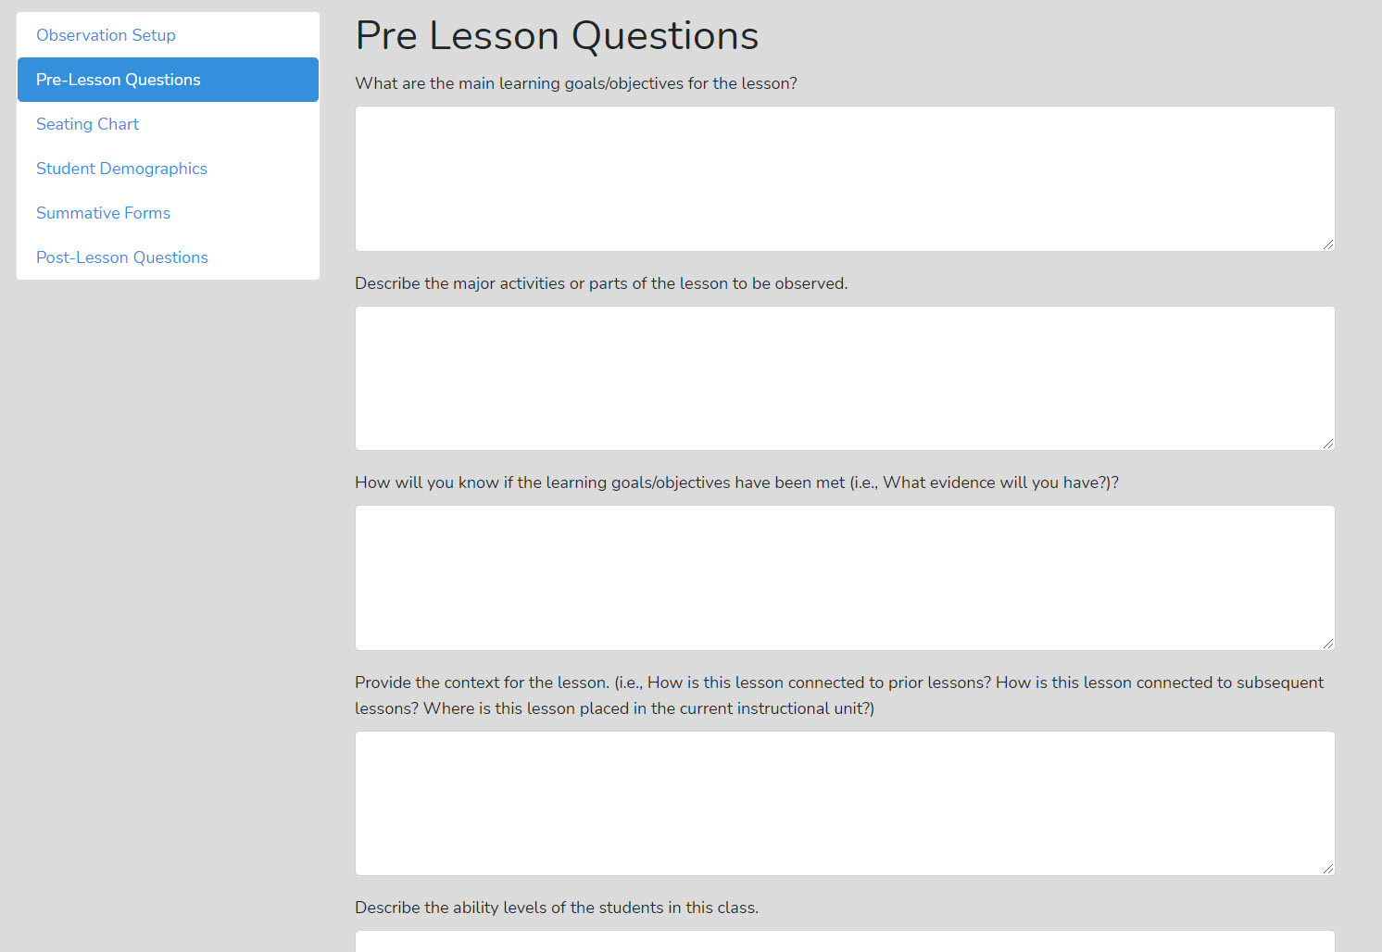

Qualitative Observation Categories and Comments - The observer, or multiple team members, provide comments labeled by categories. There are many comment categories to choose from when adding comments to an observation.
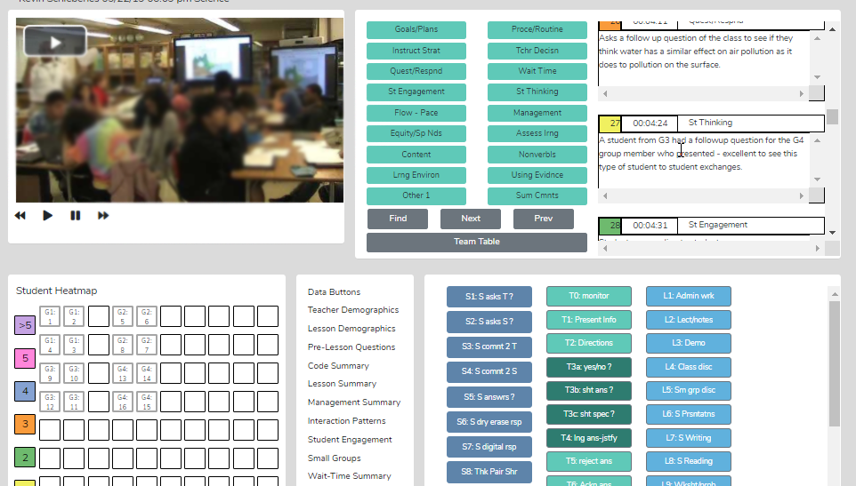

Seating Chart - The teacher or observer can create a Seating Chart and refer to this when making comments, showing each student and small group designations if desired.
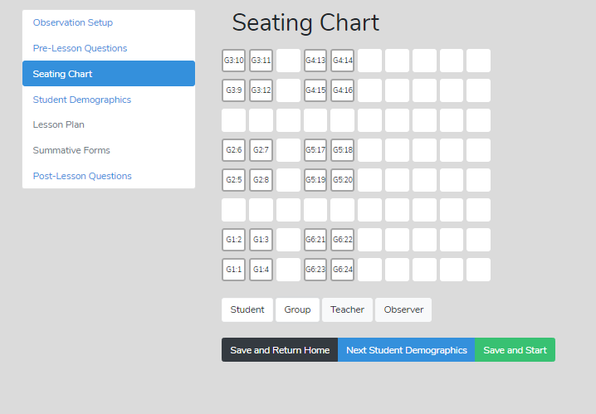
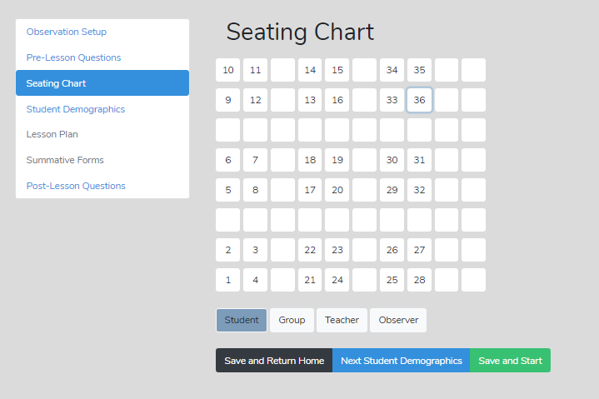

Post-Lesson Questions - To stimulate reflection, post-lesson

questions can be filled out or accessed via the settings or the observation/analysis page.

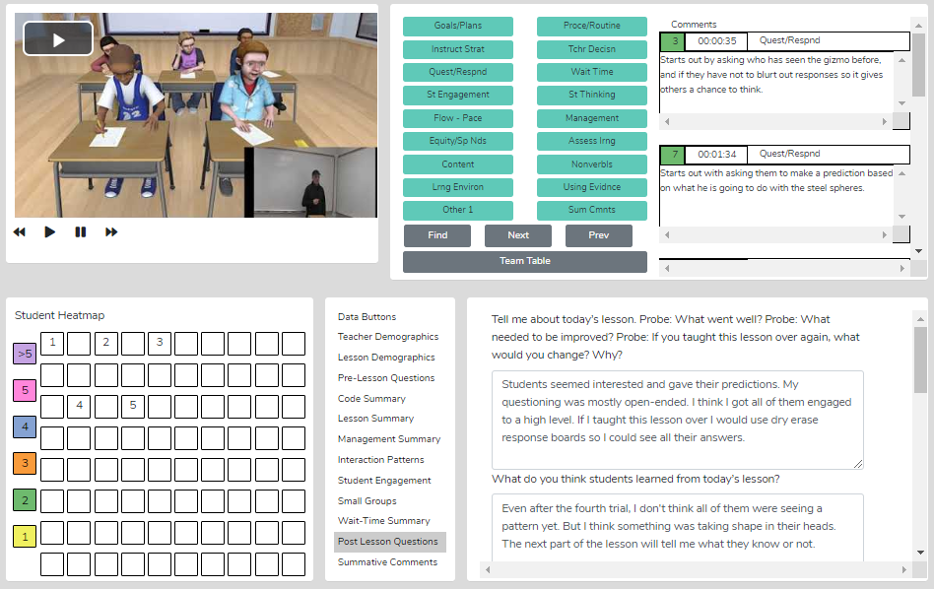

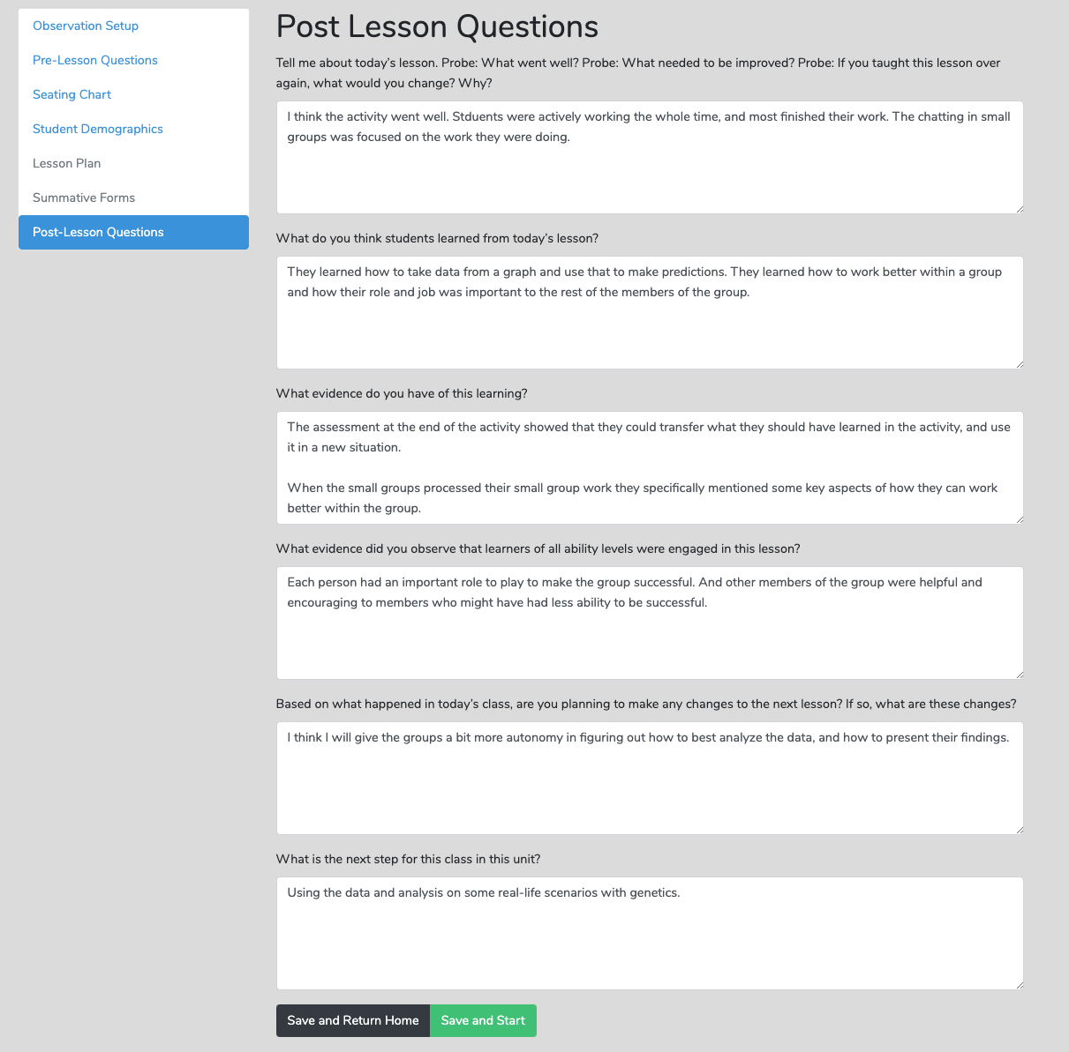

Team Table - A user can choose whose comments (or data/analysis) to view using this feature.
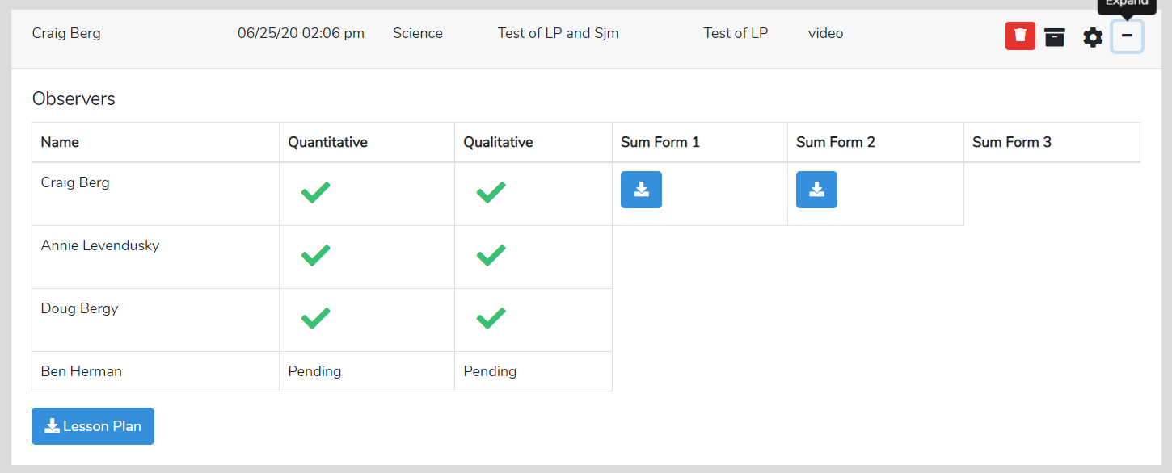

Using Data and Evidence – If the quantitative observation is completed before the qualitative observation, the observer can use data from the quantitative analysis to support comments made during qualitative observation, providing evidence-based feedback, recommendations, and coaching.
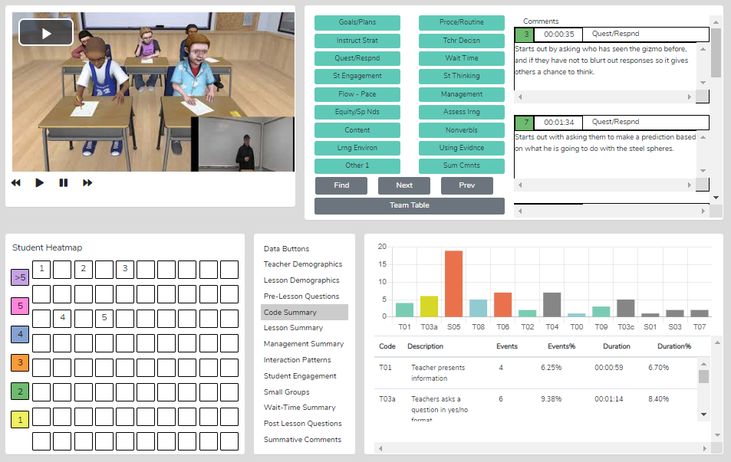

Summative Comments and Summative Forms
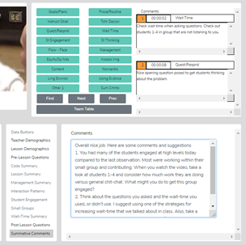

When the observation is over, the observer can add Summative Comments and/or fill in up to three Summative Forms to share with the observation team.
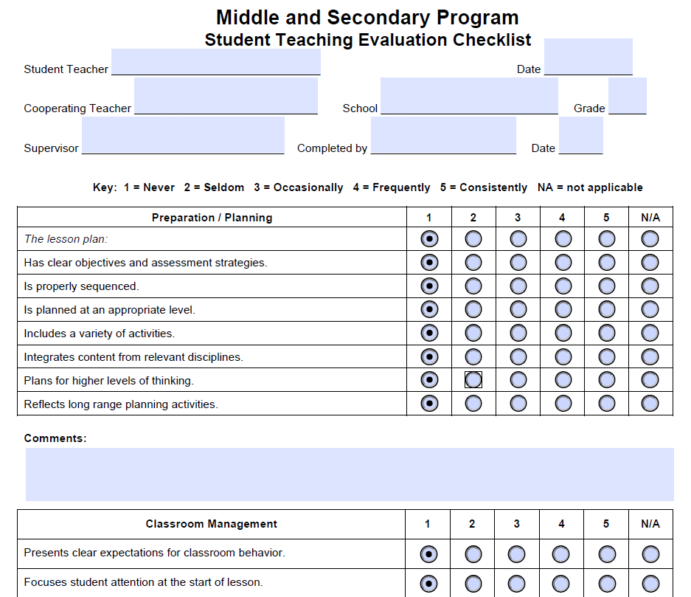

Suggested Uses - The team member's qualitative analysis might be useful regarding:
- The teaching observation of a fieldwork student or student-teacher by the teacher preparation program supervisor - After the observation, the qualitative analysis page is available to the student-teacher, who can view comments, respond to post-questions, post their reactions and commentary, and fill out the self-reflective Summative Form(s).
- When using video for the observation, team interaction and communication can be enhanced, as any team member can do a qualitative analysis of that lesson and view any other team member's running commentary and summative comments.
- When using video, all comments are linked to specific video segments so the viewer can see any particular action as it occurred in the classroom.
- Methods of teaching instructors can view the video of pre-service teachers implementing suggested strategies, view pre-service teachers' analyses and reflections, and add their comments or suggestions.
- For a classroom teacher's yearly observation, a teacher can capture a video of their teaching and complete a self-analysis while an administrator adds their observation, merging their commentary with the teacher's. A conversation then follows this whole process. When using video, comments are linked to the video, making it easy to locate any part of the observation and showcase events being discussed, enhancing feedback and coaching sessions.
- Research team members can share data and analysis screens by printing the data and analysis screens or exporting the raw data to a .xls spreadsheet for more refined and custom analysis.

The Quantitative Mode

The Quantitative Mode – Highlights and Important Features

Quantitative Analysis and Feedback Options
The SMT quantitative model allows the user to collect and then analyze data related to teacher and student actions during a lesson. This data is coupled with the specific lesson type in play to show when and where student and teacher actions occur in lessons. The raw data is displayed, time-coded, and linked to the events as they took place in the video. The resulting raw data and analysis of data offer substantive insights into the activity and events of the lesson. The analysis and feedback options described below will highlight the benefits of using quantitative data during the feedback and coaching process. Training Levels 3, 4, 5, and 6 focus on collecting data on student engagement, misbehaviors, and teacher actions during a lesson.

Power of Video-linked Data - When using video, the data collected is linked to specific video segments that represent the data and the type of action or event by both teachers and students. On the analysis screens, the observer, teacher, or team member can go directly to the video linked to specific data points and see examples in action.

Highlights of the Qualitative Mode
- Observations can be completed live in the classroom or by using a pre-recorded video or audio file.
- SMT collects extensive data regarding teacher and student actions that is linked to events in the classroom.
- There is an immediate post-observation analysis of data with visual representations displayed in tables, graphs, and heat maps of seating charts.
- With a seating chart, the data are linked to specific students, small groups and analyzed by student demographics.
- Data are linked to video segments making it easy to locate specific examples of a teacher or student’s actions.
- Small group actions can be noted for examining small group dynamics and engagement.
- The lesson plan is attached to the observation for ease of access for the observer or any team member.
- Summative forms tailored to local needs can be filled out, attached, and viewable by any team member. SMT provides some standard forms, or users can also upload and use their own personalized forms as well. SMT provides some standard forms, or users can also upload and use their own personalized forms as well.
- SMT provides a platform for the observation team (of up to four people) to collaborate and communicate.

Quantitative Mode - Data Collection Screen

The data collection screen contains a seating chart, the video window (live or audio-only), and the data collection buttons observers use to note teacher and student actions that produce rich, robust indicators and analyses.
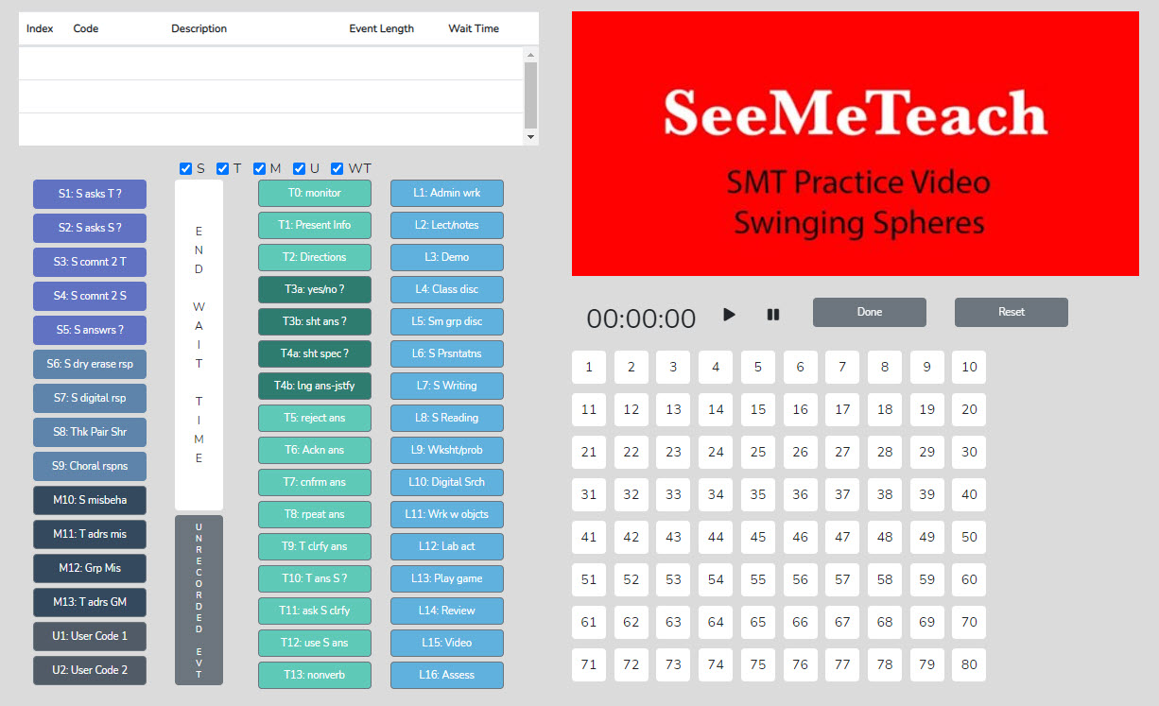

The initial view and impression for some are that there are a lot of buttons. However, button sets can be toggled off for novices or users who wish to collect only specific data (as seen below), making it easy to collect critical data such as student engagement. A user could learn to collect just the student engagement data in minutes. The training videos and manual scaffold the user from simple to complex data collection.
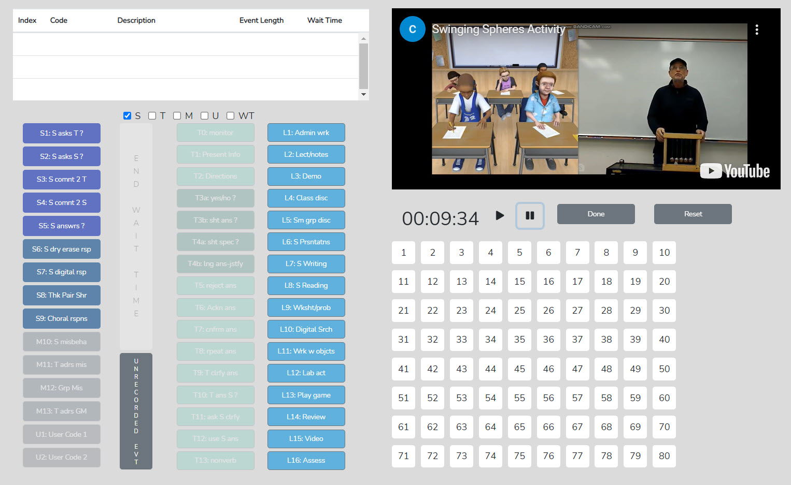

Post-Observation Data Analysis Screens

After collecting data during an observation, here are examples of the data analysis screens and output available immediately afterward.

Code Summary – This feature provides a graph of the number of events of each code used during data collection and shows the relative and specific use of T, S, M, and U codes. Underneath the graph is a data table that displays data for each specific code by event frequency, event frequency compared to the total number of events, time coded by the specific event, and time accrued for that event compared to the total time of all events. The T code data is tallied underneath this data table, as are the S, M, and U codes. This data is also recorded as a percentage of total events and total time.
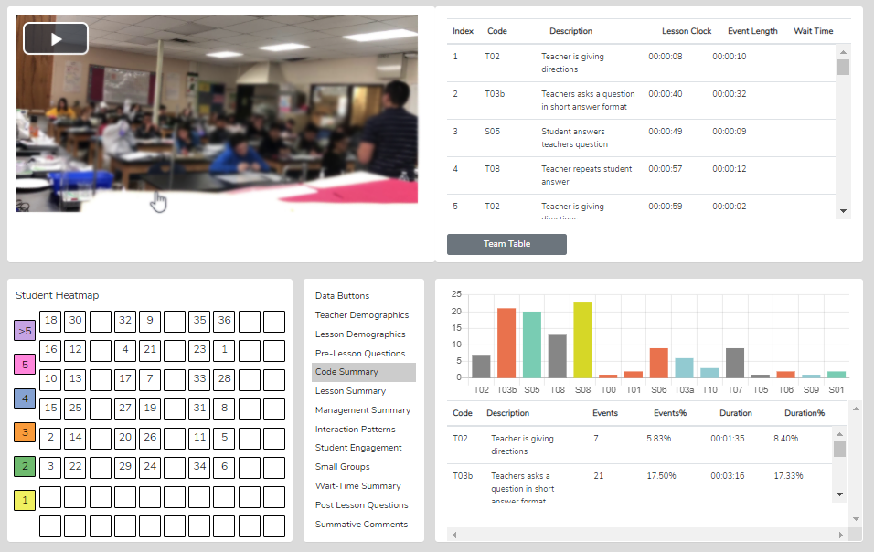

Things to Ponder About Code Summary
- Looking at Code Summary, the data table, and the graph:
  - What were the predominant T codes exhibited in this lesson?
  - When looking at the data for the four question types (T3a, T3b, T4a, and T4): what is the tendency of the teacher to ask open-ended questions requiring students to think more deeply, to speculate, and construct answers vs. asking questions that require a yes/no or short-answer memory-type response?
  - If the goal was to dig into student thinking at a deep level, consider the type and number of questions asked (and your memory of the teacher asking questions in the video). What might you conclude?
- What does the teacher tend to do following a student's response? Do they tend to judge responses, acknowledge, and then clarify for a student, or instead ask a student to explain?
- Considering the type and number of questions asked, what might you conclude if the goal was to dig into student thinking at a deep level? What changes would foster more of this?
- What is the total % of T codes vs. % of S codes? (This indicates whether the teacher is doing most of the talking and events or if the talking is balanced between the teacher and students, and at what level the students are contributing to the teacher-student or student-student interactions in that lesson.)

Lesson Type Summary – When coding a lesson, the observer notes the type of lesson in play by clicking an L button at the very start of the observation and a different L code each time the lesson type changes within the observation. As such, lesson segment types are noted and displayed in quantitative analysis mode in the Lesson Summary data window as a timeline showing the order and length of each lesson segment. This lesson segment display serves as a time-context reference when viewing other data, such as Student Engagement or Management Summary, so the user can see where misbehaviors or students' responses occurred in the lesson.

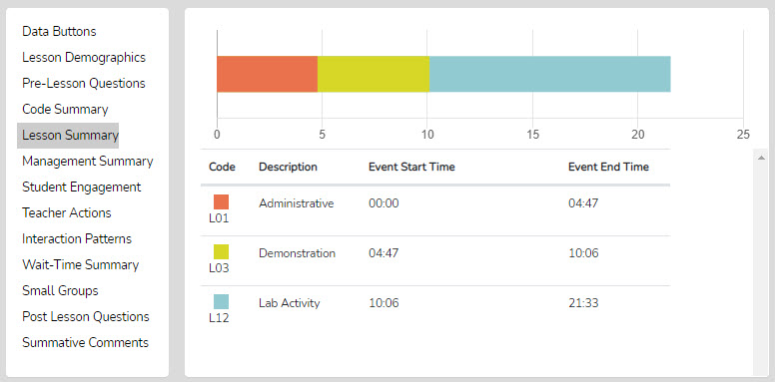

With the Lesson Summary information, the user can consider the following:

- Teachers can view how much time was spent on each segment of the lesson and think about if more or less time was used on lesson segments than intended and how the use of time affected the outcomes of the lesson.
- After the bell rings and the class period begins, teachers can analyze how much time it took to start teaching and then decide what to do differently to begin teaching right at the start of the class period.
- Teachers can examine how much time was used for each segment of the lesson and the time needed for transitions between each part of the lesson, allowing the teacher to ponder what changes should be made to reduce the time needed for transitioning from one part of the lesson to another.
- If the lesson ended early, teachers could view that the time at the end of the lesson was not used for instruction and think about some productive things to insert into the lesson to utilize the remaining class time.
- Teachers can consider the whole class period and what might have been done to use the time even a bit more productively.

Management Summary – Management Summary provides a seating chart, timeline, and individual student data for misbehaviors using black bars on the timeline that are also linked to the video and the teacher's response and intervention using red bars linked to the video. It also shows when and how long the teacher reacted to and addressed misbehavior. Clicking a bar starts playing the video linked to that event.
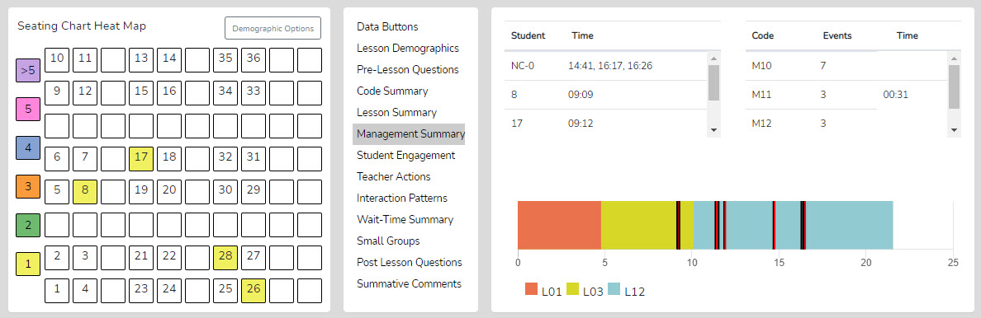

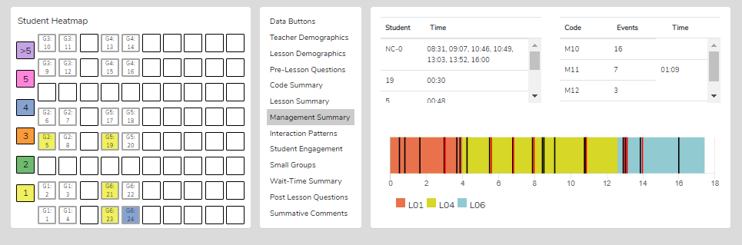

Demographic Highlighting in the Seating Chart Heat Map - In addition, if data is collected for specific students using the student seat number before entering the M code, the data can be displayed and toggled on or off by clicking the Gender, ELL, SPED, or Minority buttons. If the observer wonders how the students with special needs are disengaged during the lesson, toggle this information to find out. If the observer or teacher is concerned about equity of participation regarding gender, minority, ELL, or students with special needs, then this data is available.

Things to Ponder - How Can SMT Users Utilize the Specific M Code – Student Misbehavior Data?
When Viewing the Code Summary:
- How many classroom management events were noted by the observer?
- How many of those classroom management events were not addressed by the teacher?
  - Note that when the number of M10 events is added to the number of M12 events, if that number is greater than the number of M11 and M13 events, the teacher is probably ignoring some of the student misbehaviors either intentionally or due to the frustration of not having an impact when they do intervene.
- How much time did the teacher use to intervene in management events? (M11 and M13)

When Viewing the Seating Chart Heat Map:
- Where in the classroom are the problems occurring?
- Is there a small group or table of students exhibiting most of the misbehaviors?
- Are behavioral issues proximal or distant to where the teacher is located?

When Viewing the Management Summary:
- Where in the lesson, or during which lesson type, did the management issues occur? (Vertical bars on the lesson segment timeline)
- How many management issues occurred at the start, end of class, or during transitions from one lesson segment to another? (Vertical bars on the lesson segment timeline)

When Viewing the Video:
- How much time was needed to get all the students settled and begin the lesson when transitioning from one lesson segment to another?
- How was the teacher's movement around the classroom?
- How did the students behave or misbehave today as a whole, compared to other days in general?
- Regarding specific students who might tend to misbehave, how was their behavior today?
- Was there anything about this lesson that might have contributed to more or fewer management issues?

Student Engagement Summary – Displays student engagement events (S codes), noted by student seating number (or generically if seating chart numbers were not used), and when the events occurred. The specific time of student and teacher data is displayed on the lesson-type timeline, with black bars for student events and red bars for when the teacher engaged the whole class using Think-Pair-Share, digital devices, or other means. Clicking a bar starts the video linked to that event. In addition, the seating chart heat map shows, by color code, how many events are linked to specific students.

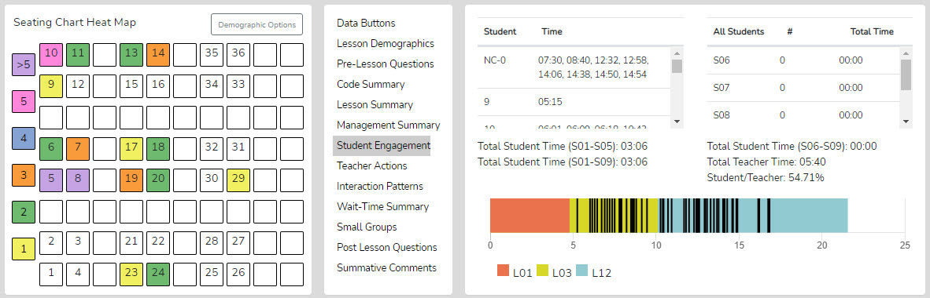

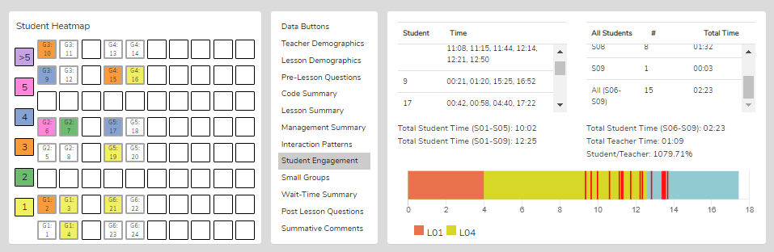

Demographic Highlighting in the Seating Chart Heat Map - In addition, if data is collected for specific students using the student seat number before entering the S code, the data can be displayed and toggled on or off by clicking the Gender, ELL, SPED, or Minority buttons. If the observer wonders how students with special needs are engaged during the lesson, toggle this information to find out. If the observer or teacher is concerned about equitable participation by gender, minority, ELL, or students with special needs, this data is available.

Things to Ponder Using S Codes – Student Engagement Data?
- Consider how many students responded to at least one question and how many were not part of the conversation. (Heat Map)
- Think about your teaching, how many students responded to each other at least once, and what you might change to produce more student-to-student interactions. (Interaction Patterns S-S #)
- Think about the average number of responses per student, how that fits your student engagement goals, and how that number might be increased. [Total of S1-S5 plus (the total of S6-S9 x the number of students in the class) / number of students in class]
- Look at the various parts of the class or type of lesson segment and determine if or how students were engaged, as evidenced by vertical bars. Think about parts of the lesson that were absent student contributions and engagement and how your lesson might be altered to produce more student engagement.
- Using the demographic toggles on the Seating Chart Heat Map, examine student engagement by demographics such as gender, minority, ELL, and Special Education – think about what the data suggests regarding equity in student engagement.

Teacher Actions Summary – Teacher Actions Summary is a timeline from the beginning to the end of the lesson that displays a backdrop of the lesson type (colors) in play and shows symbols for when the teacher exhibited various T code actions, so the user can follow the sequence of teacher actions throughout the lesson. The timeline also displays M and S code data; in fact, almost all collected data are represented on the timeline, providing a robust set of teacher and student actions. The user can easily see when any management issues occur in the context of the rest of the teacher and student actions in the lesson. Since this is a visual display of teacher actions, student actions, and misbehaviors, as well as the teacher's reaction to misbehaviors, it provides the user with a visual of the flow of action from the beginning to the end of the lesson and displays sequences, as well as the predominance or lack of teacher or student actions. For example, if the teacher is curious about their use of questioning, it is easy to see when any of the four questioning codes were used and what codes occurred before or after. The user may find a complete absence of higher-level questions. The user may readily see what they tend to do following a student's response. The user can target specific codes by toggling the display of T, S, or M codes on or off. Aside from wait-time data, all data is shown on this summary screen, which is often a large chunk of information and may clutter the screen.

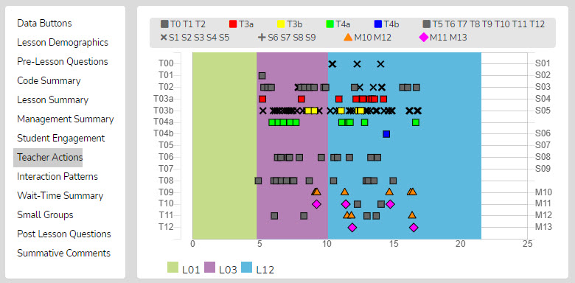

As shown below, the viewer can zoom in or out to allow data points to be separated from each other.

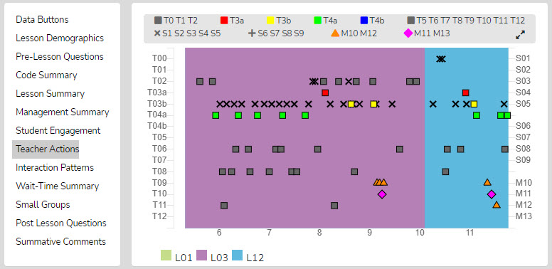

Finally, as with other data points in SMT, the user can click on any data point (symbol), and the linked video will play.

Things to Ponder About Teacher Actions Plus Data
- Looking at the Teacher Actions Plus screen:
  - What question types were used in the lesson? What followed questions in terms of S codes – one student response, or was it more than one student response? After the student(s) responded, what did the teacher tend to do next?
  - How did the teacher use the whole-group response engagement S codes (S6-S9) to engage all students in generating answers and providing maximum feedback to the teacher? If S6-S9 were not used, what evidence is there that the teacher attempted to increase students' oral contributions to the lesson?
  - Knowing that T codes (teacher responses) T6, T11, T12, and sometimes T8 tend to help get and keep students thinking more so than T5, T7, T9, and T10, what does the visual tell you about the teacher's use of the various response codes?
  - What stands out about the student misbehavior actions M10 and M12, and then how would you characterize the teacher's reaction to student misbehaviors M11 and M13?
  - How was the distribution of S codes and student contributions to the lesson?
  - What was the mix of S codes? How many S1-S4 codes were present during the observation?

Interaction Patterns – Using all the teacher actions (T codes) and student engagement actions (S codes), the user can view the predominant patterns of interaction between the teacher and students. In addition, numbers show how often students interact with each other (S-S), how often the traditional teacher-student-teacher pattern (T-S-T) is used, and how often one teacher action follows another (T-T).

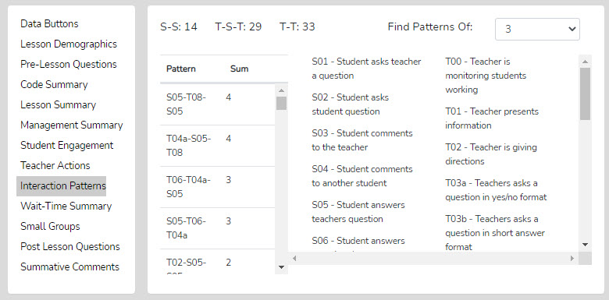

Things to Ponder About Interaction Patterns – Teacher-to-Student Interactions Data

- Looking at Interaction Patterns, examine the 3-code pattern tendency, then the 4-code pattern tendency. How are the most common patterns consistent with the goals for the lesson? What are some changes to how the teacher interacts with students that would be more consistent with the intentions of the lesson?
  - How did the teacher initiate questions and then respond to student thinking? How did the teacher's tendencies encourage or discourage student responses and engagement?
  - When students respond – what does the teacher tend to do? Do they tend to judge responses, acknowledge them, and then clarify for the student, or instead, ask the student to clarify? Different tendencies are more effective depending on the goals of instruction and the level of thinking or engagement the teacher wants from students.

Small Group Summary – When completing a quantitative observation and student engagement or misbehavior data is collected and tagged by an individual or group number, the observer can then use the Student Engagement, Management Summary, Seating Chart Heat Map, and Small Group analysis displays to examine the results and determine various things about how the lesson impacted small groups.

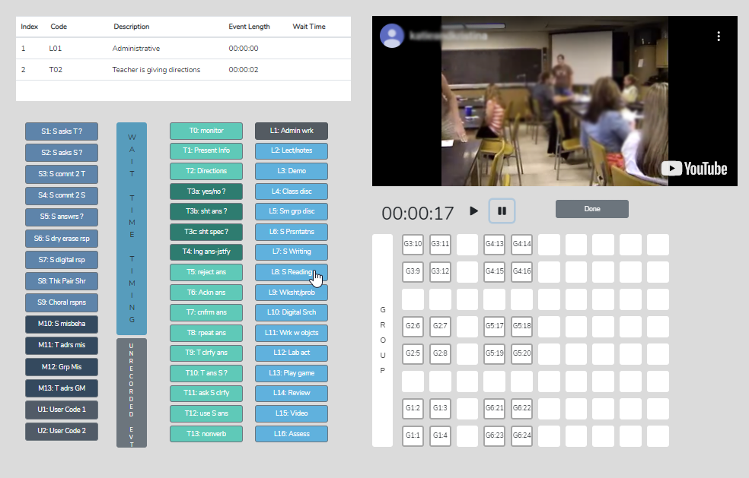

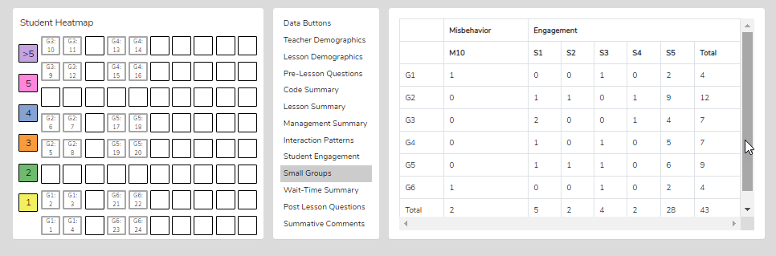

The Group Summary data collected with the student seating number allows examination of group dynamics and the number and levels of S code types of interactions that reveal the impact of a lesson on student-to-student interactions. The table shows S codes and M10 event responses coming from specific groups. If the teacher and observer were wondering how the lesson stimulated student actions (S codes) within the small group, this data would indicate that. The Seating Chart Heat Map would show how much interaction occurred within that group and color-coding to show each member's contributions.

Things to Ponder Regarding Group Engagement and Equity Among Group Members Data
- What was their intention when the teacher approached and interacted with the small groups? What did they want to accomplish by doing so versus observing the groups in action?
- What did the teacher notice about interactions with the small groups?
- How did the teacher's interactions foster the goals for the small group and the lesson? In what ways, if any, did the teacher's interactions lessen the intention of the lesson or weaken the intended purpose of having students work in small groups?
- Small groups are a great place to ask good questions and to foster student-to-student interactions – what did the observer notice regarding such? How might the teacher improve?
- How was the teacher's ability to pace themselves and get around to all small groups without taking too much time with one small group?
- We know the power of using cooperative learning strategies with small group structures (versus simply students in a group expected to work together). What might the teacher have done differently regarding small group strategies, and what impact might it have had on student engagement, thinking, and learning?

Wait-Time Summary – The wait-time data is located within the Wait-Time Summary. The Wait-Time Summary includes general summaries of wait-time by wait-time type, events, total time, and averages for each wait-time. In addition, the lower half of the summary provides wait-time averages by a specific teacher or student action. For example, the user can determine whether more wait time is allowed for higher-level questions that require deeper thinking than for lower-level questions.

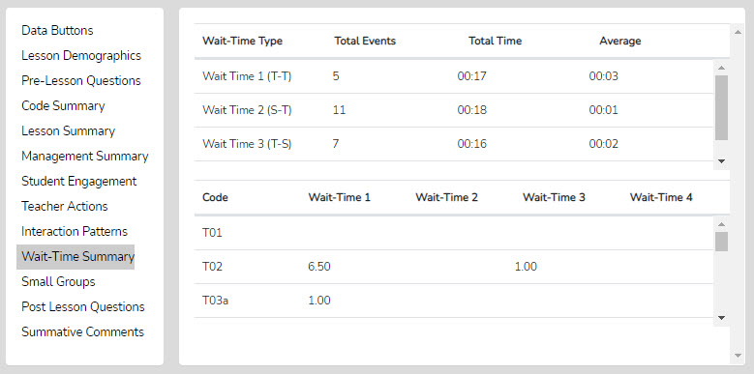

Questions to Ponder and How SMT Users Can Utilize the Wait-Time Data
- How does the WT1 average correspond to the teacher's intention for using wait-time to give students ample opportunity to think about the teacher's question?
- How does the WT2 average correspond to the teacher's intention to use wait-time to give students ample time to think about a student's response and respond to that student? (Look at the relationship between the WT2 average and the S-S count in Interaction Patterns.)
- How does the average WT for question types differ regarding higher-level questions and students needing more think time to generate an answer?
- If the WT average is lower than expected or desired, what is the teacher's concrete plan for increasing their WT?

Running Record - The Running Record lists all the events in sequence from the lesson start to finish. The user can scroll through the events and can click on any event to see the related video. While SeeMeTeach ® has significant built-in data analysis for instant viewing, the data can be exported to a .csv file for analysis with powerful statistical packages.
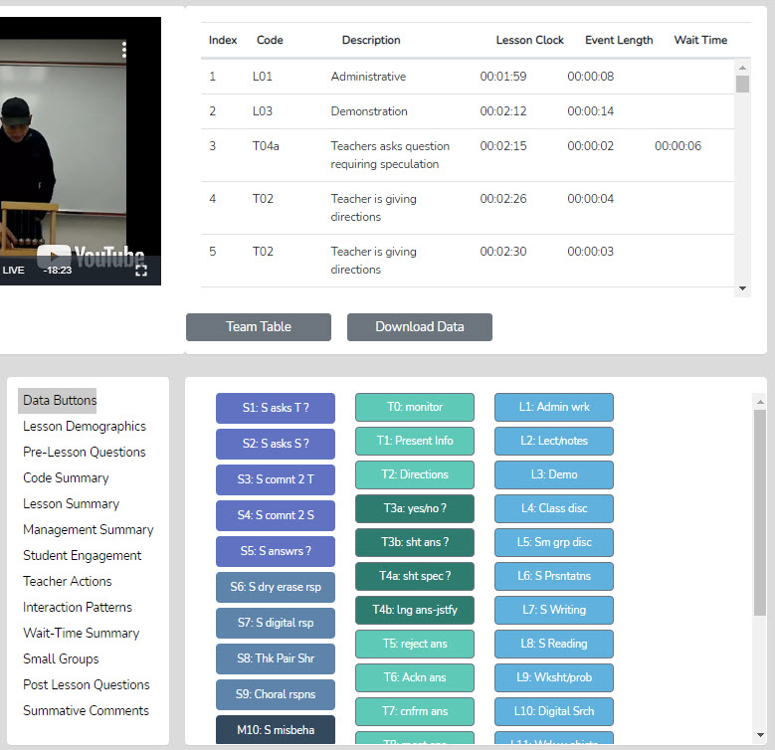

Data Buttons - The Data Buttons feature serves as a Search and Find function, allowing the user to quickly locate linked video examples of specific T, S, M, or U events. Clicking on a button finds the first of that specific code/event in the Running Record window, and the linked video begins to play. And at the bottom of the Running Record window, there is a note indicating how many events of that type were located. This feature is particularly helpful for identifying the teacher's habits and tendencies. For example, the observer might notice that the teacher has a habit of asking yes/no questions, then clarifying the answer for the student. In this case, we know that having the teacher change how they interact and respond would be beneficial for learning more about the student's thinking. For example, the teacher could have asked the student to clarify their answer. As such, the observer might use that data or video, in whole or in part, to make a point about how a teacher's choices affect student engagement and their ability to uncover student thinking.

Lesson Demographics – This contains information about the lesson entered during the New Observation lesson setup, or it can be edited (course name, period, lesson topic, subject, and grade level).

Pre-Lesson Questions – Questions posed to the teacher that will provide context and the lesson's intent.
You can access Pre-Lesson Questions from both the Settings and Analysis screens.

- What are the main learning goals/objectives for the lesson?
- Describe the major activities or parts of the lesson to be observed.
- How will you know if the learning goals/objectives have been met? For example, what evidence will you have?
- Provide the context for the lesson. How is this lesson connected to the prior lesson? How is this lesson connected to the subsequent lessons? Where is this lesson placed in the current instructional unit?
- Describe the ability levels of the students in this class.
- What will you do to maximize the engagement of all ability levels of students?
- How will you differentiate the lesson for all types of learners?

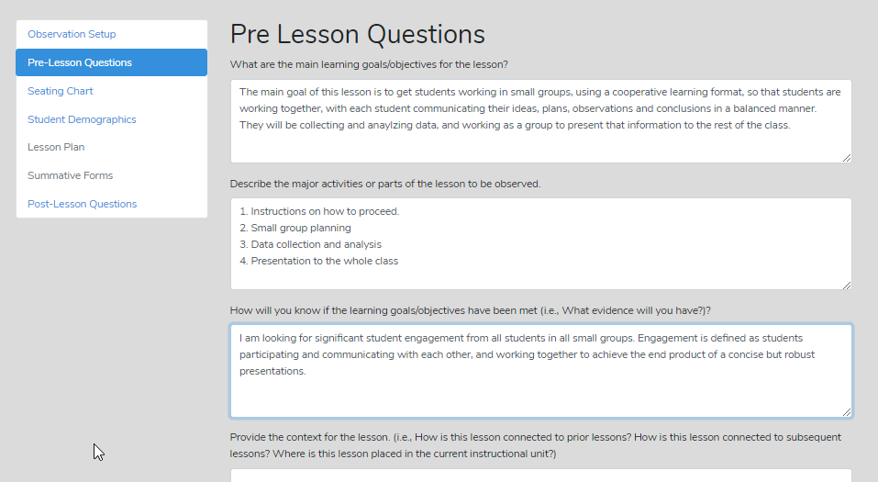

Post-Lesson Questions – Questions for the teacher to respond to following the lesson and observation.
Post-Lesson Questions can be accessed from both the Settings screen and the Analysis screen.

- Tell me about today's lesson. Probe: What went well? What needed to be improved? If you taught this lesson over again, what would you change? Why?
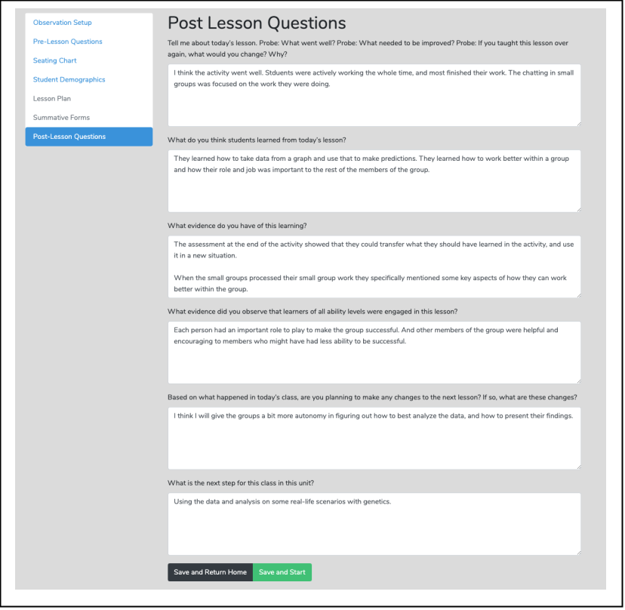
- What do you think students learned from today's lesson?
- What evidence do you have of this learning?
- What evidence did you observe that learners of all ability levels were engaged in this lesson?
- Based on what happened in today's class, are you planning on making any changes to the next lesson? If so, what are those changes?
- What is the next step for this class in this unit?

Team Unification and Synergy Using Data and Feedback – If another member of the team has completed the quantitative coding of the video before leaving the data analysis screen (or from the Dashboard), the user can open the Team Table, click, toggle on, and view the data gathered and the analysis by that team member. Or the user can jump to any team member's completed quantitative or qualitative observation by clicking on the green checkmark in the expanded Dashboard.
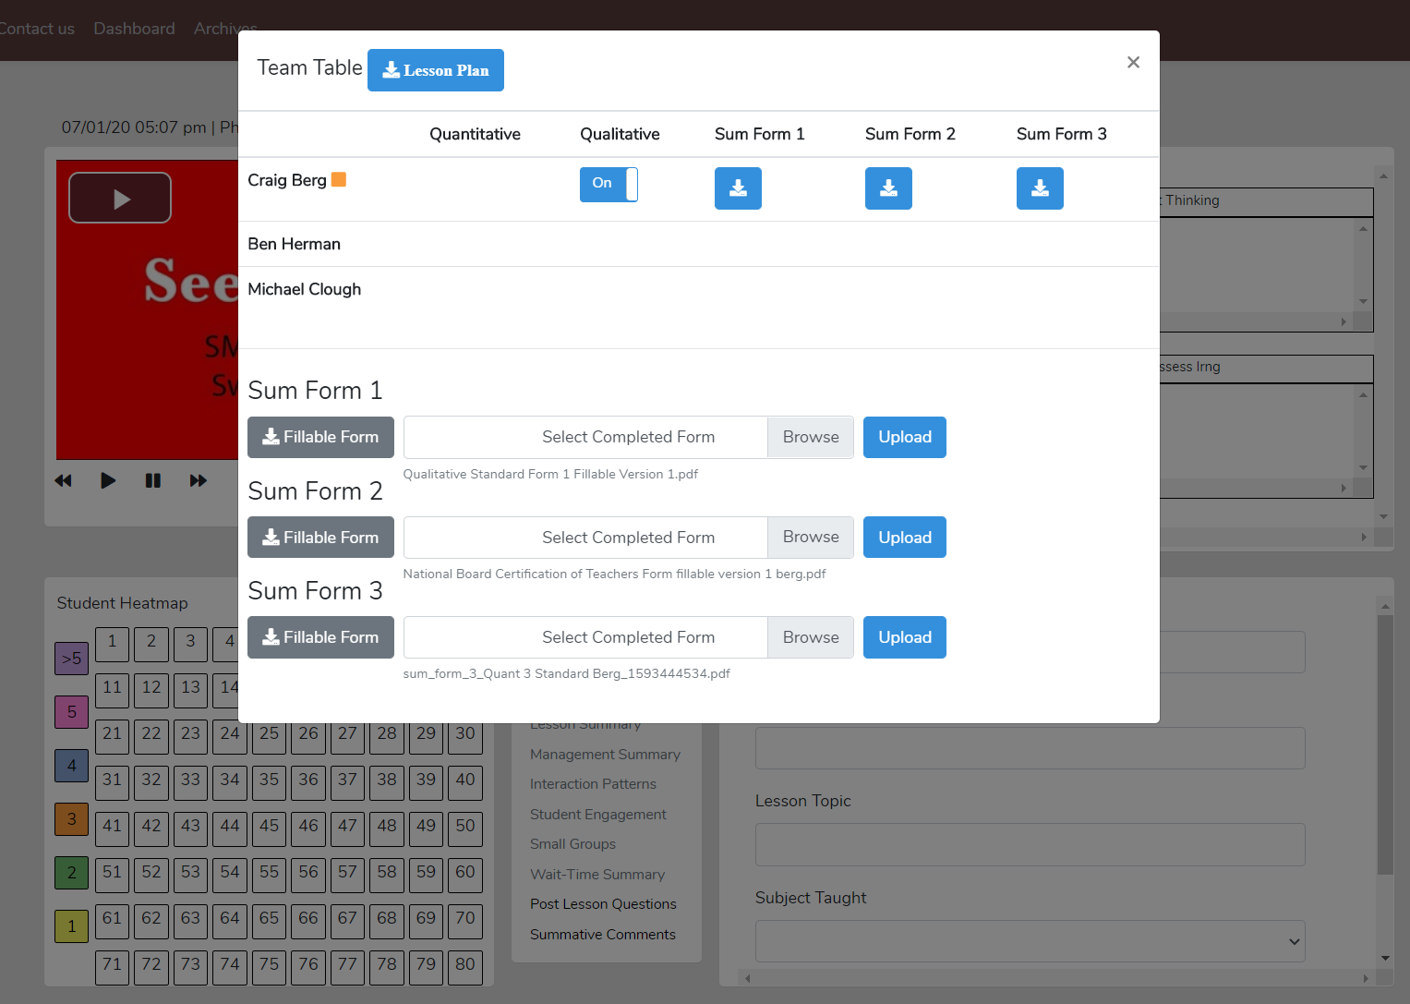

Summative Comments and Summative Forms - When the observation is over, the observer can add Summative Comments and/or fill in Summative Forms.

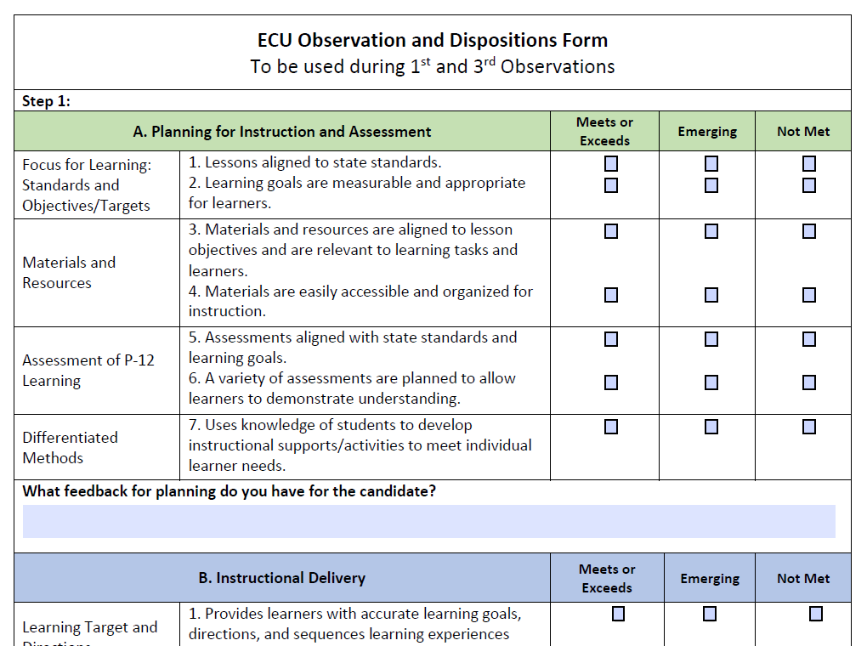

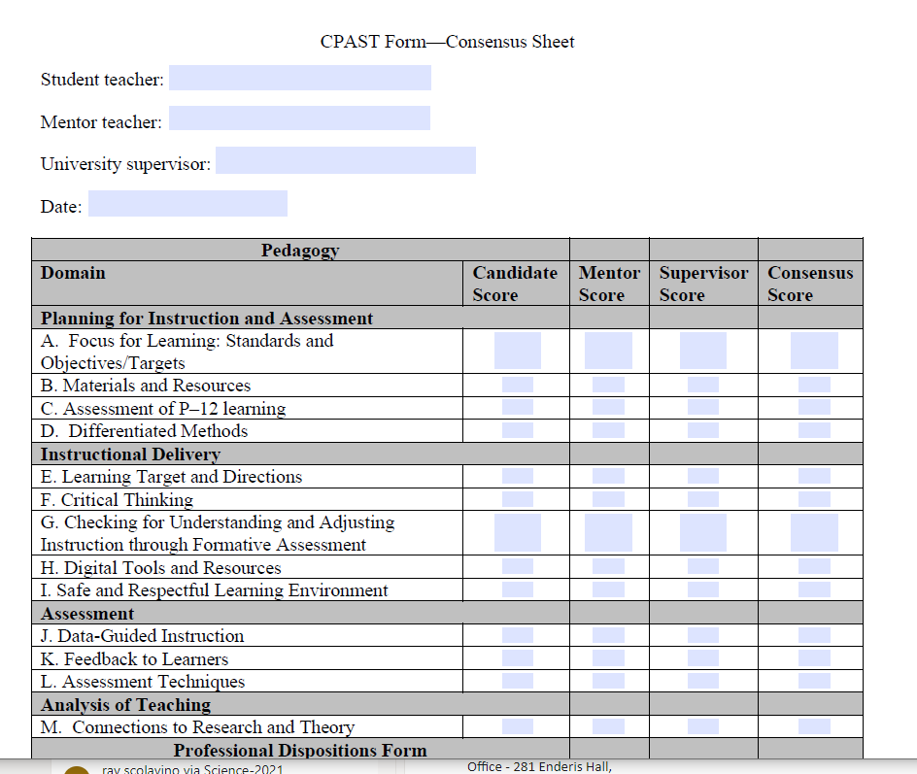
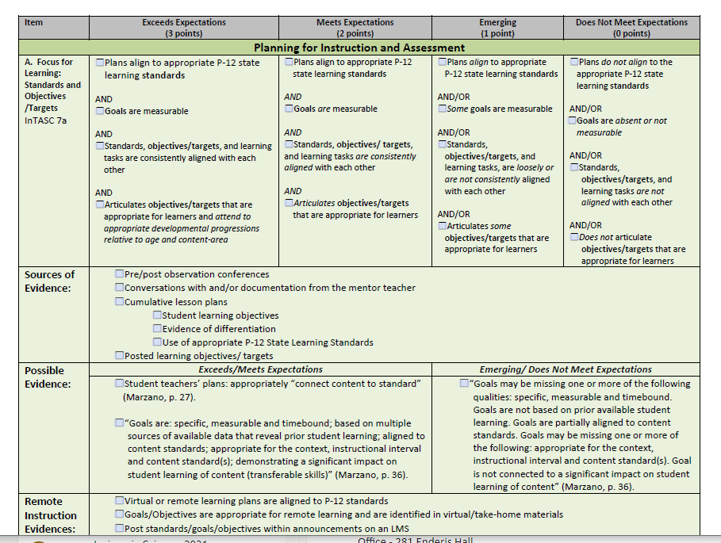

More Information

To learn more about SeeMeTeach, go to www.seemeteach.com and view the short promo video. Then perhaps look through the User's and Training Manual for more details about the many strengths of using SMT for teacher observations vs. another observation platform.
Registering to Use SMT

To use SMT, the user must first register by going to www.SeeMeTeach.com under Plans and Prices, then registering for a Basic Plan – Single User, or registering for a Group – School or Teacher Preparation Plan. A single user can still collaborate with other SMT users but is not part of an official group. Once a single user or a group has completed the registration, they can collaborate on observations and proceed through the scaffolded training levels comfortably. A group of users might consist of administrators and teachers in a school, or instructors, students, and cooperating teachers in a university teacher education program.

Registration For Basic Plan – Single User
A person can register as a single user and collaborate with other SMT-registered single users. Once registered, the user can invite colleagues to register for SMT and collaborate with them on teaching observations. A single user cannot collaborate with group members, as only designated group members can collaborate. However, a group member can still function outside of the group by registering for SMT under a Basic Plan – Single User with an email different from the one used for the SMT group. A Single User can collaborate with as many other Single Users as they choose.

* Note that the FAQs at www.SeeMeTeach.com (Prices and Plans) or below in this document have FAQs that are helpful when considering whether to register as a Single User or for a Group of Users

Registration For Groups Such as Schools or Teacher Education Programs
For an SMT group to form and function, the lead person registers and invites the individuals who will be part of the observation group.

Steps To Take To Register For and Add Users To a Group
1. Key information required for registering a group is the name and email of the key person and how many people are in the group. Note that the key person or group administrator is part of the group and can participate in observations, but their membership is free. Therefore, the person registering should factor that into the number of group members needed. Payment is by credit card or purchase order using the institution's ACH.
* If paying by credit card, begin at www.seemeteach.com under Prices and Plans and continue with the process of registering and paying.

* If not paying by credit card, the person registering for the group should be prepared with a Purchase Order Number, and within Prices and Plans, there will be a link to a page of information to fill out and fax or email to SeeMeTeach. Upon receiving the group registration request, SeeMeTeach will confirm receipt of the registration/PO and confirm to the key person that their group can begin using SMT. Then SMT will email an invoice for payment. When the key person receives an invoice, they should process the payment quickly to continue using SMT. The invoice must be paid within 30 days, or the account will be frozen until payment is received.

2. After an account has been established, the group administrator logs into SMT. Under their account name drop-down is a heading for Contacts. Clicking Add New User allows them to add users to their group up to the number requested per their registration. When they add a new user, SMT sends an email invite; recipients must open it, accept it, and add a bit of information, such as a password they will use to log into SMT. Each user invited will be listed in the Observers List and will either have a green dot (if they have accepted the invite) or a yellow dot (if they have not yet accepted) under the column Status.

3. Note that the number of individuals within a group can be increased during a payment period, and the organization will be billed accordingly, but the group size may not be decreased during a payment cycle. Once registration is complete, there are no refunds if a member leaves the group. If a group member leaves the school or the program and is no longer part of the group, the administrator can Remove them. Removing a user should free up one of the paid group slots so that the administrator can Add New User to invite a new teacher or teacher education student to the group.

Once the user or group is registered and has access to SMT, they should complete training to learn how to use SMT. The training begins with how to create an observation, followed by how to use the qualitative mode, and subsequently, a series of lessons on using the many features of the quantitative mode. Training support materials consist of video overviews and narratives describing the what, how, and why of SeeMeTeach ®, with practice sessions offered and structured to develop the user's skills.

Terms of Service

Before using SMT, you must read and agree to the complete Terms of Service/Privacy Agreement. The TOS/PA was provided during registration and is also located at the bottom of each page on the SMT website. Make note that the TOS/PA may be modified when necessary; modifications may occur after your initial reading during registration, so you are hereby advised to periodically read the TOS/PA for changes that may apply to you.

The following is a condensed version but is NOT a substitute for reading the complete TOS/PA document.

In short, SMT was designed and priced so anyone could access and use this powerful tool. The once-per-year registration fee covers the registrant's personal use for one year. Registration will automatically renew to allow for continued SMT usage unless the user cancels the renewal.

If you are a participant in a school or teacher preparation group, your institution may pay your fee. For those in a group, such as a school or a teacher education program, your participation may depend on continued employment at that school or district or whether you are an active student in a teacher preparation program or have completed teacher training at that school or institution. After moving to another school, your membership may change to that of the new school group (if they use SMT) or you may use it independently by registering as a single user.

As a single user, you may invite others to be part of your observation team at your discretion, per the TOS/PA. A single user may choose to continue using SMT independently of their school, teacher education program, or ancillary to what they do for observations. If the user is part of a school or teacher education group and wants to use SMT independently outside the group, they must also register as a Single User with an email different from the one used and associated with the group.

Whether you pay the registration fee or your school or teacher education program pays it, SMT is for non-commercial use only. As a registered user, or any user, you may not use SMT in any manner related to a consulting contract, any method of commercial purpose, or for-profit, performing a paid service without first establishing a written agreement with SeeMeTeach ® before any such intended use. The definition of the use of SMT includes:

* any work related to consulting or as a grant evaluator
* any teacher or future teacher-related observation
* any evaluation provided to a teacher, school, district, school board, university, or any teacher preparation program (formal or informal) while serving as a consultant or independent contractor.

In other words, you may not make money by using SeeMeTeach ® in any manner without first procuring a written agreement and a licensing agreement between SeeMeTeach ® and yourself/your company.

Teacher Education - Frequently Asked Questions

FAQ: How can I set up an SMT account for myself (methods instructor) and the 35 future teachers in my class?

Answer: Go to www.seemeteach.com, and under Plans and Pricing, you will find the link to register and pay for a school or teacher preparation plan. The class leader or the administrator who sets up the account can participate in the group, and they are not counted toward the number of paid slots for their group. At registration, they need to know and enter how many paid accounts (teachers or other administrators) they want in their group, along with the group members' emails.

FAQ: What do I do if I have a group consisting of a clinical experience supervisor and 25 fieldwork students, and I want to add four more fieldwork students and cooperating teachers to my group?

Answer: At this time, email doc@seemeteach.com and let them know how many more users to add to your group account. Include the institution’s name, department, program, the group leader or administrator's name, the email used for the group SMT account, and a phone number. SMT will add those additional slots to your account and invoice the administrator for the change in registration.

FAQ: I have 21 users in my group, but one person left the program and will no longer be a part of our SMT group. Can I fill that slot with another person?

Answer: Yes, you can fill that slot with another person. Go to SMT Login, Contacts, and Remove the user who has left the group. That should free up a slot and show how many more users you can invite before you reach the paid registration limit. If that number is one or more, then invite a new user to the group. They will get an email invitation to click to accept (and create a password, etc.). The new user, of course, doesn't pay because the group administrator has already paid for the group members. If the administrator needs more slots than they initially required, see the answer to the FAQ above, in which you contact doc@seemeteach.com for support.

FAQ: I am the university supervisor for ten fieldwork students. I want to form a group of 10 students, plus myself. How do we pay for SMT registration?

Answer: There are a couple of things to consider.

- First, a typical "group" registration (see alternative group formation below) can be paid by:
  - one credit card payment that covers all members of the group, or
  - the group administrator initiates payment via purchase order (email to doc@seemeteach.com or fax 866-414-3456, and SMT generates an invoice sent to the group's administrator.

Remember, when forming a group, the group administrator has a free account, so for 1 group admin and 10 students, the request to SMT is for 11 users, but the cost is only for 10 users.

- Second, if each student in the group is paying for their registration, how can the group administrator collect the money from the ten fieldwork students?
  - Some universities add a course fee per student to cover the cost of SMT registration. Then, when the fieldwork supervisor (and the administrator of the SMT group) registers themselves and their students, they pay with a department credit card or provide a Purchase Order number so an invoice can be sent to the department for payment.
  - Note that sometimes teacher education programs pay for the registration cost for the cooperating or mentor teacher so they too can participate and collaborate in observations and feedback.

- Third, if the two group payment suggestions above are not feasible, the alternate group registration via a single-user plan process may work better. The alternative way to establish a group is to set up an informal group where the university supervisor and fieldwork students register as Single Users and then invite each other (and accept) as collaborators. Also, read the response below to understand why this might be a preferable option in some instances.

FAQ: In a teacher preparation program, if I am a methods instructor who has assignments linked to Fall semester fieldwork placements and my students who are registered SMT users finish my course and their fieldwork, then the students enter a different course in the Spring semester with a different course instructor/fieldwork supervisor who wants them to use SMT to process their student teaching observations, is it best to form registered groups or best to have all the students and the instructor/supervisor register as single users – the alternative group registration?

Answer: Unlike teachers in a school who stay within that group for the whole school year, teacher education students start and finish courses or start and complete fieldwork or student teaching experiences during a semester. So, in some scenarios, it is probably best to have teacher education students register as single users and have each student pay the registration fee that will cover them for one whole year. Then, for the 1st semester, each user can invite whoever needs to be part of their collaborative team, such as their methods instructor (or vice versa), their cooperating teacher, their university supervisor, and fellow fieldwork students if they are working together at a school placement. This process may also be best for an assignment from the methods instructor that requires small groups to collaborate on observation and provide feedback. When the semester ends and teacher education students are in different classes or have new collaborators, they can remove users from their Contacts List who no longer should be collaborators and add new collaborators as needed. The benefit of having all those users in one formal group using the group plan vs. a single-user plan is that no user in the group can invite someone who shouldn't have access. As such, if videos are used for observation, they remain accessible to only the group members and the instructor – the people who usually have access to those classrooms.

FAQ: With the power of SMT and how the potential for collaboration between the university supervisor, student-teacher, and cooperating teacher is built right into SMT, how can we get more cooperating teachers involved in using SMT and being part of the collaborative team, sharing observation notes, data, and summative forms?

Answer: Universities highly value cooperating teachers for the feedback and mentoring they provide. Some universities secure grants and gifts from donors to cover the cost of registration for the cooperating teachers. Some institutions simply build it in as an expense, while other universities have the fieldwork student or student-teacher pay a course fee that covers the cooperating teacher's SMT registration.

FAQ: If I am in a school group or a teacher education group, I know that I can only have collaborators from a select group of people that the group administrator has invited to the group. How can I do so if I want colleagues outside of the group to collaborate with me on observations and feedback?

Answer: You are correct. You cannot collaborate with anyone outside the group using that group account. First, keep in mind that privacy rules would likely prevent you from sharing any video of K-12 students with people who would not normally be working with them. Also, school district policies and laws need to be considered, especially in the United States, where the Children's Online Privacy Protection Act ("COPPA") applies to children under the age of 13 and requires parental permission to record or store any video of children under the age of 13.

However, if you sign up as a single user, you can invite anyone you would like to include as a collaborator on observations. Remember that SMT will only let a specific email address work for a group or as a single user, but not both. For example, if your school email address is used with your school group, you must use a different email address, such as @gmail .com or @yahoo .com, when registering for your single-user account.

FAQ: How long does the registration cost cover?

Answer: Each registration is good for one year from the registration date. For the user's convenience, registration will automatically roll over unless the user cancels their registration. SMT gives plenty of notice before the new registration begins. The user or administrator will receive an email 30 days before the rollover, giving them plenty of time to cancel before renewal. For schools or teacher education groups that paid for the group members, the renewal email is sent to the administrator who established the group. Those who registered as a Single User will also receive a 30-day notice of renewal.

K-12 Schools - Frequently Asked Questions

FAQ: How can I set up a school account for myself (the Principal) and the 35 teachers in my school?

Answer: Go to www.seemeteach.com. Under Plans and Pricing, you will find the link to register and pay for a school or teacher preparation plan. The administrator who sets up the account can participate in the group, and they are not counted in the number of paid slots for their group. At registration, they need to know and enter how many paid accounts (teachers or other administrators) they want in their group. They will be asked to enter the emails of group members they plan to invite.

FAQ: What do I do if I have a school group consisting of the Principal and 25 teachers, and I want to add four more teachers to my group?

Answer: Email doc@seemeteach.com and let them know how many more users to add to your group account. Include the school district name, the school, the group administrator's name and email used for the group SMT account, and a phone number. SMT will add those slots to your account and invoice the administrator for the registration change.

FAQ: I have 21 users in my group, but one teacher left the school and will no longer be a part of our SMT group. Can I fill that slot with the teacher who takes their place?

Answer: Yes, you can fill that slot with another person. Go to SMT Login, Contacts, and first remove the user who has left the group to free up space for the new person. Then SMT will show how many more users you can invite into the group before reaching the paid registration limit. Invite a new user to the group if that number is one or more. They will get an email invitation they must click to accept (and they create a password, etc.). The new user, of course, doesn't pay because the group administrator has already paid for the group members. If the administrator needs more slots than they initially required, see the answer to the FAQ above, where you contact doc@seemeteach.com for support.

FAQ: With the power of SMT and how the potential for collaboration between the university supervisor, student-teacher, and cooperating teacher is built right into SMT, how can we get more university supervisors and student-teachers involved in using SMT and being part of the collaborative team, sharing observation notes, data, and summative forms?

Answer: Universities highly value collaboration between the university supervisor and the cooperating teacher for the feedback and mentoring they provide. The school might suggest that the teacher education program use SMT as an observation platform because SMT gathers a ton of data for feedback, recommendations, indicators of growth, and decision-making. Some universities secure grants and gifts from donors to cover registration costs for the university and cooperating teachers. Others build it into the expense, while other universities have the fieldwork student or student-teacher pay a course fee that covers the cooperating teacher's SMT registration.
FAQ: If I am in a school group or a teacher education group, I know that I can only have collaborators from a select group of people that the group administrator has invited to the group. How can I do so if I want colleagues outside of the group to collaborate with me on observations and feedback?

Answer: You are correct. You cannot collaborate with anyone outside the group using that group account. First, remember that privacy rules would likely prevent you from sharing any video of K-12 students with people who would not normally be working with them. In addition, you need to consider school district policies and laws, especially in the United States, where the Children's Online Privacy Protection Act ("COPPA") applies to children under the age of 13 and requires parental permission to record or store any video of children under the age of 13.

However, if you sign up as a single user, you can invite anyone you would like to include as a collaborator on observations. Remember that SMT will only let a specific email address work for either a group or a single user, but not both. For example, if you use your school email address with your school group, you must use a different email address, such as @gmail or @yahoo, when you register for your single-user account.

FAQ: How long does the registration cost cover?

Answer: Each registration is good for one year from the registration date. For the user's convenience, registration will automatically roll over unless the user cancels their registration. And SMT gives plenty of notice before the new registration begins. The user or administrator will receive an email 30 days before the rollover to allow plenty of time to cancel before renewal.

FAQ: Can I cancel my initial registration or cancel it after the renewal has taken place?

Answer: Once registration or renewal is finalized, the user can still cancel at any time by going to SMT, logging in, and clicking the Cancel Account button under Billing. If the registration or renewal process has already occurred, no refunds will be given. However, since the user paid for registration, they will still have access to and can use that account until the initial registration or renewal period ends. Because the user canceled the account, the next renewal will not take place. Registration renewal emails are automatically sent to the SMT user's account email. The renewal email will be sent to the administrator who established the group for schools or teacher education groups.

SMT Supporting Documents

SMT Teacher Explorations and Challenges – A series of min-action research explorations into teaching. A teacher identifies an issue, collects baseline data, implements a potential solution or change to their teaching, and collects data to compare with the baseline data, looking at critical indicators of change and effective instruction.

SMT Professional Development Modules – A series of modules focusing on specific strategies and pedagogy related to exemplary instruction for the discipline.

SMT and edTPA – Documents that guide how to vastly improve the use of data and critical indicators when planning, teaching, analyzing, and reflecting on lessons when writing edTPA Rubrics 6-10.

SMT and NBCT – How to incorporate data as evidence and indicators of powerful instruction into the NBCT reflection submission.

SMT Cooperating Teacher – How a cooperating teacher can incorporate data as evidence and indicators of effective instruction when providing feedback and coaching to future teachers in a clinical setting.

SMT and Teacher Education – How methods instructors and fieldwork supervisors can use SMT to provide feedback and coaching using evidence-based indicators. How the data collected can serve as evidence of overall program effectiveness.

SMT, Teachers, Administrators, and Schools – How using SMT, Teacher Challenges, and SMT Professional Development Modules can replace or supplement teacher observation.

Graduate Students and Other Researchers – How SMT can provide a platform for pedagogical research and using data vs. impressions.

Grant and Curriculum Impact Evaluators – How SMT can be used to evaluate the impact of grant-supported professional development or curriculum development on teaching and instruction, bringing critical data and indicators into the process.

